a `P
GREATER LAS VEGAS ORCHID SOCIETY
ORCHID COLUMN
CAROL SIEGEL, EDITOR
“THE ORCHIDS OF HAWAII” CAROL SIEGEL, PRESENTER

“I must have flowers-always and always”-Claude Monet”

THE GREATER LAS VEGAS ORCHID SOCIETY
THE ORCHID COLUMN
SUNDAY, JUNE 14, 2026 1 pm
ORCHIDS FOR SALE SHOW AND TELL
MARK ROMANSKY presents:
“WHERE CAN I BUY ORCHIDS”

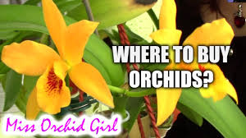

Mark Romansky, our great member speaker, will delight us with an informative and amusing talk on how to buy our very favorite thing- orchids. Since shopping for orchids is one of the great delights of the orchid hobby, you won’t want to miss this one. If you have any favorite vendors, please share them with us.
We will also have several dozen orchids in bloom from Hilo Orchids. Their plants are reasonably priced, very well-grown and always re-bloom for most of us.

EPIPACTIS GIGANTEA

JOEL DAVIDSON GETS US ORCHIDS FROM THE MGM
We have all missed the hotel orchids that we used to get donated by the big hotels. They stopped sharing them with us and started giving/selling them to their employees. BOOHOO. Dr Joel Davidson, our long-time member, was able to convince the MGM to
(wait for it) donate orchids to us again. We hope to have some this month!! The orchids are a big money-maker for the club and a source of lots of pleasure so thank you, Joel. Hopefully, this is the start of a wonderful new chapter for us.
JUNE POTLUCK


Bring something yummy for our spring potluck I will have a sunflower décor.

SHOW AND TELL

We will have show and tell this meeting. You can even bring
something you just bought.


We are pleased that so many paid dues and even gave us donations to bolster our treasury. They were appreciated. DUES FOR 2026 WILL BE WILL BE $40 FOR AN INDIVIDUAL AND $60 FOR A COUPLE. DONATIONS, OF COURSE, ARE ALWAYS APPRECIATED.

We now have the ability for you to pay your dues online! Just click on the link, and the rest is quite clear. The form will ask for your credit card information which is secure through the Square application. I tried it, and it worked great. If you want to add a little extra for a donation, just add it on to your membership. It says “donation” instead of “dues” due to a technicality because we are a non-profit. You will receive a receipt immediately.. You can also pay at the meeting, but it makes the treasurer’s job much easy if someof you do this online.
Here is the link-
https://square.link/u/NDRpbeQq?src=sheet

COMING SOON!
The Huntington and Orchid Digest's
Speakers Day 2026, Saturday, June 20, 2026
10:00 am to 7:30 pm
Hybrid event: In-person and Virtual
﻿at The Huntington
1151 Oxford Rd, San Marino, CA 91108
Registration includes:
Four Speakers, Vendors, Book Sales, On-Site Silent Auction, Happy Hour, Dinner, Recording
﻿Members through 6/12/26:
$99.00: In-person registration, recording
Virtual $40.00: lectures, recording
Nonmembers: $125.00: In-person registration, recording
Virtual $55.00: lectures, recording
Non-members: Join now and take advantage of the member rate for the coming year on all Orchid Digest Events, plus the journal!

Register Now



Speakers

  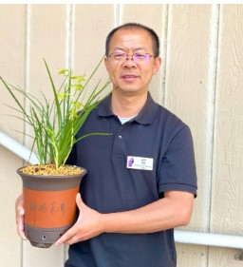
  Jack Zhu: “Beyond the Bloom: Variegation and Culture of Cymbidiums, including Cymbidium lancifolium”
  Jack is the owner of Fang Hua Gardens, specializing in the cultivation and preservation of Asian orchids. He is a leading expert in the field of Asian cymbidiums and has received over 40 AOS awards. He blends traditional growing techniques with the rigorous standards of orchid judging. He is an accredited AOS judge.


  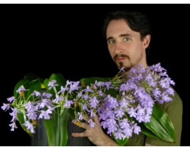
Nicholas Rust: "Terrestrial Orchids"
Nick is an up-and-coming hybridizer. Recognizing the terrestrials were of special interest, he focuses on Habineria, jewel orchids, Australian terrestrial orchids and Bulbophyllum. He began hyrbidizing terrestrial orchids in 2018 and opened a small orchid nursery, Rustyexotics where he shares the wonders and beauty of his work.

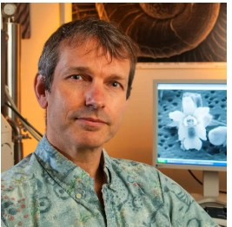

﻿Daniel Geiger: "Facination of the Overlooked Miniature: Oberonia"
Daniel has been growing orchids for over 20 years. He pioneered terrarium cultivation of tropical orchids and has developed a special interest in the genus Oberonia. He has written dozen of scientific articles, and is finishing a 1,250 page global monograph. His expertise in macro- and microphotography and scanning electron microscopyis widely recognized.

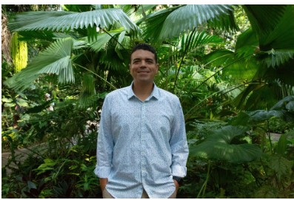

﻿Jason Downing
Jason is the Director of Research at the Fairchild Tropical Botanic Garden in Coral Gables, Florida, where he focuses on orchid research, propagation, education, and conservation. The Million Orchid Project, their citizen science program is the largest public orchid outreach program and has led to over 600,000 native orchids being replanted in Florida.

  Register NOW!
  Register Here

Not a member?
Join now to get member discounts and the journal!﻿
Be part of a special orchid community.﻿

JOIN THE ORCHID DIGEST NOW!

  
  Click to Visit our Meta Page: Orchid Digest Friends
  Click to Visit our Website

YOUTUBE MISS ORCHID GIRL
www.missorchidgirl.com

One of the most popular orchid channels on YouTube is Miss Orchid Girl. Over ten years, the very charming Dani has produced 2583 very useful free videos on almost a daily basis. She has over 537K subscribers and has had over 84 million views. She presents hours and hours of simple, easy-to-understand and professional tutorials suited for beginners and experienced growers. Her tips and tricks cover every subject from making your orchids rebloom, building an orchid collection on a budget, caring for slipper orchids, selecting 10 mini cattleyas, figuring out if your orchid is dead and alive, and evaluating orchid myths. She has orchid care for beginners as well as an orchids in bloom spotlight. Most of her content is free, but in 2024 she will air two public videos each week but will have exclusive content for those who pay a monthly fee.


Diana, website genius, and I created our new website https://lasvegasorchidsociety.org/
If you don't get a newsletter or don't remember a meeting date, it is always there as well as lots of information.
Do click on it. There are 22 articles that might interest you.

Upcoming Events:
Sunday June 14, 2026 Mark Romansky
“Where to Buy Orchids”

Sunday, July 12 Peter Lin :”Discovering Fragrant Orchids”

Sunday, August 9, 2026 Carol Siegel August 9, 2026
“Orchids and Hummingbirds- Sex in the Fast Lane”

Sunday, Sept 13, 2026 Bridget Uzar “The Orchid Royalty- Cattleya”

Sunday, October 11 Fred Clarke “The 80% Grower”

Sunday, Nov 8, 2026 Diana Smith “Bugs and Diseases”

