P
GREATER LAS VEGAS ORCHID SOCIETY
ORCHID COLUMN
CAROL SIEGEL, EDITOR
“THE ORCHIDS OF HAWAII” CAROL SIEGEL, PRESENTER

“I must have flowers-always and always”-Claude Monet”

THE GREATER LAS VEGAS ORCHID SOCIETY
THE ORCHID COLUMN
SUNDAY, December 14, 2025 1 pm
HOLIDAY PARTY HOLIDAY ORCHIDS
RUSSELINE ZELLNER AND JOHN ANTHONY ENTERTAIN
MUSIC AND SONG
CAROL SIEGEL “HOW TO BUILD AN ORCHID COLLECTION”
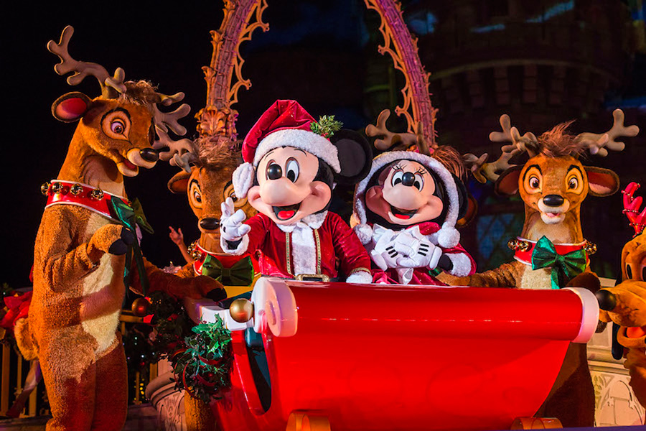
Many thanks to Joellen Lewis who generously paid our insurance for the club. How kind of her!

JASON FISCHER, OF ORHIDS LIMITED (WWW.ORCHIDWEB.COM), ONE OF OUR VERY FAVORITE SPEAKERS, WILL DELIGHTS US WITH A TALK ON THE VANILLA ORCHID, ONE OF THE VERY FEW EDIBLE ORCHIDS. WE WILL ALSO HAVE 36 VANILLA PLANTS FOR SALE! KATE SCHLATTER WILL DELIGHT US ON THE PIANO AT 1PM.
I have attached to the newsletter an article on growing vanilla called “The Scoop on Vanilla,” which I published in Orchid Digest in 2008.
Jason’s describes his talk: “Growing Vanilla- With the species' population in decline and their habitats being converted to other purposes, the Vanilla orchid is listed as endangered on the IUCN Red List of Threatened Species. If there were no Vanilla, how many of your beloved foods, scents, and more would be affected? This lecture will cover various species and cultivars of Vanilla, how to grow them indoors vs outdoors, how to create the seedpod, and how to harvest and create
your own Vanilla extract!”Jason will also include a short greenhouse tour at the end of the lecture.

Show original message

EPIPACTIS GIGANTEA

JOIN US FOR OUR ANNUAL HOLIDAY PARTY AT THE RAINBOW LIBRARY.
We will have a holiday orchid raffle from Hilo Orchid Farm with tickets being only $8, and the club subsidizing the rest. Everyone will get an orchid who buys a ticket. The Board- Diana Smith, Cathy Loftfield, Jackie Bravermann, Phyllis Bond and I- will pay personally for a glorious Chinese Feast, and we ask everyone to bring something chocolate for our Chocolate Bar for dessert. I have donated holiday hats and necklaces, holiday décor and imprinted pens for little favors. Thanks to Cathy Loftfield for providing drinks for our feast and to me for providing holiday-theme plates and such.
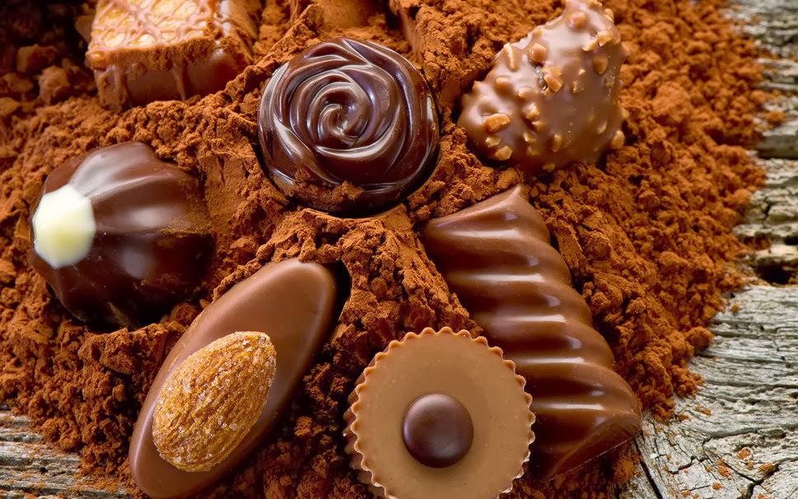
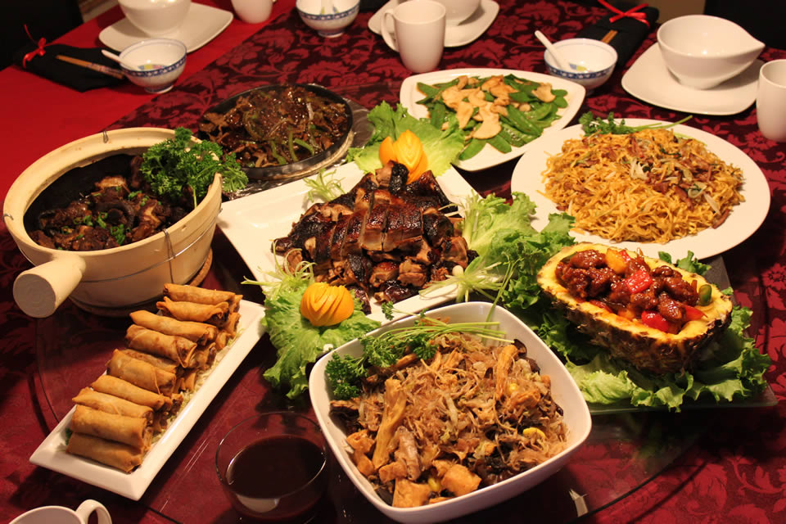

We will have special holiday entertainment at our meeting. I will treat the club to two terrific entertainers, the dynamic duo of John Anthony and Russeline Zellner. They are a much-in-demand professionals who performed for us several times last year . They are just world-class, and I know you will enjoy them. Come promptly at 1pm to enjoy their song and music. They will play from 1-2. The meeting room will be open at noon.

HOW TO BUILD AN ORCHID COLLECTION by Carol Siegel
Many of us just buy orchids with no plan and wind up with a mishmash of orchids that we are not thrilled with. I will do a power point presentation based on an article I wrote published in Orchid Digest last year on how to build an orchid collection that is planned out, healthy, and that thrills you. Nobody ever talks about this, but it is an important part of being a happy orchid hobbyist.

BRING IN CANS OF FOOD FOR THE POOR AT THIS HOLIDAY
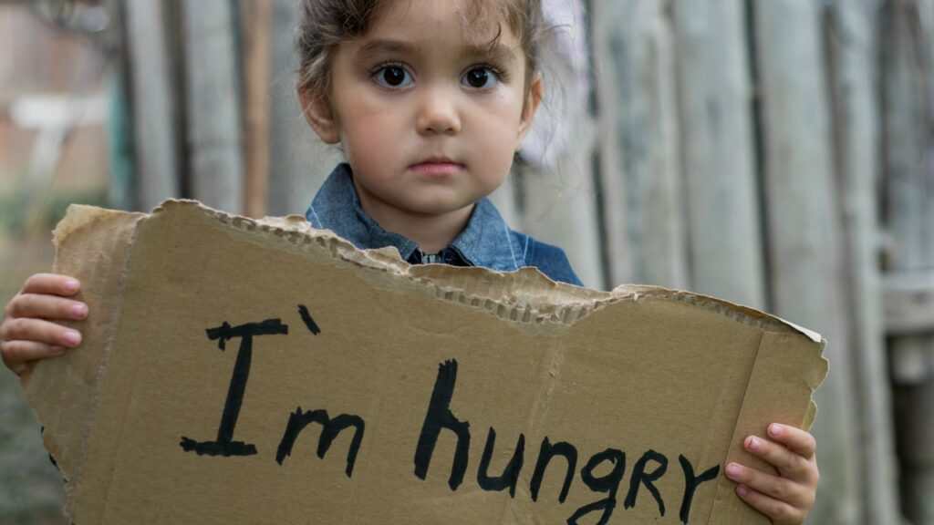

IN KEEPING WITH OUR TRADITION OF GIVING, WE ASK YOU TO BRING IN TO OUR PARTY MEETING A FEW CANS OR BOXES OF FOOD FOR US TO DONATE TO THE SALVATION ARMY. IT IS A WAY OF GIVING TO OTHERS IF WE ARE LUCKY ENOUGH TO NOT SUFFER FROM HUNGER


Diana, website genius, and I created our new website https://lasvegasorchidsociety.org/
If you don't get a newsletter or don't remember a meeting date, it is always there as well as lots of information.
Do click on it. There are 22 articles that might interest you.

ELECTIONS
CONGRATULATIONS TO OUR CURRENT BOARD ON BEING ELECTED AGAIN. THANKS FOR ALL YOUR HARD WORK.
IT WAS APPRECIATED!
Carol Siegel, Pres Cathy Loftfield, VP
Phyllis Bond, Secy Jackie Bravermann, Treas
Diana Smith, treasured ex-emeritus member who does and did so much for so long for us


DUES FOR 2025 WILL BE WILL BE $40 FOR AN INDIVIDUAL AND $60 FOR A COUPLE. DONATIONS, OF COURSE, ARE ALWAYS APPRECIATED. THIS YEAR WE NO LONGER GET HOTEL PLANTS AND DUE AND DONATIONS ARE SPECIALLY IMPORTANT NOW TO KEEP OUR WONDERFUL PROGRAMS GOING. I have been personally chipping in, but it would be nice to have the club more self-sufficient.
In 2023, members gave donations of $1500, and it made all the difference.
If you haven’t paid your 2025 dues, PLEASE FEEL FRREE TO PAY YOUR 2026 DUES…. Until the end of the year, we will forgive your back dues just this once.

We now have the ability for you to pay your dues online! Just click on the link, and the rest is quite clear. The form will ask for your credit card information which is secure through the Square application. I tried it, and it worked great. If you want to add a little extra for a donation, just add it on to your membership. It says “donation” instead of “dues” due to a technicality because we are a non-profit. You will receive a receipt immediately.. You can also pay at the meeting, but it makes the treasurer’s job much easy if someof you do this online.
Here is the link-
https://square.link/u/NDRpbeQq?src=sheet

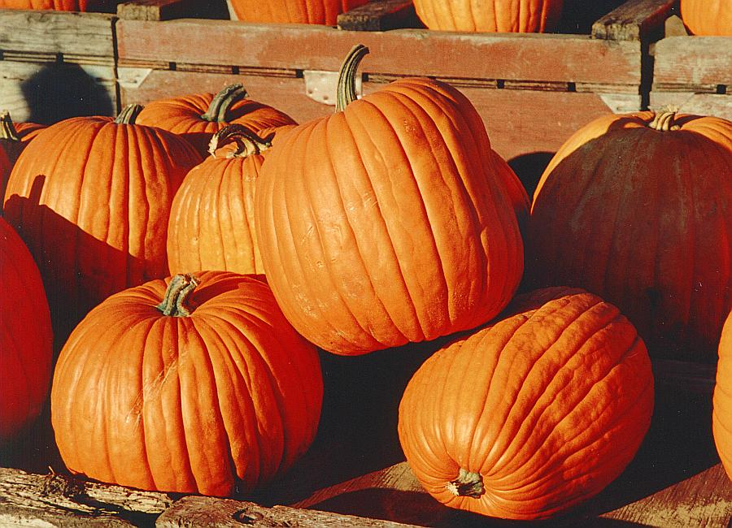

Thanks to everyone who made our Thanksgiving potluck such a hit especially Barry King, Jan Carey, Catherine Winchester, Cathy Loftfield, Dan Mumau and me who all brought meats and fish. I can’t mention everybody, but it was really outstanding
The talk on the Chelsea Flower Show by our in-person favorite Art Chadwick was just wonderful. It was a wonderful meeting thanks to all of your generosity and participation. Thanks to Ole for helping with sales. Such a nice man…


WHITE ELEPHANT SALE
REMEMBER THAT WE WILL HAVE OUR WHITE ELEPHANT SALE AT OUR MEETING ON January 12.
Be looking around for unwanted loot to bring to the meeting. It is our main fundraising event, and we are grateful for your trash and treasure.

Upcoming Events:
SOME DATES ARE DIFFERENT BECAUSE OF LIBRARY
AVAILABILITY

Sunday, December 14 Holiday party Carol Siegel “How to Build an Orchid Collection” John Anthony and Russine Zellner perform Chinese Feast

Sunday, January 11, 2026 Mark Romansky “Secrets to Potting an Orchid” White Elephant Sale

Sunday, February 8, 2026 Beth Davis “All About Cattleyas”

March 22, 2026 Fred Clarke “The Fabulous Flower Fields” (every other Saturday and Sunday in March was taken- really) Note this is the third Sunday.

Saturday,April 18, 2026 Cathy Loftfield “The Santa Barbara Orchid Show” All Sundays taken and most Saturdays, too

Somewhere between the end of April and the beginning of May, we will visit Calico Basin to see our native orchid Epipactis gigantea in bloom (depending on Mother Nature…)

Sunday, May 10, 2026 Beth DaviS “All About Dendrobium”

Sunday June 14, 2026 Mark Romansky (tentative)
“Where to Buy Orchids”

