P
GREATER LAS VEGAS ORCHID SOCIETY
ORCHID COLUMN
CAROL SIEGEL, EDITOR
“THE ORCHIDS OF HAWAII” CAROL SIEGEL, PRESENTER

“I must have flowers-always and always”-Claude Monet”

THE GREATER LAS VEGAS ORCHID SOCIETY
THE ORCHID COLUMN
SUNDAY, NOVEMBER 9, 2025 1:30 PM
ROOM IS NOT AVAILABLE UNTIL 1 PM (Not noon as is usual)
ART CHADWICK IN PERSON
“THE CHELSEA FLOWER SHOW”
THANKSGIVING POTLUCK
“THE TWO OF US” CAROL JOYCE?& MARGARET CARBAUGH ENTERTAIN
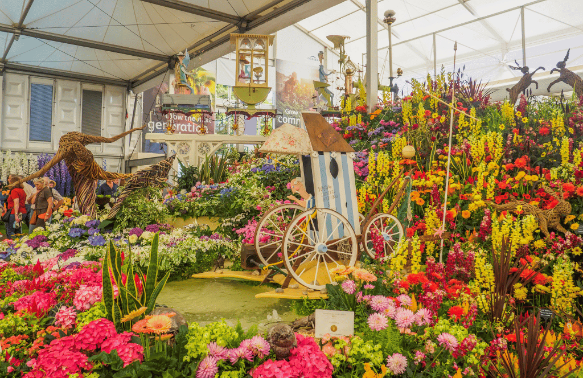
THE CHELSEA FLOWER SHOW 2025
https://www.youtube.com/watch?v=w1EyncWJcfc
If you select this address, copy it (control C) & paste it into the GOOGLE search bar at the top of your page (control V), you will see a delightful 40-minute video about the Chelsea flower show. If you can’t figure it out, call your grandchild. They know everything, even if they are only eight.

JASON FISCHER, OF ORHIDS LIMITED (WWW.ORCHIDWEB.COM), ONE OF OUR VERY FAVORITE SPEAKERS, WILL DELIGHTS US WITH A TALK ON THE VANILLA ORCHID, ONE OF THE VERY FEW EDIBLE ORCHIDS. WE WILL ALSO HAVE 36 VANILLA PLANTS FOR SALE! KATE SCHLATTER WILL DELIGHT US ON THE PIANO AT 1PM.
I have attached to the newsletter an article on growing vanilla called “The Scoop on Vanilla,” which I published in Orchid Digest in 2008.
Jason’s describes his talk: “Growing Vanilla- With the species' population in decline and their habitats being converted to other purposes, the Vanilla orchid is listed as endangered on the IUCN Red List of Threatened Species. If there were no Vanilla, how many of your beloved foods, scents, and more would be affected? This lecture will cover various species and cultivars of Vanilla, how to grow them indoors vs outdoors, how to create the seedpod, and how to harvest and create
your own Vanilla extract!”Jason will also include a short greenhouse tour at the end of the lecture.

Show original message

EPIPACTIS GIGANTEA

THANKSGIVING POTLUCK
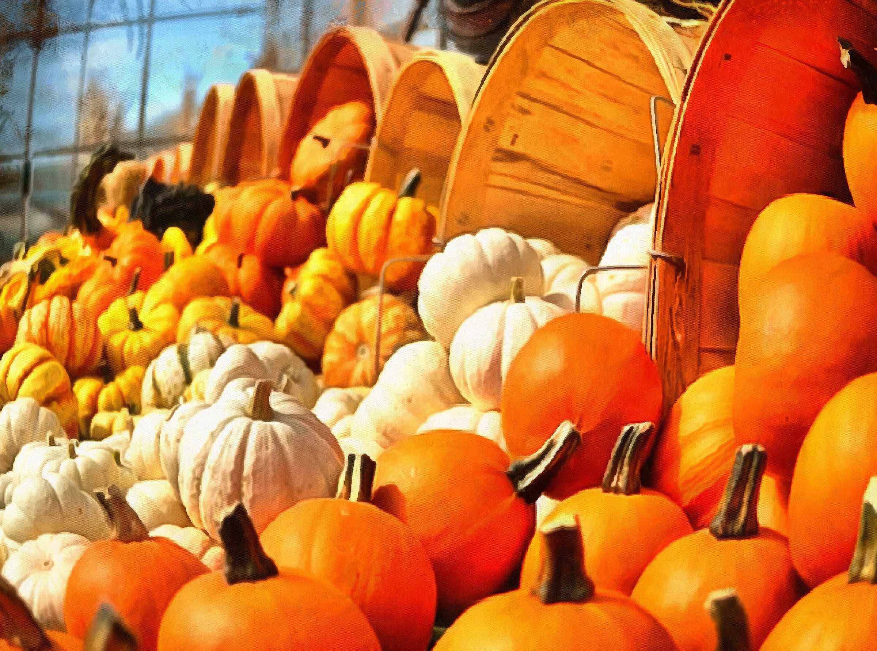

We will have a special Thanksgiving potluck. Cathy will bring drinks and marinated shrimp. Barry King will bring a ham. Jan Carey will bring a roast pork dish. Catherine Winchester will prepare a turkey, and Dan Mumau and I will bring a prime rib. I will donate Thanksgiving plates and décor, and the rest of us will bring seasonal sides and salads and desserts. Please remember that if you are bringing a meat, please have it sliced and ready to go on a platter with serving utensils. We are really not set up for carving and slicing, and we have only one oven. The library will be open at
1 that Sunday (not 12 as usual) so 1 or 1:30 would be good.

VANILLA PLANTS
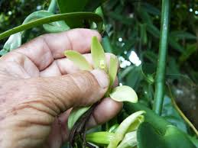

We have a few vanilla plants left from the last meeting. We sold them for $20, but they will be on sale for just $10, well below our cost. Grab one. They are fun to grow into long vines.

MANY THANKS TO PHYLLIS BOND WHO GENEROUSLY PICKED UP OUR CLUB INSURANCE THIS MONTH. VERY KIND OF HER. THANK YOU.

ART CHADWICK PRESENTS IN PERSON
“OUR SILVER GILT AWARDED 2025 CHELSEA FLOWER SHOW EXHIBIT”
We will take Art and his wife Jane, charming people, to Fogo de Chao for dinner on Thursday, Nov 6th at 6 pm
Call me if you would like to join by Nov 1.
Everyone except the Chadwicks pays for his own dinner. 702-525-3714 or email
growlove@cox.net
Art holds a BS in Electrical Engineering from North Carolina State and an MBA from James Madison University. He founded Chadwick & Son Orchids Inc in 1989 with his father who had been growing orchids since 1943.
The Chadwick’s first book, The Classic Cattleyas, was released in 2006 and sold out. An updated second edition was released in 2022. Martha Stewart favorably reviewed the book and had both Chadwick’s on her TV Show. Another book, First Ladies and their Orchids: A Century of Namesake Cattleyas, was released in the summer of 2024. For twenty years, Art wrote a monthly orchid advice column that was carried by newspapers around the country
The Chadwick’s have the distinction of naming Cattleya hybrids after the wives of the six most recent U.S. Presidents and personally presenting the flowers to most of the honored recipients.
Art is a 'regular' on the orchid society speaker's circuit and has spoken at two World Orchid Conferences - France 2005 and Ecuador 2017 – and is scheduled for the Germany WOC in 2026.
In May 2025, Chadwick’s exhibited internationally at the Chelsea Flower Show in London. Their 28’ long educational display, “The History of British Cattleya Orchids” won a silver-gilt medal from the Royal Horticultural Society and visit from Queen Camilla. The exhibit is now heading to the United States and the 2026 Philadelphia Flower Show.
Chadwick’s operates 13 greenhouses in rural Powhatan County, two retail stores in Richmond, and boards over 13,000 orchids for local clients. The company was recently featured in Southern Living magazine, The New York Times, Bloomberg News, Smithsonian magazine, Better Homes and Gardens, The Washington Post, The CBS Evening News, and Oprah magazine.
ELECTIONS
We will have our annual elections at our November meeting. The current board is willing to continue to serve. Carol Siegel pres Cathy Loftfield vice president Phyllis Bond secretary and Jackie Bravermann for treasurer. If you would like to nominate someone or yourself for a position, email our election chairlady Myra Glassman hotshrink@hotmail.com

NICE CATTLEYA VIDEOOne of my favorite you tube sites is Miss Orchid Girl. Shehas hundreds of fun videos on growing orchids, and her information is excellent, and she is very entertaining. Below is the address of her videa, about 20 minutes, on cattleyas. Copy the address into your google search bar. It is a nice video (copy control C paste control V) or ask the grandkids.
https://www.youtube.com/watch?v=2DS6yAhGtws

WHAT’S COMING UP (PLEASE NOTE THAT SOME DATES ARE DIFFERENT BECAUSE OF LIBRARY AVAILABILTY SO PAY ATTENTION…)
Sunday, Nov 9 Art Chadwick in person “The Chelsea Flower Show” Carol Joyce and Margaret Carbaugh sing
Please note that we could only get the library from 1-5 so show up at 1:30 to hear singing until 2:30. We will have a Thanksgiving

December 14 Holiday party Carol Siegel “How to Build an Orchid Collection” John Anthony and Russine Zellner perform Chinese Feast

January 11, 2026 Mark Romansky “Secrets to Potting an Orchid” White Elephant Sale

February 8, 2026 Beth Davis “All About Cattleyas”

March 22, 2026 Fred Clarke “The Fabulous Flower Fields” (every other Saturday and Sunday in March was taken- really) Note this is the third Sunday.

Saturday,April 18, 2026 Cathy Loftfield “The Santa Barbara Orchid Show” All Sundays taken and most Saturdays, too

May 3, 2026 1st Sunday since Mother’s Day is the 2nd Sunday) Beth DaviS “All About Dendrobium”

