P
GREATER LAS VEGAS ORCHID SOCIETY
ORCHID COLUMN
CAROL SIEGEL, EDITOR
“THE ORCHIDS OF HAWAII” CAROL SIEGEL, PRESENTER

“I must have flowers-always and always”-Claude Monet”
THE GREATER LAS VEGAS ORCHID SOCIETY
THE ORCHID COLUMN
SUNDAY, October 12, 2025 1 pm
JASON FISCHER
THE STORY OF THE VANILLA ORCHID
Kate Schlatter will delight on the piano at 1

It was bound to happen some time- after 25 years- but in September it did- big time. The website showed we did not have a reservation for Sunday, and I called everyone I had a good number for at 9 pm (which is a lot of people…) and emailed and cancelled the meeting. At noon, on Sunday, I got an email reminding me (WHAT!!)of our reservation, but it was too late. Hence the oy vey. I have confirmed all the rest of our reservations, and they don’t know what happened, but I apologize to anyone who made food. I personally had an enormous bowl of pasta salad and a Jerusalem salad I will eat til Christmas.

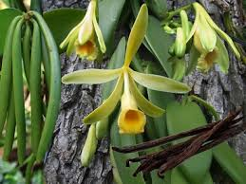
JASON FISCHER, OF ORHIDS LIMITED (WWW.ORCHIDWEB.COM), ONE OF OUR VERY FAVORITE SPEAKERS, WILL DELIGHTS US WITH A TALK ON THE VANILLA ORCHID, ONE OF THE VERY FEW EDIBLE ORCHIDS. WE WILL ALSO HAVE 36 VANILLA PLANTS FOR SALE! KATE SCHLATTER WILL DELIGHT US ON THE PIANO AT 1PM.
I have attached to the newsletter an article on growing vanilla called “The Scoop on Vanilla,” which I published in Orchid Digest in 2008.
Jason’s describes his talk: “Growing Vanilla- With the species' population in decline and their habitats being converted to other purposes, the Vanilla orchid is listed as endangered on the IUCN Red List of Threatened Species. If there were no Vanilla, how many of your beloved foods, scents, and more would be affected? This lecture will cover various species and cultivars of Vanilla, how to grow them indoors vs outdoors, how to create the seedpod, and how to harvest and create
your own Vanilla extract!”Jason will also include a short greenhouse tour at the end of the lecture.

Show original message

EPIPACTIS GIGANTEA

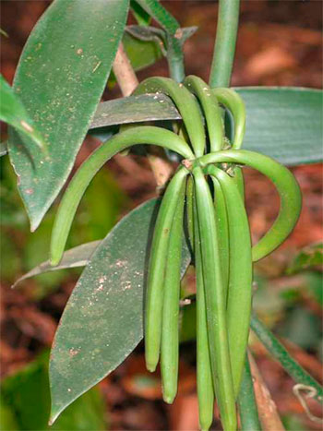
We will have this program at the Oct meeting
We have vanilla plants for sale.
Jason Fischer
Orchids Limited (OrchidWeb)
General Manager, Hybridizer, Content Creator

Jason Fischer co-owns and manages his family business Orchids Ltd, more known as OrchidWeb, established in 1978. Orchids Ltd. is a mid-sized operation of 4 greenhouses with 15,000 square feet of growing space, an outdoor seasonal shade house, and a laboratory for seed production located in Plymouth, MN.
Jason has had a life-long education in orchids mainly from the opportunity to be raised in a family orchid business. Jason’s educational interests were strongly influenced by orchids & Japan. He studied the Japanese language and culture for 6 years in high school and at the University of Minnesota. Jason lived in Kyoto, Japan from 2001 to 2003, which in turn influenced his interests in East Asian orchids for their unique culture and aesthetics.
Having worked for his father since the age of 5, Jason has learned the orchid world from the business and hobbyists perspective. He took an interest in orchid hybridization and lab work at 14, and first started breeding with Phalaenopsis, which later on lead to Paphs, Phrags and miscellaneous hybrids.
Jason began presenting lectures in 2004, and has travelled internationally to give various presentation over the years. His orchid interests are Phragmipedium, Paphiopedilum, Stanhopeinae, Neofinetia and East Asian species in general. He also has interest in producing hybrids that both have attractive flowers and foliage. The Phragmipedium Jason Fischer, registered by his father Jerry Fischer in 1996, still holds the most FCC awards ever giving out by the AOS to an orchid hybrid, 2nd to the species Paph. rothschildianum.
Experience:
-Lectured for over 50 different orchid societies in the US, Japan, Canada, Australia & New Zealand.
-Speaker for the 19th & 20th World Orchid Conferences in Miami & Singapore
-Speaker at 19th Australian Orchid Council Conference 2012, Perth
-Speaker for the 7th New Zealand National Orchid Expo 2013
-Coordinated the Orchids Limited laboratory from 1998 to 2000
-Currently in management, breeding and marketing for Orchids Limited
-Creates zoom classes and tutorials based on various orchid subjects.
-Hosts classes and events at Orchids Limited in Plymouth, MN
DESERT POTLUCK EXTRAVAGANZA



I will provide DESERT décor and paper goods. The food won’t be desert-themed (cause there isn’t a lot to eat in the desert…) but the décor will be !Cathy will graciously provide drinks We ask all of you to bring something yummy -some main dish, side, salad or dessert for 10-12 people with serving spoons. Just lovely! I will provide coffee this month.
Oct 12 Jason Fischer “Vanilla” Kate Schlatter plays the piano at 1 pm

Nov 9 Art Chadwick in person “The Chelsea Flower Show” Carol Joyce and Margaret Carbaugh sing
Please note that we could only get the library from 1-5 so show up at 1:30 to hear singing until 2:30. We will have a Thanksgiving potluck so be ready to sign up for something at the October meeting. We will also have elections.

December 14 Holiday party Carol Siegel “How to Build an Orchid Collection” John Anthony and Russine Zellner perform

January 11, 2026 Mark Romansky “Secrets to Potting an Orchid” White Elephant Sale

February 8, 2026 Beth Davis “All About Cattleyas”

March 22, 2026 Fred Clarke “The Fabulous Flower Fields” (every other Saturday and Sunday in March was taken- really) Note this is the third Sunday.

April 12, 2026 Cathy Loftfield “The Santa Barbara Orchid Show”

May 3, 2026 1st Sunday since Mother’s Day is the 2nd Sunday)

