**sept**

**GREATER LAS VEGAS ORCHID SOCIETY**

**ORCHID COLUMN CAROL SIEGEL, EDITOR**

**Cathy Loftfield**

**“The Orchids of the Old World”**

**SUNDAY, November 3, 2024 1 pm**

**1st Sunday of the Month**

**Z**

**OF PAPUA NEW GUINEA”**

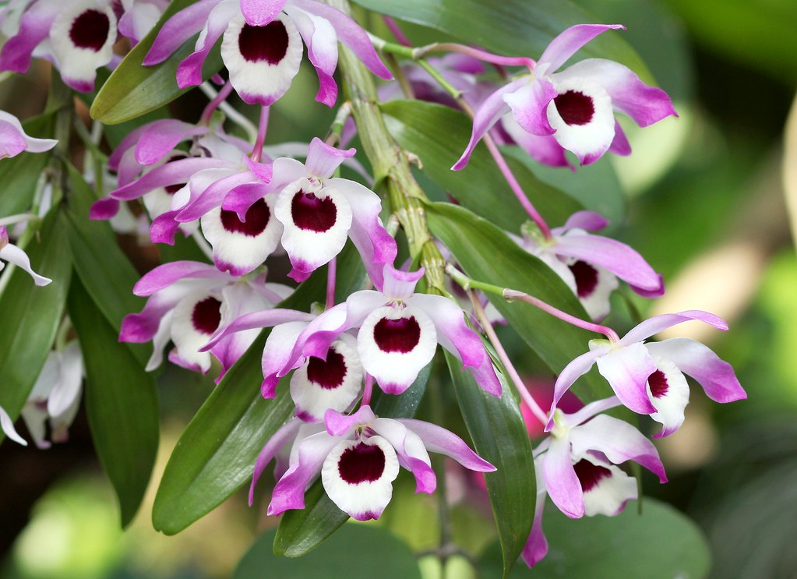

**Cathy Loftfield will be presenting a Power Point presentation on the diverse and interesting orchids of the Old World. An email will follow with details about Cathy’s wonderful talk.**

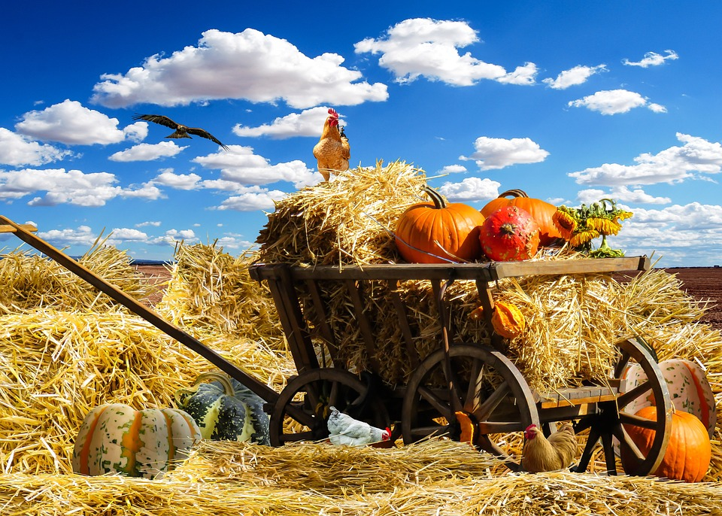

**THANKSGIVING POTLUCK THIS MONTH**

**I WILL PROVIDE THANKSGIVING PAPER GOODS AND DÉCOR. WE ASK EVERYONE TO BRING SOMETHING TO ROUND OUT OUR MEAL. WARREN ADLER IS BRINGING A TURKEY, PHYLLIS BOND IS BRINGING A HAM, CHRISTINE DELACRUZ IS BRINGING A SALMON, AND JAN CAREY IS BRINGING A PORK ROAST. PLEASE REMEMBER TO HAVE YOUR MEATS CUT UP ALREADY AND HAVE SERVING UTENSILS . I WILL BRING MY KAHLUA BREAD PUDDING AND A CAKE. WE WOULD LOVE IF SOMEONE BROUGHT A BEEF ROAST OR BRISKET. THINK A THANKSGIVING SIDE DISH LIKE CRANBERRY RELISH, SWEET POTATOES, GRAVY, SALAD, VEGETABLE, A NOODLE DISH OR CUCUMBER SALAD, SHRIMP, FRUIT SALAD, PIES… IF THAT IS NOT YOUR THING, BRING SOMETHING ELSE YUMMY (WE ARE not fussy- just hungry)**

**REMEMBER SERVING UTENSILS…**



Diana, website genius, and I have finished our new website https://lasvegasorchidsociety.org/

We will improve it as time goes by, a work in progress, but we are proud of it. If you don't get a newsletter or don't remember a meeting date, it is always there as well as lots of information.

Do click on it. We are proud of it. There are 22 articles that might interest you.

|  |  |  |
| --- | --- | --- |
| |  | | --- | |  | |  |



**BRING YOUR BLOOMING BEAUTIES TO THE LIBRARY FOR SHOW AND TELL. YOU CAN EVEN BRING PLANTS THAT YOU JUST BOUGHT OR THAT ARE NOT IN BLOOM BUT HAVE AN INTERESTING STORY .**

**. DUES FOR 2025 WILL BE SLIGHTLY MORE- A SINGLE WILL BE $40 AND $60 FOR A COUPLE. DONATIONS, OF COURSE, ARE ALWAYS APPRECIATED.**

**Last year, members gave donations of $1500, and it made all the difference. We no longer get hotel plants and dues are really important to us now.**

**If you haven’t paid your 2024 dues, PLEASE FEEL FRREE TO PAY YOUR 2025 DUES…. Until the end of the year, we will forgive your back dues just this once.**

**We now have the ability for you to pay your dues online!   Just click on the link, and the rest is quite clear. The form will ask for your credit card information which is secure through the Square application. I tried it, and it worked great. If you want to add a little extra for a donation, just add it on to your membership. It says “donation” instead of “dues” due to a technicality because we are a non-profit. You will receive a receipt immediately.. You can also pay at the meeting, but it makes the treasurer’s job much easy if someof you do this online.**

|  |  |  |  |  |  |  |  |  |  |  |
| --- | --- | --- | --- | --- | --- | --- | --- | --- | --- | --- |
| **Here is the link-**   |  |  |  | | --- | --- | --- | |  |  |  | | |  | | --- | | <https://square.link/u/NDRpbeQq?src=sheet> | | | | |  |  |  |
|  |  |  |
| ELECTIONS | | |

**Our elections will be at our Nov meeting. The current board, which has done such an outstanding job, has been willing to serve again. If you would like to nominate someone else, please call Myra Glassman, our election chairlady at 702-985-1466.**

**Carol Siegel, Pres Cathy Loftfield, VP**

**Christina Delacuz, Secy Jackie Bravermann**

**HOLIDAY PARTY**



**On December , we will have our holiday party at the library. The Board will treat everyone to a Chinese Feast from Buffet at Asia. We ask you to bring something chocolate for our DESSERT chocolate bar. Remember this is for DECEMBER not next month (OY). We will have holiday hats and décor. Don’t forget to bring a few cans of food to donate to the unfortunate at this holiday season. I will treat the club to entertainment from the duo which provided such great entertainment on my birthday last year, the marvelous**

**Russine Zellner and John Anthony. We will have holiday plants again, and Art Chadwick will appear**

**IN PERSON to present a talk on “First Ladies and Their Orchids,” based on his new book.**

**WHITE ELEPHANT SALE**

**REMEMBER THAT WE WILL HAVE OUR WHITE ELEPHANT SALE AT OUR MEETING ON January 12.**

**Be looking around for unwanted loot to bring to the meeting. It is our main fundraising event, and we are grateful for your trash and treasure.**



**UPCOMING EVENTS**

**November 3, 2024 Cathy Loftfield “Orchids of the Old World”THIS IS THE FIRST SUNDAY IN NOVEMBER**

**December 8, 2024 IN PERSON Art Chadwick “The First Ladies and Their Orchids” Live entertainment Russelline and John Christmas party at library**

**January 12, 2025 Mark Romansky “Potting Media”**

**WHITE ELEPHANT SALE**

**February 9, 2024 Mary Gerritsen “Slippery Tales”**

**March 9, 2025 Ron Parsons**

**April 13, 2025 GREENHOUSE TOUR**

**May 5 Beth Davis “Waldor Orchidss- The Story Goes On and On”**

**JUNE 2 Carol Siegel :”Buidling an Orchid Collection”**

**I have been asked for my Bok Choy Salad recipe after I brought it in October. Happy to share.**

**CAROL’S BOK CHOY SALAD 2 bok choy, chopped**

**2 carrots, diced**

**1 red peper, diced**

**4 oz. sunflower seeds**

**4 oz. sliced almond**

**2T sugar**

**2 pkges Top Ramen type noodles (not seasoning packet)**

**1 stick butter**

**DRESSIG**

**2 tbsp sugar**

**6 tbsp vinegar )I like flavored)**

**3 T soy sauce**

**2 T peanut butter**

**¼ cup mayonnaise**

**Amounts vary. The dressing should be sweet and sour in just the right way**

**Mix together vegetables.**

**Separately mix together nuts, noodles broken up, and sugar. Saute mixture in butter. Set aside.**

**Mix dressing and set aside.**

**At last possible minute, mix sauteed items, vegetables, and dressing. Noodles get soft after a few hours and lose their special crunch so don’t mix before. You can double the recipe, add more peanut better and sesame oil and more mayo. It is more art than science but it is very yummy. The recipe was given to me by my favorite and only daughter-in-law Linda, a gifted Atlanta cook and a great gal.**

**ORCHID CARE**

**Orchids Limited has a very good section on how to care for your orchids. Here is the link. It has tips on growing, potting and caring for your orchids.**

[**https://www.orchidweb.com/orchid-care-basics**](https://www.orchidweb.com/orchid-care-basics)

**If you have trouble making this work, just copy (control C), go to google bar, and paste (control V)**

**If this is too much for you, go to** [**www.orchidweb.com**](http://www.orchidweb.com) **and then look for orchid care at the top and click on it.**