a `P
GREATER LAS VEGAS ORCHID SOCIETY
ORCHID COLUMN
CAROL SIEGEL, EDITOR
“THE ORCHIDS OF HAWAII” CAROL SIEGEL, PRESENTER

“I must have flowers-always and always”-Claude Monet”

THE GREATER LAS VEGAS ORCHID SOCIETY
THE ORCHID COLUMN
Saturday, April 18, 2026 1 pm
Our meeting is on a Saturday because of library availability
Cathy Loftfield “The Santa Barbara Orchid Show”
KATE SCHLATTER ON PIANO AT 1 PM
ORCHIDS FOR SALE SHOW AND TELL

https://www.youtube.com/watch?v=GvBUTuPYWRE&t=18s

You can opposite click on the hyperlink above and choose
“open hyperlink” to see the video on the orchid show.
Alternately you can press control and then click on the link above to see the video. Can’t figure out- ask a grandchild.
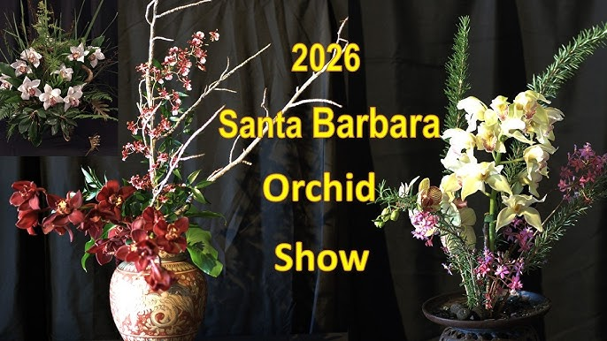

EPIPACTIS GIGANTEA

Cathy Loftfield, our wonderful vice-president, will present a fun presentation on the Santa Barbar Orchid Show
Information on how I got started growing orchids.
By Cathy Loftfield
I started growing orchids for very different reasons than most people. My husband (who has since passed) and I belonged to the Nevada Camera Club and one of our goals was to get the coveted Kaleidoscope of Blues Award Plaque. To achieve this award, one has to get blue ribbons in 10 of the 12 camera club categories. One of the categories that I had not received a Blue Ribbon was in the still life category. I happened to be at Trader Joe’s and saw this very lovely orchid that I purchased to photograph. At the next meeting I submitted my photo and received a Blue Ribbon. Thereafter, every time I went to Trader Joe’s, I bought another orchid to photograph.
After my sister-in-law Becky Biondi found out that I was growing orchids, she insisted that I join the Las Vegas Orchid Society. I met so many wonderful people at the Orchid Society who were learning to grow orchids in the desert like myself. This wonderful hobby has filled by life for 22 years.

Information on The Santa Barbara International Orchid Show
By Cathy Loftfield

The Santa Barbara International Orchid Show has the following activities to explore:
1. An exhibit hall devoted to elaborate orchid exhibits and displays that have vibrant colors, delicate structures, and enchanting fragrances.
2. Las Floralias: Santa Barbara’s very own floral design club. See artfully and stunning floral designs that are featured annually at the Show.
3. Art Show: Discover Orchid-Inspired Art by local artists.
4. Workshops, Talks, and Demonstrations: Enjoy and signup for repotting, talks, and mounting orchid workshops.

EPIPACTIS GIGANTEA

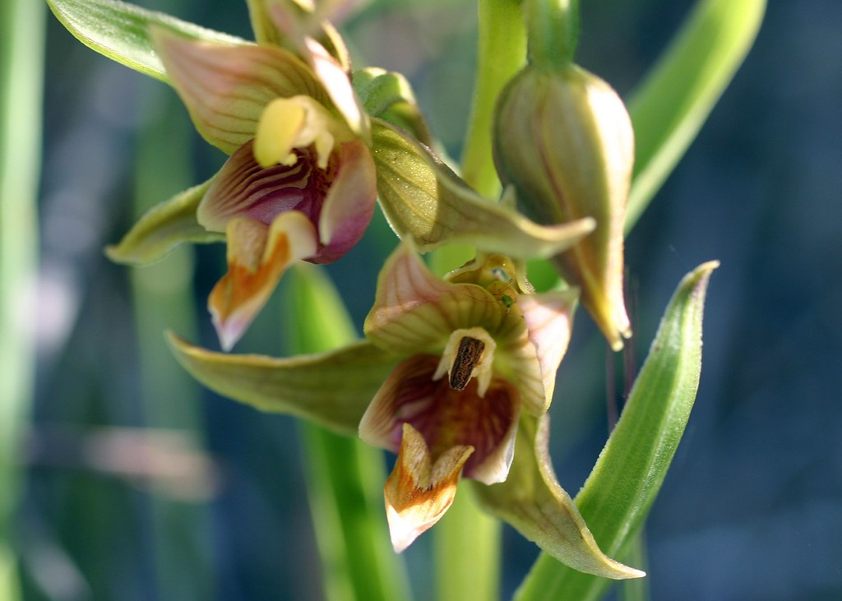

At the end of April or beginning of May, depending on when this native orchid is in bloom, (we will notify you as soon as Mother Nature tells us…), MARK ROMANSKY WILL LEAD US ON A WALK IN CALICO BASIN IN RED ROCK TO SEE OUR NATIVE ORCHID EPIPACTIS GIGANTEA GROWING RIGHT HERE IN THE DESERT. MARK IS A WONDERFUL, KNOWLEDGEABLE MAN, AND WE TREASURE HIM. MEMBERS SAW THOUSANDS IN THE SHADE OF THE RED ROCK. HEAVEN. THE ROUND TRIP WALK TAKES ABOUT AN HOUR AND IS A MODERATE WALK. BRING SNEAKERS, WATER, A HAT AND A CAMERA OR PHONE.

The orchids are very showy with a beautiful erect stem with lots of burgundy and apricot flowers up and down the stem. They love water and grow against the gorgeous red sandstone rocks, moistened by springs that wet the base of the rock. They are deciduous and disappear in winter, but reappear every spring by the thousands. They are found all over- western North America, western Canada, central Mexico and are the most abundant orchid of the Pacific coast of North America. They are called the “Chatterbox Orchid” because there lips wave in the breeze, attracting their syrphid fly pollinator which we actually saw carrying pollinia. A terrestrial orchid (growing in the ground), it forms big clumps, making a gorgeous display. 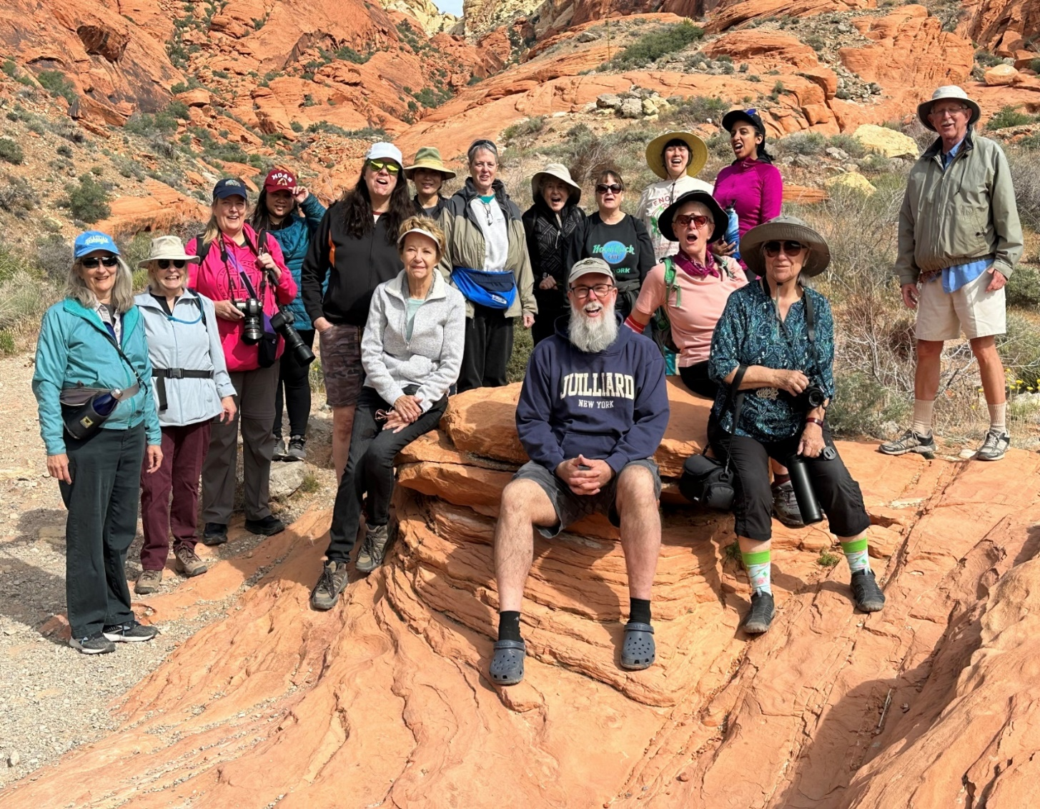

SPRING POTLUCK
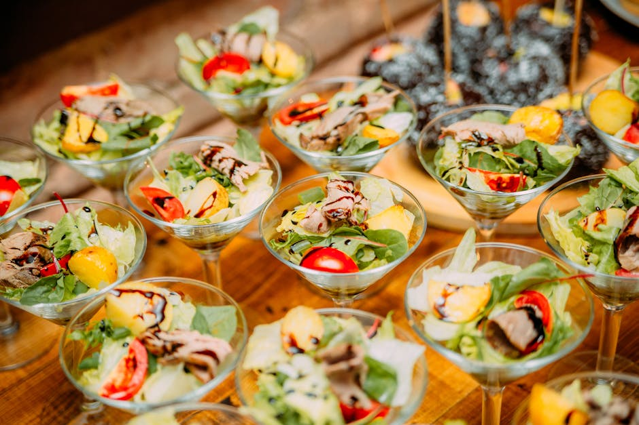

Bring something yummy for our spring potluck I will have a sunflower décor.

SHOW AND TELL

We will have show and tell this meeting. You can even bring
something you just bought.


I have attached a list of members to the email. Check your name. IF THERE IS NOT A 26 AFTER YOUR NAME, YOU STILL NEED TO PAY YOUR INDIVIDUAL $40 DUES OR $60 COUPLE DUES. IT MAKES SUCH A DIFFERENCE IN PROVIDING FUN AND INTERESTING PROGRAM. IF YOU NO LONGER CAN BE PART OF OUR CLUB- BOO HOO- PLEASE REPLY TO THIS EMAIL.
We are pleased that so many paid dues and even gave us donations to bolster our treasury. They were appreciated. DUES FOR 2026 WILL BE WILL BE $40 FOR AN INDIVIDUAL AND $60 FOR A COUPLE. DONATIONS, OF COURSE, ARE ALWAYS APPRECIATED. THIS YEAR WE NO LONGER GET HOTEL PLANTS AND DUE AND DONATIONS ARE SPECIALLY IMPORTANT NOW TO KEEP OUR WONDERFUL PROGRAMS GOING. I have been personally chipping in, but it would be nice to have the club more self-sufficient. In 2023, members gave donations of $1500, and it made all the difference.
If you haven’t paid your 2025 dues, PLEASE FEEL FRREE TO PAY YOUR 2026 DUES….

We now have the ability for you to pay your dues online! Just click on the link, and the rest is quite clear. The form will ask for your credit card information which is secure through the Square application. I tried it, and it worked great. If you want to add a little extra for a donation, just add it on to your membership. It says “donation” instead of “dues” due to a technicality because we are a non-profit. You will receive a receipt immediately.. You can also pay at the meeting, but it makes the treasurer’s job much easy if someof you do this online.
Here is the link-
https://square.link/u/NDRpbeQq?src=sheet

YOUTUBE MISS ORCHID GIRL
www.missorchidgirl.com

One of the most popular orchid channels on YouTube is Miss Orchid Girl. Over ten years, the very charming Dani has produced 2583 very useful free videos on almost a daily basis. She has over 537K subscribers and has had over 84 million views. She presents hours and hours of simple, easy-to-understand and professional tutorials suited for beginners and experienced growers. Her tips and tricks cover every subject from making your orchids rebloom, building an orchid collection on a budget, caring for slipper orchids, selecting 10 mini cattleyas, figuring out if your orchid is dead and alive, and evaluating orchid myths. She has orchid care for beginners as well as an orchids in bloom spotlight. Most of her content is free, but in 2024 she will air two public videos each week but will have exclusive content for those who pay a monthly fee.


Diana, website genius, and I created our new website https://lasvegasorchidsociety.org/
If you don't get a newsletter or don't remember a meeting date, it is always there as well as lots of information.
Do click on it. There are 22 articles that might interest you.

Upcoming Events:
SOME DATES ARE DIFFERENT (not the second Sunday) BECAUSE OF LIBRARY
AVAILABILITY
Saturday,April 18, 2026 Cathy Loftfield “The Santa Barbara Orchid Show” All Sundays taken and most Saturdays, too

Somewhere between the end of April and the beginning of May, we will visit Calico Basin to see our native orchid Epipactis gigantea in bloom (depending on Mother Nature…) Our orchid guru, Mark Romansky, will lead us.

Sunday, May 10, 2026 Beth DaviS “All About Dendrobium”

Sunday June 14, 2026 Mark Romansky
“Where to Buy Orchids”

Sunday, July 12 Peter Lin :”Discovering Fragrant Orchids”

Sunday, August 9, 2026 Carol Siegel August 9, 2026
“Orchids and Hummingbirds- Sex in the Fast Lane”

Sunday, Sept 13, 2026 Bridget Uzar “The Orchid Royalty- Cattleya”

Sunday, October 11 Fred Clarke “The 80% Grower”

