**sept**

**GREATER LAS VEGAS ORCHID SOCIETY**

**ORCHID COLUMN CAROL SIEGEL, EDITOR**

**Peter Lin**

**“A Tale of Two Grand Orchid Shows- The Taiwan 23rd World Orchid Conference and the Taiwan International Orchi Show”**

**SUNDAY, OCTOBER 13, 2024 1 pm**

**Z**

**OF PAPUA NEW GUINEA”**

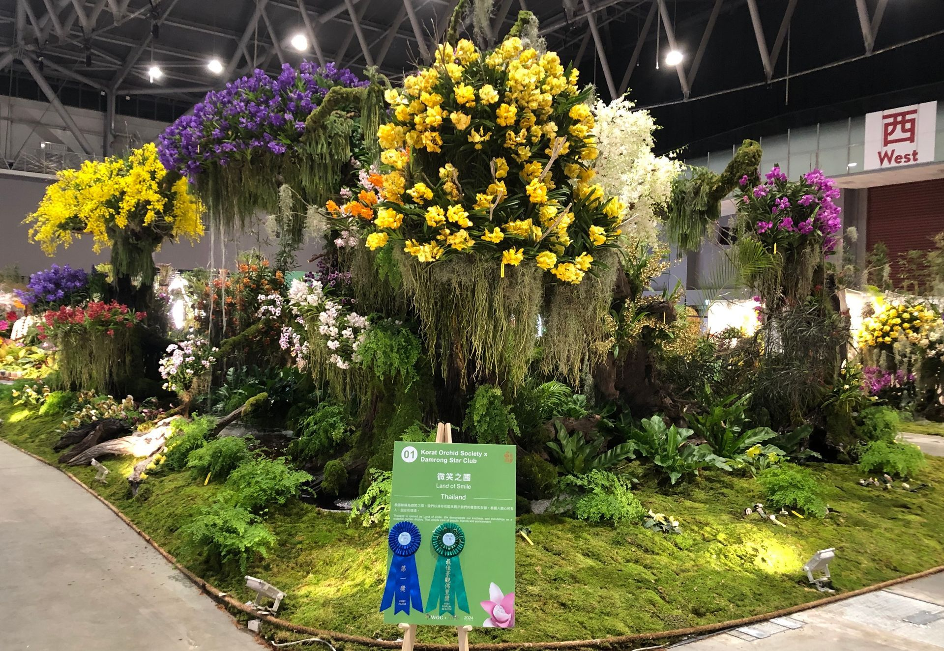

**Peter Lin will be presenting the talk: A Tale of Two Grand Orchid Shows! This presentation includes both the Taiwan 23 rd World Orchid Conference and the Taiwan International Orchid Show held in February 2024, in Tainan, Taiwan. Take a tour of the tens of thousands of orchids on display. There are grand floor displays AND many specimen size orchids. A vase with purple flowers
**

**Looking Back - Taiwan 2024**

**The 23rd World Orchid Conference brought together over 650 orchid registrants worldwide, all eager to share their passion for these exquisite flowers. The event featured impressive displays from international and local organizations, with entries from the Dominican Republic, Hong Kong, Indonesia, Japan, Singapore, Thailand, and Taiwan.**

**This conference was a gathering of orchid enthusiasts and a platform for innovation in orchidology. A highlight of the event was its unprecedented approach to judging: 200 orchid experts from 23 countries meticulously evaluated 1600 individual orchids using a cutting-edge, paperless voting system, underscoring the event's commitment to progress and efficiency. Additionally, the conference offered a wealth of knowledge through presentations on diverse topics by 100 speakers and 51 posters, fostering a vibrant exchange of ideas.**

**Taiwan's WOC not only successfully achieved its objectives by showcasing the beauty of orchids and emphasizing conservation, but it also played a role in promoting global collaboration in orchidology. The conference's impact was felt worldwide, with attendees' feedback indicating that this was one of the most successful world orchid conferences to date, further solidifying the global community's commitment to orchid research and conservation.**

**ABOUT OUR SPEAKER:**

**Peter started growing orchids over 40 years ago, but then stopped due to school and starting a career. It wasn’t until about 20 years ago that the orchid bug came back and he is now heavily involved once again. He is an accredited judge with the American Orchid Society and a hybridizer of mini-catts and mini Vandas. He enjoys meeting with other orchid enthusiasts, and can often be found at various orchid shows and societies around the country. He also has hundreds of photos of his orchids that he maintains on Flickr. You can view them by typing this address into the internet:**

[**http://www.flickr.com/photos/minicatt/collections/**](http://www.flickr.com/photos/minicatt/collections/)

**Due to limited growing space, Peter likes to specialize in miniature orchids, both species and hybrids, and has received numerous AOS awards. His other interests in orchids include Dendrobiums,**

**Angraecoids, and Neofinetias. He maintains thousands of orchids at his home in Southern California in 3 small greenhouses, as well as an offsite greenhouse.**

**FOR SALE AT MEETING**

**WE WILL HAVE BLOOMING ORCHIDS FOR SALE AT THE MEETING.**

**IN ADDITION, I HAVE DONATED HORTICULTURAL OIL AS WELL AND PUT THEM IN BOTTLES. I BOUGHT BOTTLES THAT WERE TOO BIG BY MISTAKE SO YOU WILL GET TWICE AS MUCH OIL FOR THE $10 PRICE WE CHARGED LAST YEAR. THEY MAKE A GREAT NON-TOXIC INSECTICIDE FOR THE CRITTERS THAT ORCHIDS ATTRACT LIKE MEALY BUGS AND SCALE. PUT A COUPLE OF TABLESPOONS OF THE OIL IN A SPRAY BOTTLE WITH RUBBING ALCOHOL FROM THE PHARMACY. SPRAY ON YOUR PROBLEM PLANTS. ALTHOUGH NON-TOXIC, OF COURSE, DON’T EAT OR DRINK THE MIXTURE. (duh) ALWAYS TRY TO RINSE THE NASTIES OFF WITH WATER FIRST. REPOTTING IS ALWAYS GOOD BECAUSE THE CRITTERS SOMETIMES GET INTO THE MEDIA. IF YOU ADD A CINNAMON STICK TO THE MIXTURE, IT IS GOOD FOR TREATING AND PREVENTING FUNGUS. CINNAMON IS THE GROUND BARK OF THE CINNAMUM TREE, AND ITS NATURAL FUNGICIDE PROTECTS THE TREE IN NATURE.**

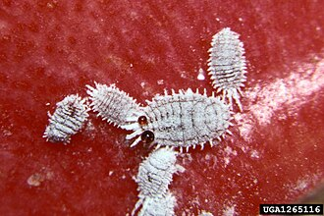

**ITALIAN POTLUCK THIS MONTH CAUSE WHO DOESN’T LOVE ITALIAN**

**I WILL PROVIDE ASIAN-STYLE PAPER GOODS AND DÉCOR (JUST FOR A CHANGE). WE ASK EVERYONE TO BRING SOMETHING ASIANISH FOR 10-12 PEOPLE WITH SERVING SPOONS. I WILL BRING MY BOK CHOY SALAD. THINK A NOODLE DISH OR CUCUMBER SALAD OR A STIR FRY OR WONTONS OR EGG ROLLS or A RICE DISH OR ASIAN SLAW OR WHATEVER. IF THAT IS NOT YOUR THING, BRING SOMETHING ELSE YUMMY (WE ARE not fussy- just hungry) BECAUSE ASIAN DESSERTS ARE NOT THAT COMMON, MAYBE WE WILL HAVE A COOKIE BUFFET AND SOME FRUIT THING. OUR ITALIAN FEAST LAST MONTH WAS SENSATIONAL. ATTENDANCE WAS A LITTLE LIGHT SO WE ALL GOT TO STUFF OURSELVES AND BRING HOME MORE.**



Diana, website genius, and I have finished our new website https://lasvegasorchidsociety.org/

We will improve it as time goes by, a work in progress, but we are proud of it. If you don't get a newsletter or don't remember a meeting date, it is always there as well as lots of information.

Do click on it. We are proud of it. There are 22 articles that might interest you.

|  |  |  |
| --- | --- | --- |
| |  | | --- | |  | |  |

We have had a problem making our new site come up first on the Google search engine. Our old site was still first because it had so many more hits over the years, and that is how Google algorithms decide who comes up first (DRAT…)

Thanks to all the folks with a sense of humor who logged onto our new site to help it rise to the top. I have managed to reach Steve Campbell, and I paid him, AND IT LOOKS LIKE OUR OLD SITE IS NO LONGER ACTIVE. If you click on it, it is empty.



**BRING YOUR BLOOMING BEAUTIES TO THE LIBRARY FOR SHOW AND TELL. YOU CAN EVEN BRING PLANTS THAT YOU JUST BOUGHT OR THAT ARE NOT IN BLOOM BUT HAVE AN INTERESTING STORY .**

**. DUES REMAIN $35 FOR A SINGLE AND $50 FOR A COUPLE. DONATIONS, OF COURSE, ARE ALWAYS APPRECIATED.**

**Last year, members gave donations of $1500, and it made all the difference.**

**If you haven’t paid your 2024 dues, please….We now have the ability for you to pay your dues online! Dues are still $35 for an individual and $50 for a couple.   Just click on the link, and the rest is quite clear. The form will ask for your credit card information which is secure through the Square application. I tried it, and it worked great. If you want to add a little extra for a donation, just add it on to your membership. It says “donation” instead of “dues” due to a technicality because we are a non-profit. You will receive a receipt immediately.. You can also pay at the meeting, but it makes the treasurer’s job much easy if someof you do this online.**

|  |  |  |  |  |  |  |  |  |  |  |
| --- | --- | --- | --- | --- | --- | --- | --- | --- | --- | --- |
| **Here is the link-**   |  |  |  | | --- | --- | --- | |  |  |  | | |  | | --- | | https://square.link/u/NDRpbeQq?src=sheet | | | | |  |  |  |
|  |  |  |
|  | | |

**UPCOMING EVENTS**

**October 13, 2024 Peter Lin “The Glorious World Orchid Conference in Taiwan”**

**November 3, 2024 Cathy Loftfield “Orchids of the Old World”THIS IS THE FIRST SUNDAY IN NOVEMBER**

**December 8, 2024 IN PERSON Art Chadwick “The First Ladies and Their Orchids” Live entertainment Russelline and John Christmas party at library**

**January 12, 2025 Mark Romansky “Potting Media”**

**WHITE ELEPHANT SALE**

**February 9, 2024 Mary Gerritsen “The Orchid Conservation Alliance”**

**March 9, 2025 Carol Siegel “Building an Orchid Collection”**

**April 13, 2025 Beth Davis “Waldor Orchidss- The Story Goes On and On”**

**JUNE 2025 GREENHOUSE TOUR**