**GREATER LAS VEGAS ORCHID SOCIETY**

**ORCHID COLUMN**

**CAROL SIEGEL, EDITOR**

**MARY GERRITSEN**

**“THE ORCHIDS AND TRIBES OF PAPUA NEW GUINEA”**

**SUNDAY, AUGUST 11 1 PM**

**Z**

**OF PAPUA NEW GUINEA”**

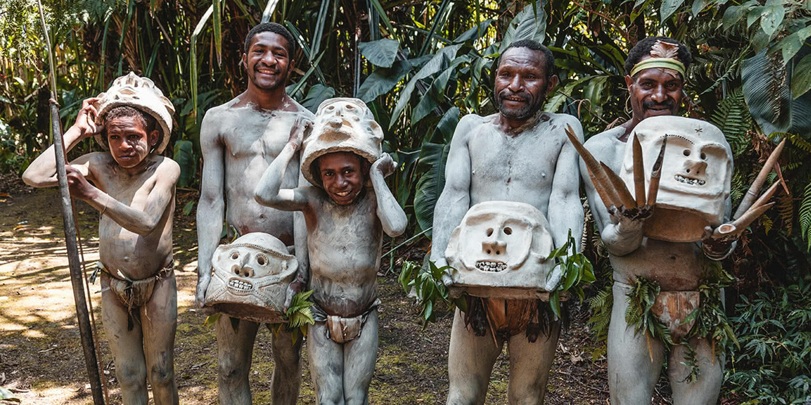

Orchids of Papua New Guinea

One of Mary Gerritsen’s ’s absolute favorite orchid destinations, Papua New Guinea (PNG) offers an incredible visit to a country that is tangled in time. The lecture, based on three different PNG expeditions, covers the Port Moresby area (nature parks, the amazing cultural museum, Varirata National Park), the Western and Southern Highlands (Mt. Hagen area, also Mt. Wilhelm), New Britain, and the islands of the eastern cape (Normanby, Ferguson). Fantastic scenery, visits with some of the many tribes, a sing-sing, a moo-moo (traditional pig roast), birds of paradise, and of course, orchids. Expect incredible photographs of orchids in the wild, many rarely if ever seen in cultivation.

Biography

Mary has been interested in plants for most of her adult life, and has been growing orchids on and off for the last 40 years, despite several cross country moves as part of her “other life” as a biomedical scientist. Her passion for orchids was rekindled when she moved to the San Francisco Bay area in 1997 and attended an orchid show. Returning home with a few plants, she decided to join a local orchid society to learn more about taking care of them, and from these beginnings, her current passion grew exponentially! Now Mary truly has put her roots down, and has orchids in two greenhouses, five lath houses, her front porch, sun room, and anywhere else she can put them. Her collection of about two thousand plants, mostly species, is rich in masdevallias and other miniature orchids of many different genera. Mary has traveled extensively to see orchids in situ, including many countries in Central and South America, Southeast Asia, as well as Australia, Papua New Guinea, South Africa, Madagascar, Europe & Mediterranean islands, the USA and Canada. She has co-authored six botanical books with co-author and photographer Ron Parsons “Masdevallias, Gems of the Orchid World”, “Calochortus, Mariposa Lilies and their Relatives”, “A Compendium of Miniature Orchid Species” (a two book set), “A Bay Area Guide to Orchids and their Culture” “The American Orchid Society Guide to Orchids and their Culture”, and the recently released “The Compendium of Miniature Orchid Species, 2nd edition” (a four book set). Mary has served as president and vice president for both the Peninsula and San Francisco Orchid Societies, and is currently president and chief executive officer of the Orchid Conservation Alliance and a director of the Orchid Digest.

### Best Homemade Bagel Recipe - How To ...

**BAGEL EXTRAVAGANZA**

**Diana Smith and I will be providing bagels from Bagel Café for our August meeting. We ask each of you to provide something to go on these bagels- tuna, shrimp or chicken salad, cold cuts, cheese, coleslaw or potato salad, pastrami, turkey, salad, fruit salad (or a main dish if you like) or dessert for 10-12 people with serving utensils. We get lots of desserts so perhaps some of us might think food this time although desserts are always welcome. I am always overwhelmed by member’s generosity, time, expense, and deliciousness when it comes to our potlucks. Thank you so much for going above and beyond to make the food so lavish.**

**Many thanks to Cathy Loftfield for running the July meeting.**

**I will be at a party in Atlanta for my newest great-granchild Emerson. It is the only thing that would trump an orchid meeting.**



Diana, website genius, and I have finished our new website https://lasvegasorchidsociety.org/

We will improve it as time goes by, a work in progress, but we are proud of it. If you don't get a newsletter or don't remember a meeting date, it is always there as well as lots of information.

Do click on it. We are proud of it. There are 22 articles that might interest you. Last month, Zoom added A-I to its website, which isn’t as smart as it thinks it is since it prevented us from accessing the new “improved” site for some time. We managed finally to access our speaker on the journey of a seedpot, but for those who left early, we recorded the talk. It will only be accessible for a few more weeks and only through the following link. It was a great talk, and I think you will enjoy it.

|  |  |  |
| --- | --- | --- |
| |  | | --- | |  | |  |

<https://lasvegasorchidsociety.org/videos>



**BRING YOUR BLOOMING BEAUTIES TO THE LIBRARY FOR SHOW AND TELL. YOU CAN EVEN BRING PLANTS THAT YOU JUST BOUGHT OR THAT ARE NOT IN BLOOM BUT HAVE AN INTERESTING STORY .**

**. DUES REMAIN $35 FOR A SINGLE AND $50 FOR A COUPLE. DONATIONS, OF COURSE, ARE ALWAYS APPRECIATED.**

**Last year, members gave donations of $1500, and it made all the difference.**

**If you haven’t paid your 2024 dues, please….We now have the ability for you to pay your dues online! Dues are still $35 for an individual and $50 for a couple.   Just click on the link, and the rest is quite clear. The form will ask for your credit card information which is secure through the Square application. I tried it, and it worked great. If you want to add a little extra for a donation, just add it on to your membership. It says “donation” instead of “dues” due to a technicality because we are a non-profit. You will receive a receipt immediately.. You can also pay at the meeting, but it makes the treasurer’s job much easy if someof you do this online.**

|  |  |  |  |  |  |  |  |  |  |  |
| --- | --- | --- | --- | --- | --- | --- | --- | --- | --- | --- |
| **Here is the link-**   |  |  |  | | --- | --- | --- | |  |  |  | | |  | | --- | | https://square.link/u/NDRpbeQq?src=sheet | | | | |  |  |  |
|  |  |  |
|  | | |

**UPCOMING EVENTS**

**August 11, 2024 Mary Gerritsen “The Orchids and Tribes of Papua New Guinea”**

**September 8, 2024 Fred Clarke “*Cattleya mossiae-***

**National Flower of Venezuela”**

**October 13, 2024 Peter Lin “The Glorious World Orchid Conference in Taiwan”**

**November 3, 2024 Cathy Loftfield “Orchids of the Old World”THIS IS THE FIRST SUNDAY IN NOVEMBER**

**December 8, 2024 IN PERSON Art Chadwick “The First Ladies and Their Orchids”**

**January 12, 2025 Mark Romansky “Potting Media”**

**WHITE ELEPHANT SALE**

**February 9, 2024 Mary Gerritsen “The Orchid Conservation Alliance”**

**March 9, 2025 Carol Siegel “Building an Orchid Collection”**

**April 13, 2025 Beth Davis “Waldor Orchidss- The Story Goes On and On”**

**JUNE 2025 GREENHOUSE TOUR**

**(article on New Guinea follows below)**

**AMAZING NEW GUINEA**

**Carol Siegel**

**In August, Mary Gerritsen will present the tribes and orchids of New Guinea which is an amazing place, little known to most of us. I thought you might like to know a little about this huge and amazing island. It is the world’s second largest island, located in Melanesia in the southwestern Pacific Ocean. It is located to the north of Australia, separated by the 93-mile-wide Torres Strait, although both landmasses lie on the same continental shelf. During episodes of low sea levels during glaciations in the past, both New Guinea and Australia were connected in the combined land mass called Sahul. Who knew!**

**The eastern half of the island is the major land mass of the nation of Papua New Guinea. The western half, known as Western New Guinea, forms a part of Indonesia, organized into six provinces.**

**With less than one-half of one percent (0.5%) of the Earth's surface—New Guinea has an immense**[**biodiversity**](https://en.wikipedia.org/wiki/Biodiversity)**, containing between 5 and 10 percent of the total species on the planet. This percentage is about the same amount as that found in the United States or Australia. The island is so large that it is considered 'nearly a continent' in terms of its biological distinctiveness.**

**A high percentage of New Guinea's species are**[**endemic**](https://en.wikipedia.org/wiki/Endemic_(ecology)) **(found only there and no place else) and thousands are still unknown to science: probably well over 200,000 species of insect, between 11,000 and 20,000 plant species, and over 650 resident bird species. Most of these species are shared, at least in their origin, with the continent of Australia, which was until fairly recent geological times part of the same land.**

[**New Guinea**](http://www.orchidsnewguinea.com/)**is home to some of the most beautiful and interesting creatures in the world; most notably birds of paradise, cassowaries, tree kangaroos and other Marsupials, the Monotremes Platypus and Echidna, and birdwing butterflies inhabit the dense forests that still cover large tracts of the plains and the rugged mountain ranges.**

**New Guinea also harbors a tremendous number of orchids, certainly in excess of 3000 species.It is estimated that many are undiscovered, and estimates are as high as 3500-4000 species, or 15-20% of all the world’s species in this one island! Only some areas in the Andes may possibly be richer in orchids than New Guinea.They can be found almost anywhere, from the hot mangrove swamps and beach forests to the chilly grasslands above the timberline on the highest mountains. In the altitude range between the upper hill forests to the misty montane moss forests their abundance and diversity can be staggering, in number of species as well as specimens.**

**This is where this website Orchids of New Guinea (**[**https://www.orchidsnewguinea.com/**](https://www.orchidsnewguinea.com/)**)**

**fills a gap. It contains descriptions of all presently recognised 142 genera (January 2020) and just over 2900 species descriptions, and in addition the huge gallery of coloured orchid images, distribution maps, drawings and images of type specimens, more than 17000 in total.**

**The geography and topography of New Guinea with its mountains, jungles, swamps creates a lot of isolation of different orchid habitats, and isolation helps create new species. It helps explain why there are so many unique species of orchids in this place.**

**This same isolation of small geographical areas, the isolation of different groups (only 13% of Papuans live in towns), and the tribal divisions which encourage people to be proud of their own languages, has resulted in an amazing linguistic diversity on this island. Papua New Guinea is the most linguistically diverse country in the world. It is conservatively estimated that there are 6000 languages in the world, yet this place has an estimated 840 languages just there- spoken by only around 9 million people. The same isolation that produces a lot of orchid species has resulted in a lot of languages!! Each language has an average of 7000 speakers, and even those these languages represent 12% of the world’s total, most have fewer than 1000 speakers, with a handful having speakers that number in the tens or hundreds of thousands. I can’t wait for Mary’s presentation on this amazing and diverse island.**