**GREATER LAS VEGAS ORCHID SOCIETY**

**ORCHID COLUMN**

**CAROL SIEGEL, EDITOR**

**SUNDAY,** JUNE 23, 2024 **1 PM**

**BRIDGET UZAR “THE JOURNEY OF A SEEDPOD”**

**Our June 23rd meeting will feature a club favorite, Bridgit Uzar of Carter Holmes nursery, who will present a very special talk on growing orchids from seed, a subject we have never discussed before. We loved her talks on troubleshooting orchids and on lady slipper orchids and were delighted when she agreed to come back in June to discuss how nurseries grow orchids from seed.**

**Bridget Uzar is a fourth-generation green thumb, and a second- generation orchid grower. Following in her father’s footsteps, she has been at Carter and Holmes Orchids for over twenty years but has been around orchids her whole life, essentially growing up under the**

**benches. Bridget began working at C&amp;H in2002 in an everyday potting and watering capacity, eventually being given charge of the collection and**

**breeding houses. She made her first Cattleya cross in 2008 and hasn’t stopped since.**

**Starting in 2009, she began working on the**

**digital photography, catalog publications and other marketing work for Carter and Holmes Orchids. Today, Bridget has been the chief grower and hybridizer for over a decade overseeing greenhouse management and production. She also handles the company**

**marketing emails as well as promotional material and social media. She is a gifted speaker, and her talks are always so interesting and well-researched.**

**POTTING MATERIAL**

**Last month, in honor of our new website, Diana and I held a free raffle which we donated with potting mix and pots. Members were interested in purchasing more of the potting media so this month I had the club purchase potting material in bulk which I will put in plastic bags in smaller quantities and sell for the club. We are doing this as a service to you since there was interest in this.**

**POTLUCK on JUN 23**

**I will provide July 4th theme paper goods and decorations. We ask each of you to provide a main dish, side dish, or dessert for 10-12 people with serving utensils. We get lots of desserts so perhaps some of us might think food this time although desserts are always welcome. I am always overwhelmed by member’s generosity, time, expense, and deliciousness when it comes to our potlucks. Thank you so much for going above and beyond to make the food so lavish.**

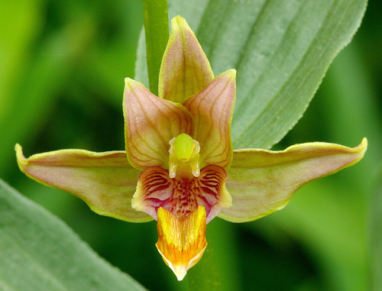

**WE THANK MARK ROMANSKY FOR THE WONDERFUL WALK TO SEE OUR NATIVE ORCHID EPIPACTIS GIGANTEA IN CALICO BASIN. ONE OF OUR 14 NATIVE NEVADA ORCHIDS, THIS GROWS IN THE SHADOW OF THE SANDSTONE RED ROCKS ALL OVER LAS VEGAS, ESPECIALLY IN PLACES THAT ARE WETTED BY UNDERGROUND SPRINGS. THREE FEET TALL, DECIDUOUS, (DYING BACK TO THE GROUND EVERY FALL AND REAPPEARING IN THE SPRING), AND POLLINATED BY SYRPHID FLIES, THIS ORCHID IS A LAS VEGAS GEM. HOW LUCKY ARE WE!**

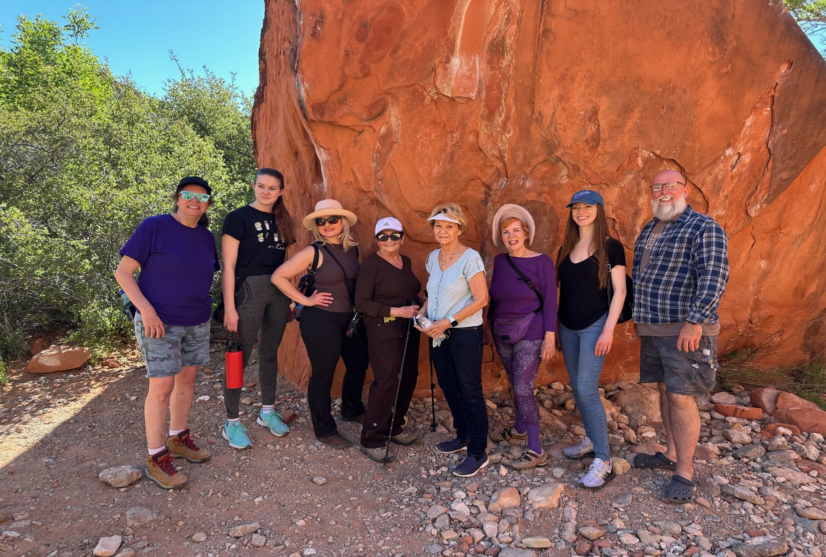

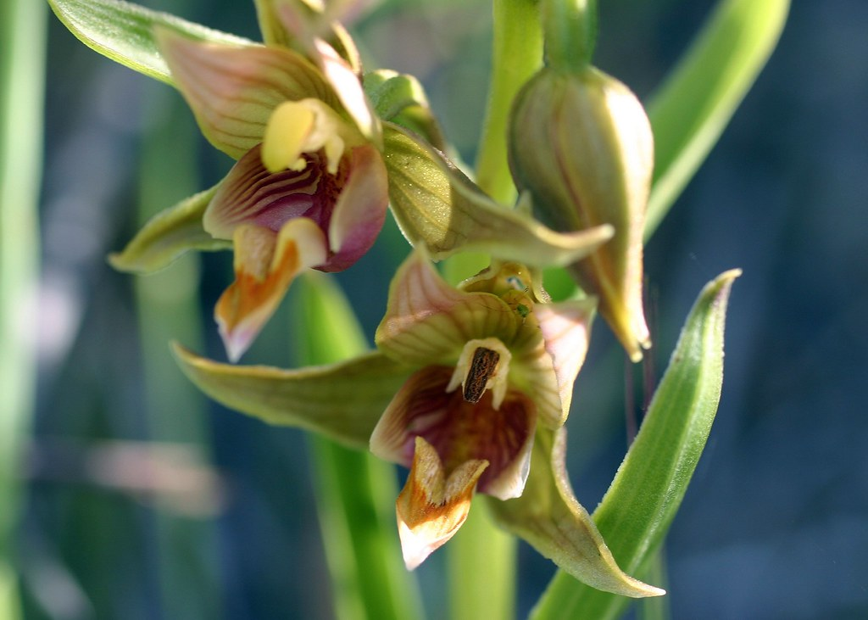

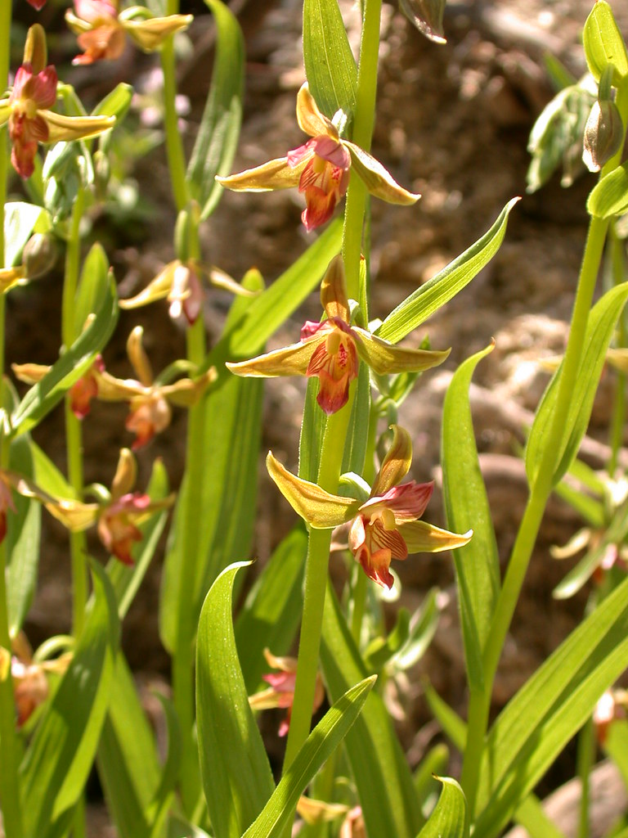

[This Photo](http://www.flickr.com/photos/nativeorchids/1057374279/) by Unknown Author is licensed under [CC BY-SA-NC](https://creativecommons.org/licenses/by-nc-sa/3.0/)



Diana, website genius, and I have finished our new website <https://lasvegasorchidsociety.org/>

We will improve it as time goes by, a work in progress, but we are proud of it. If you don't get a newsletter or don't remember a meeting date, it is always there as well as lots of information.



**BRING YOUR BLOOMING BEAUTIES TO THE LIBRARY FOR SHOW AND TELL. YOU CAN EVEN BRING PLANTS THAT YOU JUST BOUGHT OR THAT ARE NOT IN BLOOM BUT HAVE AN INTERESTING STORY .**

**. DUES REMAIN $35 FOR A SINGLE AND $50 FOR A COUPLE. DONATIONS, OF COURSE, ARE ALWAYS APPRECIATED.**

**Last year, members gave donations of $1500, and it made all the difference.**

**If you haven’t paid your 2024 dues, please….We now have the ability for you to pay your dues online! Dues are still $35 for an individual and $50 for a couple.   Just click on the link, and the rest is quite clear. The form will ask for your credit card information which is secure through the Square application. I tried it, and it worked great. If you want to add a little extra for a donation, just add it on to your membership. It says “donation” instead of “dues” due to a technicality because we are a non-profit. You will receive a receipt immediately.. You can also pay at the meeting, but it makes the treasurer’s job much easy if someof you do this online.**

|  |  |  |  |  |  |  |  |  |  |  |
| --- | --- | --- | --- | --- | --- | --- | --- | --- | --- | --- |
| **Here is the link-**   |  |  |  | | --- | --- | --- | |  |  |  | | |  | | --- | | https://square.link/u/NDRpbeQq?src=sheet | | | | |  |  |  |
|  |  |  |
|  | | |

**UPCOMING EVENTS**

**Saturday June 23, 2024 Bridgit Uzar “The Journey of a Seedpod”**

**July 14, 2024 Alan Koch “Growing in the Home”**

**August 11, 2024 Mary Gerritsen “The Orchids and Tribes of Papua New Guinea”**

**September 8, 2024 Fred Clarke “*Cattleya mossiae-***

**National Flower of Venezuela”**

**October 13, 2024 Peter Lin “The Glorious World Orchid Conference in Taiwan”**

**November 3, 2024 Cathy Loftfield “Orchids of the Old World”THIS IS THE FIRST SUNDAY IN NOVEMBER**

**December 8, 2024 IN PERSON Art Chadwick “The First Ladies and Their Orchids”**

**January 12, 2025 Mark Romansky “Potting Media”**

**WHITE ELEPHANT SALE**

**February 9, 2024 Mary Gerritsen “The Orchid Conservation Alliance”**

**March 9, 2025 Carol Siegel “Building an Orchid Collection”**

**April 13, 2025 Beth Davis “Waldor Orchidss- The Story Goes On and On”**

**JUNE 2025 GREENHOUSE TOUR**