**GREATER LAS VEGAS ORCHID SOCIETY**

**ORCHID COLUMN**

**CAROL SIEGEL, EDITOR**

**SUNDAY,** MAY 5, 2024 **1 PM**

**RON PARSONS “THE ORCHIDS OF MADAGASCAR”**

**ANGRAECUM SESQUIPEDALE FROM MADAGASCAR BEING POLLINATED BY THE MOTH XANTHOPAN MORGANI PRAEDICTA**

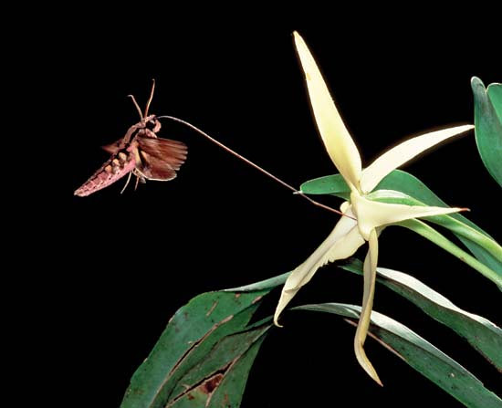

**Our May meeting is the first Sunday of May, May 5, due to availability of our library. Ron Parsons, a favorite of ours, will be speaking on the orchids of Madagascar. He has recently visited there and promises an exciting talk on their unique orchids. He is considered to be one of the finest flower photographers in the United States. His photography and encyclopedic knowledge of orchids is known both nationally and internationally. He has been photographing plants for over 25 years has taken thousands of photos of orchids and other flowers.**

**He has been growing orchids for more than 40 years. He has nearly 60,000 digital images, most of which are orchids and a 100,00 slide images. He has had over 3000 published images which have appears in books, magazines, journals and periodicals. He has co-authored with Mary Gerritsen books on miniature orchids, Masdevallias, and mariposa lilies. Check out his website at** [**www.flowershots.net**](http://www.flowershots.net)**.**

**I will be donating pots and potting material so the club can sell them at the May meeting. People always want small quantities of that. You can get pots, bark, and sphagnum moss on Amazon in smaller quantities. You can get pots at Repotme.com, and sunsetvalleyorchids.com sells larger quantities of moss and bark.**

**POTLUCK IN MAY**

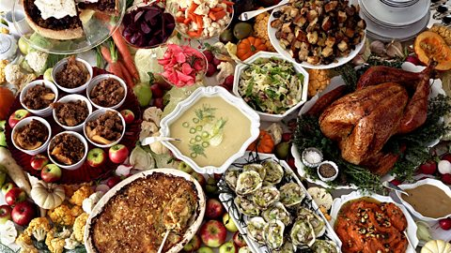

**We thank Dan Mumau, Diana Smith, Maria Demeo, Marilee Easton and Phyllis Bond for a delicious feast in April. I will provide paper goods, tablecloths and such for the May meeting. We need each of you to bring something for 10-12 people with serving utensils. It will be as fun as you make it. The theme is pool party (bathing suits are optional although clothing isn’t…) just joking…**

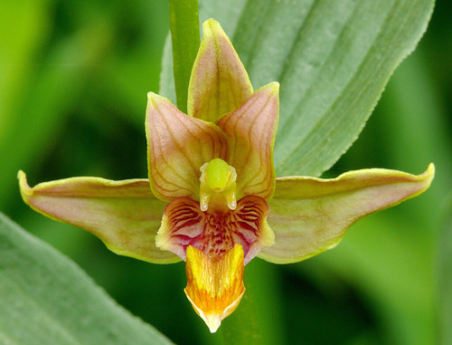

**JOIN US FOR AN ORCHID WALK IN CALICO BASIN AT THE BEGINNING OF MAY**

**Join Mark Romansky for a walk in Calico Basin in Red Rock State Park to see our native orchid *Epipactis gigantea* in bloom by the thousands right near Las Vegas. The walk is an hour and is free. I will notify you when the orchids are up and in bloom, and we can take our walk. Spoke to Mark, and he is going up next week-end, the week-end of our meeting, so probably we will go the following weekend, May 11th. Stay tuned.**

**How do you get there?**

**The walk is in Calico Basin, and we meet at Red Spring(s). You go down Charleston as far west as you can go as though you are going to Red Rock. Make a left and continue until BEFORE the entrance to Red Rock. If you get to Red Rock you have gone too far. There is a sign for Calico Basin Red Spring. You make a right turn and go straight until you can go no further. On the left is the entrance to the Red Spring parking lot. We will meet in front of the outhouse (very cloassy). I will give you all the specific details on date and time as soon as Mark gives them to me.**



**Our website is down for some unknown reason. It appears to show information from 2017- OY. Diana has created other websites, and she and I have created a new website. We will keep you posted. Sorry for the inconvenience, but that’s life….**

**Just an update- It is really coming along, and we are enjoying working together. Nobody is smarter or more fun to work with than Diana.**



**BRING YOUR BLOOMING BEAUTIES TO THE LIBRARY FOR SHOW AND TELL. YOU CAN EVEN BRING PLANTS THAT YOU JUST BOUGHT OR THAT ARE NOT IN BLOOM BUT HAVE AN INTERESTING STORY .**

**. DUES REMAIN $35 FOR A SINGLE AND $50 FOR A COUPLE. DONATIONS, OF COURSE, ARE ALWAYS APPRECIATED.**

**Last year, members gave donations of $1500, and it made all the difference.**

**If you haven’t paid your 2024 dues, please….We now have the ability for you to pay your dues online! Dues are still $35 for an individual and $50 for a couple.   Just click on the link, and the rest is quite clear. The form will ask for your credit card information which is secure through the Square application. I tried it, and it worked great. If you want to add a little extra for a donation, just add it on to your membership. It says “donation” instead of “dues” due to a technicality because we are a non-profit. You will receive a receipt immediately.. You can also pay at the meeting, but it makes the treasurer’s job much easy if someof you do this online.**

|  |  |  |  |  |  |  |  |  |  |  |
| --- | --- | --- | --- | --- | --- | --- | --- | --- | --- | --- |
| **Here is the link-**   |  |  |  | | --- | --- | --- | |  |  |  | | |  | | --- | | https://square.link/u/NDRpbeQq?src=sheet | | | | |  |  |  |
|  |  |  |
|  | | |

**UPCOMING EVENTS**

**May 5, 2024 Ron Parsons (First Sunday) “Orchids of Madagascar”**

**Saturday June 23, 2024 Bridgit Uzar “The Journey of a Seedpod”**

**July 14, 2024 Alan Koch “Growing in the Home”**

**August 11, 2024 Mary Gerritsen “The Orchids and Tribes of Papua New Guinea”**

**September 8, 2024 Fred Clarke “*Cattleya mossiae-***

**National Flower of Venezuela”**

**October 13, 2024 Peter Lin “The Glorious World Orchid Conference in Taiwan”**

**November 10, 2024 Cathy Loftfield “Orchids of the Old World”**

**December 8, 2024 IN PERSON Art Chadwick “The First Ladies and Their Orchids”**

**January 12, 2025 Mark Romansky “Potting Media”**

**February 9, 2024 Mary Gerritsen “The Orchid Conservation Alliance”**

**March 9, 2025 Carol Siegel “Building an Orchid Collection”**

**April 13, 2025 Beth Davis “Waldor Orchidss- The Story Goes On and On”**

A LITTLE ABOUT MADAGASCAR

AND ITS ORCHIDS

Madagascar is a fascinating country. Associated with orchids, the island houses many amazing orchid species. It exports aboutyt 40% of the world’s vanilla, and its orchid *Jumella fragranss* is used to flavor a traditional rum on Reunion Island. Madagascar has over 1000 orchid species (about 10% of the plant species on the island) of which 90% are endemic, only known there

The very restricted distribution of many Malagasy orchids makes them particularly vulnerable to habitat change and loss. This is especially relevant since most of the population of Madagascar lives by subsistence farming and is poor. This has led to the decine of several orchids, but Kew has been working very hard on the in-situ conservation of their orchids, coupled with the reintroduction of selected species.

The island of Madagascar is situaterd in the Indian Ocian about 400 km (248 miles) east of continental Africa. It has an amazing tropical to subtropical climate. It separated from mainland Africal 165 million years ago during the Middle Jurassic during the same time the dinosaurs roamed the oceans and land. It developed in a unique way due to its isolation, accounting for the fact that 9 out of every ten orchids occurs only there.

*Angraecum sesquipedale* is perhaps their most famous orchid. Known for its 9-inch + nectary, the orchid puzzled botanists who couldn’t figure out its pollinator. Darwin suggested it was a moth with a long proboscis to fits down the long nectary. Forty years later, they found the pollinator, a hawkmoth which was named Xanthopan morgani praedicta, because Darwin predicted it.