**sept**

**GREATER LAS VEGAS ORCHID SOCIETY**

**ORCHID COLUMN CAROL SIEGEL, EDITOR**

**Fred Clarke**

**“CATTLEYA MOSSIAE- NATIONAL FLOWER OF VENEZUELA”**

**SUNDAY, SEPTEMBER 8 1 PM**

**Z**

**OF PAPUA NEW GUINEA”**

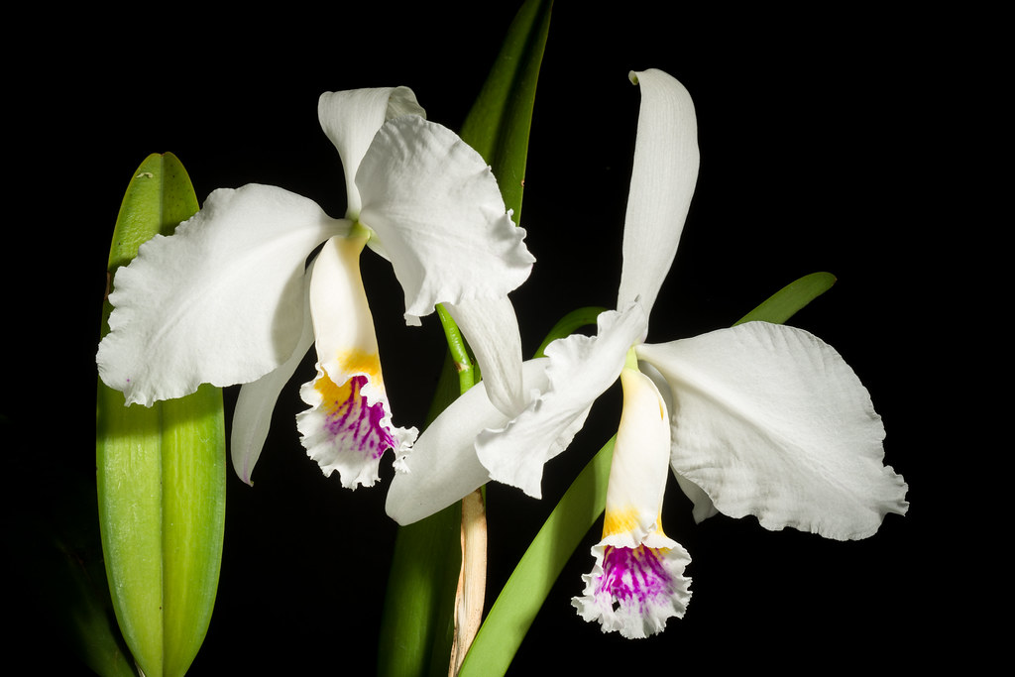

***On September 8th, Fred Clarke will present a PowerPoinr program on “Venezuela's National Flower, Cattleya mossiae.” The talk is a beautiful expose of C. mossiae in the wild with amazing pictures of thousands of flowers covering the trees. Learn about the habitat and the perils that await C. mossiae as well as how to grow it.***

***Cattleya mossiae is the queen of Venezuelan Cattleya's. Once the most popular corsage flowers for Mother’s day, it is now rarely seen in collections and in the cut flower trade.***

***The presenter will be Fred Clarke of Sunset Valley Orchids in Vista. Fred Clarke has been growing orchids for 42 years and has been hybridizing for 38 of those years. With over 34 years as a professional grower and manager in the horticultural industry, Fred applies these skills at his orchid nursery; Sunset Valley Orchids, located in San Diego, California. He is a passionate orchid grower whose curiosity in orchids is broad and varied. Although developing Cattleya hybrids has been his sustaining interest, he is also actively creating new Paphiopedilum and Aussie Dendrobium hybrids plus some others to be named if they work out!***

***His pioneering work in Catasetum intergeneric hybrids led to the development of several notable hybrids, most recently the grex, Fredclarkeara After Dark, which produced “the blackest flower ever witnessed”. This grex has received over 100 awards worldwide with nine FCC’s and thirty AM’s from the AOS judges!***

***Fred is a big favorite of the club. We will have 24 mini cattleyas in bloom for sale at $15.\***

***Cattleya mossiae***

***Carol Siegel***

***(an excerpt from an article I wrote for Orchid Digest on national flowers in 2011)***

**In Venezuela, *Cattleya mossiae*, known as Flor de Mayo, replaced another orchid, *Catasetum pileatum*, as the national flower in 1948. The darling of Venezuela received quite an honor in having been chosen since Venezuela boasts eight magnificent and impressive unifoliate (one-leaved) cattleyas including *C. lueddemanniana, C.* *percivaliana, C. gaskelliana*, and *C. jenmanii*. Springtime is *C. mossiae* time, and it is in bloom for Easter and Mother’s Day. The second cattleya to be discovered, it caused a sensation when it was introduced to the horticultural world in Europe in 1836; this was fifteen years after John Lindley had established the Cattleya genus with *C. labiata*. It has large, showy flowers with four or five flowers per spike and multiple leads. A single plant can produce 20 flowers or more. William Hooker, in his original description of the species called it “the most magnificent of all the orchidaceous plants.” The first plant to reach Europe was sent to George Green in England by a Venezuelan friend; he gave it to Mrs. Moss who bloomed it. She sent the flowers and her own pencil sketch to William Jackson Hooker who described it as a new species, named for her. The flowers she sent were a stunning eight and one half inches (22 cm) across with a lovely rose-lavender color and a strong fragrance. This plentiful orchid was imported in large numbers into Europe. It was one of the most abundant of the large-flowered cattleyas in the wild, and hundreds of thousands were also imported into the United States. There were enough alba forms of *C. mossiae* that Frederick Sander could tell his collectors to include a case or two with every shipment. In contrast, only one or two alba plants were found in most other large Cattleya species in over 100 years of collecting.**

It became the darling of the cut-flower industry in the 40s and 50s. Unlike *C. labiata* which was rather scarce, *C. mossiae* was plentiful enough so that anyone with enough money could buy one. It was the favorite for spring dances, graduations, Easter, and Mother’s Day for years. At the eight of the cut-flower orchid era, *C. mossiae* ‘Mrs. J.T. Butterworth’ sold for $10,000. Its petals measured 9 ½ inches (24 cm) across and it was the only *C.* *mossiae* plant to receive an FCC/AOS until the end of the century.

Almost all the good spring cattleya hybrids today have *C. mossiae* in their background, including the very famous *Lc*. Canhamiana, a primary hybrid with *Cattleya purpurata* (syn. *Laelia* *purpurata*), known for years as the bridal orchid. In the 1930s, Thomas Young in Boundbrook, New Jersey grew more than 10,000 of the semi-*alba* hybrid in eight to ten inch pots (about 150,000 flowers) yet could not keep up with the demand.

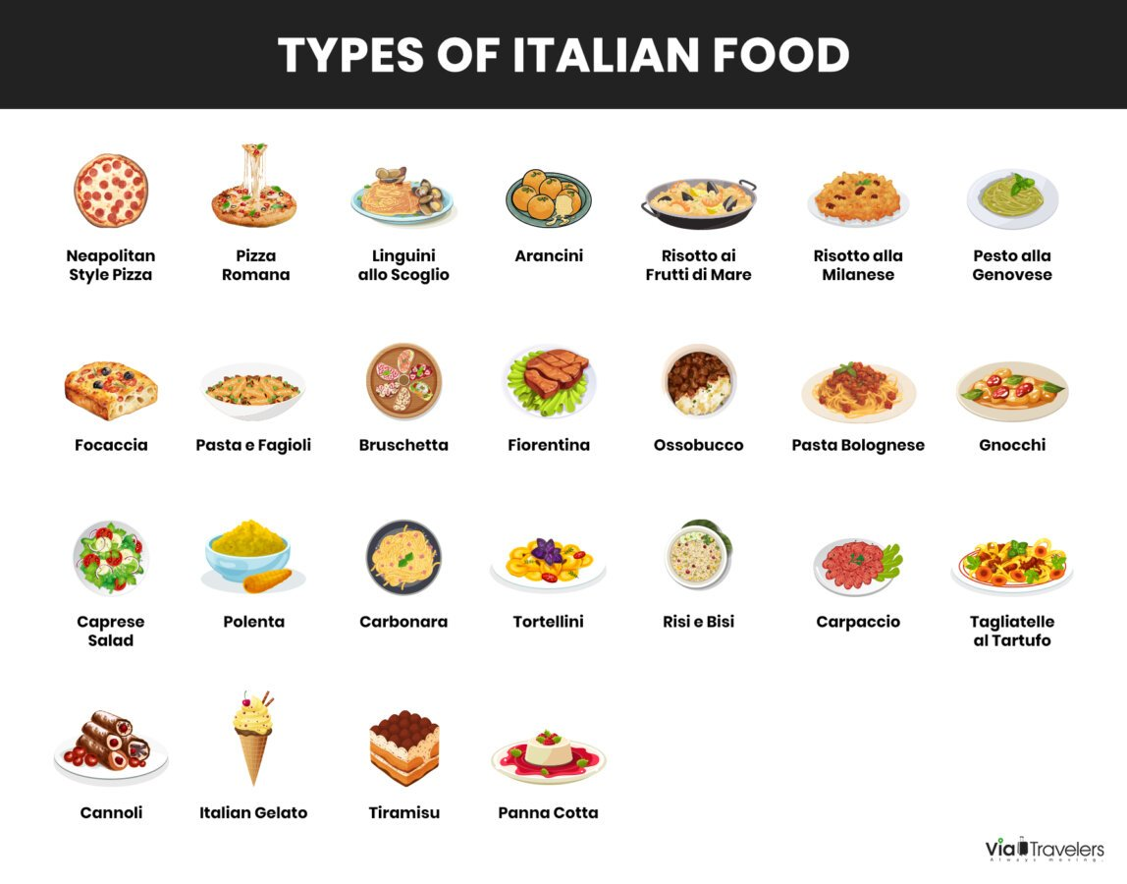



**ITALIAN POTLUCK!!**

**We will be having an Italian potluck! I have donated lovely Italian-themed paper goods, and each of us is asked to bring something for 10-12 people with serving spoons with an Italian theme. (Don’t want to do an Italian theme. Just make something yummy). Think Caesar salad, Italian desserts, pastas, casserole, mealballs, garlic bread, antipasto, sub sandwich, pizza, minestrone soup, garlic knots, eggplant- like that. What fun!!**



Diana, website genius, and I have finished our new website https://lasvegasorchidsociety.org/

We will improve it as time goes by, a work in progress, but we are proud of it. If you don't get a newsletter or don't remember a meeting date, it is always there as well as lots of information.

Do click on it. We are proud of it. There are 22 articles that might interest you. We recorded the talk on New Guinea. It will only be accessible for a few more weeks and only through the following link. It was a great talk, and I think you will enjoy it.

|  |  |  |
| --- | --- | --- |
| |  | | --- | |  | |  |

<https://lasvegasorchidsociety.org/videos>

We have had a problem making our new site come up first on the Google search engine. Our old site was still first because it had so many more hits over the years, and that is how Google algorithms decide who comes up first (DRAT…)

Thanks to all the folks with a sense of humor who logged onto our new site to help it rise to the top. I have managed to reach Steve Campbell, and I paid him, and he assures me that in the next few days all inquiries will be redirected to our

new site. Fingers crossed as that will solve our problem.



**BRING YOUR BLOOMING BEAUTIES TO THE LIBRARY FOR SHOW AND TELL. YOU CAN EVEN BRING PLANTS THAT YOU JUST BOUGHT OR THAT ARE NOT IN BLOOM BUT HAVE AN INTERESTING STORY .**

**. DUES REMAIN $35 FOR A SINGLE AND $50 FOR A COUPLE. DONATIONS, OF COURSE, ARE ALWAYS APPRECIATED.**

**Last year, members gave donations of $1500, and it made all the difference.**

**If you haven’t paid your 2024 dues, please….We now have the ability for you to pay your dues online! Dues are still $35 for an individual and $50 for a couple.   Just click on the link, and the rest is quite clear. The form will ask for your credit card information which is secure through the Square application. I tried it, and it worked great. If you want to add a little extra for a donation, just add it on to your membership. It says “donation” instead of “dues” due to a technicality because we are a non-profit. You will receive a receipt immediately.. You can also pay at the meeting, but it makes the treasurer’s job much easy if someof you do this online.**

|  |  |  |  |  |  |  |  |  |  |  |
| --- | --- | --- | --- | --- | --- | --- | --- | --- | --- | --- |
| **Here is the link-**   |  |  |  | | --- | --- | --- | |  |  |  | | |  | | --- | | https://square.link/u/NDRpbeQq?src=sheet | | | | |  |  |  |
|  |  |  |
|  | | |

**UPCOMING EVENTS**

**September 8, 2024 Fred Clarke “*Cattleya mossiae-***

**National Flower of Venezuela”**

**October 13, 2024 Peter Lin “The Glorious World Orchid Conference in Taiwan”**

**November 3, 2024 Cathy Loftfield “Orchids of the Old World”THIS IS THE FIRST SUNDAY IN NOVEMBER**

**December 8, 2024 IN PERSON Art Chadwick “The First Ladies and Their Orchids” Live entertainment Russelline and John Christmas party at library**

**January 12, 2025 Mark Romansky “Potting Media”**

**WHITE ELEPHANT SALE**

**February 9, 2024 Mary Gerritsen “The Orchid Conservation Alliance”**

**March 9, 2025 Carol Siegel “Building an Orchid Collection”**

**April 13, 2025 Beth Davis “Waldor Orchidss- The Story Goes On and On”**

**JUNE 2025 GREENHOUSE TOUR**