`P
GREATER LAS VEGAS ORCHID SOCIETY
ORCHID COLUMN
CAROL SIEGEL, EDITOR
“THE ORCHIDS OF HAWAII” CAROL SIEGEL, PRESENTER

“I must have flowers-always and always”-Claude Monet”

THE GREATER LAS VEGAS ORCHID SOCIETY
THE ORCHID COLUMN
Sunday, March 22,2026 1 pm
FRED CLARKE “THE FLOWER FIELDS”
KATE SCHLATTER ON PIANO AT 1 PM
ORCHIDS FOR SALE SHOW AND TELL

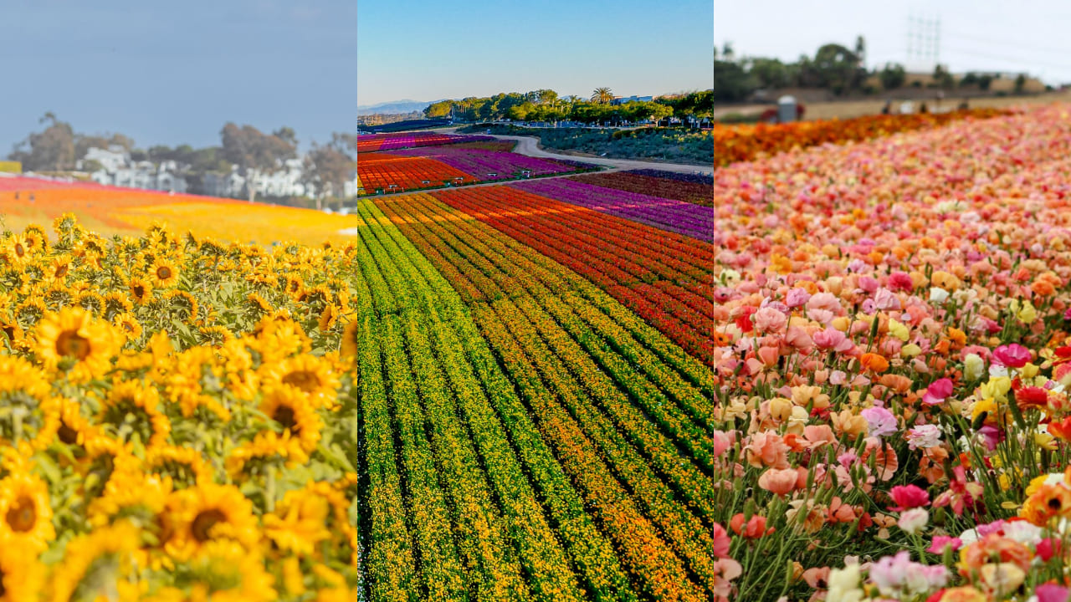

EPIPACTIS GIGANTEA

Each spring, the hills of Carlsbad burst into color as
tens of millions of ranunculus flowers bloom along the
coast. Starting March 1, The Flower Fields opened for
the season, welcoming visitors to one of Southern
California’s most iconic spring attractions. Spread across nearly 55 acres, the property features sweeping rows of vibrant flowers overlooking the Pacific — a favorite backdrop for photos, weekend outings, and family day trips. But it’s more than just a walk through the blooms.
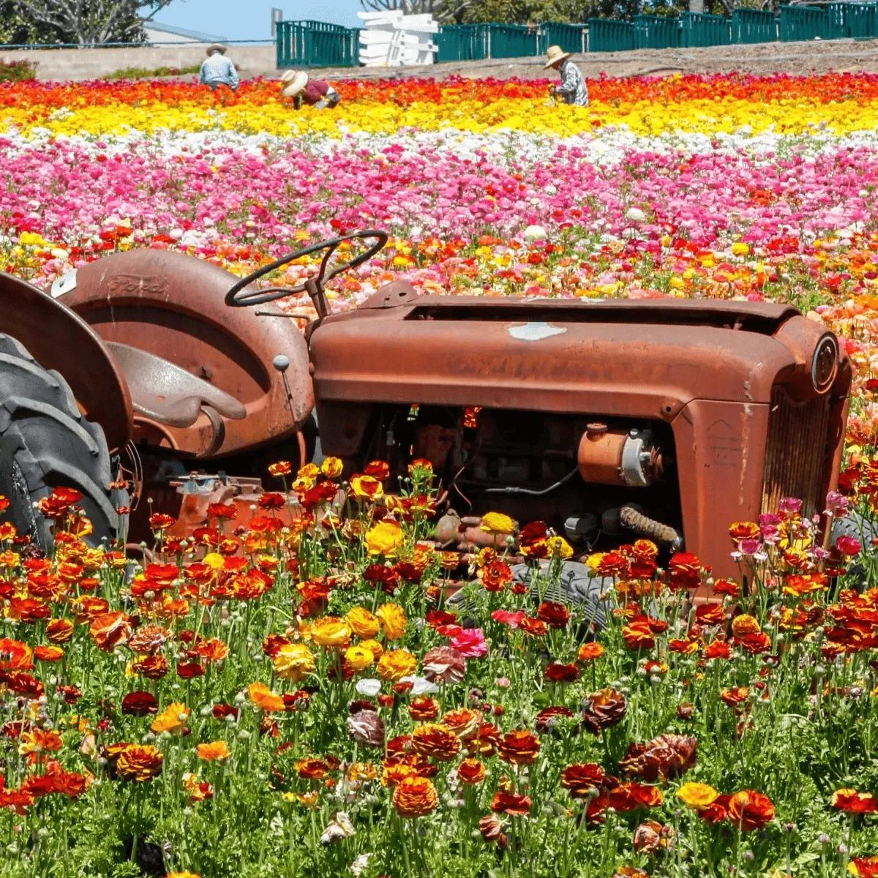
Fred Clarke of Sunset Valley Orchids has managed the
Flower Fields in Carlsbad, California for many years.
He will speak about these beautiful fields. He is, of
course, primarily known for his work in orchids but
this will be a fun talk.
Fred Clarke has dedicated over 44 years to developing
orchids hybrids and producing select species for the
orchid enthusiast. These hybrids are one-of-a-kind
plants, like original pieces of art. Fred began growing
orchids and built his first greenhouse in 1977. He is
committed to the education of orchid hobbyists from
around the world in the culture of their plants. He is
also a professional grower and manager in the
horticultural industry; he applies these skills at his
orchid nursery, Sunset Valley Orchids, located in San
Diego, California. He is a passionate orchid grower
whose curiosity in orchids is broad and varied.
Although developing Cattleya and Catasetinae hybrids
has been his sustaining interest, he is also actively
creating new Paphiopedilum, Australian Dendrobium,
Zygopetalum, and a few others to be named if they
come out good! His pioneering work in Catasetum
intergeneric breeding has led to the development of
many notable hybrids, including the grex,
Fredclarkeara After Dark, which produced “the
blackest flower ever witnessed”, and received an
amazing number of awards with 17 First Class
Certificates and over 100 awards worldwide! Fred is
an acclaimed speaker and travels extensively within
USA, Canada, Mexico, Australia, New Zealand, and
Central America. He is an accredited American
Orchid Society Judge. His hybrids have received
hundreds of quality awards for orchid enthusiasts
from the American Orchid Society and Orchid Judging
organizations from around the world.

What You’ll Find This Season
Endless Fields of Ranunculus
About 80 million flowers blanket the landscape in
bright stripes of red, pink, yellow, orange, and white.

Butterfly Encounter
Step inside a special enclosure where hundreds of
butterflies flutter freely around guests.

Glass in Flight Exhibit
Large-scale glass sculptures by artist Alex Heveri are
displayed throughout the grounds, featuring colorful
birds and insects integrated into the natural setting.

Tractor Wagon Rides
Hop on a tractor-pulled wagon for a guided
Ride through the fields (additional fee applies).

Spring Market
A seasonal pop-up market showcases local vendors
and specialty goods.

Visitors will also find an American flag created
entirely from flowers, themed gardens, an orchid
greenhouse, a playground for kids, and a sweet pea maze.
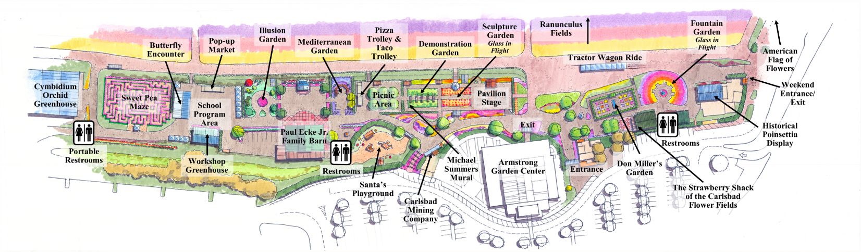
Tickets and Food
General admission is $27 for adults, $25 for seniors 60 and older, and $17 for children ages 3–10.
Food stands throughout the venue offer pizza, fresh salads, kettle corn, lemonade, tacos, coffee, cotton candy, and the crowd-favorite strawberry milkshake.
Fred Clarke, general manager of the Flower Fields, doesn’t seem to have lost his enthusiasm for the locale, even after 18 years.
“This is one of the most beautiful places you can imagine here in
Southern California,” he said

A little history
Even though it’s only open to the public for a short
period of time in spring, the Flower Fields are a year
round farming operation in Carlsbad within a half mile
of the ocean.

With so many beautiful flowers in the world, how did
the ranunculus, with the strange name that means
“little frog” in Latin and is awkward to pluralize
(ranunculi and ranunculuses are both accepted),
come to be king here?

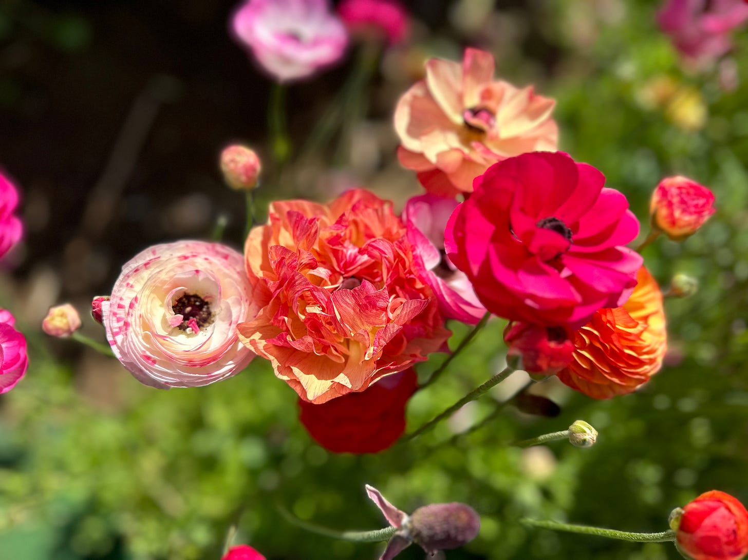

Part of the buttercup family and a product of the
Mediterranean, the ranunculus, is perfectly suited to
the coastal California climate—wet winters (at least
lately!) followed by dry summers, Clarke said.
In the ‘40s and ‘50s, poinsettias were sold as cut
flowers on the property. After poinsettias became
more popular as potted plants and moved to the
greenhouse, ranunculus were grown for their bulbs,
which gardeners prized. But then it was discovered
the blooms made great cut flowers, lasting about two
weeks in a vase.

When people started invading the property to admire
the blooms, the owners decided they might as well
charge for admission instead of running off the
trespassers. And that was the start of a business that
now attracts some 250,000 visitors annually.¹

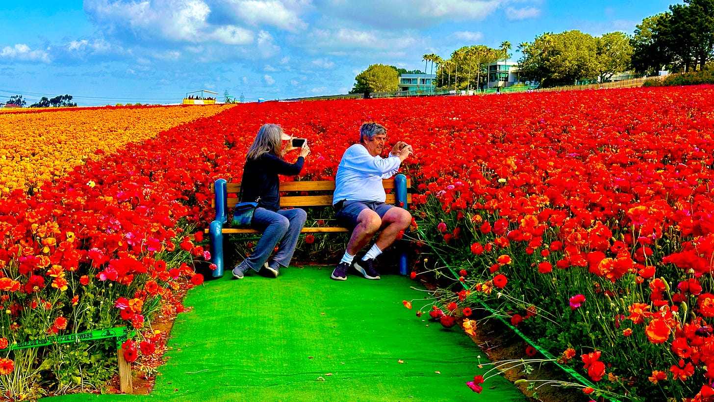

About 25 years ago, the Ecke Family, which owns the
land, and the City of Carlsbad set aside the 55-acre
parcel as an agricultural gift for the community in
perpetuity. Definitely an anomaly in urbanized
Southern California, it’s “really the last bastion of
what was once the floriculture capital of the United
States,” Clarke said. “That’s why we’re here today, to
keep this not just for this generation, but for future
generations to enjoy.”
The power of flowers to improve your outlook is
apparently another side benefit of visiting the fields,
Clarke told us.
“No matter what your mood when you get here, the
flowers will make you happy,” he said.

SPRING POTLUCK
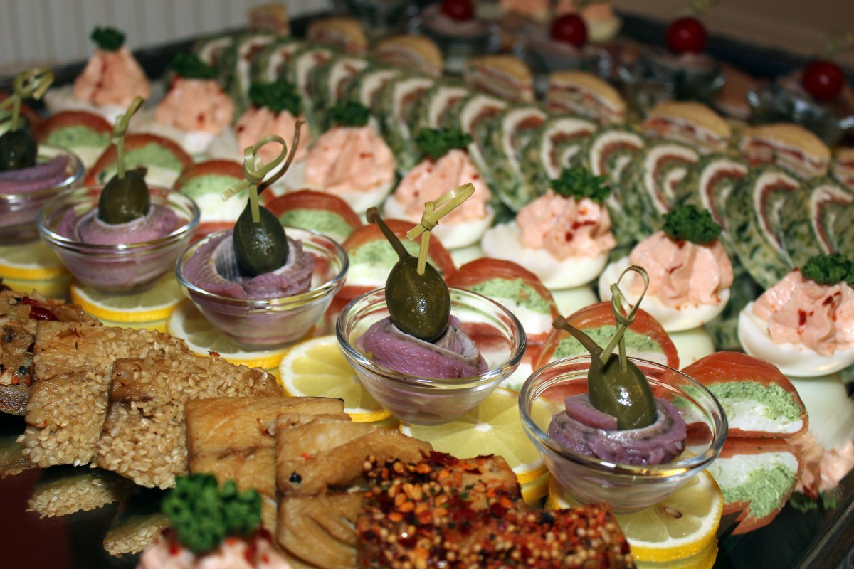
Don’t forget to bring a dish, salad, side dish, main dish, or dessert
with serving utensils for 10-12 people. I will bring spring-themed
paper goods and decorations. It will be as wonderful as we make it.

SHOW AND TELL

We will have show and tell this meeting. You can even bring
something you just bought.



We are pleased that so many paid dues and even gave us donations to bolster our treasury. They were appreciated. DUES FOR 2026 WILL BE WILL BE $40 FOR AN INDIVIDUAL AND $60 FOR A COUPLE. DONATIONS, OF COURSE, ARE ALWAYS APPRECIATED. THIS YEAR WE NO LONGER GET HOTEL PLANTS AND DUE AND DONATIONS ARE SPECIALLY IMPORTANT NOW TO KEEP OUR WONDERFUL PROGRAMS GOING. I have been personally chipping in, but it would be nice to have the club more self-sufficient. In 2023, members gave donations of $1500, and it made all the difference.
If you haven’t paid your 2025 dues, PLEASE FEEL FRREE TO PAY YOUR 2026 DUES….

We now have the ability for you to pay your dues online! Just click on the link, and the rest is quite clear. The form will ask for your credit card information which is secure through the Square application. I tried it, and it worked great. If you want to add a little extra for a donation, just add it on to your membership. It says “donation” instead of “dues” due to a technicality because we are a non-profit. You will receive a receipt immediately.. You can also pay at the meeting, but it makes the treasurer’s job much easy if someof you do this online.

Here is the link-
https://square.link/u/NDRpbeQq?src=sheet


Diana, website genius, and I created our new website https://lasvegasorchidsociety.org/
If you don't get a newsletter or don't remember a meeting date, it is always there as well as lots of information.
Do click on it. There are 22 articles that might interest you.

Upcoming Events:
SOME DATES ARE DIFFERENT (not the second Sunday) BECAUSE OF LIBRARY
AVAILABILITY

Sunday, March 22, 2026 Fred Clarke “The Fabulous Flower Fields” (every other Saturday and Sunday in March was taken- really)

Saturday,April 18, 2026 Cathy Loftfield “The Santa Barbara Orchid Show” All Sundays taken and most Saturdays, too

Somewhere between the end of April and the beginning of May, we will visit Calico Basin to see our native orchid Epipactis gigantea in bloom (depending on Mother Nature…) Our orchid guru, Mark Romansky, will lead us.

Sunday, May 10, 2026 Beth DaviS “All About Dendrobium”

Sunday June 14, 2026 Mark Romansky
“Where to Buy Orchids”

Sunday, July 12 Peter Lin :”Discovering Fragrant Orchids”

Sunday, August 9, 2026 Carol Siegel August 9, 2026
“Orchids and Hummingbirds- Sex in the Fast Lane”

Sunday, Sept 13, 2026 Bridget Uzar “The Orchid Royalty- Cattleya”

