**sept**

**GREATER LAS VEGAS ORCHID SOCIETY**

**ORCHID COLUMN**

**CAROL SIEGEL, EDITOR**

**SLIPPERY TALES” BY MARY GERRITSEN**

**SUNDAY, FEBRUARY 9 1 PM**

**HAPPY VALENTINE’S DAY**



**I will treat for the duo of Russeline and John who entertained us at the Christmas party for our February meeting because it is my birthday, and I just love them. They will sing and play music from 1-2 so come on time.**

**Our speaker, Mary Gerritsen, will entertain us with a Zoom presentation called “Slippery Tales.”  A talk originally prepared for a Paphiopedilum Guild meeting, this lecture is a compilation of Mary’s various adventures to see Orchids in the Wild. As she was preparing the lecture, it became evident that nearly every time a slipper orchid was involved, there was some additional twist and occasionally mishap! Featuring photos and travels to see slipper orchids in Thailand, Sulawesi, Borneo, southern and western China, North America, Mexico and South America. This is one of Mary’s most requested lectures, and the audiences are left roaring with laughter and clutching their sides over her descriptions of the misadventures**

**Our speaker will be Mary Gerritsen, whom we have loved in the past. Mary has been interested in plants for most of her adult life, and has been growing orchids on and off for the last 40 years, despite several cross country moves as part of her “other life” as a biomedical scientist. Her passion for orchids was rekindled when she moved to the San Francisco Bay area in 1997 and attended an orchid show. Returning home with a few plants, she decided to join a local orchid society to learn more about taking care of them, and from these beginnings, her current passion grew exponentially! Now Mary truly has put her roots down, and has orchids in two greenhouses, five lath houses, her front porch, sun room, and anywhere else she can put them. Her collection of about two thousand plants, mostly species, is rich in masdevallias and other miniature orchids of many different genera. Mary has traveled extensively to see orchids in situ, including many countries in Central and South America, Southeast Asia, as well as Australia, Papua New Guinea, South Africa, Madagascar, Europe & Mediterranean islands, the USA and Canada. She has co-authored six botanical books with co-author and photographer Ron Parsons “Masdevallias, Gems of the Orchid World”, “Calochortus, Mariposa Lilies and their Relatives”, “A Compendium of Miniature Orchid Species” (a two book set), “A Bay Area Guide to Orchids and their Culture” “The American Orchid Society Guide to Orchids and their Culture”, and the recently released “The Compendium of Miniature Orchid Species, 2nd edition” (a four book set). Mary has served as president and vice president for both the Peninsula and San Francisco Orchid Societies, and is currently president and chief executive officer of the Orchid Conservation Alliance and a director of the Orchid Digest.**

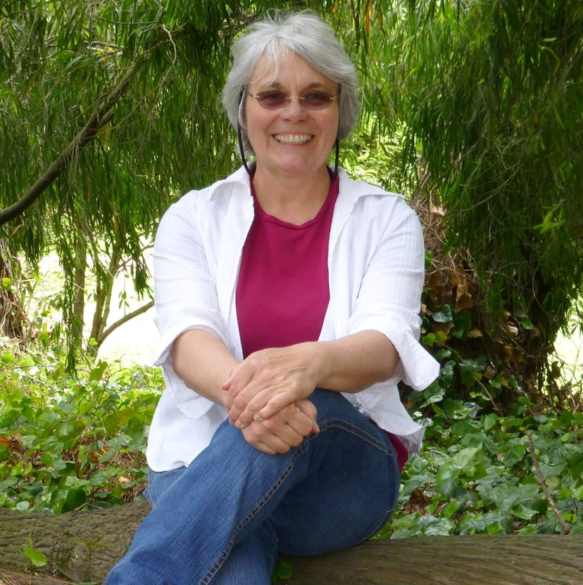

**We will make every effort not to move the meeting along to get everyone out before kickoff. As such, we will not have a show and tell. We will have MANY orchids for sale from 808 Orchids that we think you will love. They will be beautiful dendrobium in bud/bloom for $20 and worth it. Also, Mark Levin has donated 70 years of orchid magazines to the club, which are a great source of information. He is moving to Spain so we are lucky. We will sell them for four for a dollar. They go for $7 each on Ebay. PLEASE TRY TO SUPPORT THIS EFFORT TO MAKE OUR CLUB IN GOOD FINANCIAL SHAPE- AND ALSO GET A GREAT DEAL.**

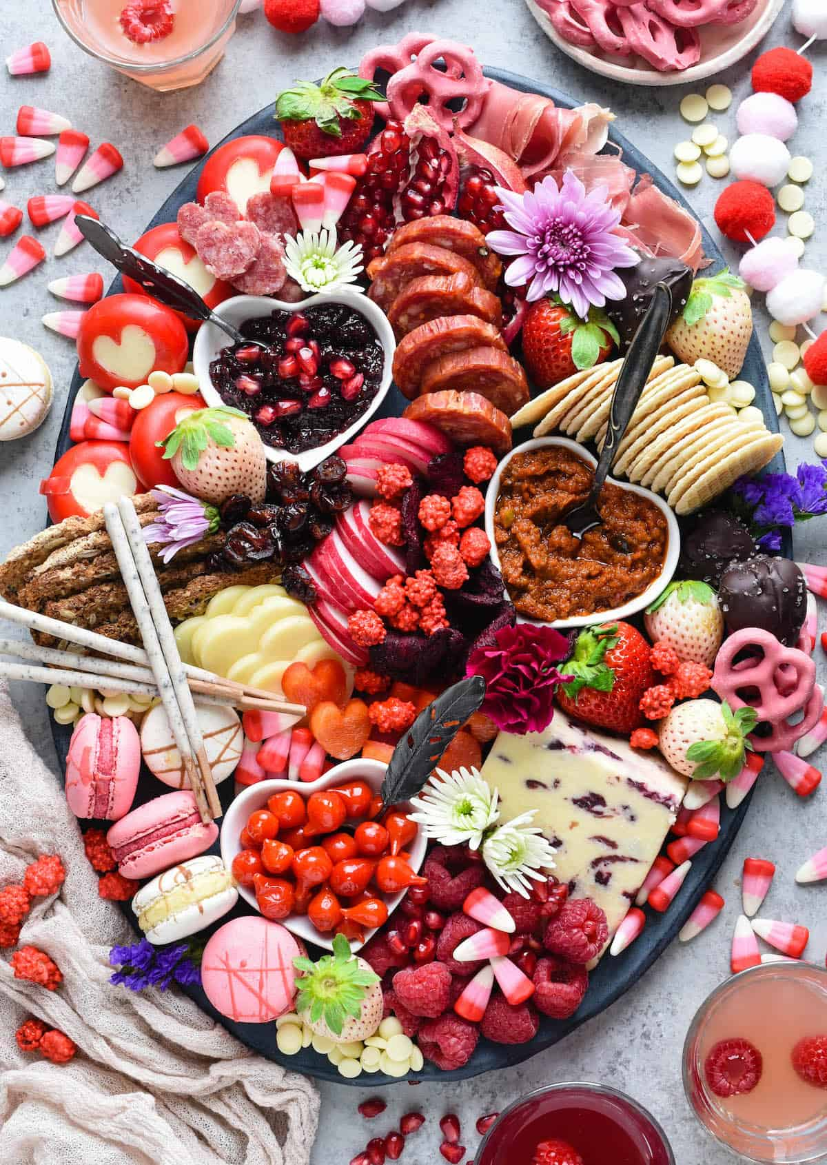

**VALENTINE’S DAY BUFFET**

**I WILL HAVE LOVELY VALENTINE DÉCOR AND PAPER GOODS FOR OUR MEETING. WE WILL HAVE A BUFFET SO PLEASE BRING SOMETHING YUMMY TO SHARE WITH ALL OF US WITH SERVING SPOONS. IT WILL BE AS DELICIOUS AS YOU MAKE IT!**

Diana, website genius, and I have finished our new website https://lasvegasorchidsociety.org/

We will improve it as time goes by, a work in progress, but we are proud of it. If you don't get a newsletter or don't remember a meeting date, it is always there as well as lots of information.

Do click on it. There are 22 articles that might interest you.

**DUES FOR 2025 WILL BE SLIGHTLY MORE- A SINGLE WILL BE $40 AND $60 FOR A COUPLE. DONATIONS, OF COURSE, ARE**

|  |  |  |  |  |  |  |  |  |  |  |
| --- | --- | --- | --- | --- | --- | --- | --- | --- | --- | --- |
| **We now have the ability for you to pay your dues online!   Just click on the link, and the rest is quite clear. The form will ask for your credit card information which is secure through the Square application. I tried it, and it worked great. If you want to add a little extra for a donation, just add it on to your membership. It says “donation” instead of “dues” due to a technicality because we are a non-profit. You will receive a receipt immediately. You can also pay at the meeting, but it makes the treasurer’s job much easy if someof you do this online.Here is the link-**   |  |  |  | | --- | --- | --- | |  |  |  | | |  | | --- | | https://square.link/u/NDRpbeQq?src=sheet | | | | |  |  |  |
|  |  |  |  |
| |  | | --- | |  | | | |  |

**UPCOMING EVENTS**

**February 9, 2024 Mary Gerritsen “Slippery Tales”**

**I will provide Russine Zellner and John Anthony duo as entertainment for my birthday treat**

**March 9, 2025 Ron Parsons “The Orchids of Ecuador”**

**April 13, 2025 GREENHOUSE TOUR Dan Mumau, Carol Siegel, Cheryl Sego**

**May 11 Beth Davis “Waldor Orchids- The Story Goes On and On”**

**JUNE 7 SATURDAY Carol Siegel :”Buildng an Orchid Collection” Note that this meeting is on a Saturday (don’t ask…) Music by Carol Joyce duo**

**July 13 Peter Lin**

**August 10 Bridget Uzar “The Myths of Orchid Growing”**

**Sept 14 Jason Fischer**

**Oct 12**

**Nov 9 Tentative Fred Clarke**

**December 14 Holiday party Art Chadwick in person**