a `P
GREATER LAS VEGAS ORCHID SOCIETY
ORCHID COLUMN
CAROL SIEGEL, EDITOR
“THE ORCHIDS OF HAWAII” CAROL SIEGEL, PRESENTER

“I must have flowers-always and always”-Claude Monet”

THE GREATER LAS VEGAS ORCHID SOCIETY
THE ORCHID COLUMN
SUNDAY, AUGUST 9, 2026 1 pm
ORCHIDS FOR SALE HILO ORCHID FARM HOTEL ORCHIDS
FRED CLARKE “THE 80% ORCHID GROWER”

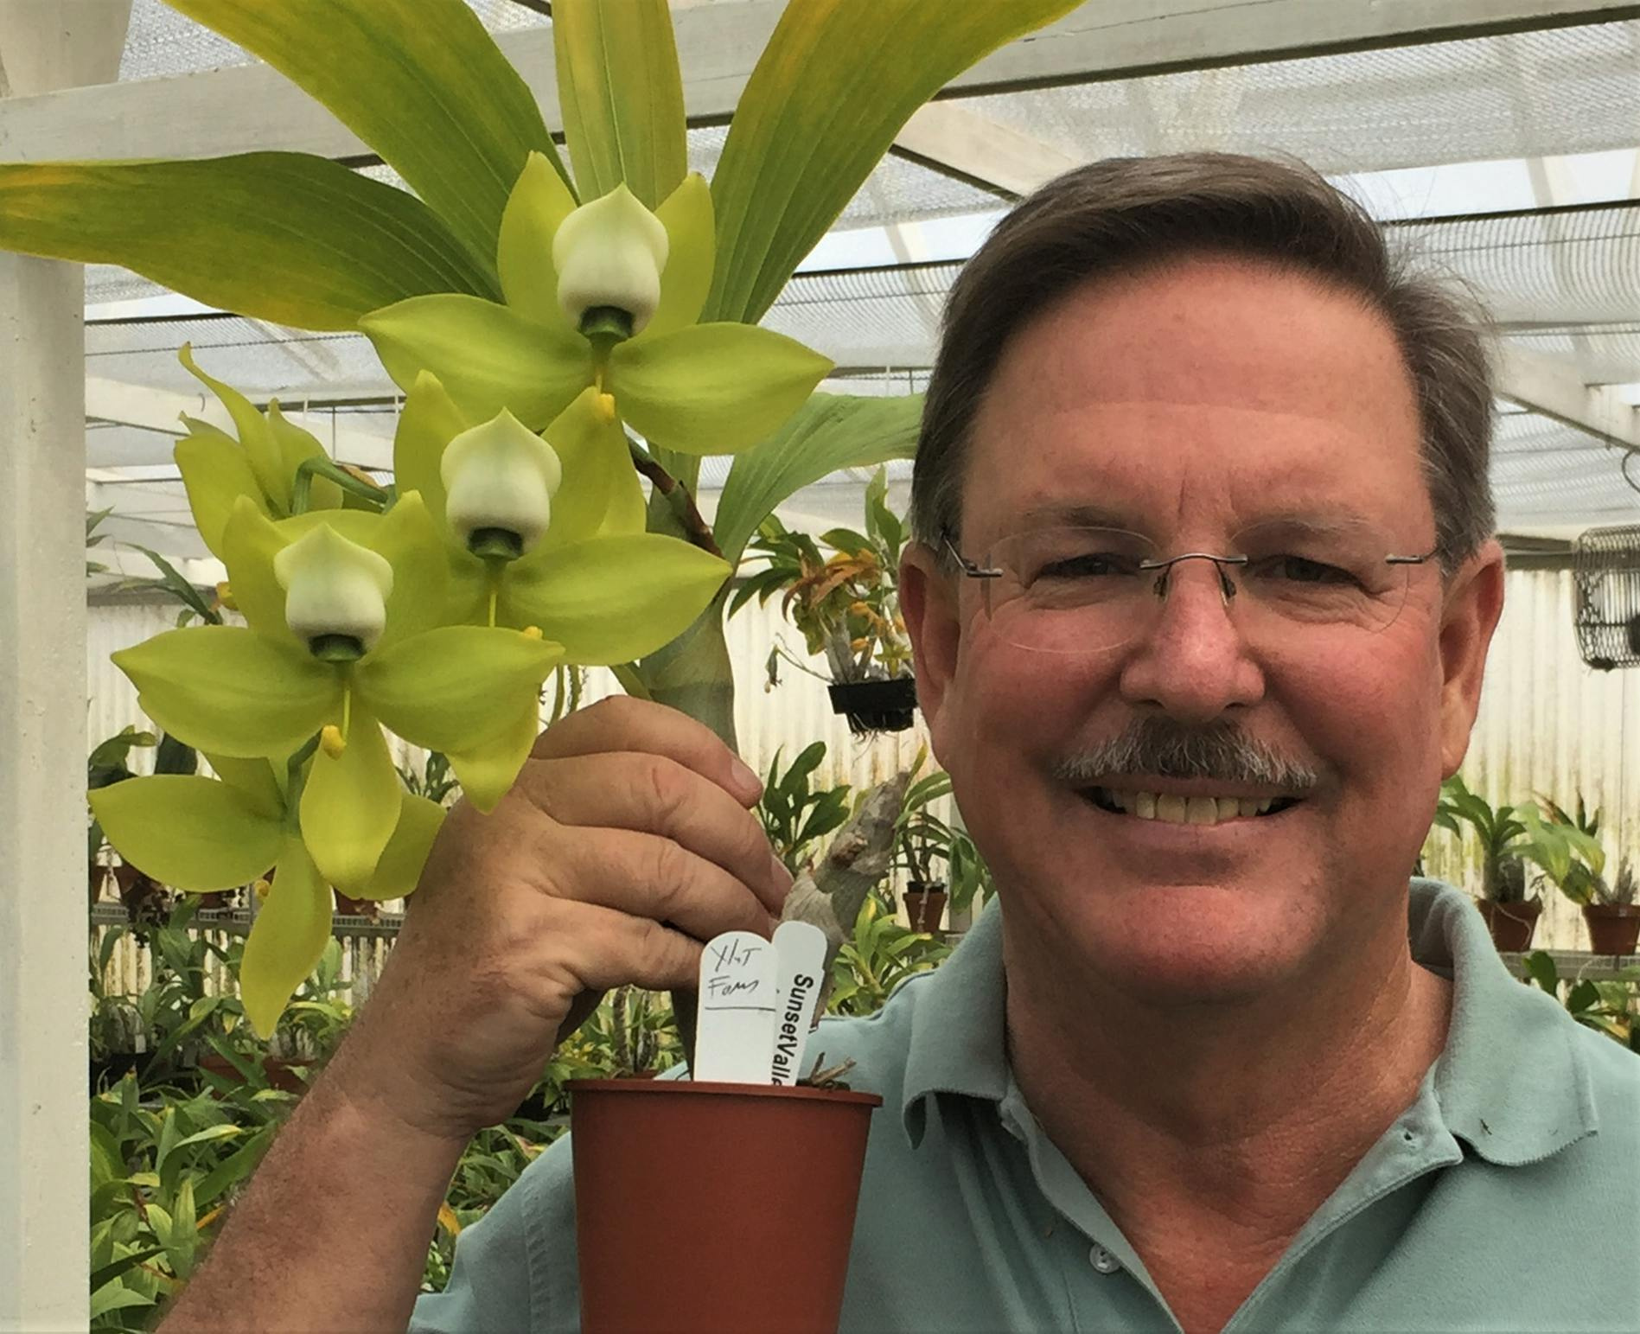

u have any favorite vendors, please share them with us.
We will also have several dozen orchids in bloom from Hilo Orchids. Their plants are reasonably priced, very well-grown and always re-bloom for most of us.

EPIPACTIS GIGANTEA

FABULOUS FRED CLARKE

"Becoming an 80 Percentile Grower"
Ever wonder what the most important requirements are for growing the best orchids?
Learn about the underlying reasons of how and why orchids grow as they do. Then explore the fundamentals and advanced growing techniques to best grow them. Orchid plant culture is explained as you have never heard it before. Learn how to become an 80 percentile grower, expect to be wowed by this talk!
The presenter will be Fred Clarke of Sunset Valley Orchids in Vista. Fred has been growing orchids for 42 years and has been hybridizing for 38 of those years. With over 34 years as a professional grower and manager in the horticultural industry, Fred applies these skills at his orchid nursery; Sunset Valley Orchids, located in San Diego, California.
He is a passionate orchid grower whose curiosity in orchids is broad and varied. Although developing Cattleya hybrids has been his sustaining interest, he is also actively creating new Paphiopedilum and Aussie Dendrobium hybrids plus some others to be named if they work out!
His pioneering work in Catasetum intergeneric hybrids led to the development of several notable hybrids, most recently the grex, Fredclarkeara After Dark, which produced “the blackest flower ever witnessed”. This grex has received over 100 awards worldwide with nine FCC’s and thirty AM’s from the AOS judges!
Fred is an Accredited Judge in the Pacific South Judging Region. His plants have received hundreds of quality awards from the American Orchid Society.
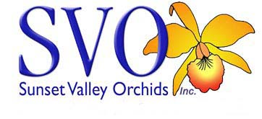

HOTEL PLANTS ARE BACK!

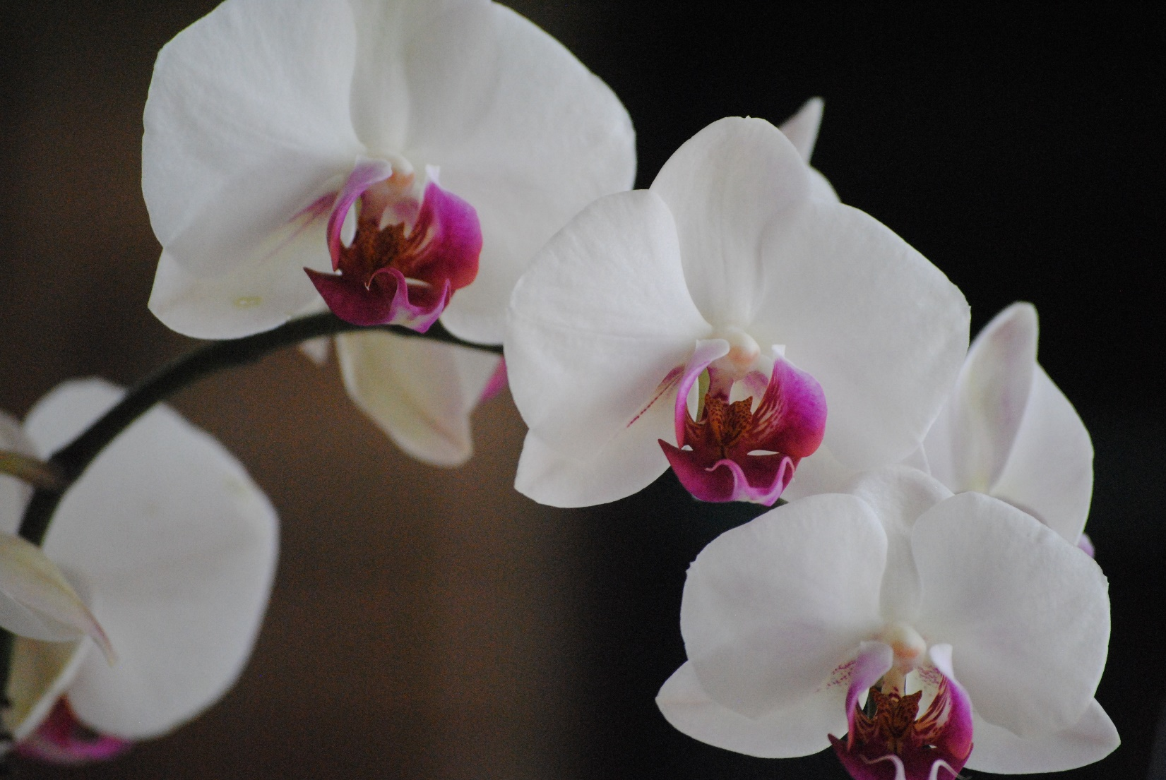
We have all missed the hotel orchids that we used to get donated by the big hotels. They stopped sharing them with us and started giving/selling them to their employees. BOOHOO. Dr Joel Davidson, our long-time member, was able to convince the MGM to
(wait for it) donate orchids to us again. We will have about 12 trays of donated orchids. The orchids are a big money-maker for the club and a source of lots of pleasure so thank you, Joel. Hopefully, this is the start of a wonderful new chapter for us. Our member Michael Hearne was kind enough to receive the orchids from Joel and care for them. We are so grateful to you both. We know it is a lot of work.
For decades, Ole Borresen has been a loyal and true friend of our club. He has shlepped orchids from hotels, stored them and cared for them, and even sold them and some of his own cacti for us. It has been a true act of love and friendship, and we have really appreciated his time and effort. He has sold nursery plants for us- and made the most delicious food. He is unable to do that now, and we want him to know how much we have appreciated all he has done for us. We hope he will continue to grace the club with his friendliness and knowledge.
AUGUST POTLUCK
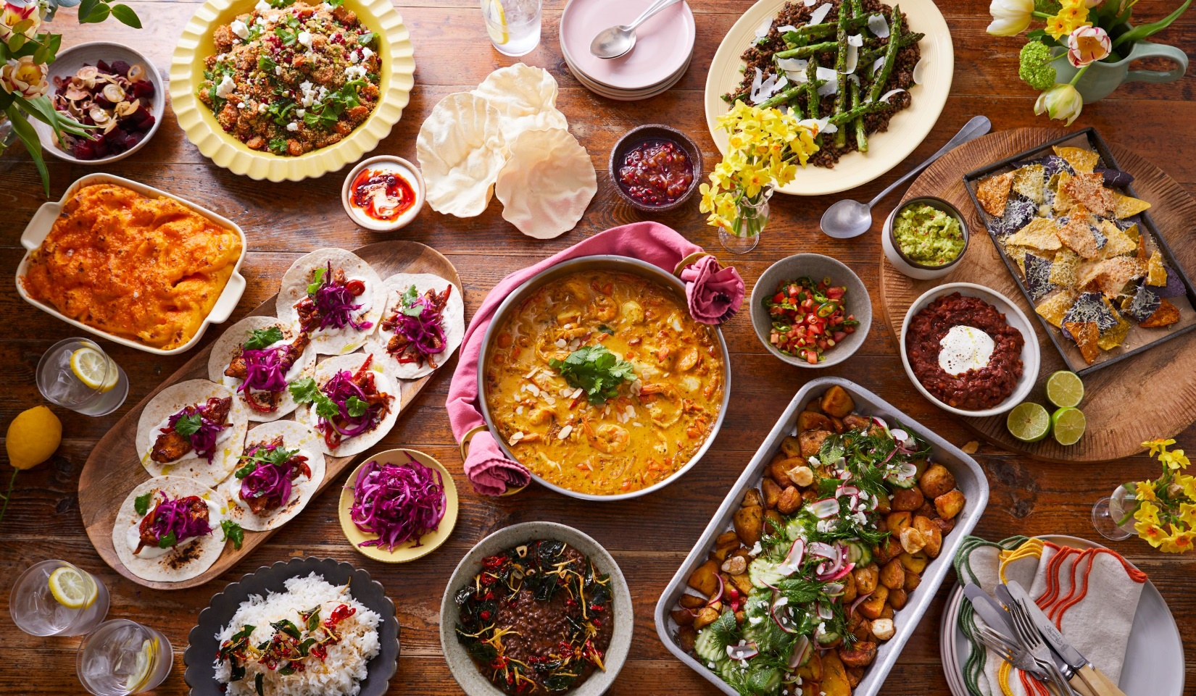

Bring something yummy for our potluck I will have a BEACH décor.

SHOW AND TELL

We will have show and tell this meeting. You can even bring
something you just bought.


We are pleased that so many paid dues and even gave us donations to bolster our treasury. They were appreciated. DUES FOR 2026 WILL BE WILL BE $40 FOR AN INDIVIDUAL AND $60 FOR A COUPLE. DONATIONS, OF COURSE, ARE ALWAYS APPRECIATED.

We now have the ability for you to pay your dues online! Just click on the link, and the rest is quite clear. The form will ask for your credit card information which is secure through the Square application. I tried it, and it worked great. If you want to add a little extra for a donation, just add it on to your membership. It says “donation” instead of “dues” due to a technicality because we are a non-profit. You will receive a receipt immediately.. You can also pay at the meeting, but it makes the treasurer’s job much easy if someof you do this online.
Here is the link-
https://square.link/u/NDRpbeQq?src=sheet


Diana, website genius, and I created our new website https://lasvegasorchidsociety.org/
If you don't get a newsletter or don't remember a meeting date, it is always there as well as lots of information.
Do click on it. There are 22 articles that might interest you.

Upcoming Events:

Sunday, August 9, 2026 Fred Clarke “The 80% Grower” A culture talk

Sunday, Sept 13, 2026 Bridget Uzar “The Orchid Royalty- Cattleya” Kate Schlatter on piano

Sunday, October 11 Carol Siegel August 9, 2026
“Orchids and Hummingbirds- Sex in the Fast Lane” Carol Joyce and Margaret Cambaugh sing

Sunday, Nov 8, 2026 Diana Smith “Bugs and Diseases”

Sunday, Dec 13 Holiday party Art Chadwick by Zoom
Russeline Zellner and John Taylor perform

Sunday, January 10 Jason Fischer “The Secret to Growing Great Phalaenopsis” and tour of his nursery White Elephant Sale

April 11 Luau Hawaiian dancers Carol Siegel”Orchids of Hawaii”

June 6, 2027 Greenhouse tour

