**P**

**GREATER LAS VEGAS ORCHID SOCIETY**

**ORCHID COLUMN**

**CAROL SIEGEL, EDITOR**

**“THE ORCHIDS OF HAWAII” CAROL SIEGEL, PRESENTER**

**THE GREATER LAS VEGAS ORCHID SOCIETY**

**THE ORCHID COLUMN**

**SUNDAY APRIL 13, 2025 12:30PM**

**(NOT AT THE LIBRARY- AT HOMES)**

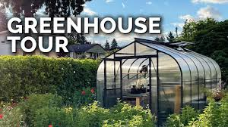

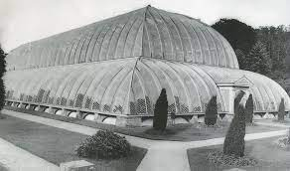

**GREENHOUSE TOUR SUNDAY APRIL 13 12:30 PM (earlier than usual)**

**You guessed it! That is MY greenhouse (in my dreams…) Actually, it is the Great Conservatory of the 19th Century collector the Duke of Devonshire. They say Queen Victoria drove her carriage right through the front door. We won’t visit THIS growing area, but we will visit some you might possibly be able to afford. At any rate, you will certainly get some great growing ideas.**

(**I GROW IN MY GARAGE UNDER LED LIGHTS) WE WILL HAVE A GREENHOUSE TOUR STARTING AT 12:30 PM AT CHERYL AND TERRY SEGO’S HOUSE WHERE THEY GROW UNDER LED LIGHTS (AND WE WILL HAVE HORS D’OEUVRES) AND THEN ON TO DAN MUMAU’S GREENHOUSE WHICH IS SUNK INTO THE GROUND and HAVE A POTTING DEMO (AND THEN WE WILL HAVE A MAIN DISH AND SALAD) AND THEN ON TO MY GARAGE GROWING AREA (AND DESSERT ) MY HUSBAND THINKS IT IS FUNNY THAT THE GREENHOUSE TOUR INCLUDES FOOD, BUT I DON’T KNOW WHY THAT IS FUNNY… IT IS DELICIOUS!**

**EACH OF US WILL TELL YOU HOW WE BUILT OUR GREENHOUSES OR GROWING AREAS**

**12:30 PM Home of CHERYL AND TERRY SAGO**

**6916 Hawaiian Sky Ct. 702-373-5150 Appetizers at 12:30 Earlybirds are welcome! It is on the 215 and N Decatur. Enter the tract on Lotus Flower. Orchids Cactus Garden Collectibles Tea Pots And Guy Stuff! Wood Shop Hot Wheels 100 year old Model T & * Grow Light Information!**

**Tour and hors d’oeuvres**



**Click on the PDF to see all their information and cute file.**

**Followed by Home of Dan Mumau 9647 Rainfall Avenue 89147**

**702-362-5251It is located midway between Ft Apache and Grand Canyon off of Spring Mt Road. If you are heading west on Spring Mt from Ft Apache, this would be your second left. The connecting street is called Manor Oak. You’ll turn left onto Manor Oak and then right on Rainfall Ave. He is the last house on the left hand side in the cul de sac.**

**Tour and main dish and dalad**

**Followed by Home of Carol Siegel 8601 Robinson Ridge Drive**

**89117 702-525-3714 I live in Canyon Gate Country Club between Durango and Ft Apache on Sahara going west. When you pass guard gate, make a right on Medalist and continue around. The street in a very short distance becomes Iron Ridge and then Robinson Ridge Drive. I am the first house on Robinson Ridge. I have shell doors. Please park on the side of the street where the houses are when you visit me. I have left your names at the guard gate. Say you are with the orchid society.**

**Tour and dessert**

**Cheryl and Dan do not have gated communities. I do, but I have gotten permission. Cheryl is first. Dan and I live fairly close to each other which is why we arranged it that way. Fun!**

BELOW IS A CHECKLIST TO BRING TO THE GREENHOUSE TOUR TO TAKE NOTES. DAN AND OLE WILL SPEAK ABOUT THE ITEMS BELOW.

CHECKLIST FOR OUR GREENHOUSE TOUR

As you go to each grower’s growing area, make sure you find out about all their tips for growing orchids. All growers have to solve the problem of how to provide light for their plants, how to water them, how to fertilize them and provide air movement, how to control temperature, how to provide humidity, how to provide shelving, and how to provide the correct medium for them. Fancy or modest, a growing area works because it provides these basic orchid needs. The following are questions that you might keep in mind to ask when visiting our members’ growing areas:

1.Why did you choose this kind of growing area? (greenhouse, sunroom, atrium, lights, windowsill, bathroom…)

2. How did you build it? What kind of material did you use? Why? Would you do it again? Did you do it yourself? Did you hire somebody? Who?

3. How do you provide and control light? Do you use shade cloth? Where do you put different plants to provide for high and low light? What lessons have you learned?

4. How do you control temperature? Do you have an evaporative cooler

5. What kind of shelving or tables do you use?

6. How do you provide humidity for your plants? What percentage are you able to provide?

7. How do you provide air movement? How important is this? 8.What kind of water do you use? (tap, deionized, r/o, bottled…)

How often do you water? How? (hose, sink,misting, automatic…) 9. What kind of medium do you grow in? How often do you change it? Do you vary your potting medium for different plants? 10. What kind of fertilizer do you use? How often? Do you add any other kind of supplement (oyster shells, calcium, etc.)

11. How do you control pests?

12. What kind of orchids are you most successful with? Why is that? Are there any you have trouble growing. Why?

13. Where do you like to buy your orchids?

**EPIPACTIS GIGANTEA**

**At the end of April or beginning of May, depending on when this native orchid is in bloom, (we will notify you as soon as Mother Nature tells us…), MARK ROMANSKY WILL LEAD US ON A WALK IN CALICO BASIN IN RED ROCK TO SEE OUR NATIVE ORCHID EPIPACTIS GIGANTEA GROWING RIGHT HERE IN THE DESERT. MARK IS A WONDERFUL, KNOWLEDGEABLE MAN, AND WE TREASURE HIM. MEMBERS SAW THOUSANDS IN THE SHADE OF THE RED ROCK. HEAVEN. THE ROUND TRIP WALK TAKES ABOUT AN HOUR AND IS A MODERATE WALK. BRING SNEAKERS, WATER, A HAT AND A CAMERA OR PHONE.**

**The orchids are very showy with a beautiful erect stem with lots of burgundy and apricot flowers up and down the stem. They love water and grow against the gorgeous red sandstone rocks, moistened by springs that wet the base of the rock. They are deciduous and disappear in winter, but reappear every spring by the thousands. They are found all over- western North America, western Canada, central Mexico and are the most abundant orchid of the Pacific coast of North America. They are called the “Chatterbox Orchid” because there lips wave in the breeze, attracting their syrphid fly pollinator which we actually saw carrying pollinia. A terrestrial orchid (growing in the ground), it forms big clumps, making a gorgeous display.** 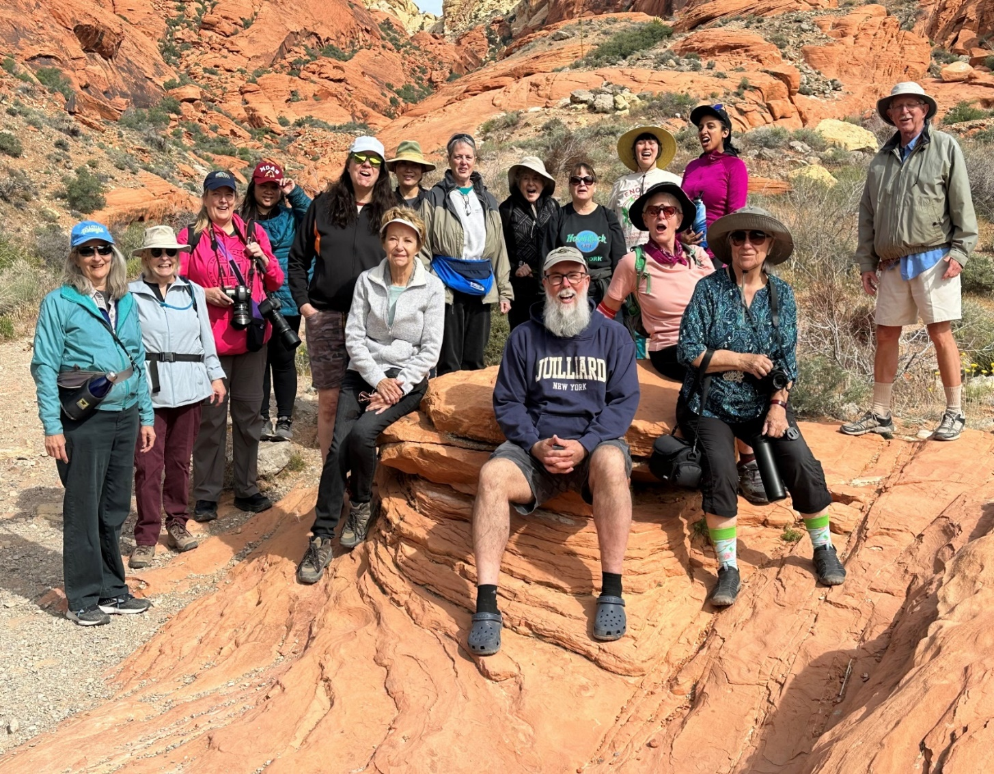

**IF YOU CONTINUE ON, I HAVE WRITTEN A SILLY LITTLE POEM ABOUT MY ORCHID ADDICTION BELOW.**



CONFESSIONS OF AN ORCHID ADDICT

Carol Siegel

I have a secret, and I’m really ashamed

I lust after every orchid that’s ever been named.

You’d never know it to look in my eyes

That I’m an addict would be a surprise.

I don’t have to kick coke or give up the booze

(Though I do find the weight a little difficult to lose).

Please don’t judge me too hard or look down your nose

It’s much easier to happen than you’d ever suppose.

I am embarrassed to tell you I’m just on the skids

I am totally, completely hooked on orchids.

It started so slowly what led to my woes

I was just food shopping at Trader Joe’s

I was turning a corner and some flowers caught my eye

I had to have one or surely I would die.

“What’s one little orchid; it just cost twelve bucks!”

And now they deliver orchids in great big trucks.

I sit at my computer in the dark of night

I order from nurseries from last to first light.

My wallet is flat, and my bills are high

You should, my friends, hear my husband sigh.

Normally honest as Abe, I’ve become a liar

As the credit card bill goes higher and higher.

“Orchids Ltd. sells chicken and crackers and such

I really don’t ever buy orchids that much.

They call it Cal Orchid but they really sell shoes

Oh, honey it’s really much better than booze.”

The boxes are sneaked into the garage by dark

I have so many orchids I can no longer park

On garbage day my lawn is filled with Styrofoam

That blew out of boxes when no one was home.

The cartons they sit in a pile mountain high

A very large reminder of all the orchids I buy.

It isn’t just orchids but orchid dishes and books

Orchid shirts and pictures and bathroom hooks.

I am starting to speak Latin although I can’t find my keys

And I even like native orchids you discover on your knees.

I take trips to see orchids that grow far away

And when I spy them growing it just makes my day.

I tried very hard to achieve orchid sobriety

So I went and joined an orchid society

I told the president I heard he could help

He laughed so hard he gave out a yelp.

“Oh, sweetie, forget it, it’s never been done

Nobody gives up orchids, absolutely no one.

You can beat the booze and surely stop smoking

But if they say you’ll quit orchids surely they are joking.

And now I am the society president

And I know now just what he meant.

So all you other addicts and hopeless afficionados

Just enjoy the addiction and meet at some shows!