RESETTING A DECODER:
Decoders can lose their information for a number of reasons. Resolution: – re-program with the ultimate re-programming being to reset the decoder to its factory settings. All decoders that are NMRA compliant can be re-set even though it is not set out as a NMRA Standard. This is far quicker, simpler and easier than trying to determine which individual CV is at fault.
Use the following chart to reset your decoder.
MANUFACTURER | ID | CV NUMBER  FOR RESET | VALUE FOR RESET | NOTES
DIGITRAX | 129 | CV 8 | 8
LENZ | 99 | CV 8 | 33
LOKSOUND (ESU) | 151 | CV 8 | 8
MRC (old) | 143 | CV |  | Generally, not reliable in Read Back
MRC (new) | 143 | CV 125 | 1 | Generally, not reliable in Read Back
NCE | 11 | CV 8 | 2
SOUNDTRAXX  OLDER | 141 | CV 8 | 2
SOUNDTRAXX  NEW | 141 | CV 8 | 8
TRAIN CONTROL SYSTEM | 153 | CV 8 | 8 | Alternatively use
 |  | CV 30 | 2
QSI | 113 |  |  | SEE BELOW
To reset QSI decoders:
1. Place locomotive on main track if it is responding to its address; if not use programming track. 2. Follow three steps - Set CV 49 = 128, Set CV 50 = 255, Set CV 56 = 113.
NOTES: 1) most likely will require “Power Pax” or a PTB (Programming Track Booster).
2) When decoder resets, locomotive will emit 3 whistle/horn blasts.
3) Refer to manual for selective resets.
Notes: 1. Some decoders can be reset by using “Programming on the Main”, as long as you can receive responses (lights, whistle/horn) from the address. If not, then use your programming track.
2. A reset to factory values will clear all altered CV values.
3. In all cases after a reset to factory values, the locomotive should respond to address “3”. Users can only read the Manufacturer’s ID in CV8, not the value you might enter.
4. Sound decoders generally require a PTB.
5. Some decoder resets require track power to be cycled “off”, and then “on” to complete.
6. A successful reset might be indicated by the locomotive twitching during the process, emitting a clicking sound, blowing its whistle/horn, flashing its lights or even offering a verbal comment.
7. Re-program using your documented values.
PROGRAMMING TRACK: A requirement for every model railway.
For mobile decoders, it's easiest to have a portion of your model railway double as a programing track. Locate your programming track near your programming device, i.e. Command Station or Computer. For simplicity, make it a part of the model railway’s trackage to minimize handling of locomotives. It can be on your modelling bench BUT ideally a track in the locomotive service area will be its best location. This allows driving a locomotive to the programming section, to read or change values stored in its decoder.
DISADVANTAGES: (Not in any specific order)
1) Must be made and installed. (research, understanding, time, doing, tools, parts)
2) Generally, increases the cost of the DCC system. (DPDT toggle switch)
3) Locomotives must be moved to this for programming. (time, effort)
4) Locomotives must return to main trackage to test/confirm motor operation or functions. (time, patience)
ADVANTAGES: (Not in any specific order)
- Decoder inrush current is not an issue.
- You do not need to know the decoders address to program it.
2) You can read any CV valued for verification and/or documentation.
3) An “OFF” position in the programming track wiring, allows locomotives to be placed there without damage.
4) Programming occurs in an electrically safe environment (<12V, 0.025 mA) with no short-circuit risk of damaging the decoder.
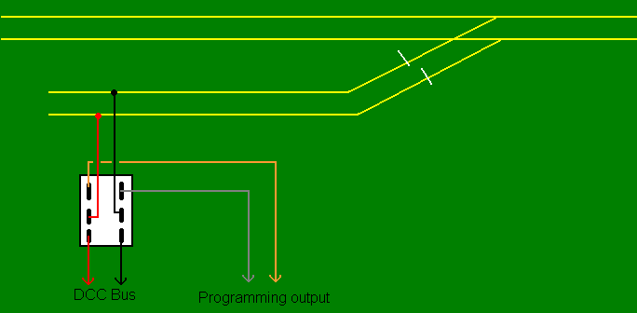
PROGRAMMING TRACK WIRING
ABSOLUTE ISOLATION

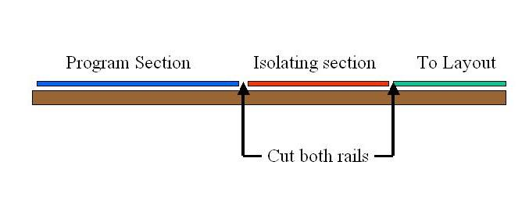

Programming Track Booster: If attempts to program a decoder result in a non-responsive decoder or unwanted changes, a Programming Track Booster (PTB) may be needed. This usually is an issue with sound-equipped decoders which require more voltage during programming but it works well for non-sound decoders. It is connected between the command station/booster and the programming track per the manufacturer’s instructions – Read!!
The sole purpose of a PTB is to make this task more reliable. A PTB will not solve problems created by the user during installation. It may offer short-circuit protection as well as basic diagnostics. There is a possibility of feedback to aid in the troubleshooting of problematic decoders. It may not be needed depending on the DCC brank/model of decoder chosen. The device will be recommended by the decoder manufacturer when there can be difficulties programming a particular decoder. Consult the decoder and PTB manufacturer or your dealer to determine if this device will help.

