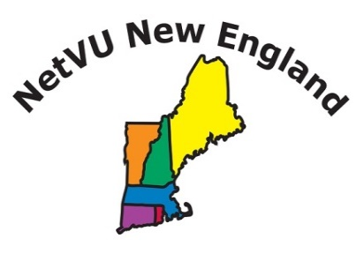
Sponsor Registration
2019 Fall Conference
Red Jacket Mountain View Resort & Water Park
2251 White Mountain Hwy Route 16
North Conway NH 03860

When: | October 27th – 29th, 2019
Where: | Red Jacket Mountain View Resort & Water Park  800-752-2538  Get our special room rate by saying you are attending NetVU  http://www.redjacketresorts.com
Sponsorships:  Co- Sponsorship – Meet & Greet Reception or Dinner  Co-Sponsorship -- Lunch  Co-Sponsorship -- Breakfast  Vendor  Friend of NetVU New England | - 1 Trade Area Table  2 Free Registrations  - Sponsorship of Sunday’s Meet & Greet Reception  - Signage at registration desk (all sponsors)  - 1 Trade Area Table  - 2 Free Registrations  - Sponsorship of the luncheons (not exclusive)  - Signage at registration desk (all sponsors)  - 1 Trade Area Table  - 2 Free Registrations  - Sponsorship of breakfasts (not exclusive)  - Signage at registration desk (all sponsors)  - 1 Trade Area Table  - 1 Free Registration  - Signage at registration desk (all sponsors)  - Added to Sponsorship list you still must register to attend  Additional Attendees from your company at $350 per person | $3000  $2500  $1500  $750  Any  Amount
Attendees: | We expect over 100 attendees. All sponsors will receive contact information for attendees in electronic format prior to and after the conference.
Publications: | Your company name and logo, will be displayed throughout the conference area.

There will be a trade area located in the Lobby and vendors can sponsor a table in that area. You will be able to have signage on that table showing you as sponsor. Although there will be no pipe and draping, the vendor is free to use their table as they want.

Sponsors/Vendors will each have time to introduce their product during the conference to encourage attendees to visit their tables and/or participate in any door prizes they want to donate for Tuesday’s closing ceremony.

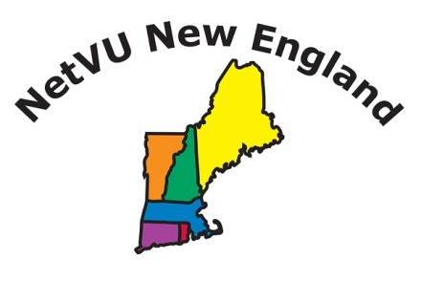
2019 SPONSOR REGISTRATION

Company: ___________________________________________________________________________________
Address: ____________________________________________________________________________________
Phone __________________________________ | Fax ______________________________________________
Contact Name _____________________________ | E-mail ____________________________________________
Sponsorship Opportunities (see previous page for descriptions)
Co-Sponsor Dinner (includes 2 registrations) | $ 3,000.00 | $ ________
Co-Sponsor Lunch (includes 2 registrations) | $ 2,500.00 | $ ________
Co-Sponsor Breakfast (includes 2 registrations) | $ 1,500.00 | $ ________
Vendor (includes 1 registration)  Friend of NetVU NE Our sincere thanks! | $ 750.00  $ your donation amt | $ ________  $ ________
 | Total Due | $ ________
Additional Attendees $350.00
Logo and Description: Please email your logo along with a 75 word description of your products or services to be included in the website to pealahan@rileyinsurance.com.

Attendee(s):

Name _____________________________ E-mail ____________________ Badge Name ___________________

Name _____________________________ E-mail ____________________ Badge Name ___________________

Name _____________________________ E-mail ____________________ Badge Name ___________________

TO REGISTER Mail or email Registration Form with Check made payable to NetVU New England or Credit Card Payment to:

Riley Insurance Agency
Attn: Peggy
P O Box 659
Brunswick ME 04011
pealahan@rileyinsurance.com

PAYMENT INFORMATION
Check Enclosed $__________

