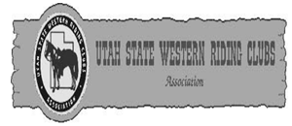

UTAH STATE WESTERN RIDING CLUBS
RULE BOOK

MEMBERSHIP BOOKLET
2017, 2018, 2019, 2020

______________________
CLUB

______________________
MEMBER

TABLE OF CONTENTS
Introduction Page 1
Setting up Clubs Page 1
Shows Page 2
General Information Page 3
Grand Entry Page 3
General Rules Page 3
Glossary Page 7
Judged Events Page 8
Parades Page 9
Drills Page 10
Western Pleasure Page 10
Pairs' Pleasure Page 11
Ranch Cow Cutting Page 11
Reining Page 12
(Pattern #7) Page 13
(Pattern #8) Page 13
(Pattern #9) Page 13
(Pattern #10) Page 13
Timed Cattle Events Page 13
Team Penning Page 14
Wild Cow Milking Page 15
Chute Events Page 15
Breakaway Roping Page 16
Tie Down Roping Page 16
Ribbon Pull Page 17
Team Roping Page 17
Arena Speed Events Page 18
Hide Race Page 19
5 In A Row Page 19
Potato Race Page 20
Team Barrels Page 21
Single Barrels Page 21
Water Race Page 22
Pony Express Relay Page 22
Team Pole Bending Page 23
Single Pole Bending Page 23
Team Keyhole Page 23
Single Keyhole Page 24
Trailer Race Page 24
(Diagrams for Specified Events) Page 25
Pole Bending Page 26
Keyhole Page 26
Team Penning Page 27
Barrels Page 27
REINING PATTERN #3 - 2017 Page 29
REINING PATTERN #4 - 2018 Page 30
REINING PATTERN #5 - 2019 Page 31
REINING PATTERN #6 - 2020 Page 32

UTAH STATE WESTERN RIDING CLUBS ASSOCIATION
The Utah State Western Riding Club Association was founded in January 1948. The purpose of the club is
- To promote the interest and love of all people for the horse, and particularly the western riding horse.
- To teach all club members and the public different ways to enjoy the riding horse.
- To promote civic interest in the western type saddle horse among members.
- To conduct and manage shows, parades, and exhibitions connected to the western type saddle horse.
- To provide enjoyment and amusement for club members and the general public. The State will be divided into Regions. Regions divided into Districts. Districts will be composed of riding clubs.
The State annual meeting will be held the second
Tuesday in January at a place to be selected by the Board of Directors. This is the time and new officers for the coming year will be elected. Each District will elect two (2) directors to represent them on the Board of Directors. Those directors are to vote as their District dictates on all matters pertaining to running of the State Organization.
It is the Directors' and club presidents' responsibilities to make sure all horses, members and teams adhere to the rules, which include qualifying in the Grand Entry, Parade, or Post Parade. Unless otherwise stated in the rulebook, violations of the rules will result in a disqualification. The officers and directors of the U.S.W.R.C.A. have printed this book which sets forth the rules of the U.S.W.R.C.A. for all events in 2017, 2018, 2019, and 2020. These rules are to be used by judges, stewards, and club members as written with no changes for individuals or clubs without the approval of the Board of Directors.
Members will have the opportunity to participate in three (3) shows per year.
Riding Clubs: The steps to set up a club
- Solicit members. There is no minimum number for members, but many events require three (3) or more members. There are two types of members: riding and non-riding. Riding members must pay USWRCA state dues and are eligible to participate in USWRCA riding competitions (district, region, and state

-1-
competitions). Non-riding members must be
included on the roster, but they do not have to pay state dues nor are they able to participate in USWRCA riding competitions. They are eligible to participate in non-riding competitions (civic awards) though.
- Elect officers
- Look on the USWRCA website (www.uswrca.com),
- Contact a member from your area or the State
- Secretary to receive a new club application. Be voted into a District.
- District directors will bring the new club application, plus the required club fee, to the State Directors' meeting for acceptance.
- Club names may be chosen by the members. Club colors should also be selected. A club number will be assigned by the State Secretary.
Active club members in good standing who are 15 years old on or before June 1 of the current year may represent their club in any team or individual event at the U.S.W.R.C.A. shows. A club roster must be submitted and all dues for the U.S.W.R.C.A must be paid to the State by the second Tuesday in June. Changes or additions to the club roster may be made from the second Tuesday in June to July 31, but each change or addition must be accompanied by a $10 fee. Club members may only belong to one (1) club at a time and may only represent the club they are a member of.
Horses used in any event must be 100% owned by an active club member of the same club on or before June 1 of the current year. (Leasing is not a form of ownership.) Any falsified ownership of horses may result in permanent expulsion of the involved member or members from the U.S.W.R.C.A. Horses may only be ridden to represent one (1) club.
District Show: Any U.S.W.R.C.A club may compete in their assigned District Show if the above qualifications are met.
Riders must qualify in the Parade or Grand Entry. Horses must be ridden by a club member. Any member of the club may ride another member's horse so long as that club member is a member of the U.S.W.R.C.A. Only two (2) teams from each club may enter the Region Show from the District Show. Only clubs/contestants that qualify to ride in parade may be allowed to participate in the event. No contestants may ride at the end of the parade or separate from their club.

-2-
It is the club presidents' and directors' responsibilities to make sure all horses, members and teams are legally substituted, not under 15, and are using legal equipment.
Region Show: Each District may enter only five (5) singles, pair, or teams in each event and one alternate.
Drill and Parade; however, will have three (3) teams entered from each Class with an alternate for each. Alternates should be available at meets in case of sickness or accident when given 72 hours notice. If the alternate did not receive 72 hours notice but is available and desires to ride, the announcer or show secretary must be notified before the event is over. That team may run last. Any contestant that fails to attend any show without giving 72 hours notice, or without a reasonable excuse, will be barred from that event the next year. State Directors will determine if the excuse is reasonable.
State Show: Locations for State meets shall be determined by the Board of Directors by the May meeting. As often as possible, the meet will be held in the President's region. The working order at the state competition will be President's Region first and past president's Region second. Each Region may enter only nine (9) teams in each event and one alternate. Drill and Parade will enter five (5) teams and an alternate from each class. Individuals, Teams and Alternates will be governed under the same rules as the Region Show.
WE SINCERELY HOPE THAT FAIRNESS AND GOOD SPORTSMANSHIP WILL PREVAIL, AND A GOOD TIME WILL BE HAD BY ALL.

GENERAL INFORMATION

GRAND ENTRY:
A Grand Entry will be held at all shows (District, Region, and State). It will not be judged. All riders must be qualified (see glossary) by riding in the Grand Entry or Parade at least once during any show. No one may ride in the Grand Entry double, without a saddle, or leading a horse. All riders must be listed on the official State roster to be inside the arena
GENERAL RULES:
- When the National Anthem is being played, all club flags shall be dipped as courtesy to our nation's flag.
Hats should be removed. (see United States Flag
Etiquette.)

-3-
- Integrity of the Event: The intent of each event will be maintained as listed in events rules. There will be no creative interpretation of the rules of an event or giving one team an advantage over the other teams. Any creative interpretation of the rules will be considered a gimmick and not allowed.
- If an event is added to the program, an event must be dropped from the program.
- It will be the direct responsibility of each club president to see that all of the riders in his/her club are qualified.
- All steward and timers must be instructed and have watches checked before the start of each show.
- Unless otherwise stated in the rulebook, violations of the rules will result in a disqualification.
- Those entering the competition area must be on a club roster and adhere to the dress code.
- Dress Code:
a. All members that enter the arena must wear long or short sleeved (not sleeveless), western shirt with snaps or buttons up the front. It must have a collar or collar stand. Queen-style or slinky tops are not acceptable western wear. No tee shirts, sweat shirts or golf-styled shirts will be allowed. b. Long pants are required.
  - Cowboy boots are preferred; however, any western style footwear will be allowed as long as it is designed for riding and has a heel.
  - It is mandatory for men to wear a western hat in all timed events, but will not be required for women. Participants, both men and women, may wear safety helmets during any speed event as a safety issue in lieu of western hats. No ball caps or sun visors will be allowed except in the hide race. The board of directors has voted “sombreros” are a type of western hat.
  - Hats that fall off during a timed event should not be picked up until after all teams in the arena have finished running. Hats should be retrieved by a member of the team that lost it.

-4-
- One member of each team must wear a club number on their back. All contestants in single events must wear a club number or number assigned by the show secretary. Numbers must be at least 1/2-inch wide on a 4x6 inch contrasting background or on a club vest or shirt. No A or B will be required at shows. But may be listed in the program to avoid confusion if a club has two teams in an event. Parade and Drill teams will NOT be penalized for not displaying the club number.
- A member may be disqualified or banned for unsportsmanlike conduct.
- A member may be disqualified or banned for any inhumane treatment or cruelty to an animal, such as raw or bleeding sores on the horse's head or mouth from a bit or hackamore.
- A local vet's name and telephone number will be published in the programs of Region and State Shows.
- Sponsors shall be allowed at Region and State Shows only if they have paid the money as an official sponsor of the U.S.W.R.C.A to the secretary. Clubs may still sell tickets for special drawings for their clubs or districts.
- Awards will be handed out after the event is over and if no protest has been filed.
- Protest: A protest must be filed with the officials before the start of the next event to allow winners to be chosen and awards handed out. The protest must be presented by the club president or District director to the head steward or show chairperson.
Protests must be accompanied by a fee of $75. If the protest is sustained in favor of the protestant, the fee is returned. If the protest is denied, the fee is kept by the association.
- In case of any foul or show provided equipment problem, the team must pull up immediately and ask for a rerun. If contestants continue and go through completion for any event, no protest may be filed.
- Everyone in every event will get a time regardless of a disqualification if they finish the event. This will be in case a protest is filed by any participant.

-5-
- All contestants and/or horses may only be entered in an event one time.
- A club will be allowed to substitute up to 50% on any team; however, in single-horse events or Pairs' Pleasure, the horse may not be substituted.
- If the baton is dropped while passing it, a team member must dismount, pick up the baton, remount the horse, then pass the baton to the next rider on the team. If the baton is dropped during the ride, the rider must dismount, pick up the baton and continue through the pattern.
- A broken pattern in any event, except reining, will be a disqualification.
- Equipment failure in any event that requires the team to leave the arena will be a disqualification. No time or rerun will be given.
- Gates will be closed when all teams are in the arena and remain closed until the last person of all teams has finished the event. Gates will remain closed during all single events.
- Rakes or harrows shall be available at each show and used to assure the best arena conditions.
- In case an event is not filled with qualified teams, there will be a draw for remaining teams. Fast times or partial catches will be considered first. Points for High Point Awards will not be given for any drawn positions.
- State and Region High Point Awards will be awarded to the high point Man, Woman, Horse, and Club of each Competition. High Point Civic Awards will only be awarded at the State level.
It will be the responsibility of the club or district
secretary to fill out the form provided by the State Secretary for the high point civic award and file it with the State Secretary two weeks prior to the state competition. Failure to file the required form will result in the points not being considered for the award.
- The following formula will be used for high point woman, man, horse and club: 1st place= 6 points,2nd place=5 points; 3rd place=4 points, 4th place =3 points; 5th place=2 points; 6th place= 1 point

-6-
- The following formula will be used for high point civic awards: one point for every $5.00 in money or materials donated, every 5 miles traveled to approved functions, and/or 1 hour of time served. 5 points will be awarded to a club for each event attended. Please see official form to be filed with the secretary for further details.
- These points shall be tallied and awarded for each individual Region and State Show. District points will not be applied to the High Point Man, Woman, Horse, and Club for the State Trophies.
d. If a club member is riding another member's horse, the owner of the horse concedes the points to the rider of the horse. (All points go to the rider of the horse, with the exception of High Point Horse points.)
27. There will be no major rule changes made between rulebooks unless it is a safety issue.
Note: When a judge/steward is in doubt of any penalty or infraction, and if it is not clearly stated in the rule book, the benefit shall always be given to the contestant or team.
Note: In roping, speed events and team penning, western type equipment must be used. The hackamore is the optional choice of the contestant; however, the judge/steward may prohibit the use of equipment they consider severe.

GLOSSARY: Descriptions and Clarifications
- Baton: An object not to exceed 12 inches in length and that has no knobs. Batons shall be furnished for all State and Region shows and shall be any color.
- Closed Reins: Both ends of the rein attached to the bit, such as a roping rein.
- Curb Bit: A bit that has shanks. Works with leverage and a curb chain/strap or curb action. It may have a solid or broken mouth piece.
- Gimmick: A novel or tricky feature or detail that is added to, or incorporated within, something to increase its attractiveness or effectiveness. Glitter is not considered a gimmick.
- Hackamore: A flexible braided rawhide or leather or rope bosal with a core of rawhide or flexible cable. Absolutely no rigid material or metal will be permitted under the jaw.

-7-
- Mecate reins: A form of rope, with a tail or lead line, used for closed reins usually with snaffle bit or hackamore.
- Mounted: To get on a horse and be ready to ride.
- Qualify: Riders must ride once in a Grand Entry or Parade. Any member of a club may ride another member's horse as long as that club member is on the roster of the U.S.W.R.C.A.
- Regalia: Emblems, symbols, tack, equipment, dress, etc. pertaining to a club or organization...
- Romal: An extension of braided material attached to closed reins. Romal reins are held with no finger between the reins.
- Snaffle Bit: A bit that has no shanks. It may have a broken or solid mouthpiece. Snaffle bits work with no leverage, only direct pull. The mouthpiece will be round, oval or egg shaped smooth, unwrapped metal. An optional chin strap may be attached below the reins.
- Steward: A person who is chosen to oversee the rules and regulations of the race or event are followed. All stewards must be on the roster.
- Western Bridle: Headstall will be of western type such as split ear or brow band with a curb bit. (For detailed explanation of western equipment see Rule 443 in the AQHA handbook.)
- Moderate extension of a jog: A slight lengthening of the stride of the horse. The rider must remain seated.

JUDGED EVENTS
(Unless otherwise stated in the rulebook, violations of the written rules will result in a disqualification.)
It is recommended that whenever possible judges be picked from the Judges' Roster of the U.S.W.R.C.A unless approved by the Board of Directors. All judges should adhere to the rules and regulations of the U.S.W.R.C.A. At all times, when judging a show, judges must act in a professional manner in regards to dress and conduct. Score cards for all judged events should be posted after each class. If a judge has reason to believe a horse is unsound in any way, it is his/her duty to dismiss the horse from the class and not place them.
Protests may not be filed pertaining to a judge’s decision when placing contestants.

-8-
Exhibitors and assistants in Western Pleasure, Pairs Pleasure, Reining, and Ranch Cow Cutting, must wear long pants, long sleeve shirt, western hat and cowboy boots. The board of directors has voted “sombreros” are a type of western hat. Chaps are mandatory in Pleasure classes. Horses ridden in Western Pleasure, Pairs' Pleasure, Reining, and Ranch Cow Cutting will be ridden with a western saddle and appropriate western bridle, snaffle bit or hackamore (see glossary). Exhibitors and assistants horses in these events may not be ridden with martingales, draw reins, tie downs, cavessons, or mechanical hackamores.
- A western bridle is ridden with one hand using either split or Romal reins. The hand must be around the reins with the index finger only between the split reins. When using Romal reins, the hand must be around the reins with no fingers between the reins.
- The snaffle bit may be ridden with split or Mecate reins using one or two hands.
- The hackamore may be ridden with split or Mecate reins using one or two hands.
- Protective boots, leg wraps, and bandages may be used in Reining and Ranch Cow Cutting but not in Pleasure classes.
Note: Judges sheets will be reviewed each year at the judges clinic. Judges sheets will be posted each year on the USWRCA website prior to the District, Region and State shows.

PARADE
There will be two (2) classes. Class A will be eleven (11) members and up. Class B will be ten (10) members or less. U.S. Flags will be counted in the Parade Class (see U.S. Flag Etiquette. There will be no backward movement as a group in any of the parade maneuvers. Teams without enough members may compete if no alternate exists or is present. They may not place above any team that has the correct number of members. Parade will be judged on the following:
- Appearance: Riders, horses and tack clean and in good working order (show shape). Uniformity in dress and tack is a plus.
- Conduct: Riders and horses should show good, safe manners during the parade route. Maneuvers should show correct spacing, alignment, and a coordination with flowing movements.

-9-

DRILLS
Drills will be classified in the same manner as the Parade Classes. All riders in the arena will be counted. U.S. Flags will be counted in the Drill, but must be posted at the beginning of the Drill and may only be un-posted at the completion of the Drill (see U.S. Flag Etiquette).

The time is not to exceed ten (10) minutes. The time will start when the first horse enters the arena and end when the last horse leaves the arena. At eight (8) minutes a two minute warning will be given by the announcer. Teams will be given two (2) minutes to clear the arena or be disqualified. Drill teams must be available at the time they are scheduled. Teams without enough members may compete if no alternate exists or is present. They may not place above any team that has the correct number of members.
Drills will be judged on the following:
- Appearance: Riders, horses, and tack clean and in good working order (show shape). Uniformity in dress and tack is a plus.
- Degree of Difficulty: A team that performs a more difficult drill should receive more credit than a team that performs relatively easy maneuvers. Difficulty is determined not only by the difficulty of the maneuver itself, but also by the speed (trot/lope) at which it is ridden and the spacing between the riders during the maneuver.
- Precision Performance: Maintaining consistent spacing, showing symmetry and definition during each maneuver. A drill should flow from one maneuver to another with liveliness and energy that compliments the music and the variety of patterns. Riders should be alert to prevent collisions, crooked lines, broken gaits, non-round corners, etc.

WESTERN PLEASURE (Ladies and Men's)
Horses are to be shown at a walk, jog, and lope in both directions of the arena on a reasonably loose rein with light contact and control. A “moderate extension” of a jog may be asked for in at least one direction. Riders should sit at the “moderate extension.” Passing is permissible and

-10-
should not be penalized as long as the horse maintains a proper and even cadence and rhythm. Horse should back easily and stand quietly. Horses may be reversed at a walk or jog only. Credit should be given to the flowing, balanced and willing horse that gives the appearance of being fit and a pleasure to ride while exhibiting correct gaits when called for with smooth transitions. Horses should carry their heads in a natural, relaxed position. Riders will not be asked to dismount except for appropriate equipment checks.

PAIRS' PLEASURE
Western Pleasure rules shall apply to this class.
Horses will be shown in the same manner as outlined in
Western Pleasure, and after the rail work will be asked to: Ride out of line, dismount, drop at least one rein per rider, and step at least three (3) full steps in front of their horses.
Return and mount then back into line. Horses should stand and back quietly. Horses painted to match will be disqualified. Horses may not be substituted in this class. Equipment used should match (i.e., both horses in western bridles, snaffle bits, or hackamores).

RANCH COW CUTTING
Ranch Cutting is designed to show the ability of the horse and rider to enter a herd of cattle and make a cut. The horse should work quietly but alertly, causing very little disturbance to the herd or the animal brought out to work. Ranch cutting will be judged using U.S.W.R.C.A Rules, following the general rules of NCHA and NRCHA where applicable. The score card to be used will be the U.S.W.R.C.A Score Card as amended in 2009. An average score will be seventy (70). One half points are permissible. There will a 2 ½ -minute time limit. When a judge is in doubt about a penalty, the benefit should always go to the contestant. Panels or fences will be used in the ranch cow cutting event.
Credit and Deductions:
Credits or Deductions may be given for the following categories of a run's content: driving an animal a sufficient distance from the herd, holding it in a working position as near the center of the arena as possible, the degree of difficulty, eye appeal, the courage shown in staying on a tough cow, the amount of time actually spent working cattle, the horse showing 'cow' and the horse showing a great deal of expression, loose reins, horse charging, and excessive herd holder help.

-11-
Penalties:
One (1) Point Penalties: One (1) point penalties-losing working advantage, noise directed to cattle. “Toe”, foot, or stirrup on the shoulder.
Three (3) point penalties: Hot quit, second hand on reins if a curb bit is used, cattle picked up or scattered, spur in shoulder, pawing or biting cattle failure to make a deep cut, back fence.
Five (5) point penalties: Horse quitting a cow, losing a cow, changing cattle after a specific commitment, failure to separate a single animal after leaving the herd. Disqualification score of zero (0) :
Horse turns tail or falls to the ground. Illegal equipment. Leaving working area before time expires.

REINING
To rein a horse is not only to guide him, but also to control his every movement. The best reined horse should be willingly guided or controlled with little or no apparent resistance. Any movement on his own must be considered a lack of control.
Credit should be given for smoothness, finesse, attitude, quickness in performing various maneuvers, while using controlled speed. The official guideline for the application of the rules for judging shall be as specified in the NRHA Handbook (Judges' Guide). Contestants will be penalized but not disqualified for breaking a pattern. The score will be on a basis of 0 to infinity with 70 denoting an average performance. The individual maneuvers are scored in ½ point increments from low of -1 ½ (extremely poor quality) to a high + 1 ½ (excellent quality) with a score of 0 denoting a maneuver that is correct with no degree of difficulty. U.S.W.R.C.A permits the judge the option of awarding a re-ride to any contestant who is unable to compete a pattern for reasons that are out of the rider's control.
*Penalties - Please see NRHA Handbook. Examples of penalties are:
Half (½) point penalties: Delayed change of lead per one stride, jog more than 2 strides, under or over spinning 1/8 of turn, failure to be on correct lead for ½ or less than one turn at the end of the arena, failure to be at least 20 feet from wall or fence.
One (1) Point Penalties: Over spinning ¼ spin, out of lead for each quarter of the circle; this is cumulative, out of lead at the turn at the end of the arena for more than ½ turn.

-12-

Two (2) Point Penalties: Breaking gait, freezing up in spins or rollbacks, failure to stop or walk before executing a canter departure, not completely passing specified marker before initiating a maneuver, off lead completely around the turn at the end of the arena. Five (5) Point Penalties: Spurring in front of cinch, holding saddle with either hand, blatant disobedience, use of either hand to instill fear or praise, failure to follow the pattern, five (5) point penalty for each “omission” or “inclusion” of maneuvers. Failure to complete the pattern as written, inclusion of maneuvers not specified in pattern.
No Score will include but not be limited to: Abuse of animal, illegal equipment, fall to the ground by horse or rider, equipment failure that delays completion of the pattern.

YEAR 2017: REINING PATTERN #7 (See diagram on page 29)
YEAR 2018: REINING PATTERN #8 (See diagram on page 30)
YEAR 2019: REINING PATTERN #9 (See diagram on page 31)
YEAR 2020: REINING PATTERN #10
(See diagram on page 32)

TIMED CATTLE EVENTS
(Unless otherwise stated in the rulebook, violations of the written rules will result in disqualification.) There will be no rough treatment of stock. Judges can disqualify and give any contestant or team a “No Time” if it is believed any action on the competitor's part to be unnecessary roughness to the cattle. If the arena director or other official observes or becomes knowledgeable of an unfit or injured animal(s), the director or official has the responsibility to immediately have the animal(s) removed. “Immediately” may be defined as stopping a run in progress to help avoid further injury to the animal(s) or competitor(s). Only the director or judge has the authority to determine what an unfit and/or injured animal is.

-13-

TEAM PENNING
Set Up: A foul line will be set at the half-way point in the arena. A “pen” will be created approximately 75% of the distance from the cattle end of the arena. The pen will ideally use one 8-foot panel, two 16-foot panels, and two 24-foot panels. The side of the pen that is closest to the cattle will be the 16-foot panel, and be connected to the two 24-foot panels. The side furthest from the cattle will have an 8-foot panel on one side with a 16-foot wing on the other which is swung open. The opening will be 10 feet.
Cattle will be numbered in sets of three. The number assigned to each team to pen will be drawn and held as confidential prior to the beginning of the contest. A foul-line judge, pen judge, and timer and announcer are required for this event.
Rules: Within a 90-second time limit, a team of three (3) riders must cut from the herd and pen three head of cattle with the same assigned number. The fastest time with the most cattle penned will win. A warning must be given to the team working the cattle when there are thirty (30) seconds remaining.
All cattle will be bunched on the cattle side of the foul-line within the designated area before time begins. The Foul-Line Judge will raise the flag to signal when the arena is ready. Contestants will be given their cattle number when the nose of the first horse crosses the foul/start line. Time will be taken from the Foul Line Judge's signal that the first horse's nose has crossed the foul line until the pen judge's signal that the contestants have finished their run. To call for time, one rider must be at the pen gate and raise a hand for the flag. Flag will drop when the nose of the first horse enters the pen and the rider calls for time. However, the flag will not drop and time will continue if there are un-penned cattle that are not on the herd side of the foul line. In this case, time will be taken when the Foul Line Judge signals that all un-penned cattle are on the herd side of the foul-line.
In the event that an animal escapes from the pen after time is called for, but prior to the time any un-penned cattle are on the herd side of the line, the team will be given a “no time”. An “escaped animal” is one with any part of the animal out of the pen. A team may call for time with only one or two assigned cattle in the pen; however, teams penning three head will place higher than a team with two penned cattle, and those with two

-14-

penned cattle place higher than a team with one penned calf regardless of the time. A team calling for time with wrong numbered cattle in the pen will be judged a “No time”.
If five or more head of cattle are across the start/foul line at the same time, the team will be scored a “No Time”. Sixty (60) seconds after the last member of a team finishing leaves the arena, the following team must be in the arena ready to ride. Any delay will be judged a “No Time” unless waived for a good cause. As each new team begins a run, there should be the same number of cattle in the arena.
In the event that a team draws a number where there are less than three identical numbers in the arena, a team is given a number that has already been used, or other official or mechanical error, a rerun shall be given. Reruns shall be run at the end of the group. If more than one rerun is necessary, they will run in the order of occurrence. The fall of horse or rider shall not eliminate the entry; however, any attempt by a dismounted rider to work cattle before remounting will result in automatic disqualification.
(see diagram on page 27)

WILD COW MILKING
Set Up: Teams shall consist of one mounted roper and one mugger. Muggers and ropers will be on one side of starting line with the cattle on the other side.
Rules: Within a two minute time period, the roper must milk the cow he/she roped that is being held by his/her own mugger. Roper must rope the cow before it is mugged. Time will be taken from the signal to start to when the roper enters the finish circle. To qualify for a time, at least one drop of milk must run out of the end of the bottle.
Cattle are not assigned. There must be as many cows as teams in the arena. The cow must be milked standing up, and the rope must be free of the saddle and horse before milking or team will be disqualified. If the cows are to be used in more than one section of this event, it is mandatory that they rest between sections. District competitions may tie a ribbon on the tail of cow in lieu of milking, but Region and State shows shall have wet cows.

CHUTE EVENTS

BREAKAWAY ROPING, TIE DOWN ROPING
RIBBON PULL & TEAM ROPING
Stock will be chute run: A mechanical barrier or electric eye barrier will be used in all chute events.

-15-
If a mechanical barrier is used, the neck rope must be tied with string. No metal snaps or hardware shall be used on neck ropes. Suggested score length is the
length of the roping box minus four (4) feet, but may vary depending upon condition of the arena and cattle. After called for, cattle belong to the contestant come what may, except: (1) if an animal escapes the arena, the flag will be dropped and the contestant(s) will get the animal back “lap and tap”, with time added from when the stock left the arena; or (2) in case of mechanical failure or if a contestant is fouled by the barrier. The contestant must pull up and declare it to receive a rerun.
A ten (10) second penalty will be added to the competitor's time for beating the barrier. The barrier judge has the right to add a ten (10) second penalty any time the barrier is beaten, such as a horse rearing up over barrier. If the barrier fails to work or the pigtail is carried more than to (10) feet from the pin, there is no rerun. The penalty will be taken off, unless the contestant obviously beat the barrier. This decision will be made by the barrier judge or flagger.
BREAKAWAY ROPING
Set up: Timer, Flagger, Barrier Judge, String, Barrier Rules: Breakaway is open to both men and women. Within a thirty (30) second time limit, contestant will come from behind the barrier to rope the calf. Time will be taken from the trip of the barrier to the flagger's signal that the rope has broken free from the horn. Rope must be released from the hand and not just placed out to snag the calf. Any catch is legal as long as the rope goes over the head. “Over the head” is defined as both ears and the nose. Rope must be tied with a string supplied by the show management to the saddle horn. If the contestant breaks the string, a “No Time” will be given.
A long white flag provided by the roper must be attached to the end of the rope. The rope may not be run through the bridle, tie down, neck rope or any other device.
No Loops can be rebuilt, but a roper can use two loops if two ropes are carried.
TIE DOWN ROPING
Set Up: Timer, Flagger with a stopwatch, 2 people to untie calves, Barrier Judge, Barrier
Rules: The rope must be tied hard and fast, not dallied. Within a sixty (60) second time limit, contestant will come from behind the barrier to rope

-16-
the calf, dismount, throw calf by hand and tie any three (3) feet with at least one (1) or more wraps and a half hitch. Time will be taken from the trip of the barrier to the flagger's signal that the roper is finished.
If the calf is down when the roper reaches it, the calf must be let to its feet and thrown by hand. If roper's hand is on the calf when the calf falls, the calf is considered “thrown by hand”. Catch as catch can, but rope must hold calf until roper gets hand on calf. Three (3) legs must remain tied for six (6) seconds, as timed by the flagger from the time the rope horse takes his first step forward after the roper has remounted until approved by the flagger. If calf gets up before the six (6) seconds elapse, a “No Time” will be given. Roper must not touch calf or take rope off calf after signaling they are finished until after the judge has completed his examination. Rope must remain slack until flagger approves the tie. In the event a contestant's catch rope is off the calf, the six (6) seconds starts when roper clears the calf. Flagger must watch calf during the six (6) second period and will stop the watch when a calf kicks free, using the time shown on the watch to determine whether calf was tied long enough to qualify. No loops can be rebuilt, but a roper can use two loops if two ropes are carried. The calves must weigh between 200 and 300 pounds each.

RIBBON PULL
Set Up: Timer, Flagger, Barrier Judge, Barrier, Ribbons Rules: Within a twenty (20) second time limit, contestant will come from behind the barrier with the help of a hazer and capture a two (2) foot long ribbon, glued from the middle with a one (1) foot streamer on each side, to the middle of the back of the cattle. Time will be taken from the trip of the barrier to the flagger's signal that the ribbon has been captured. A full ribbon is not required to qualify a run.
In case the ribbon prematurely comes loose, the contestant must pull up and not continue in order to qualify for a rerun

TEAM ROPING
Set Up: Timer, Flagger, Barrier Judge, Barrier Rules: Within a sixty (60) second time limit, one team member shall rope the head of the steer, dally, and pull the steer for his partner to rope the hind legs. Time will be taken from the trip of the barrier to the flagger's signal that the steer is roped, and both horses are facing the steer in line with both ropes tight. The team member coming from behind the barrier must throw the first rope.

-17-
There are only three (3) legal head catches, (1) around both horns; (2) around one horn and the nose; and (3) around both horns and nose. If rope bridles the steer, Hondo passes over a horn, or the loop crosses itself, the head catch is illegal and results in a “No Time”. If steer is roped by one horn, roper is not allowed to ride up and remove the loop or put over the other horn or nose with his/her hands.
Any heel catch behind both shoulders is legal if the rope goes up the heels. If the heeler ropes a front foot or feet in the heel loop, this is a foul catch. Should the front foot or feet come out of the heel loop prior to the flagger calling for time, the time will be counted. If only one hind leg is caught, a five (5) second penalty will be added to the team's time. All questionable catches will be decided upon by the flagger.
Roping steers without turning loose of the loop will be considered a “No Time”. Dropped or broken ropes will be considered a “No Time” regardless of whether time has been taken or not. Each contestant will be allowed to carry only one rope. Each team will be allowed three (3) loops in all. A rope that must be recoiled or rebuilt is considered a thrown loop.
In case the flagger flags out a team that still legally has one or more loops coming, the flagger will give them the same steer back lap and tap.
Any heeler that is female or 55 years of age or older the day of the competition may tie on. Under no circumstances should a header tie on. U.S.W.R.C.A requires tie-on ropers to use a quick release for tied on ropes.

ARENA SPEED EVENTS

(Unless otherwise stated in the rulebook, violations of the written rules will result in a disqualification.)
Entrance and exit points for the single arena events shall be designated and all contestants in these events must enter and exit from the same designated gate as directed by show management.
All timed events will be timed from the nose of the first horse to the nose of the last horse both at the starting and finish lines. If any part of two (2) horses is across the starting line at the same time, the team will be assessed a five (5) second penalty.
Poles are to be used as markers at the start and finish line, except in the Pole Bending event, when barrels will be used as markers. Markers must be 30 feet apart if arena conditions permit.

-18-
A five (5) second penalty will be imposed upon a contestant each time he uses the baton, dipper or potato spear to hit the horse in an arena event. There will be no penalty for steadying a barrel or pole in either single or team events.

HIDE RACE
Set Up: Hides for all the Region and State meets will be furnished by U.S.W.R.C.A. Hide, timers, barrel. The rope attached to the hide must be twenty-five (25) feet long with a knot tied at twenty (20) feet from the hide. The dally must be on the short end above the knot tied at the twenty (20) foot mark. An eighteen (18) inch length of rope is to be firmly tied on each side of the two (2) holes made in the top edge of the hide to the drag rope. The drag rope will be a regulation lasso (roping) rope. The hide shall not have a board or pipe attached to it at any place or in any fashion.
Note: A cow hide should be used if available. If no hide is available a rug or mat may be used.
Rules: This is a two (2) person team event, one (1) on horseback and one (1) on foot. The rider will dally the rope that is tied to a hide and pull it to the other end of the arena where the person on foot is standing behind the barrel. There will be a minimum of seventy (70) feet from the fence to the starting line. There will be two hundred (200) feet between the starting line and barrel, if arena conditions permit. The starting poles, or orange cones, will be set at the edges of the arena. As the horse goes around the barrel, the person on foot must make an attempt to ride the hide.
If the person on foot is successful in catching the rope or hide, he/she must be off his/her feet in a prone position before going past the barrel to the finish line or be disqualified. The hide rider may hold any part of the rope or hide. If the barrel is tipped over, the team will be disqualified. The hide rider will be allowed to wear any type of hat, coveralls and glove, if he/she wishes. A hard hat and goggles are suggested. If the rope is dropped by the puller, it will be a disqualification. One team will run at a time. Time will be taken from the nose of the horse both at starting and finish lines, but the rider and hide must cross the finish line or be disqualified.

5 IN A ROW
Set Up: Six (6) poles, Four (4) poles for the patterns and two (2) for the starting line. Three (3) barrels.
Rules: Team is comprised of 5 members. Each member will run the event simultaneously. (Nose to tail). There will be no baton used in this event. Team members must run the entire event in the same order they start. No team member may pass another member.

-19-
Riders will start the pattern on the right or left side of the poles. Riders will weave past all four (4) poles and proceed around all three (3) barrels. (You will not circle each barrel). After running a triangle around all three (3) barrels, riders will weave back through all 4 poles. The final rider will circle the last pole before proceeding to cross the finish line.
A five (5) second penalty will be given for each pole or barrel that is knocked over. (Riders will not dismount to reset a knocked over pole or barrel).
Poles are set using the same standard as pole bending. Twenty (20) feet to the first pole and twenty one (21) feet between poles.
The barrels are set at the end of the poles in the same manner as barrels are set up. The barrel pattern will be set using a forty (40) foot pattern if the arena permits. The barrel pattern will be set forty (40) feet from the end pole.
(see diagram on page 28)

POTATO RACE
Set Up: Two (2) small barrels per team, poles for starting line, potato stick (spear) per team, twelve (12) potatoes per barrel, extra potatoes to replace the used potatoes, timers.
Rules: This is a five (5) person team event with all riders starting behind the starting line. Two (2) metal barrels, with the inside of each painted white, fifteen (15) inches in diameter and not to exceed twenty-seven (27) inches high shall be used. The receiving barrel should be twenty (20) feet from the starting line, and the holding barrel, containing twelve (12) potatoes should be one hundred (100) feet from the receiving barrel, if arena conditions permit. The barrel places will be marked for resetting if they are tipped over. If the barrel is tipped over, the rider must dismount, set it up and pick up any spilled potatoes before remounting and continuing on.
Smooth spears with no barbs are to be used. Spears may be made from wood or metal and may be any length desired. A potato from the holding barrel is to be speared and deposited in the receiving barrel. The same potato that was speared must be used to complete the run. The spear is passed to the next person behind the starting line. If the potato being deposited breaks, the contestant must spear the bigger part of the potato while still mounted and put it in the receiving barrel. Potatoes will be dumped from the receiving barrel after each team has finished the race, and new potatoes will be used for each team.

-20-

TEAM BARREL RACE
Set Up: Three (3) standard barrels, poles for starting line, timers.
Rules: The barrel race is a five (5) member team. A regulation baton is to be carried and passed to each team member. Standard barrels of metal or plastic will be used. The first barrel will be marked sixty (60) feet in a straight line from the starting line and will not be changed. Barrels will be marked at ninety (90) feet between barrels when arena conditions permit. If distances must be changed they will be dropped by fifteen (15) foot increments. Contestants are allowed a running start. They will run barrel number one (1), pass to the left of it, and complete an approximate 360 degree turn around it; then to barrel number two (2), pass to the right of it, and complete a slightly more than 360 degree turn around it, then go to barrel number three (3), pass to the right of it, and do an approximate 360 degree turn around it, then sprint to the finish line, passing between barrels number one (1) and two (2).This barrel course may also be run starting at barrel number two (2) passing to the right, then barrel number one (1) passing to the left, then to barrel number (3) passing to the left and making the turn around the barrel and back toward the finish line. (A right turn and two (2) lefts, or a left turn and two (2) rights). There will be no penalty for a rider reaching out to steady a barrel. If a barrel is knocked over, the rider must go back to the barrel, dismount, set up the barrel, go back around the barrel, and continue the pattern. If the baton is dropped either during the run or while passing, the rider must dismount, pick up the baton, remount and pass the baton to the next team member.
(see diagram #2 on page 27)

SINGLE BARRELS
Set Up: Three (3) standard barrels, poles for starting line, electric timer (if available), timers (if electric timer not available)
Rules: This is a single event for ladies and men. An electric timer will be used if at all possible. The same timers and stewards will be used for each runner. The same regulations and patterns will be used as in the team barrel race, except a five (5) second penalty will be given for a barrel knocked over. There will be no penalty for steadying a barrel. Contestant need not get off and set up a tumbled barrel.

-21-

WATER RACE
Set Up: Dippers for Region and State shows will be furnished by U.S.W.R.C.A. One (1) uniform sized dipper for each team. Dippers must be used as received. One (1) water stand, 5 ½ feet tall topped with one (1) wide-mouth quart jar, and one (1) ten (10) quart bucket of colored water per team. Extra colored water to refill buckets as needed, poles for starting line, lime to mark foul line for bucket horse, timers.
There shall be no bending the handles of the dippers. There will be five (5) members on a team. The starting line will be twenty (20) feet from the bottle stand. There is a 6 minute time limit on this event. If a team is not finished within 6 minutes they will not continue and will receive a no time.
Rules: One person on the team holds the bucket full of colored water on his/her horse behind a line marked one hundred twenty (120) feet from the starting line. If the contestant holding the bucket (or his/her horse) crosses the line, the team will be given a five (5) second penalty for each time the line is crossed. There will be no penalty for steadying the water stand. The other four (4) members on the team ride one at a time from the starting line with the dipper to the bucket where they will fill the dipper with water to fill the jar. A steward will signal when the rider's water fills the jar, and time will be taken when that horse's nose crosses the finish line.

PONY EXPRESS RELAY RACE
Set Up: One (1) saddle (no saddle pad) will be placed in a four (4) foot diameter circle twenty (20) feet from the starting line. A barrel will be placed one hundred twenty (120) feet from the starting line. Poles for starting line, lime to mark the barrel's spot, timers.
Rules: A five (5) member team with five (5) horses having on bridles and any type of reins will make up this event. The horse is to be led by reins or rein attached to the bit or hackamore. Each contestant will lead his/her horse from behind the starting line to the circle, saddle the horse, mount, ride around the barrel placed one hundred twenty (120) feet from the starting line, ride back to the circle, dismount, unsaddle, and place most of the saddle inside the circle. The horse will then be led back across the starting line. If the next contestant crosses the starting line before the preceding horse has completely crossed back across the starting line, a five (5) second penalty will be assessed. Cinch must be fastened in the regular manner and a quick buckle may be used.

-22-

Absolutely no gimmicks may be used. There shall be no touching of another team member's horse, if so a five (5) second penalty will be assessed. A five (5) second penalty will be given if barrel is knocked over. If the barrel is displaced, the team must continue on by going around the place that marked the barrel's spot.

TEAM POLE BENDING
Set Up: There will be six (6) poles in a straight line. Poles must be standard white plastic poles 1 ¼ to 1 ½ inches in diameter with bases less than fifteen (15) inches in diameter. Poles must be six (6) feet high. The first pole will be placed twenty (20) feet from the starting line. All other poles will be twenty-one (21) feet apart. Barrels will be used to mark the starting line. Lime to mark each pole's spot, batons, timers.
Rules: A team of five (5) horses and riders will compete in this event. Each rider may start on either side of the first pole and run the horse to the number six (6) pole, turn and bend back through the poles, pivot the number one (1) pole and bend back to the number six (6) pole, pivot and race back straight to the finish line. The rider must pass the baton to the next rider. There will be no penalty for reaching out with hand or arm to steady a teetering pole. If a rider knocks over the pole, he/she must dismount, set up the pole, go back around the pole and continue on through the pattern. If the baton is dropped either during the run or while passing, the rider must dismount, pick up the baton, and remount before completing the pattern or passing to the next team member.
(see diagram #3 on page 26)

SINGLE POLE BENDING
Set Up: An electric timer will be used if at all possible. Rules: The single pole bending will be the same rules as for team pole bending, except a five (5) second penalty will be given for each pole knocked over. The rider does not need to dismount and reset knocked over poles. All timers and stewards will be the same for all riders in this event.

TEAM KEYHOLE RACE
Set Up: Lime, tape measure, or measuring jig, timers, extra stewards. The keyhole will have the following dimensions: The center of the circle will be one hundred (100) feet from the starting line. The diameter of the circle will be twenty (20) feet. The width of the neck is six (6) feet with the length of the lane ten (10) feet. The outline of the keyhole will be marked with white powder (lime).

-23-
Rules: This is a five (5) member team event. Each rider will ride their horse from the starting line through the neck into the interior of the keyhole, execute a turn to the right or left, return back across the starting line. The rider will then pass the baton to the next member of the team. There will be a five (5) second penalty for each foot of the horse that steps on or over any line marking the keyhole with a maximum of four (4) feet (20 seconds) per horse. However, a rider will not be penalized to come back in the circle and finish the pattern. If the baton is dropped the rider must dismount, pick it up, remount and pass it to the next person.
(see diagram #4 on page 26)

SINGLE KEYHOLE RACE
Rules: This is a single event for ladies and men. An electric timer will be used if at all possible. The same timers and stewards will be used for each runner. The same regulations and patterns will be used as in the team keyhole race.
TRAILER RACE (No Gimmicks are to be used) Set Up: Four (4) barrels to mark the corners, timers, extra timer and stewards. Any type of horse trailer is to be brought into the center of the arena behind any type of truck. The same trailer may be used in more than one (1) heat. There may not be anything in the trailer (i.e., hay. Grain, tack, tools, etc). The back of the trailer must face the grandstand. A saddle, blanket, and bridle are to be in the back of the truck. The truck need not be empty, but the saddle, blanket and bridle may not be propped up or set on top of anything. It must be on the floor of the bed of the truck.
Rules: The horse may be loaded in the trailer and hauled into the arena or led into the arena and loaded into the trailer after the trailer is lined up. *As long as the horse is facing in the right direction for the type of trailer it will be considered facing forward. (Standing straight forward in a straight load trailer or standing sideways in a slant load trailer.) If the horse’s body turns in another direction, it will be considered as not facing forward in the trailer. A horse may look around in any direction as long as it’s body remains forward. * A horse may or may not be tied at the start or end of the race per the contestant’s discretion. The trailer gate must be securely latched in such a way that it could not swing open if the trailer was being pulled down the road.

-24-
When in the trailer, the horse can wear any type of commercial or handmade halter, but no gimmicks. The horse must be facing forward in the trailer when race is started.
The two (2) team members must be in the truck cab with the doors closed. At the “go” signal, the contestants must take the horse from the trailer, remove the halter, saddle and bridle the horse. The bit attached to the bridle must be in the horse's mouth. A chin strap is optional. No neck rope may be used. A saddle blanket must be used but must not be attached to the saddle. Cinch must be fastened in the regular manner and a quick buckle may be used. One (1) person must ride one (1) time around the arena counter clockwise on the outside of the four (4) corner barrels. These four (4) barrels will be set at the corners of the trailers and will not be moved until all the heats have finished. No penalties will be issued for knocking over a barrel, but runners must continue to go around the spot where the barrel was set. After completing the circle, the horse will be unsaddled, the bridle taken off, and the halter replaced. The horse is then to be reloaded in the trailer and the trailer gate securely latched. The saddle, blanket and bridle must be put back on the bare floor of the bed of the truck. Each piece of equipment outside or hanging outside the bed of the truck will receive a five (5) second penalty with a maximum of fifteen (15) seconds per team. The contestants must reenter the truck cab, close the doors and turn on the lights. They must stay in the truck until a steward has inspected the trailer, the horse, and the equipment. Leaving the truck before the steward gives the “okay” will be disqualification.

-25-
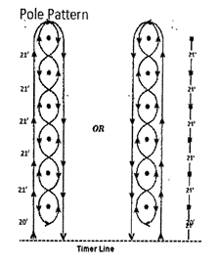
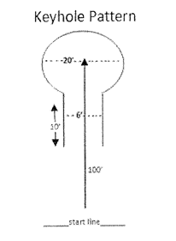
-26-
Team Penning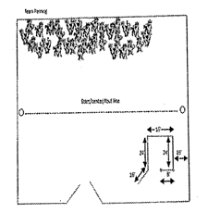

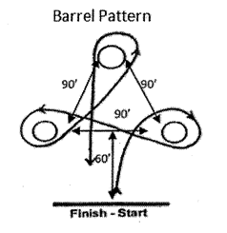

-27-
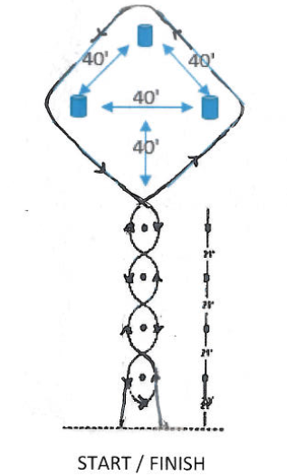

-28-
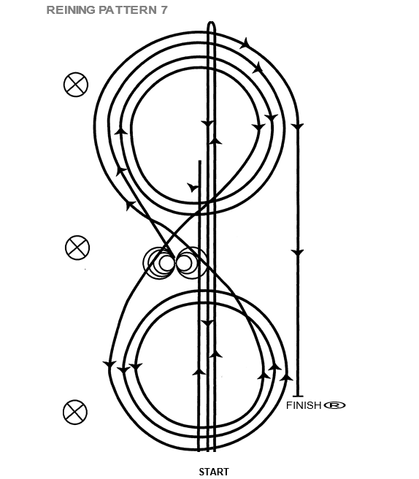
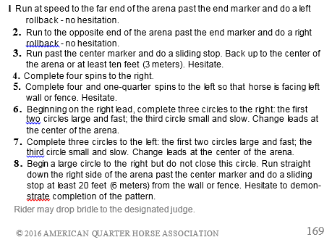
-29-
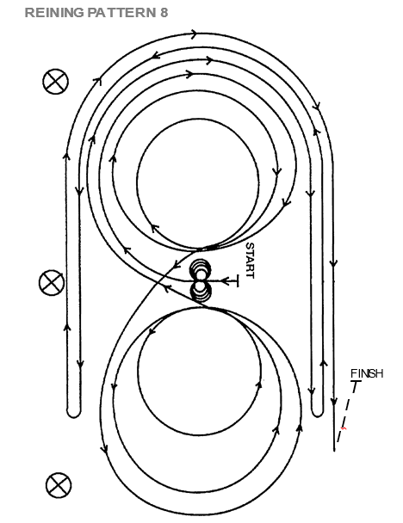
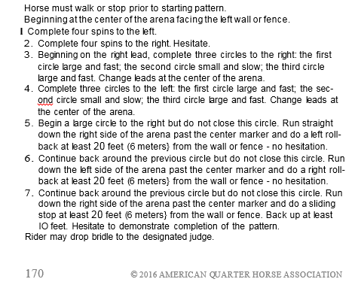
-30-
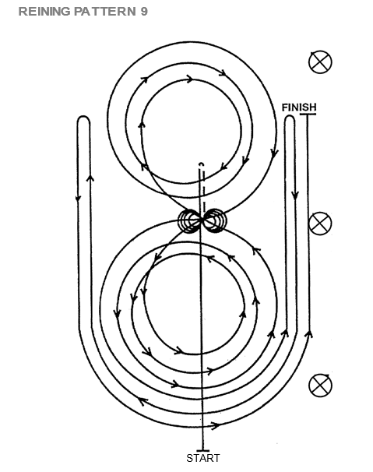
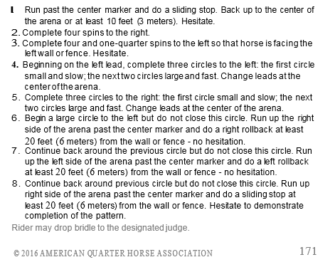
-31-
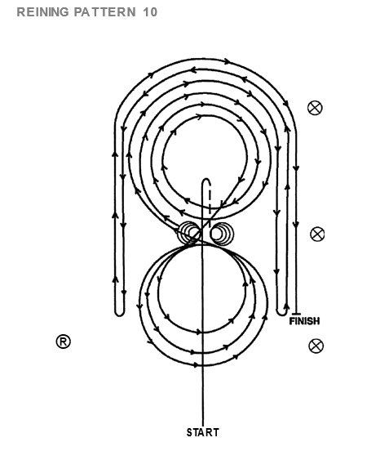
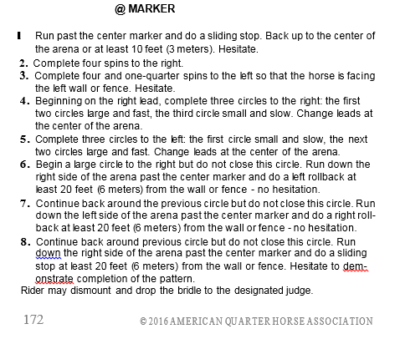
-32-
UTAH STATE WESTERN RIDING CLUBS ASSOCIATION
The Utah State Western Riding Club Association was founded in January 1948. The purpose of the club is
- To promote the interest and love of all people for the horse, and particularly the western riding horse.
- To teach all club members and the public different ways to enjoy the riding horse.
- To promote civic interest in the western type saddle horse among members.
- To conduct and manage shows, parades, and exhibitions connected to the western type saddle horse.
- To provide enjoyment and amusement for club members and the general public. The State will be divided into Regions. Regions divided into Districts. Districts will be composed of riding clubs.

WE SINCERELY HOPE THAT FAIRNESS AND GOOD SPORTSMANSHIP WILL PREVAIL, AND A GOOD TIME WILL BE HAD BY ALL.

