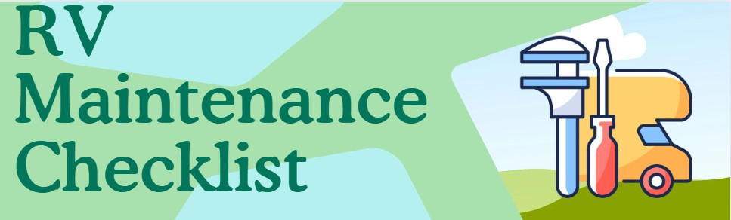The Ultimate RV Maintenance Checklist: Keep Your Rig Roaring!
Whether you're an RV newbie or a seasoned road warrior, keeping your rig in top shape can feel like navigating a maze. Fear not! This guide is here to turn your maintenance routine into a well-oiled machine, and maybe even a bit of fun. Let’s dive in and keep that RV rolling smoothly!

Before Every Trip: Your Pre-Adventure Ritual
Before you embark on your epic journey, give your RV and tow vehicle a little TLC with these essential checks:
- Check Truck Oil, Transmission & Brake Fluid
Keep your truck’s insides as happy as its outsides. A little oil and fluid check goes a long way in preventing “Oops, the engine died!” moments.
- Set Truck Tire Pressure
Inflate those truck tires like you’re preparing for a marathon. Proper pressure = safer rides and fewer pit stops.
- Set RV Tire Pressure
Make sure your RV tires are puffed up like they’ve had a triple espresso. Proper inflation means fewer blowouts and smoother sailing.
- Inspect Tire Condition
Give your tires the once-over. If they’re looking worn out or have acquired any unsightly bulges, it might be time for a swap.
- Ensure TPMS (Tire Pressure Monitoring System) is Active
Check that your TPMS is on the job, because you don't want your tires going rogue without a warning.
- Lubricate Hitch
Give that hitch a little loving with some lubricant. A slick hitch is a happy hitch.
- Inspect Hitch Components
Make sure all hitch parts are in tip-top shape. You don’t want any surprises when you hit the road!
- Lubricate Pin
Make that pin slide in and out with ease. It’s like giving your RV a smooth dance partner.
- Check Springs, Shocks, and/or Suspension
If your RV’s suspension could use a pep talk, now’s the time. Inspect it to avoid any unwanted bouncing or swaying.
- Inspect Brake Lines and Wiring
Give your brake lines and wiring a quick checkup. Think of it as your RV’s way of saying, “Thank you for keeping me safe!”
- Check Brake Fluid Level
Keep an eye on brake fluid levels—because running out is not an option when you’re barreling down the highway.
- Inspect LPG Components
Check the propane system and remember to turn it off before you tackle tunnels or bridges. We don’t want any explosive surprises!
- Check 7-Pin Connector Connection and Truck/RV Lights and Signals
Ensure your 7-pin connector is snug, and all lights and signals are flashing like a Broadway show.

Monthly Maintenance (or Every 1000 Miles): Your Routine TLC
Every month (or after 1000 miles), give your RV some well-deserved pampering with these tasks:
- Check Smoke Detector
Test your smoke detector to ensure it’s on high alert. You don’t want it snoozing on the job.
- Check LPG Detector
Make sure the LPG detector is ready to sniff out any gas leaks. It’s your first line of defense against any sneaky fumes.
- Check Carbon Monoxide Detector
Confirm the carbon monoxide detector is active. It’s like having a superhero watching your back.
- Check Water System for Leaks
Inspect your water system to make sure it’s not turning your RV into a water park.
- Check Fire Extinguisher
Make sure your fire extinguisher is ready to go. After all, you want to be prepared, not panicked.
- Lubricate Jacks and Slide Rams
Keep your jacks and slide-outs moving smoothly. A little lubrication goes a long way for a seamless setup.
- Check Hydraulic System Fluid Level
Ensure the hydraulic fluid is at the right level. It’s like keeping your RV’s lifeblood in check.
- Check Generator Oil & Filter, and Run Generator
Change the generator oil and filter, then fire it up. It’s the generator’s way of saying, “I’m ready to power up your adventures!”
- Recondition Water Softener
Pamper your water softener to ensure it’s working its magic. Soft water is happy water.
- Clean Microwave and Dishwasher Filters
Give those filters a good clean. They’ll appreciate the attention, and you’ll get cleaner dishes!
- Lubricate Slide-Out and Window Seals
Keep those seals lubricated to avoid leaks and ensure everything slides in and out like butter.
- Check for Areas that Need Re-Caulking
Inspect for cracks that need re-caulking. Your RV’s way of staying dry and cozy.
- Clean A/C Filter and Air Returns
A clean A/C filter means cooler temperatures and less sneezing. Win-win!
- Check Pin Box Bolts (for Fifth Wheels)
Tighten those bolts like you’re fixing a wobbly table. A tight pin box means less jiggle.
- Check Roof Sealant for Cracks
Inspect the roof sealant for any cracks. Think of it as checking for leaks in your raincoat.
- Check for Loose Screws on Ladder, Trim Pieces, etc.
Tighten loose screws before they become big problems. A tight screw is a happy screw!
- Clean Solar Panels
Keep your solar panels spotless to ensure they soak up every ray of sunshine. Shine on!
- Check Breakaway Cable
Ensure the breakaway cable is in tip-top shape. It’s your safety net in case things go awry.
- Lubricate Gray and Black Tank Handles
Keep those handles lubed up for smooth operation. No one likes a sticky situation!
- Check Fridge Water Line for Leaks
Inspect the fridge water line to prevent any leaks. You want cold drinks, not puddles.

Quarterly Maintenance (Every 3 Months or 2500 Miles): Your RV’s Spa Day
Every three months (or after 2500 miles), give your RV a spa day with these essential tasks:
- Check Battery Cables and Terminals
Inspect and clean the battery cables. Keep them sparkling and connected for uninterrupted power.
- Sanitize Fresh Water Tank
Clean and sanitize your fresh water tank. Fresh, clean water is a must for all your adventures.
- Inspect/Clean Max Air Vents
Ensure your Max Air vents are clear and clean. Good ventilation means less stuffy air.
- Clean Interior Fridge Coils and Exterior Vents
Clean the fridge coils and vents. They’ll thank you with cool, fresh food.
- Clean Heat Vents
Keep the heat vents clean to avoid dusty blasts. A clean vent is a warm and cozy vent.
- Change Batteries for RV Door Lock
Replace the batteries in your RV door lock. Don’t get locked out of your own home!
- Check RV Tire Lug Nuts
Ensure lug nuts are tight. It’s like giving your tires a firm handshake.
- Lubricate Compartment and Door Locks
Apply some lube to keep locks smooth and easy. No more wrestling with stubborn doors!
- Check Brake Caliper Bolts Tight
Tighten brake caliper bolts. Your brakes will appreciate the extra attention.
- Check Cable Slides are Attached
Ensure cable slides are firmly attached. You don’t want any surprises when you extend your slides.
- Check Slideout Arm Brackets Tight
Tighten slideout arm brackets to prevent any wobbly moments. Stability is key!
- Check Spare Tire Pressure
Make sure your spare tire is properly inflated. It’s your backup plan in case of emergencies.
- Check for Signs of Water Intrusion or Soft Spots in Flooring
Inspect for any water damage or soft spots. Better to catch it early than deal with a soggy mess later.

Semi-Annual Maintenance (Every 6 Months or 5000 Miles): Your Rig’s Big Check-Up
Every six months (or after 5000 miles), perform these tasks to keep your RV in top shape:
- Inspect Wheel Bearings (Re-pack Every 10,000 Miles)
Check and re-pack wheel bearings to keep them rolling smoothly. It’s like giving your wheels a spa day!
- Clean Awning Fabric
Scrub your awning fabric to prevent mildew. A clean awning is a happy awning!
- Change Water Filters
Replace water filters to keep your water fresh and clean. No one likes a funky taste!
- Lubricate Axles
Apply some grease to the axles. Lubricated axles mean smoother rides.
- Lubricate Suspension
Keep the suspension system lubricated. It’ll keep your ride smooth and your RV’s bounce in check.

Annual Maintenance: The Big Reveal
Once a year, give your RV a comprehensive check-up with these tasks:
- Inspect Brakes, Suspension, Shocks
Do a thorough inspection of brakes, suspension, and shocks. It’s your RV’s way of saying, “Thanks for keeping me safe!”
- Check LPG System and Propane Regulator
Inspect the LPG system and regulator to ensure they’re in top shape

