**Topic: ______________________________________________________ Date: ____________________________**

**1. Ask as many questions as you can about the topic:**

* Do not stop to try to answer or judge the questions
* Write each question exactly as it comes to mind
* Change any thoughts or statements into questions

**2. Choose the three most important questions. Mark them with an X.**

**3. Find different types of questions:**

* *Closed-ended questions –* can be answered with “yes” or “no” or with one word.
* *Open-ended questions –* require an explanation.

**4. Practice changing questions to get different information. Change one of each:**

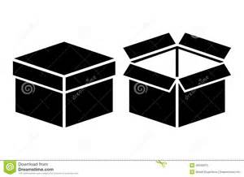

Open to Closed

Closed to Open



**5. Reflection**

|  |  |
| --- | --- |
| What did you learn? | How can you use it? |