ANNUAL MEETING

2019
The Manors of Deerwood HOA
Email: DeerwoodManors@gmail.com
Website: DeerwoodManor.com

TABLE OF CONTENTS
Annual Meeting Agenda 3
THE Manors HOA Members 4
Highlights 4
Financial Summary 4
Operating Highlights 4
Looking Ahead 4
FINANCIAL SUMMARY 5
FINANCIAL STATEMENTS 6
Statement of Financial Position (Balance Sheet) 6
Statement of Activity (Income Statement) 6
Top 3 Expenses for 2018 6
Account Receivables – Aging Summary 6
NOTES TO FINANCIAL STATEMENTS 7
A/R Aging Summary 7
Debt 7
Cash Flow 7
Going Concern 7
Takeaways 7

Annual Meeting Agenda

The Manors Annual HOA Meeting
Tuesday, December 10th, 7:30 PM - 9:00 PM at Independence Fire Department: 6500 Citation Dr, Village of Clarkston, MI 48346
Agenda:
- Call meeting to order
- President's Report: Review 2019
  - Entrances
  - Roads
  - Cul-de-sacs updated
  - Property Liens
- New Business
  - Review financials
  - Deerwood and Manors Agreement
  - Vote: Penalties for By-Law / Articles of Incorporation violations: $10 for non-compliance
  - Vote: VP and Treasurer, 2 yr. term, election
  - 2020 Projects:
    - Vote: Roads, Roads, Roads: Road Repair: To move forward with getting a quote, or patch again
    - Portable Speed Bumps
    - Cul-de-Sacs H2O / lighting improvement
- General Q & A
- Adjournment

THE Manors HOA Members

Highlights
2019 was the execution of last years issues. We have finally cleaned up the financials, all legal requirements, and landscaping. We also have entered into a new agreement with Deerwood on the joint front entrance. While the agreement is in place, execution of the first joint project, holiday lights, continues to be a work in progress.

Financial Summary
“Cash In” exceeded “Cash Out.” Large expenses included:
- New Entrance; back sub entrance
- Road Repairs

Operating Highlights
2019 was a relatively quiet year for the HOA. There were a couple of issues that took time to resolve. The biggest was a renegotiation of the agreement of financial responsibility between The Manors and Deerwood for the joint front entrance (Deer Ridge and M-15). Upon review of the signed agreement it was determined that Deerwood was not paying their share of the expenses. This resulted in me cancelling the existing Agreement. After working with their board and ours, over several months, we were able to come to a mutually equitable Agreement. For 2020 all expenses will be split 50/50. This should result in a couple of thousand dollars savings for The Manors each year. For the first part of 2019 we had turn-over in the Treasury position. Mark Gadley, volunteered to take on the responsibility and has done an outstanding job, thank you Mark.

Looking Ahead
2020 we will continue with the beautification of the sub, and policy enforcements. It is also the hope of the Board 2020 will be the year the HOA agrees to move forward with repaving the roads.
Charles Phyle II
President
12-10-2019

FINANCIAL SUMMARY

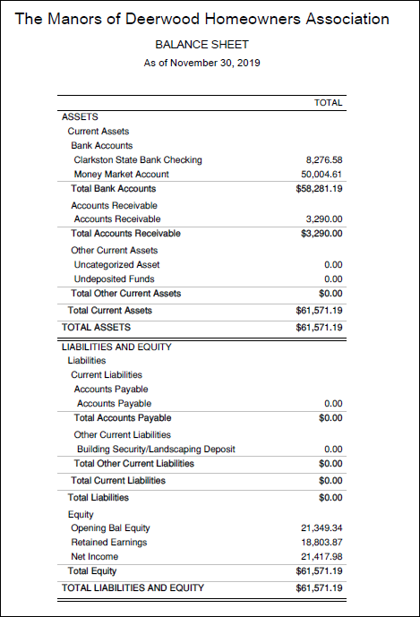
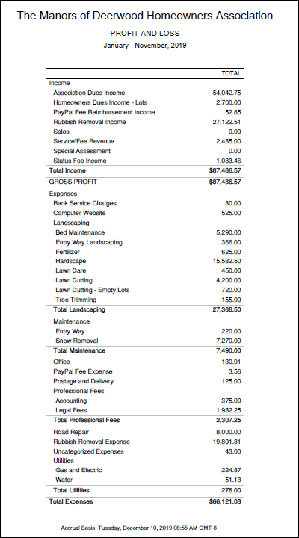
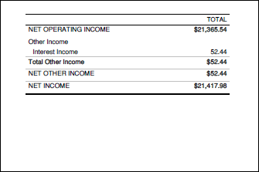

FINANCIAL STATEMENTS

Statement of Financial Position (Balance Sheet)
- Assets
- Liabilities
- Equity

Statement of Activity (Income Statement)
- Revenue
- Expenditures
- Other

Top 3 Expenses for 2019
Below are the top 3 expenses for 2019

DESCRIPTION | REVENUE | EXPENSES
Rubbish Removal |  | $19,801.81
Hardscape – Landscape Upgrades |  | $15,582.50
Road Repair |  | $8,000.00

Account Receivables – Aging Summary
- Homeowner Lot#243-Tillander Lot#316-Johnson
- Amount $1260.00 $1,290.00
- Days Past Due (285 days & 427 days) (285 days & 413 days)

NOTES TO FINANCIAL STATEMENTS

A/R Aging Summary
Actions have been taken to collect on the past due accounts. These actions include letter and Liens. Every attempt will continue to collect from the homeowners in a timely manner. Given we are an HOA, your help in letting the Past Due members know they have an outstanding balance would be helpful.

Debt
The HOA does not carry debt, beyond the terms of any service purchase (typically 30 days after the service has been rendered)
Cash Flow  Current cash flow in is sufficient for future maintenance and improvements (not including road repaving beyond minor repairs) | Going Concern  The roads have been repaired and the patches have a 2 yr. warranties, however, this is only a band aide and the other parts of the road will continue to need repairs. The day is fast approaching for the sub to have the roads repaved. The timeframe to pave roads in a 24-month process that needs to be started.  Takeaways  Our HOA fees should remain the same for 2020.
“Our HOA fees should remain as they are for 2020”

