Architectural Styles for Massachusetts Home Buyers

If you have been looking for a home in Massachusetts you may have noticed a number of different styles that appear on the landscape. Some architectural styles are more popular than others but, to be sure, there is something available for a range of tastes.

Here are some of the more popular home styles you will find in Massachusetts:

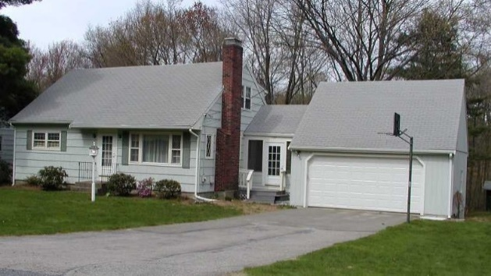
Cape - The Cape Cod is one of America's oldest house styles. It was a popular style through the 1840s and later experienced a revival when mass production techniques allowed builders to fill developments with capes after World War II. The cape is usually symmetrical in design. The roof is a steep gable type covered with shingles. Originally, capes were small in scale. Now, there are many large capes with additional wings and dormers to increase their useable space.
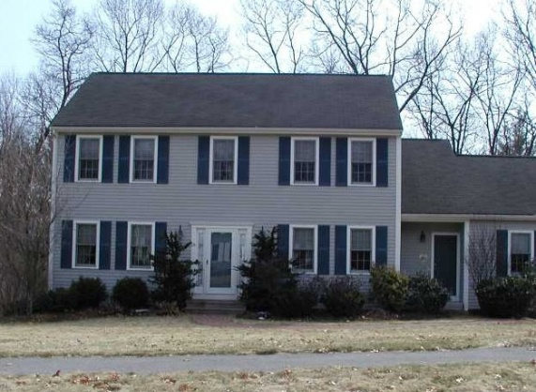
Colonial - The colonial is the most popular architectural style in the United States. It was developed in the 18th century which is considered the Colonial period. The original colonials were symmetrical with four equal sized rooms on the first floor and four rooms above. The basic colonial still has two windows on either side of a central doorway and five windows across the second floor. The floor plan for the standard colonial is a central hall with stairs, a living room to the left that is two rooms deep and a dining room on the opposite side with the kitchen behind it. All bedrooms are located upstairs.
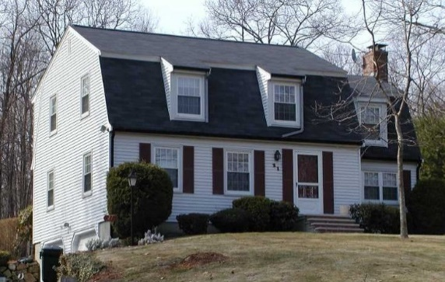
Gambrel - The gambrel has a ridged roof with two slopes on each side, the lower slope having the steeper pitch. The shape of the structure allows for a maximum of attic storage while still providing a weather tight roof. Because of the efficiency of storage the gambrel roof is often found on agricultural buildings as well as residential. The gambrel is thought to be attributable to the Dutch since Dutch colonials have a similar roof style.
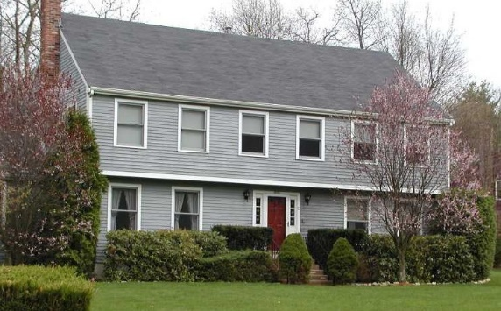
Garrison Colonial - It is widely-thought that the garrison colonial's style was influenced by colonial block houses that were used for protection against unfriendly Indians. The overhang section was there to provide a good vantage point from which to safeguard the house from intruders. Other historians dispute this and say that the style was taken from the popular Elizabethan townhouses of the period that were being built in the overcrowded cities of England. This was due to the fact that the overhang area created additional living space on the upper floors.
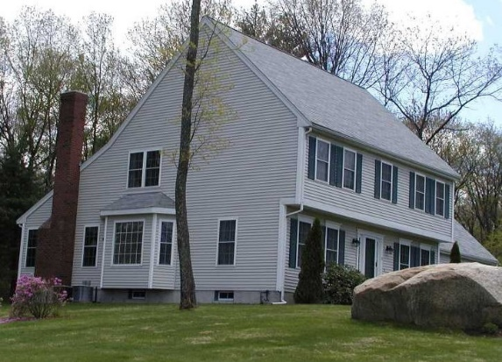
Saltbox - In 17th Century New England, adding a single-story lean-to shed to the back of a house was a clever way of increasing space. By the 18th Century, the lean-to was being built into the original construction. The hallmark of a Saltbox is the sharply sloping gable roof that resembles boxes which were used for storing salt in old country stores. The front of the house is a two-story structure while the back slopes down until it becomes one story.
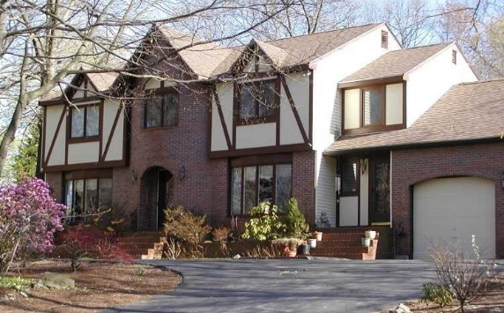
Tudor - The most distinctive feature of the Tudor house is called half-timbering. In this type of construction the actual framework of the house is left exposed and the space between the timbers is filled with brickwork or white stucco. This presents the appearance of what has sometimes been referred to as a "black and white house." Modern Tudor houses are often created using decorative woodwork that is, actually, false half-timbering. Other characteristics of the Tudor style are diamond-pane windows, steeply pitched roofs, Tudor arches and bay windows.
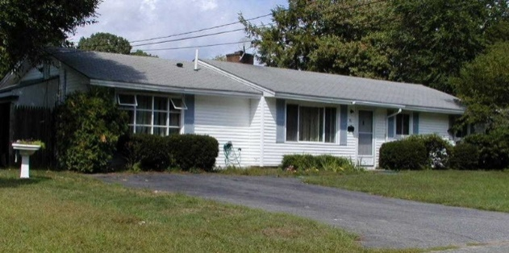
Ranch - The first ranch home was designed by Cliff May and was built in San Diego, California in 1932. The ranch style embraces the ability to move freely about, all on one level, without steps and into private patios and back yards. Today, many one-story homes are referred to as ranches.
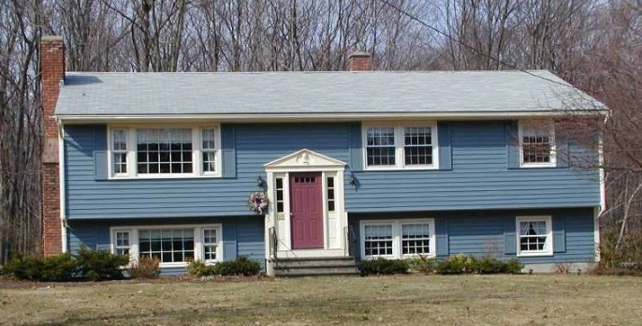
Split Level - The split level home originated in the 1950s and 1960s with the purpose of having a separation of the formal, informal and sleeping areas of the house. The basic split level has the main living on the second level. This is where the living room, dining room and kitchen are. The bedrooms are located in a separate wing on the same level. It is standard to have the lower level function as a family room as well as additional recreation and storage areas.
Of course, these aren't the only homes found in Massachusetts. There are also Victorians, Queen Annes, Dutch Colonials as well as Contemporaries.
Whatever your taste may be, I am sure that you will find the perfect style to call home. I am happy to help.

