How can I help you?

Susan brings over 30 years of customer service, vision and consulting, to her present position serving real estate needs, assisting buyers and sellers. Her strengths include project management, organizational aptitude, patience and perseverance, research, market analysis, intuitive arts and negotiations, communication and conflict resolution, as well as custom designed solutions. She takes a holistic approach to problem solving, listening to mind, heart and spirit, the all of us, with outstanding service at the forefront.

Susan Mogren Agent Availability

Mobile/Text 508-269-7677

I am available 6 days a week 9 AM - 9 PM.
I shut my phone off at 9PM and will return calls the following day.
I typically take Saturday off to be with my family.

Sundays I work with Buyers to see properties, and/or do Open House for Sellers.
It is often my busiest day!

I plan full office days on Monday and Friday.

T, W and Th evening I meet with buyers and sellers, typically 4-7:30.
If you need a special appointment to accommodate availability around work hours, children’s needs or first thing in the morning, just ask! I am happy to accommodate.
I have five conference rooms available in our Realty Executive offices. Natick, Framingham, Southborough, Holliston, and Wellesley.

I typically don’t answer my phone during a client appointment or during a home inspection. Home inspections pop up on demand and can last several hours. Please leave a message.
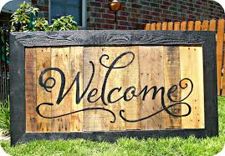

Always reach out or TEXT if you need to, I will let you know when I can get back to you.

