Wisconsin Adult Center
  - October 2017 262-695-9472 1275 E. Wisconsin Ave. Units A&B Pewaukee, WI 53072 wisconsinadultcenter@gmail.com www.wisconsinadultcenter.com
October Birthdays
SS- 10/10
HAPPY BIRTHDAY!!

All Center Halloween Party
Tuesday October 31st!
Wear a costume, have some snacks, play some games, make a craft! We will have in center trick or treat to finish the day!!

HAPPY HALLOWEEN ALL
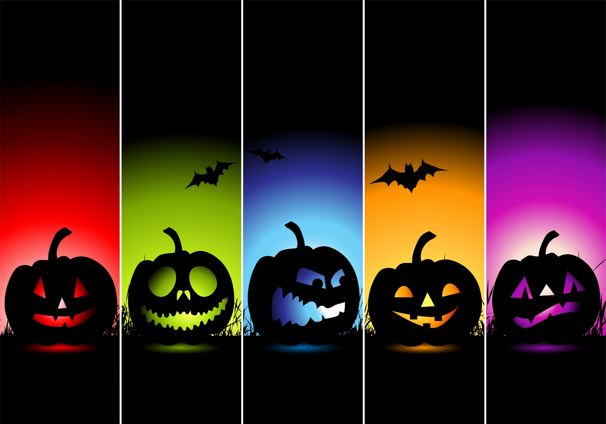
Have a frightfully spooky Halloween!

fALL FUN AT THE WAC!!
September absolutely flew by!! We kept ourselves very busy last month. As always, we had fun with arts and crafts. The members love to take home their creations or see them hanging up at the center. Bob the guitar guy came to sing and play his guitar for us on 2 fun occasions. The members love his visits. We are very lucky to have him. We spent a lot of time outside to soak in the sun before the cold weather catches up with us. We learned about a lot of cool places and things, from Thailand, to mountains, to manatees. Learning about new things is a fun way to spend our time. We will continue the journey of knowledge this month. We can’t wait!
I’m so glad I live in a world where there are Octobers. *L.M. Montgomery*

Thank You!!
Thank you to everyone who has donated art and crafts supplies. They are greatly appreciated. We can always use them, along with items such as newspaper, toilet paper rolls, egg cartons, among other things. So, once again, THANK YOU!!

Spooky Fun ahead!!
It is Halloween Season here at the WAC. We will have a lot of fun decorating the center for Halloween. We have some spooky tricks up our sleeves. In keeping with the Halloween spirt, we will review some scary movie plotlines, ‘visit’ some of the worlds most haunted places, learn about Halloween traditons around the world, and of do lots of Halloween art and craft projects. It will be a spook-tacular time!!

Have a fang-tastic October!
Lindsey, Chrissy, Tina, Rita, Kristi, Karlie, and Brandi

