  - VOICE OF WISCONSIN ADULT CENTER
CONTACT US
Wisconsin Adult Center
1275 E. Wisconsin Ave
Units A& B
Pewaukee, WI 53072
Phone:
(262) 695-9472
Fax:
(262) 691-9496
E-Mail:
wisconsinadultcenter@gmail.com

Please feel free to come to us with any questions or concerns. Our doors are always open!

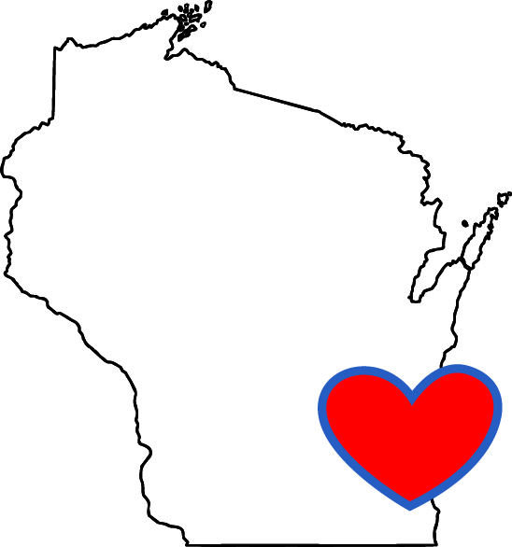
“Our mission is to create a better quality of life for all of our individuals through our compassion and dedication.”

  - This month of October is going to be the real definition of fun and adventurous at the center. October is commonly associated with the season of autumn in the Northern hemisphere and with spring in the Southern hemisphere. Knowing that we the Wisconsinites fall in the Northern hemisphere, we would take advantage of the last days of the beautiful weather and scenery. Wisconsin Adult Center has planned out for this month of October, cognitive activities, living skills, WHOGA (Wheel Chair Yoga), decorate your pumpkin day, creative arts, Columbus Day poetry, Aromatherapy, travel the world, Scenic Van Rides, Halloween day Bash some outings with weather permitting just to mention a few. Wisconsin Adult Center for the month of October has a ton of captivating, mind blowing activities lined up.
“Never regret a day in your life, good days give experience, worst days give lessons and best days give memories”.

September flew by so fast. Our September dance party was a success, we had almost everyone at the center participate and oh boy! we saw some dance moves. I can boldly say the dance party was the highlight of the month. We kept ourselves occupied at the center amidst the fun and pinch of hullabaloo. We the staff at WAC reminded ourselves “to do all the good we can, by all the means we can, in all the ways we can, in all the places we can, at all the times we can to all the people.” The past month was definitely a September to remember!

HAPPY HALLOWEEN
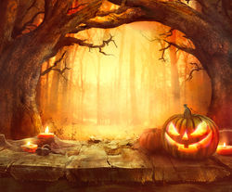
Halloween Boo

Halloween is an annual holiday celebrated each year on October 31, and Halloween 2018 occurs on Wednesday, October 31. It originated with the ancient Celtic festival of Samhain, when people would light bonfires and wear costumes to ward off ghosts. In the eighth century, Pope Gregory III designated November 1 as a time to honor all saints; soon, All Saints Day incorporated some of the traditions of Samhain. The evening before was known as All Hallows Eve, and later Halloween. Over time, Halloween evolved into a day of activities like trick-or-treating, carving jack-o-lanterns, festive gatherings, donning costumes and eating sweet treats.
REMEMBERING PEOPLE LIVING WITH BREAST CANCER.  This month of October which happens to be Breast cancer awareness month can’t go by without us sending out love and hugs out to people living with breast cancer. We at the center wish to extend a big bear hug to everyone battling breast cancer and everyone that defeated the breast cancer illness. We say, “Be strong, You never know who you are inspiring”. | 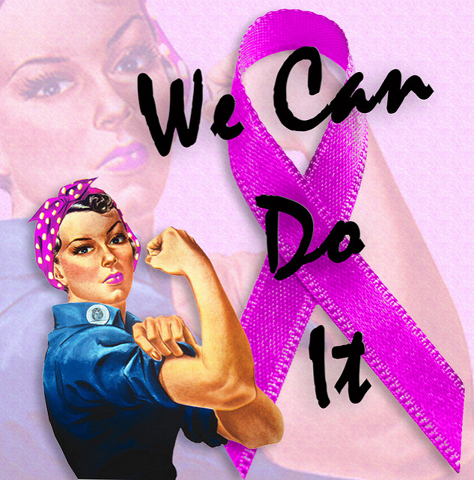

CELEBRATING BIRTHDAYS
Sahej S October 10th
Karen W October 13th
Wisconsin Adult center wishes you a happy birthday. Hope you have a fun filled one.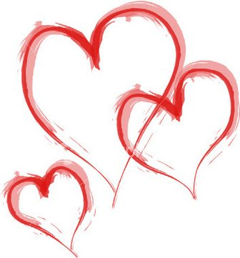
This Photo by Unknown Author is licensed under CC BY-NC-ND

^{HAPPY COLUMBUS DAY!!!}
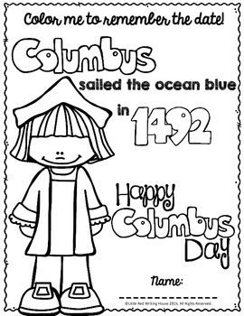

Did We Also Know That It Was on October in 1863 That President Abraham Lincoln Proclaimed A National Day of Thanksgiving?

Lindsey, Rita, Tammi, Tina, Aaron, Rita, Kristi, Hayley wishes you a happy New month.

