# **VOICE OF WISCONSIN ADULT CENTER**

**JANUARY 2019**

**Wisconsin Adult Center would like to welcome you to the new year, the year of new beginnings and beautiful things. We are pleased to know that you made it through the year with us. Last year (2018) was a successful year, it wasn’t all perfect but that’s what made it even more worthwhile, we had our days where things didn’t go as planned or expected but through it all we stood our grounds and always reminded ourselves our mission is to create a better quality of life for all of our individuals through our compassion and dedication.**

***“Imperfection is beauty, madness is genius and its better to be absolutely ridiculous than boring”.***

**This month of January which happens to be the birth month of the flower pink cottage (Dianthus Caryophyllus) we will be making a pink cottage flower craft to start of the year.**

**Did you know that the month of January is named after the Roman god Janus, protector of gates and doorways?**

**Janus is depicted with two faces, one looking into he past, the other into the future.**

**The zodiac signs for the month of January is Capricorn (until January 19) and Aquarius (January 20 onwards).**

**This month we are excited to introduce new activities on our activity calendar, just to mention a few, we have planned out this month *Taste of WAC, Women’s Tea, Men’s group, Butterfly craft, Scavenger hunt, Aromatherapy, Reminisce, Pop Movie day etc.***

**CELEBRATING BIRTHDAYS**

**Glen S January 22**

***All the staff at Wisconsin Adult Center wishes you a fun filled and a happy birthday!!!***

**FOOD FOR THOGUHT!**

**“Unless commitment is made, there are only promises and hopes but no plans”.**

[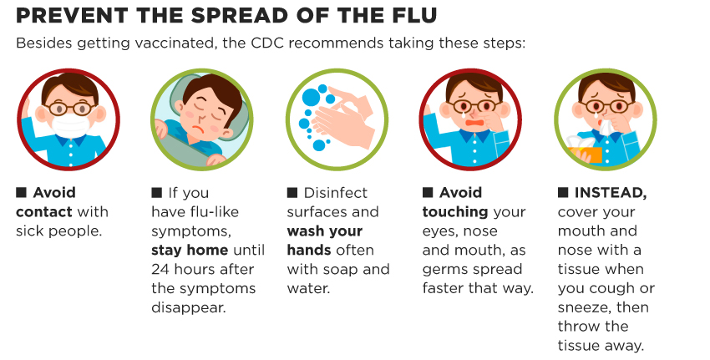](https://www.google.com/url?sa=i&rct=j&q=&esrc=s&source=images&cd=&cad=rja&uact=8&ved=2ahUKEwjPmL3LmMDfAhUk5oMKHYybAUMQjRx6BAgBEAU&url=https://www.ectorcountyisd.org/Page/28876&psig=AOvVaw3-PfcjEBlqXIFFTJHLjo52&ust=1546006341899037)

During this time of the year, Wisconsin Adult Center would appreciate it, if clients are not sent in to program when they have the flu-like symptoms in order not to spread the infective agent. We stay on top of these precautions and advise our staff to take the time off in the case of experiencing these flu-like symptoms. We have our clients and staffs best interest at heart. We hope you do understand.

|  |  |
| --- | --- |
|  |  |
|  |  |
|  |  |
|  |  |