VOICE OF WISCONSIN ADULT CENTER
FEBRUARY 2019 (Month of Love)

All across the world, the month of February is known to be the month of Love. Love they say makes all things beautiful. Why don’t we concentrate on Love this month of February?
Valentines Day also known as Saint Valentines day is celebrated annually on February 14th, originating as a western Christian feast day honoring one or two early saints named Valentinus. Most people assume Valentines day is a commercial celebration of romance and romantic love in many regions around the world. I personally think its not only a celebration of romance but a celebration of love regardless of what type of love it is whether its agape, Philia, Eros etc. Valentine’s day shouldn’t only be about the candle light dinners, the chocolates, cards, wine and roses. It should be about letting the people that matters to us know that we do love and appreciate them. That is why we at the Wisconsin Adult Center says we appreciate your business and also, we do love you all. Happy Valentine’s Day!

RECAP OF LAST MONTH
The month of January was successful, it is such a joy to know how great the first month of the year 2019 went. Amidst the bad weather and the hullabaloo, we still made the best out of the month. Its exciting to say that our new introduced activity taste of WAC was a success, sign language sessions, music therapy just to mention a few of the activities were all successful. Unfortunately, we weren’t able to do too much for our scheduled scenic van rides due to inclement weather, we look forward to better weather when we can start our our van rides. This month of February, we will be introducing a new session in our newsletter (Getting to know you corner). We would like you to get to know our wonderful caregivers that provides care to your dear ones at our center. We are also excited to let you know the new cognitive activity addition to our calendar; Reminisce Game.

Flower of the month (ROSE)
Rose is a type of flowering shrub. The name Rose comes from the Latin word Rosa. Did you know the flowers of the rose grow in many different colors? From the well-known red rose or yellow roses and sometimes white or purple roses. There are over a hundred (100) different species of roses. Roses are widely used across the world as a symbol of love, sympathy or sorrow. Red roses are going to be very popular in this month of February for Valentine’s day celebration.

Wisconsin Adult Center, 1275 E Wisconsin ave. Pewaukee, WI. 53072.
Hours of Operation Monday- Friday 8am-3pm. Please feel free to come to us with any questions or concerns.

LO  VE |  |  | LOVE IS  ALL AROUND
Getting to know you  Hi Folks, my name is Aaron A. I was born in Travindrum, India. I was adopted by my parents when I was one year old and they came to the United States with me. I graduated from Watertown High School and went ahead and attended MATC-Watertown. My hobbies and interest are going to a Badger or Husker’s football games, I love spending time with friends, going to musical concerts and women basketball games. Working at an Adult day program is such a joy that you can help put a smile on people’s face, I like interacting with the clients and seeing their smiles. I was in the hotel and restaurant business for the longest time until I finally decided one day, I needed a change, so I decided to get into a field that has a positive impact on other people’s lives. I once helped take care of my uncle who was special needs and so working here makes me remember all the wonderful times, I had with him. It’s always a pleasure walking into work every morning. |  |  | 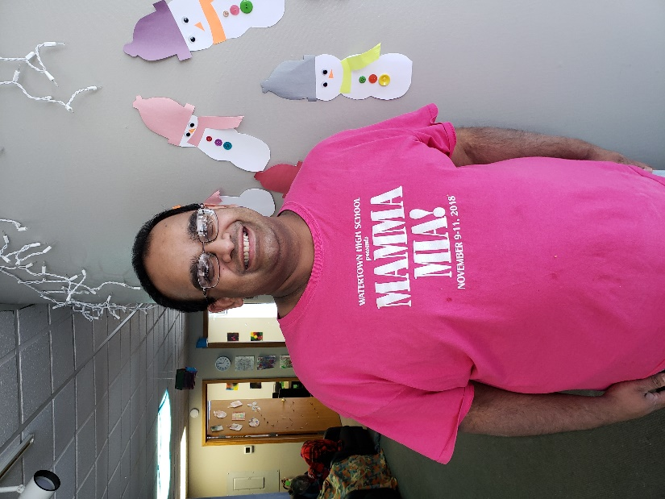
ATTENTION!  Wisconsin Adult Center would like to thank you for your usual cooperation. Few announcements to get us through this dreadful winter season.  Wisconsin Adult Center will let guardians know of any emergency closings or delayed openings due to inclement weather. We would also appreciate it if a 24-hour notice is given to us prior to a client not been able to attend program unless off course it is an emergency in order for us to plan accordingly staff wise and activity programming.  - Please make sure all winter coats and accessories are labeled with client’s full name or initials.  - If due to inclement weather Wisconsin Adult center is unable to offer transportation, but the center is opened please feel free to drop off your loved ones.  We apologize for any inconveniences. |  |  |   This Photo by Unknown Author is licensed under CC BY-NC-ND

HAPPY VALENTINE’S DAY

