  - MARCH NEWSLETTER Voice of WAC.
CONTACT US
Wisconsin Adult Center
1275 E. Wisconsin Ave
Units A& B
Pewaukee, WI 53072
Phone:
(262) 695-9472
Fax:
(262) 691-9496
E-Mail:
wisconsinadultcenter@gmail.com

Please feel free to come to us with any questions or concerns. Our doors are always open!

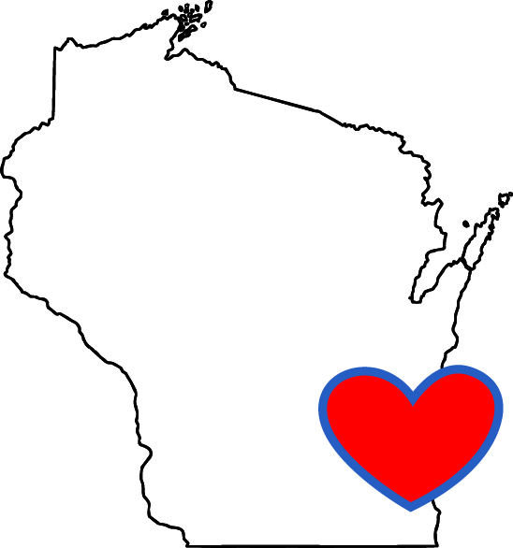
“Our mission is to create a better quality of life for all of our individuals through our compassion and dedication.”

  - Wisconsin Adult Center is excited to let you know how we are thriving in our new introduced activities. This past month we introduced the Reminisce game which is a cognitive game, Simon Says game, hands on craft projects, Trivia amongst many others and it’s amazing how successful they went. Our members enjoyed these new activities and couldn’t have enough of it. The month of February went by so fast considering the fact that February on its own is the shortest month of the year and with how mother nature has been this year bringing us not too nice so many snow days we had a couple of days off this month which couldn’t make us achieve a lot of our outing goals. We are hoping for better weather ahead so we can embark on our scheduled outings. We know members can’t wait to resume going on outings. We have planned out for this month of March some fun activities and trips with weather permitting.
“Love is a promise, Love is a souvenir. Once given, never forgotten, Never let is disappear”
Saint Patrick's Day, or the Feast of Saint Patrick, is a cultural and religious celebration held on 17 March, the traditional death date of Saint Patrick (c. AD 385–461), the foremost patron saint of Ireland. Saint Patrick's Day is a public holiday in the Republic of Ireland, Northern Ireland, the Canadian province of Newfoundland and Labrador (for provincial government employees), and the British Overseas Territory of Montserrat. It is also widely celebrated by the Irish diaspora around the world, especially in the United Kingdom, Canada, United States, Brazil, Argentina, Australia and New Zealand. Saint Patrick's Day is celebrated in more countries than any other national festival. Modern celebrations have been greatly influenced by those of the Irish diaspora, particularly those that developed in North America. In recent years, there has been criticism of Saint Patrick's Day celebrations for having become too commercialized and for fostering negative stereotypes of the Irish people.
^{CELEBRATING BIRTHDAYS}
Nikki H March 14
Derek H March 14
Joe F March 27
April E March 30
Wisconsin Adult Center would like to wish these individuals a happy birthday. We hope you have a fun-filled day!
COLOR ME
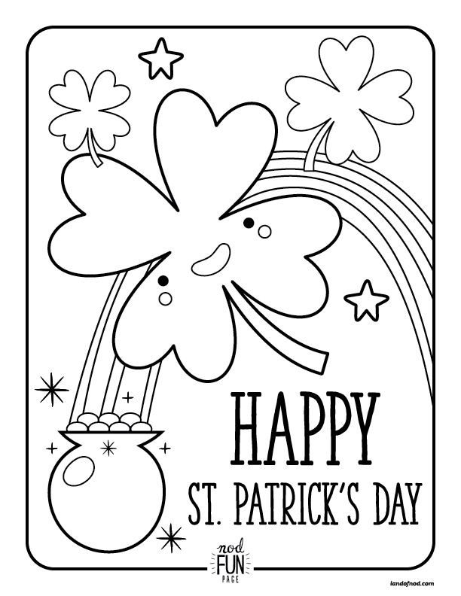
Getting to know you!

Hello folks! My name is Tammi K. I was born in Milwaukee, WI. I attended James Madison High School, Anthem College and Herzing University. I love to paint in my spare time, I love art and interior decoration as well as massage therapy.
I chose this career field because I love to help people. The joy my heart feels working with members at our program is a piece of my heart that has been missing for a long time. Seeing them smile light up my days. My message to everyone is judge not and thou shall not be judged.

Below are some of our clay art project we embarked on last month.
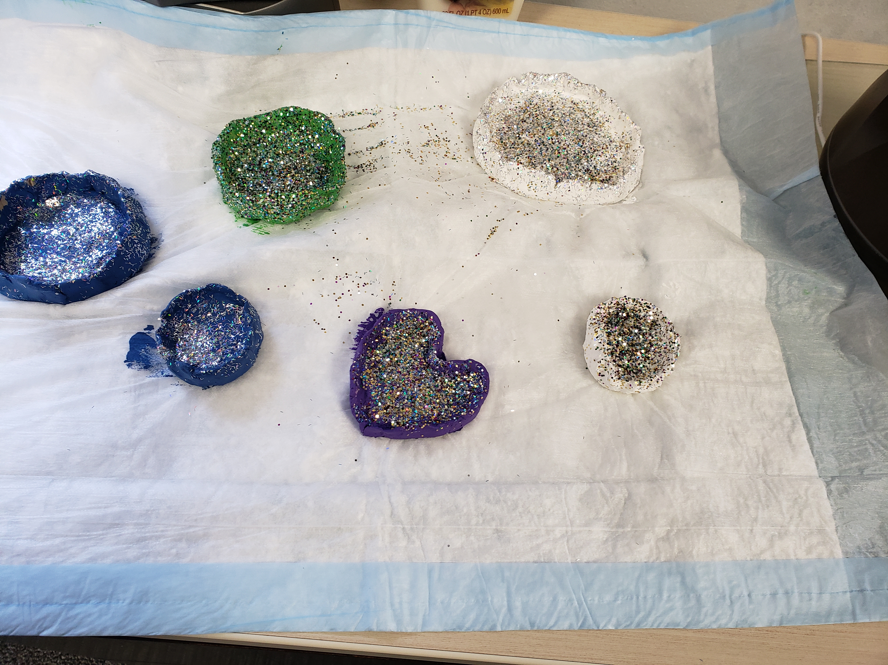
WISCONSIN ADULT CENTER WISHES YOUA HAPPY ST PATRICKS DAY!!!

