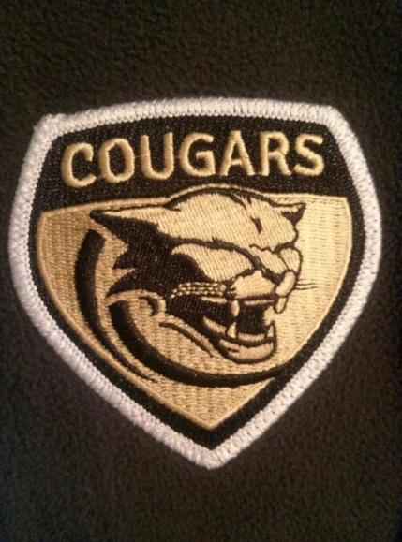
TCHS BOYS SOCCER
YOUTH NIGHT
Tuesday, February 25th

The Boys Varsity soccer team will conduct a FREE 40 minute soccer clinic for youth players in the Cougar indoor field from 6:00pm-6:40pm.

After the clinic, youth players will escort a varsity player onto the field during the pregame player introduction; and at halftime, the youth players will play a 3v3 mini soccer game.

- ALL TCYSA players that wear their team jersey will get in free. (parents will have to pay regular admission)
- All TCYSA coaches that wear their badges will get in free.
- RSVP to Lori Ricker 214-535-2210 or at Lorikr@sbcglobal.net by 2/21 4pm.

BRING YOUR WHOLE TEAM AND CHEER ON YOUR
TCHS BOYS VARSITY COUGAR SOCCER TEAM.

