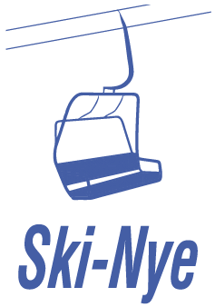

Ski-Nye Inc.

Line Work SOP

Staff Required
3 (lift mechanic, apprentice, control operator)

Tools
3 two way radios, aerial self rescue bag, assorted tools for line work

Pre-Work Preparation
Prior to beginning line work the maintenance chair shall be installed onto the lift, the grip torqued and the chair slip tested. The evacuation engine will be started to ensure functionality. The three staff shall review this SOP and ensure all radios are on the correct channel and working properly.

Control Operator Requirements
The control operator must NOT leave the control unattended while staff are in the work chair. Should the staff member be required to leave the controls another staff member can relieve them so long as they are instructed with the procedures. This ensures the lift cannot be accidentally started.

Procedures for Line Work

Before Starting the Chairlift
1. Mechanic/Apprentice will radio “All clear ready to go”
2. Control Operator will respond “Confirm, all clear?”
3. Mechanic/Apprentice responds “Confirmed, clear to go”
4. Control Operator can now start the chair

Approaching a Tower
1. Mechanic/Apprentice radios “20 feet to tower”
2. Control Operator will slow the chair
3. Mechanic/Apprentice radios “10 feet to tower”
4. Mechanic/Apprentice radios “Stop Chair”
5. Mechanic/Apprentice radios “Good there” or provides corrections and follows the ‘Before starting the chair’ procedure

Working on a Tower
1. Mechanic/Apprentice removes the brake fork from the sheave assembly
2. Mechanic/Apprentice radios “Can you get a reset?”
3. Control Operator attempts to reset; if reset cannot be achieved they will radio “Cannot reset”
4. Mechanic/Apprentice responds “Confirm no reset, starting work on tower”
5. Mechanic/Apprentice begins work on the tower
6. Upon completion, the last job is to install the brake fork
7. Mechanic/Apprentice radios “Work complete, can you get a reset?”
8. Control Operator attempts a reset; if successful, they radio “Lift reset and ready to go”
9. All staff then follow the “Before Starting the Chair” procedure again
Important: Lift mechanics must never ride the work chair around the bull wheel. They must dismount and advise the operator to move the lift once all clear.

Line Work Self Rescue
In the event the chairlift won’t start and the evacuation engine is not an option, employees can self rescue. Before this can happen the lift MUST be locked out to ensure it cannot be started. Once the lift is locked out the control operator will inform the staff in the work chair that it is safe to self rescue.

