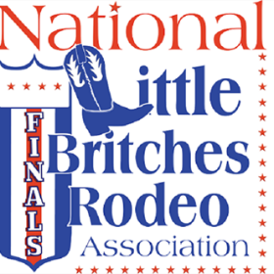 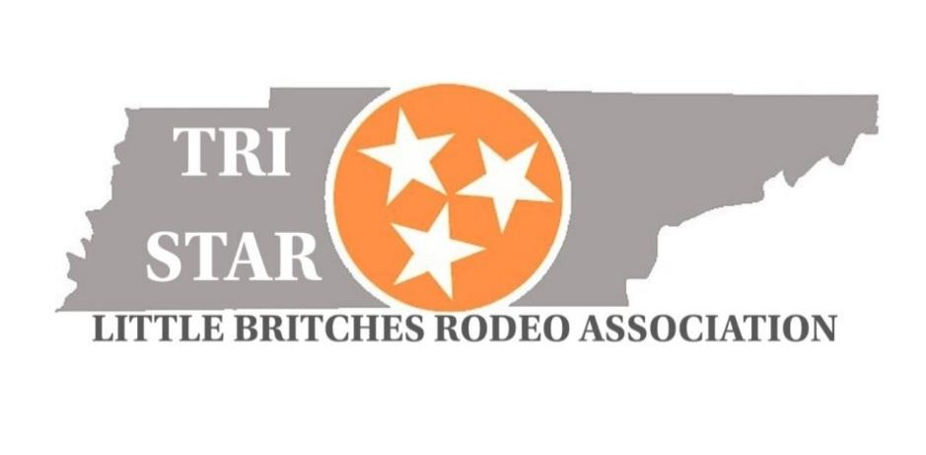

The NLBRA, which was founded in 1952, is a youth rodeo organization for kids ages 5 to18. The NLBRA’s principal goal is to develop within its members and their families a spirit of fair competition and appreciation of good sportsmanship throughout the experience of healthy rodeo competition. The Association annually sanctions over 500 youth rodeos in 33 states, which provides more opportunities for NLBRA members to earn points and qualify for the National Finals Rodeo. All of our franchises operate in accordance with the NLBRA Rulebook. More than 2,600 kids from 33 states compete in NLBRA rodeos each year. Contestants compete for prizes such as saddles, buckles, scholarships, and cash at local rodeos as well as the National Finals events. By competing at local events, contestants work to qualify for the annual National Finals Rodeo.

***Tri-Star Little Britches Rodeo Association has made it’s home at the Wilson County Fairgrounds in Lebanon, TN and we are excited to bring a NLBRA franchise to Middle Tennessee to give Tennessee, Alabama, Kentucky youth rodeo contestants an opportunity to compete and be involved close to where they live!*** Our founding board members have many years of experience and background in rodeo production and competition and are committed to making the Tri-Star Little Britches franchise a long-lasting youth rodeo option in our area!

Our season will kick off in July, 2025 and will have rodeo dates in the fall and then in the spring, 2026. Our season will not be as successful without the continued support of parents, grandparents, friends and family members who cheer on these talented youth contestants. We expect our spectator number to reach around 500 people at each rodeo.

We are seeking sponsorships to help the Tri-Star Little Britches Rodeo for the 2025-2026 season. Our season will not be possible without our partnerships with sponsors and their generosity. We would appreciate your consideration in sponsoring our association in helping to support these youth rodeo contestants with their events, year-end prizes and awards as they all work toward a goal of qualifying to compete in the Little Britches Rodeo National Finals in Oklahoma in July, 2025. We look forward to hearing from you!

TRI-STAR Little Britches Rodeo Association – 503c #29053319340029

 

**Sponsorship Opportunities**

***Major Sponsor/Saddle Sponsor***- $2000.00

• 3 x 5 banner displayed in arena

• Announcement during grand entry and periodically throughout rodeo event

* Name of sponsor on saddle

***Event Sponsor*** - $1000

• You may choose to sponsor steer wrestling, tie down roping, team roping, dally ribbon roping, breakaway roping, goat tying, goat tail untying, trail course, pole bending or flag racing.

• 3x5 banner displayed in arena

• Announced as “Event sponsored by *your company name*”

**Supporting Sponsor** - $500

• 3x5 banner displayed in arena

• Announcement periodically during rodeo

**Member Sponsorship** - $250

• Sponsor an individual family

* Any donation is welcome

 

**Sponsor Information**

Business/Sponsor Name: _________________________________________

__________________________________________________________

Address: __________________________________________________

__________________________________________________________

Phone & email:

__________________________________________________________

Website: _______________________________________________

Contact Person: Event Sponsored (If Applicable):

__________________________________________________________

Paid: (Please Circle)

Check (#__________) Cash

Amount:__________________

Tri-Star LBRA Member Name:______________________________________

Tri-Star LBRA Member Phone #:_____________________________________

**For more information:**

[tristarlbra@gmail.com](mailto:tristarlbra@gmail.com) **or on Facebook, Tri Star Rodeo**

**Lisa Thomson, Secretary 550 Airport Rd Gallatin TN 37066**