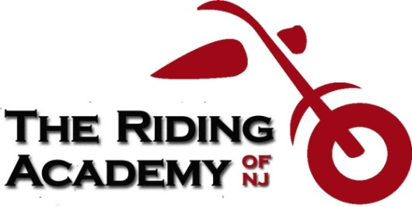
PO Box 3177, Wayne, NJ 07474-3177
(973) 742-2300
RidingAcademy1@aol.com
www.theridingacademyofnj.org

Dear Police Officer/State Trooper:

The person who possesses the NJ MVC Motorcycle Operator’s Skill Test (M.O.S.T.) Waiver Verification card AND the MSF (Motorcycle Safety Foundation) Basic RiderCourse completion card or the MSF Basic RiderCourse 2 License Waiver completion card has taken a motorcycle safety training course, which is approved by the NJ MVC, with our motorcycle training school. We also administer the MVC Written Test and Road Test at the end of both RiderCourses. These two cards are proof that the person who possesses them has passed both tests and has successfully completed the course.

Due to the Covid-19 situation in NJ with the temporary closure of all NJ MVC offices until 7/7/2020, and the extremely long wait lines once they re-opened, and the 7/20/20 discovery of one of the Wayne MVC office employees contracting the virus, would you respectfully accept these two documents in lieu of a valid NJ motorcycle permit or a valid motorcycle endorsement on their NJ Driver License until December 31, 2020? The lines at the NJ MVC offices should be back to normal by then.

By no means give the holder of these two cards a break if they violated a NJ traffic law. In fact, if they violated a NJ traffic law, also give them a summons for not having a valid NJ motorcycle permit or NJ motorcycle endorsement.

This letter is just a request for them to avoid the very long lines at the NJ MVC offices and possibly contacting the virus.

Thank you for your consideration and thank you for your service.

Stay safe and be well.

Sincerely,

Dave Bellizzi
President

