Berry Burst Cheerios Case (Mira Venkatakrishnan and Bianca Desai)

Who should be the Target Audience for the Berry Burst Cheerios and why?

We decided that mothers between the ages of 25 to 35 should be BBC’s target market because of this group’s interest and affiliation with the key product characteristics that BBC exhibits, including its taste, nutritional value, convenience, and visual appeal garnered through advertising. Customers in this market segment influence the consumption patterns of their children and aim to feed them a wholesome breakfast that is healthy, delicious, and convenient. In order to develop BBC’s positioning statement, we created a persona that exemplifies these core characteristics and fits into the narrative of the appeal that BBC holds for these customers.

Susan is a 32-year-old woman from Bloomington, Indiana. As a business professional and mother, her days are spent balancing her work life along with taking care of her children. Mornings are a hectic time as she gets ready for work while also preparing her children for school and serving them breakfast. It is therefore imperative that she can make a breakfast that is quick and easy to eat. Since her children are picky about eating their fruits and vegetables, Susan finds it challenging to feed them meals with high nutritional value - food that is high in fiber, is good for the heart, has reduced sugars, and is high in vitamins. She wants to ensure that her children’s health is being cared for in these fundamental stages of growth and development. In addition, she wants to ensure that they have a good start to the day, so she looks for cereal that tastes good and provides a fun and engaging experience with characters and colors. Therefore, Susan’s lifestyle, values, tastes and preferences, income, and interests make her an ideal customer for Berry Burst Cheerios.

Positioning Statement:
For mothers who seek to prepare a healthy and easy-to-eat breakfast for their children, Berry Burst Cheerios offers nutritious and scrumptious cereal that provides a plethora of fruity flavors that add to the classic Cheerios crunch and enables a wholesome start to the day.

Positioning Map:
Mothers are finding it difficult to feed their children a healthy breakfast, specifically when it comes to cereal. Excerpts from Appendix B support this notion. We see paralleled sentiments of female parents undergoing this challenge. A female parent stated her children only gravitated to the “sugary cereals with the fun toys.” Another said, “God only knows I give them all the vegetables and fruit they need, but do they eat them? No! Maybe if it is in the cereal, they will eat it.” These sentiments suggest that BBC should distinguish themselves from competitors by highlighting their health benefits to raise awareness amongst mothers. From the AHA check mark to Cheerios’ association with cholesterol reduction and lowered sugars, these brand identities can be leveraged to achieve the new desired positioning.

As seen in Figure 1 of Appendix A, an attribute matrix comparing product claims for weight/health benefits with taste, BBC is currently high on taste and low on weight/health benefits. To secure the desired perception shown in Figure 2 (high taste and high weight/health benefits), the company must make BBC’s nutritional value the epicenter of their messaging and be transparent about the ingredients and fruit used to generate trust with customers, who are concerned about their children’s wellbeing. Unlike competitors like Special K Red Berries, BBC’s advertising should emphasize health benefits rather than weight benefits, which is less appropriate for children, who shouldn’t be pushed into fads like diet culture at an early age. Moreover, advertisements depicting children enjoying BBC with various characters and vibrant colors could incentivize mothers to make it a household staple for their children.

APPENDIX A: Positioning Maps

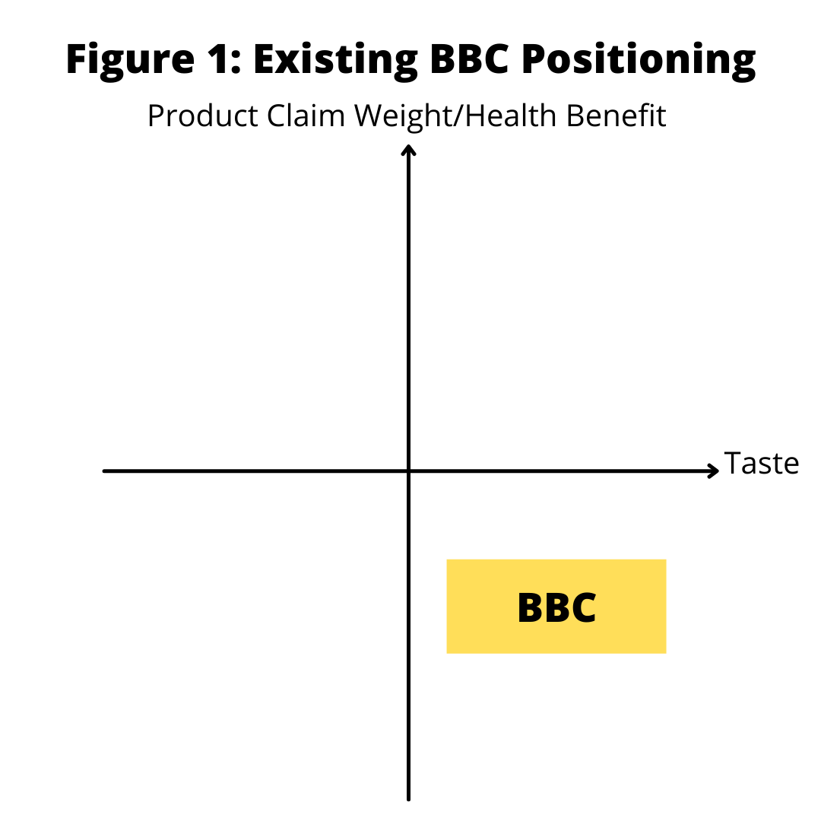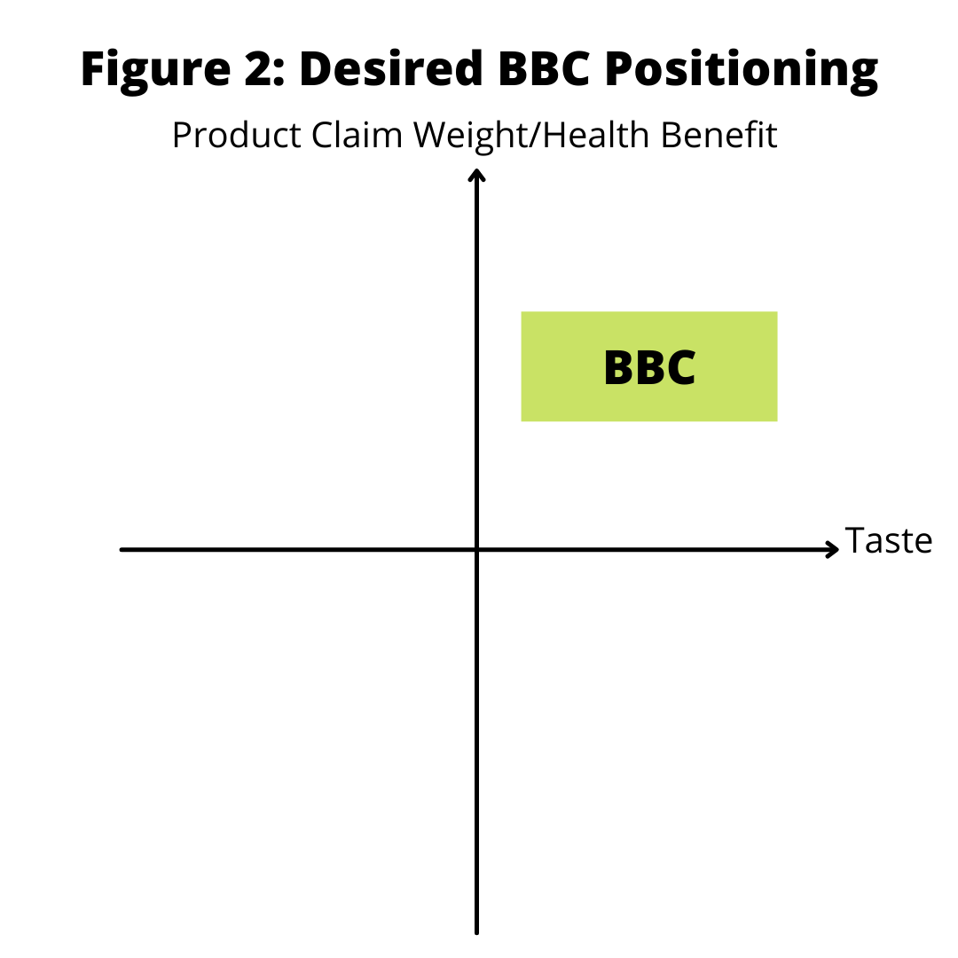

APPENDIX B: Market Segment Excerpts

Female, single parent, two young kids: It is a serious challenge to get my kids to eat healthy.
If they go shopping with me, they want the sugary cereals with the fun toys.
I can only say No to them so many times, sometimes I just give in.

Female, single parent, three young kids: God only knows I give them all the vegetables and fruit
they need, but do they eat them? No! Maybe if it is in the cereal, they will eat it.

