Career Change Wheel

Are you considering a career change? This wheel gives you the chance to look at where you are and options to consider based on your experience, where you are now and your dreams! There are six areas of your life to consider in the wheel below.

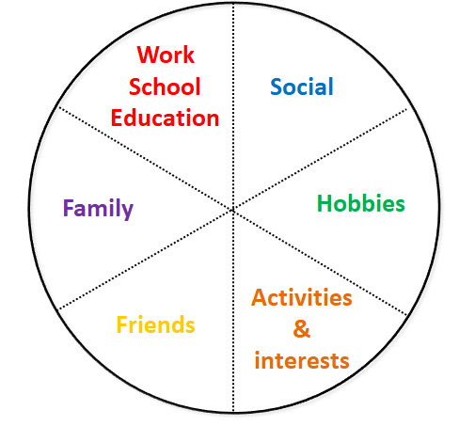

- For each area write experiences and activities that form each area these should include:
  - past and present
  - missed opportunities
  - hopes and dreams
  - things that have sparked an interest from things you have read, seen, attended, or someone you met or read about who inspired you
  - consider work, knowledge and experience of family and friends
  - consider what it is you like about each interest, hobby and activity
- Leave segments blank if they are not appropriate to you
- Put the wheel aside for a while and come back later to it to see what you need to add and what you notice about what you have done. Notice themes and links.
- Think about your context. Write down some of the key points and considerations in relation to your next possible role/job:
  - Family situation, what you give and what they need
  - How much money you need weekly/monthly; implications of a pay cut
  - Location (distance, time, cost); working from home; relocating
  - Learning a new skill, re-training, or studying for a qualification
  - Level of role/responsibility
  - Is there just one step to get where you want to be or do you need to consider a stepping stone approach
  - Work environment: alone/with others; indoors/outside; work for self/be employed etc
  - What a typical day/week would look like
  - Full time work, part time, contract, internship, work experience, project based worktime, a mix of different jobs (e.g. what you do now and your dream job)
- It is unlikely you will have a specific outcome – the process wont necessarily have made it clear your next career should be as a wildlife vet in Botswana!
- What you will have is a mixture of:
- Themes
- Areas or categories
- Ideas
- Choices
- New avenues to explore
- Ask yourself the following questions:
  - What can you do to explore these options further?
  - Who can help or advise you?
  - Who do you know who may know someone else who can help you?
- What are your main priorities to action, explore or move forwards?
- What are some of the steps you could take?
  - Big or small
  - Quick or slow
  - Do alone or with support
  - Now, tomorrow, next week, next month
- Let your plan be flexible so you can add in new actions and avenues to explore

