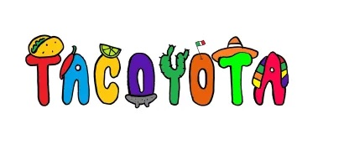”
“You can NEVER have to many Taco’s”

~Chicken ~Steak ~AL pastor Pork ~Ground Beef ~Shrimp ~Chorizo ~ Vegetarian

The Yota Taco’s
Mexican Style – Corn Tortilla, Choice of meat Cilantro & Onion

American Style- Corn Tortilla, Choice of meat Lettuce, Tomato, Cheese & Sour Cream

Torta
A Mexican sandwich refried beans, creamy avocado, Sour Cream—and piled with meat(s) and cheese(s) of your choosing.

Quesadilla
Choice of meat Cheese lettuce tomato sour cream

Burrito
choice of meat, rice & refried beans cheese lettuce tomato sour cream salsa

Macho Nachos:
Ground Beef, Refried Beans, Queso, Lettuce Tomatoes sour cream

Sides.
Mexican Rice
Refried Beans
Chips & Salsa
Chips & Queso

