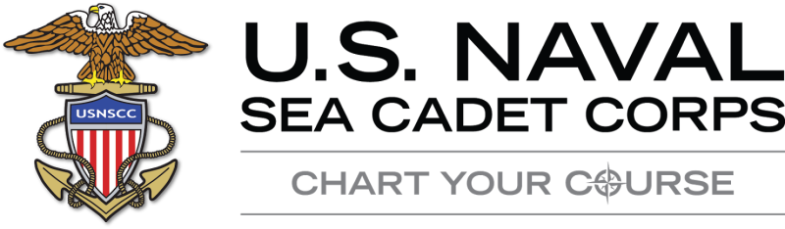

**Promotion Requirements**

**NSCC - Sea Cadet Advancement**

|  |  |  |  |  |  |
| --- | --- | --- | --- | --- | --- |
| **RATE** | **RANK** | **MINIMUM TIME IN RATE** | **CORRESPONDENCE COURSE** | **EXAM** | **REQUIRED TRAINING** |
| E-1 | SEAMAN RECRUIT (SR) | NONE | NONE | NONE | NONE |
| E-2 | SEAMAN APPRENTICE (SA) | 3 MONTHS | BASIC MILITARY REQUIREMENTS (BMR) | PQS | NSCC  RECRUIT TRAINING |
| E-3 | SEAMAN/ AIRMAN/ FIREMAN | 6 MONTHS | ** SEAMAN, AIRMAN, FIREMAN | NONE | ADVANCED TRAINING |
| E-4 | PETTY OFFICER 3RD CLASS (PO3) | 6 MONTHS | COURSE 14504 PO3/PO2 | PO3 | ADVANCED TRAINING |
| E-5 | PETTY OFFICER 2ND CLASS (PO2) | 6 MONTHS | COURSE 14504 PO3/PO2 | PO2 | POLA |
| E-6 | PETTY OFFICER 1st CLASS (PO1) | 6 MONTHS | COURSE 14145  PO1 | PO1 | ADVANCED TRAINING |
| E-7 | CHIEF PETTY OFFICER (CPO) | 6 MONTHS | COURSE 14144  CPO | NONE | STAFF RTC |

** - (1) Petty Officer Leadership Academy (POLA) may be completed at any time after being advanced to E-3 but must be completed prior to advancement to PO2. The Junior Petty Officer Development (JPD) Course is not a requirement for advancement. (2) The Airman Course may be done in lieu of the Seaman Course when assigned to a Squadron.

**NLCC – League Cadet Advancement**

**NLCC Advancement Requirements**. The [NLCC Training Syllabus](http://compass.seacadets.org/cadets/nlcc_syllabus.htm) is the source document for NLCC cadets. The syllabus contains activities and exams required for advancement. During the summer NLCC Orientation and NLCC Advanced Orientation is available for cadets to attend to augment the syllabus. Although this training is available it is **NOT** a requirement for advancement. The table below indicates the rate structure for NLCC cadets LC-1 through LC-6. The unit commanding officer is the advancement authority for NLCC cadets through all rates.

