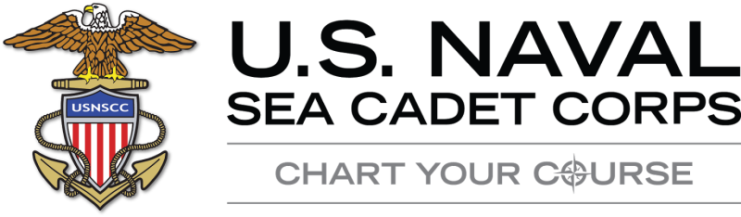

Cadets should learn the following knowledge prior to attending Recruit Training/League Orientation:

- Sea Cadet Core Values
- Sea Cadet Oath
- Sea Cadet Rank
- 11 General Orders of the Sentry (Navy version)
- NATO Phonetic Alphabet
- 14 Leadership Traits of the Marine Corps
- Sailor’s Creed
- Anchors Aweigh
- All verses of the Marine Corps Hymn
- Officer and Enlisted Ranks/Rates of the US Armed Forces

Sea Cadet Core Values
Honor, Respect, Commitment, and Service

Sea Cadet Oath
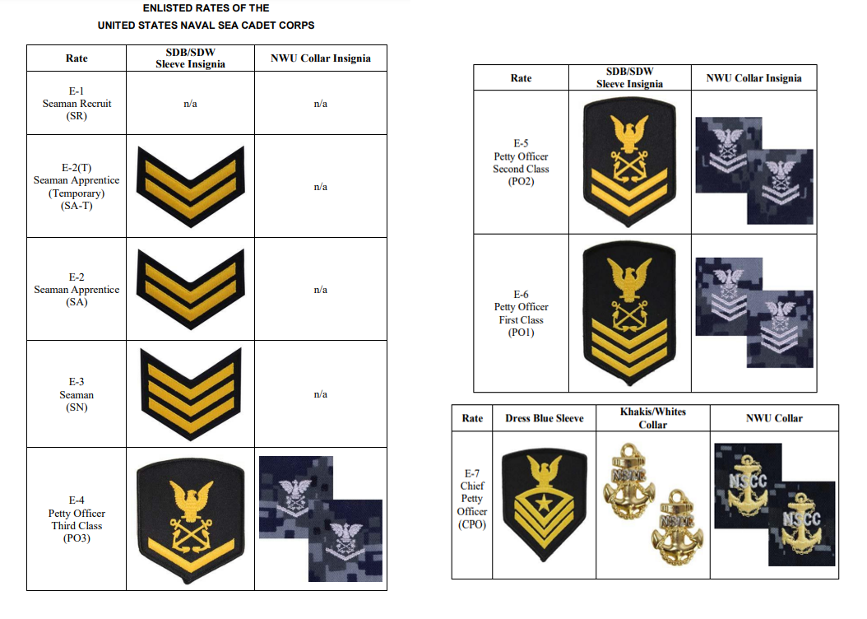
I promise to serve faithfully, honor our flag, abide by Naval Sea Cadet Corps regulations, carry out the orders of the officers appointed over me, and so conduct myself as to be a credit to myself, my unit, the Naval Sea Cadet Corps, the Navy, the Coast Guard, and my country (so help me, God).
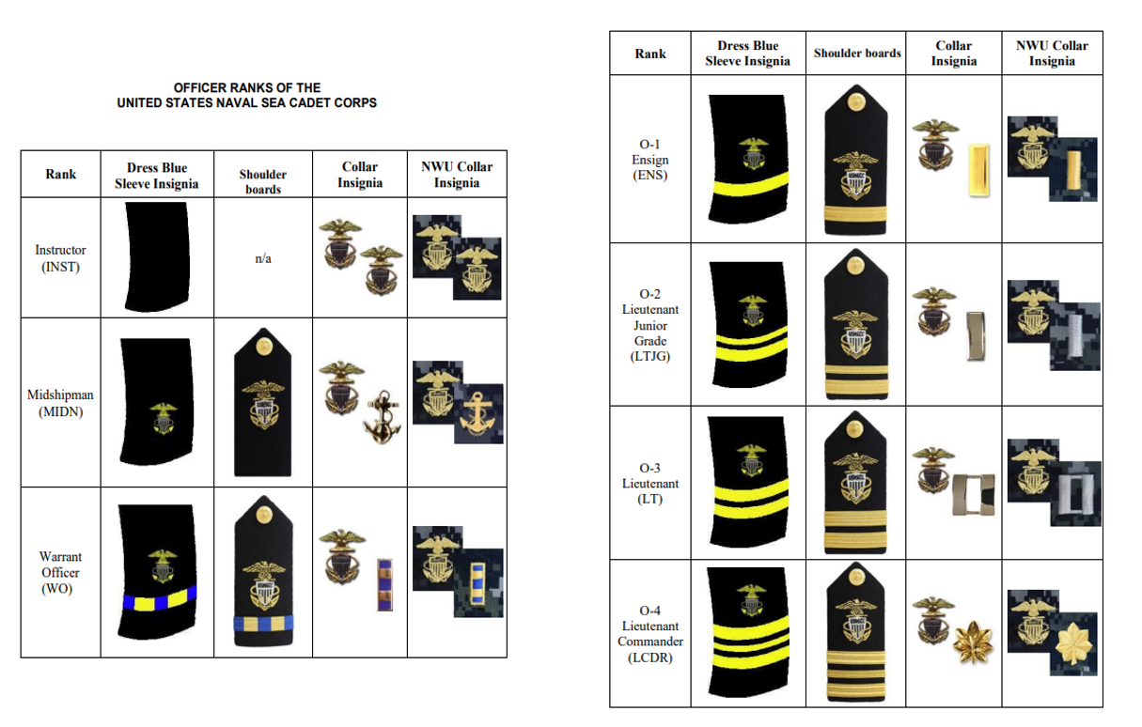
11 General Orders of the Sentry (Navy Version)
- To take charge of this post and all government property in view.
- To walk my post in a military manner, keeping always on the alert, and observing everything that takes place within sight or hearing.
- To report all violations of orders I am instructed to enforce.
- To repeat all calls from posts more distant from the guard house than my own.
- To quit my post only when properly relieved.
- To receive, obey, and pass on to the sentry who relieves me all orders from the Commanding Officer, Command Duty Officer, Officer of the Deck, and Officers and Petty Officers of the Watch only.
- To talk to no one except in the line of duty.
- To give the alarm in case of fire or disorder.
- To call the Officer of the Deck in any case not covered by instructions.
- To salute all officers and colors and standards not cased.
- To be especially watchful at night and during the time for challenging, to challenge all persons on or near my post, and to allow no one to pass without proper authority.

NATO Phonetic Alphabet:

A | Alpha
B | Bravo
C | Charlie
D | Delta
E | Echo
F | Foxtrot
G | Gulf
H | Hotel
I | India
J | Juliet
K | Kilo
L | Lima
M | Mike
N | November
O | Oscar
P | Papa
Q | Quebec
R | Romeo
S | Sierra
T | Tango
U | Uniform
V | Victor
W | Whiskey
X | X-ray
Y | Yankee
Z | Zulu

14 Leadership Traits of the Marine Corps
(JJ-DID-TIE-BUCKLE)

- J-Judgement
- J-Justice
- D-Decisiveness
- I-Initiative
- D-Dependability
- T-Tact
- I-Integrity
- E-Endurance
- B-Bearing
- U-Unselfishness
- C-Courage
- K-Knowledge
- L-Loyalty
- E-ENTHUSIASM

Sailor’s Creed

I am a United States Sailor.
I will support and defend the Constitution of the United States of America and I will obey the orders of those appointed over me.
I represent the fighting spirit of the Navy and those who have gone before me to defend freedom and democracy around the world.
I proudly serve my country's Navy combat team with Honor, Courage and Commitment.
I am committed to excellence and the fair treatment of all.

Anchors Aweigh

[Verse 1]
Stand Navy out to sea,
Fight our battle cry
We'll never change our course,
So vicious foe steer shy-y-y-y.
Roll out the TNT,
Anchors Aweigh.
Sail on to victory
And sink their bones to Davy Jones, hooray!

[Verse 2]
Anchors Aweigh, my boys,
Anchors Aweigh.
Farewell to foreign shores,
We sail at break of day-ay-ay-ay.
Through our last night ashore,
Drink to the foam,
Until we meet once more.
Here's wishing you a happy voyage home.

[Verse 3]
Blue of the mighty deep
Gold of God's great sun.
Let these our colors be
Till all of time be done, done, done, done.
On seven seas we learn
Navy's stern call
Faith, courage, service true,
With honor, over honor, over all.

Marine Corps Hymn

“From the Halls of Montezuma
To the shores of Tripoli;
We will fight our country’s battles
On the land as on the sea;
First to fight for right and freedom
And to keep our honor clean;
We are proud to claim the title
Of United States Marine.
Our flag’s unfurled to every breeze
From the dawn to setting sun;
We have fought in every clime and place
Where we could take a gun;
In the snow of far-off Northern lands
And in sunny tropic scenes;
You will find us always on the job
The United States Marines
Here’s health to you and to our Corps
Which we are proud to serve;
In many a strife we’ve fought for life
And never lost our nerve;
If the Army and the Navy
Ever look on Heaven’s scenes;
They will find the streets are guarded
By United States Marines.”

Officer and Enlisted Ranks/ Rates of the US Armed Forces

See separate PDF

