Contents
1) OVERVIEW 2
1.1) Narrative 3
1.2) Gameplay 3
2) Legend 4
3) Metrics 6
3.1) Level Dimensions 6
4) Level Layout 7
4.1) Overall Layout 7
4.2) LEVEL A 8
4.3) LEVEL B 8
4.4) LEVEL C 8
5) Objectives 9
5.1) LEVEL A 9
5.2) LEVEL B 10
5.3) LEVEL C 11
6) Asset List 12

OVERVIEW

The Reaper base controlling the Geth has been located, but the jamming towers prevent conventional orbital bombardment. The Normandy decides to land on Rannoch and use a prototype targeting laser to enable the Normandy to destroy the Reaper base. While the half of the crew of Normandy is out to use the prototype laser, Normandy gets infiltrated by Geth troops.
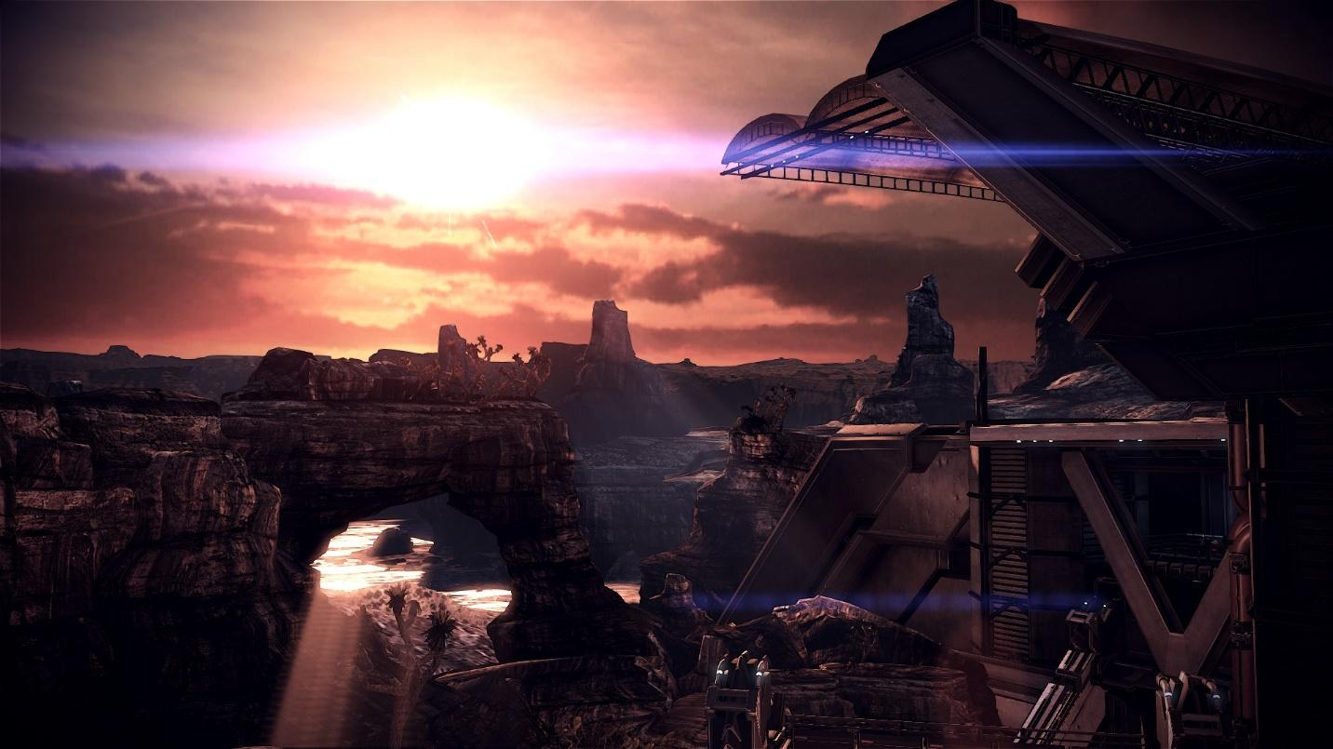

As the crew gets back to the Normandy, they are faced with swarms of Geth troops that is trying to take over the Normandy. The Geth has already begun to wreck chaos inside the Normandy. They have ceased the engine room and the ship cannot take off.
The remaining crew members in the ship is fending of the Geth troops as much as they can. But they will require your assistance as soon as possible. One of your crew mates is inside the weapons room that holds most of your weapons and fire power. The Reactor that activates the orbital bombardment also is being attacked and is close to being destroyed. Some Geth units are cloaked and are harder to track and kill.

Narrative

In this level Players have to play as Shepard (Protagonist) who will be accompanied by his crew depending on what the player had chose for the Mission: Priority Rannoch. The player will have to force his way into the ship only to find themselves caught in a crossfire between the crew of the Normandy and the Geth troops. The main priority for the player is to find the access card that will allow him to use the Elevator. The Player must fight his way through the lower level of the ship (LEVEL A) to find the access card in the Engine Room at the far end of the ship. Optional paths will allow the player to find extra ammo as well as new weapons that will aid him through out the level. Once the player finds the access card and turn the ship on at the Engine Room, player can access the lower lift to go to the second floor (LEVEL B). The second floor of the ship is the Combat Information Center. The player will have to fend off the Geth troops from destroying the reactor that powers the Orbital Bombardment. Failing to do so can risk the mission. Once the Geth Troops are defeated, players will have to rescue one of the Normandy crew guarding the weapons room from the Geth troops. Saving the crew will allow the player to find the next access card. But this time the player will have to face Geth Marauders guarding the lift. Once the player gets past the Geth Marauder, they can access the lift again to take them to the third level. (LEVEL C). The third level is a small area guarded by the best troops of the Geth. Players will have to activate two panels in either sides of the room to activate the main terminal that will allow the Normandy to launch into space and also use the orbital bombardment.

Gameplay

- Different Enemy encounters based on player skills and different enemies.
- Rewarding optional paths that will aid the player through the mission.
- Unlocking shortcuts to a better gameplay experience.
- Fighting enemies, memorizing their attack patterns, and adjusting to their group sizes to defeat them and staying alive will prove to be a challenge to the player.
- Interacting with the environment by turning on the power, accessing lifts with access cards etc.
- Ammo and weapon drops from higher ranked enemies.

Legend

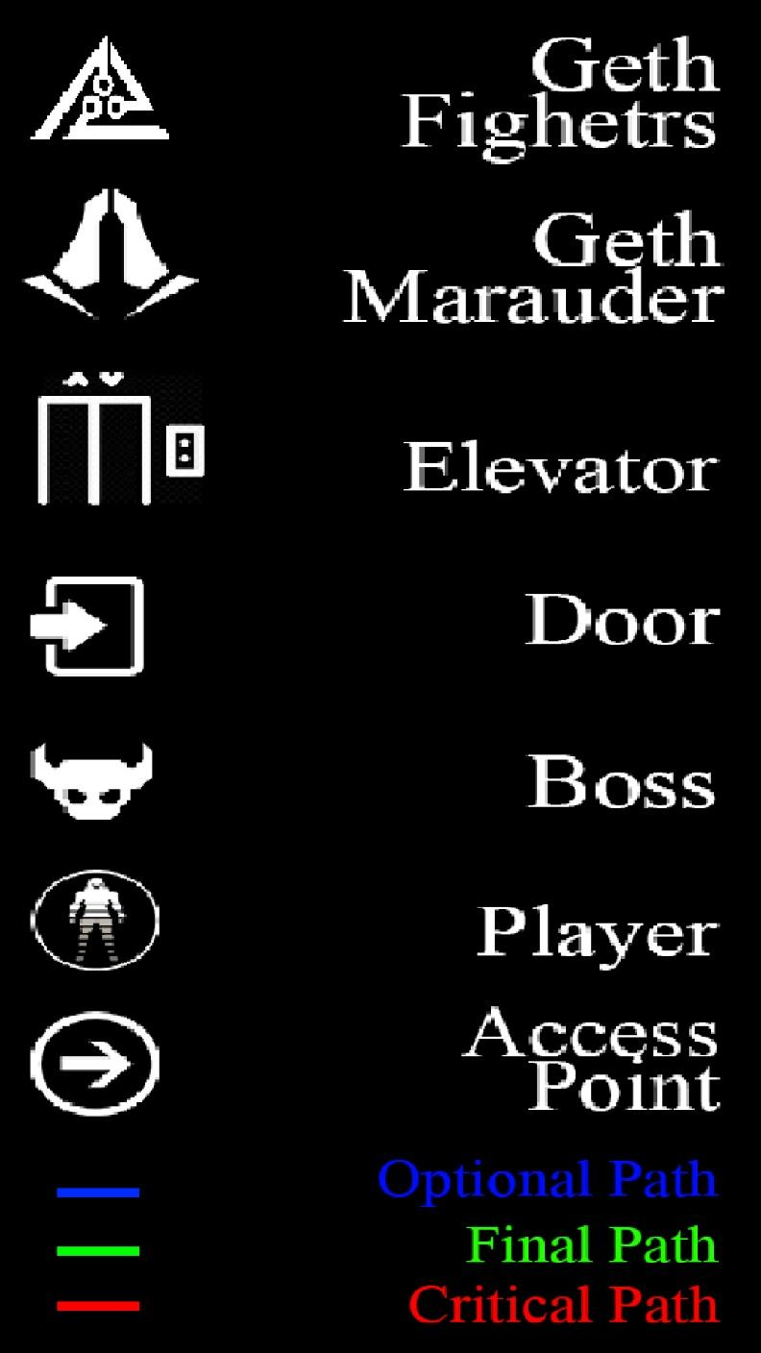
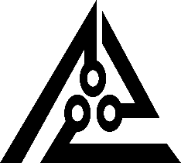 The Logo stands for the Geth fighers. Geth Fighters are the smallest troops of the Geth. They are armed with basic weapons and are easy to kill.

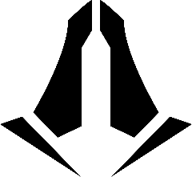The Logo stands for Geth Marauders. Geth Marauders are stronger opponents who holds rocket launchers and are harder to kill.

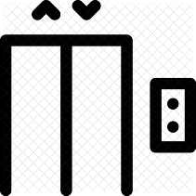The Logo denotes the position of the Elevator. The elevator is situated in the center of each floor. It can be accessed by finding the access cards for the levels.

The Logo stands to denote door areas in the level. Most doors are automatic, inside the ship and will not require players to interact with them.

The Logo shows the boss. The third floor holds the strongest opponents for the player. The boss encounter will be the hardest challenge in the game.

The Logo denotes the character that the player will be playing as. The player plays as the Protagonist Shepard from Mass Effect 3.

The Logo denotes access points. Access points are areas where the player will require to interact with the environment.

Optional / Critical / Final - Paths are marked with different colors for viewing purposes only and shows the optional, critical and final paths.

Metrics

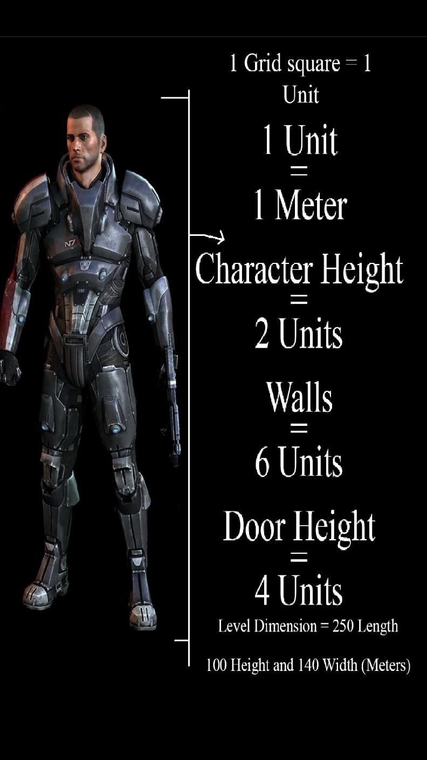
The Whole level is grid based. The grid is made of squares with each side of the square being 1 meter.

The 1 meter squares are called units. The character height is 2 units, which is equal to 2 meters. The walls of the ship is designed to be 6 units and the Doors have a height of 4 units.

3.1) Level Dimensions

250 meters (Length) x
100 meters (Height) x
140 meters (Width).

Geth Fighters are 2.5 units tall.
Geth Marauders are 3 units tall.
Geth Dreadnaughts are 3 units tall and 3 units wide.

Level Layout

4.1) Overall Layout

The following image shows the 3 different floors in the Normandy. The levels are named LEVEL A, LEVEL B and LEVEL C starting from the bottom.
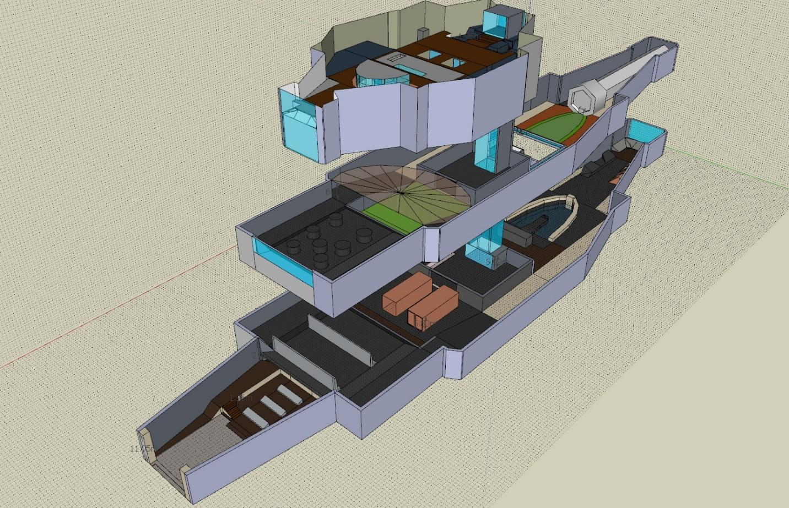

Each level have their own objectives and optional paths that reward the player. Each floor also has a lift that will allow player to travel to different levels. The lift can only be accessed by using access cards that are in different areas in the level that the player has to find.

4.2) LEVEL A

The Level A includes two areas. Player starts at the starting area marked by a red circle above.
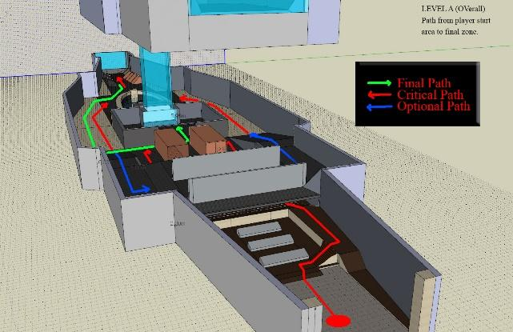
The red path shows the shortest route a player can take to reach the goal of this level. The blue path shows areas where the player can find ammo and other weapons.
This area is mostly covered by Geth fighters. They are easy to kill, but comes in large hordes that will make combat challenging.

4.3) LEVEL B

The Level B includes harder objectives and enemies. The critical paths are shown in red. Players will have to kill more Geth Fighters as well as Geth Marauders guarding them. Geth Marauders are harder to kill.
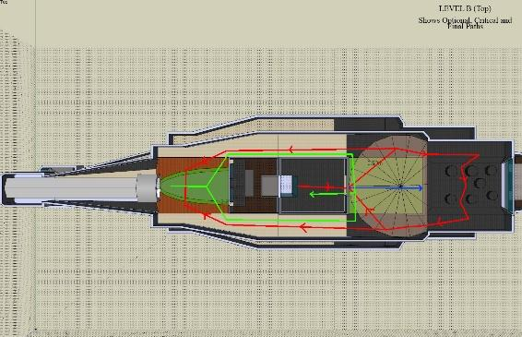

The Level includes the reactor of the ship where the enemies are trying to destroy the reactor to prevent the Normandy from destroying the Reaper Signal. The Level also includes the weapons room where the crew is being overrun by a Geth ambush.

4.4) LEVEL C
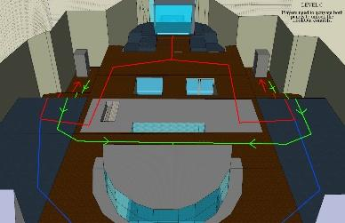
The Level C is the smallest of all the levels. Considering its size, the objectives here are tricky. Players will have to face constant Geth ambushes while they activate both the access machines to activate the lookout controls.

Objectives

5.1) LEVEL A
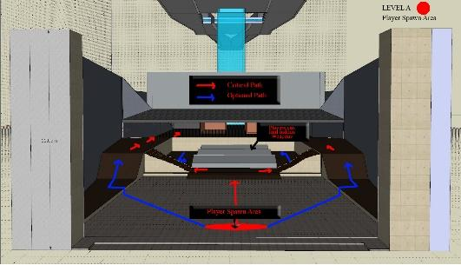
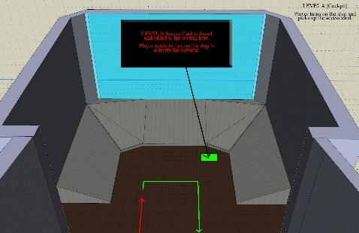
Players start as Shepard at the red circle shown in the image. He will be accompanied by the same crew the player had chose earlier for the Mission: Priority Rannoch. Once the level starts, players can walk towards the staircase in one of the sides and make their way directly towards the lift or choose to use the optional path and refill ammo or find a weapon hidden besides the computers. The main objective for players on this map are:
- Walk up the stairs from the computer lounge to the grand hall at Level A.
- Players can choose not to take the stairs and wander into the computer lounge to find extra ammo and a hidden weapon.
- The grand hall is an open area where the enemies and the player have a clear line of sight. Players are given a better chance of finding their enemies first as the floor is elevated. The elevated floor will serve as a stronger vantage point for the player. Here the player can choose to take either of the side halls that leads to the Engine Room. Players will have to face two groups of Geth Fighter troops.
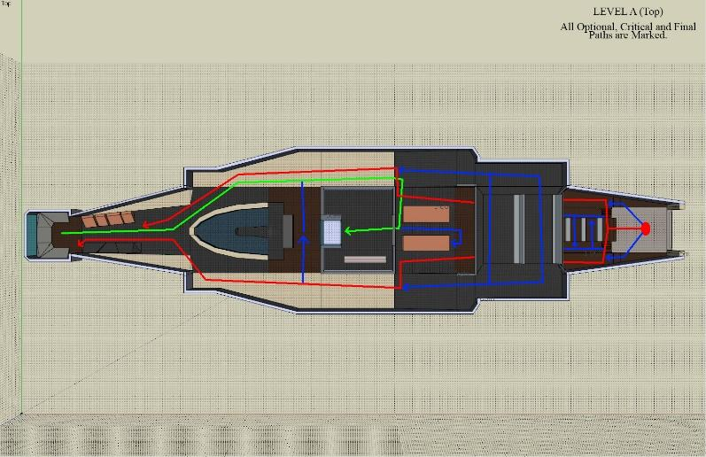
- The level shows player the lift access at the level early. But the power has been turned off by the Geth and can be activated only in the Engine Room. Players will also need an access card to use the lift that can be found in the Engine Room.
- Once the player retrieves the access card and turn the ship on, players hear the ship’s alarm and the ship AI warning players to defend the reactor on Level B.
- Players can now move to Level B using the lift at the center of Level A.

5.2) LEVEL B

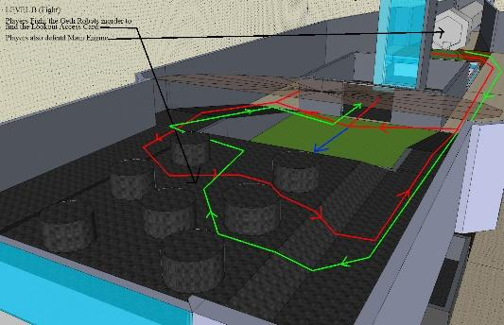
As players enters Level B, they will be able to see the reactor being attacked by Geth Fighters commanded by a stronger Geth Marauder. The glass doors on the lift is a strategic implementation for players to view the fight they are going to, before the encounter actually starts. Players can get prepared earlier giving them an upper hand.
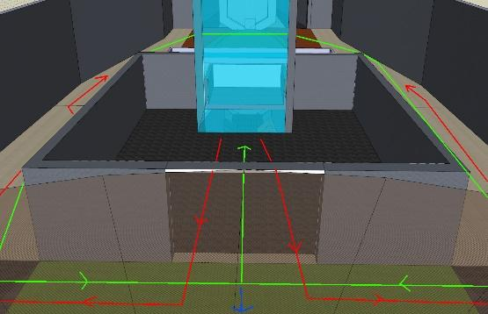
Geth Marauders are harder to kill, but moves slower than the Geth Fighters. Players can use this advantage to kill the Geth Marauders. The main objectives for players on this map are:
- Fend the Geth Marauder and the Geth Fighters away from the reactor and kill them.
- Repair the Reactor using the Repair kit placed near the reactor. Players will need to repair the damage done to the reactor to make sure the orbital bombardment works.
- Once the Player repairs the reactor, he will be able to hear gunfire from the other end of the ship. Players will find themselves in between their crew that’s defending the weapons room and a group of Geth Fighters. The player will have to rescue their crew members.
- Once they rescue the crew members, they are informed that the lookout point has been overrun and the Geth has send a Geth Dreadnaught to guard it.
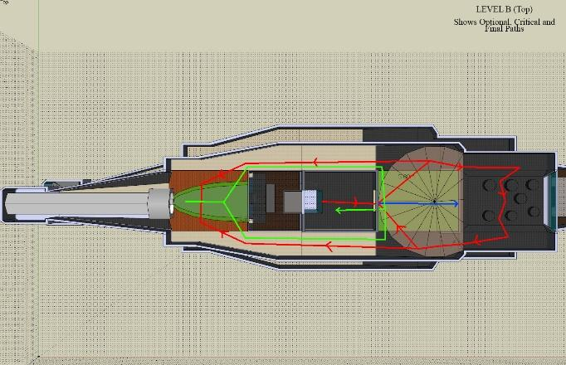
- Players can chose to run up to the lookout point where the Geth Dreadnaught awaits or look around the level for more optional areas.
- Players can find more ammo and a hidden weapon on the fuel room above the weapons room.
- Once the player is prepared, they can choose to go on to face the Geth Dreadnaught on the Level C.

5.3) LEVEL C

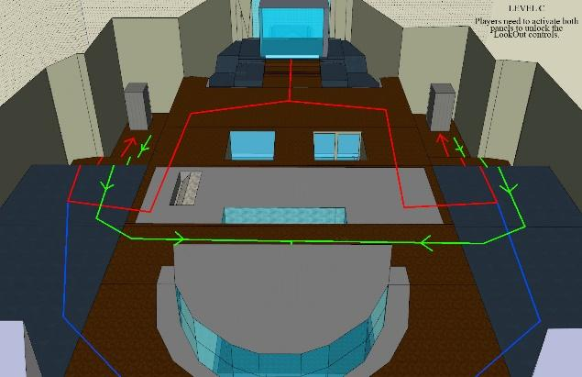
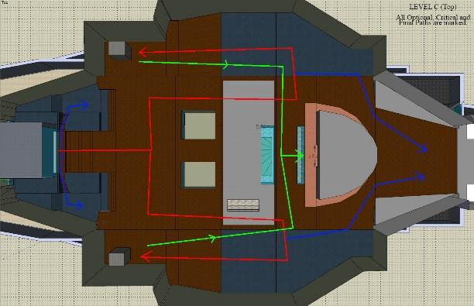
The Level C is the final level on this Mission. The Player lands into a small open hallway two find two Geth Marauders guarding the Access consoles on both ends of the room. Players will also see an inactive Geth Dreadnaught guarding the Lookout Room. Once the Geth Marauders are killed, the Geth Dreadnaught is activated. The Dreadnaught has strong fire power but cannot move. Players can choose to use the de-elevated floor as cover to escape the firepower of the Dreadnaught. However, the Dreadnaught does not move and takes a small gap time to cool its cannons down. This gap serves as an optimal time for the players to use their firepower to destroy the Dreadnaught. As the Dreadnaught reaches 30% health, more Geth Fighters start to spawn from the lift. Players will have to kill the Fighters as well as the Dreadnaught. Players can strategize to use the Dreadnaught’s firepower to kill the Fighters, if timed correctly. Once the dreadnaughts are destroyed, players will have to activate both the access controls to activate the lookout point. The Geth Fighters are flimsy but smart. They can try to deactivate one of the activated consoles, if the player takes too much time to activate the other console. The main objective for the player in this map includes:
- Enter the room and destroy the Geth Marauders.
- The Geth dreadnaught activates and can be real hard to face its firepower. Players will have to physically hide from the directed fire.
- Players can destroy the Dreadnaught when the weapons are cooling down in a small time gap.
- As the Dreadnaught reaches 30% health, more Geth Fighters join the fight making it more intense for the player.
- Once the Dreadnaught is destroyed, the hordes of Geth Fighters will still haunt the player until the player activates both the access consoles.
- Geth Fighters can try to deactivate the activated consoles, so the player should time it correctly.
- Once both the access consoles are activated, the lookout point is unlocked and the Normandy can be secured.
- The area ahead of the lookout point is a hidden area which proves as a non advantage point to most players. However, players who choose to go to that end of the room will be rewarded with a new Armor skin and a Reaper weapon that can match the firepower of the Dreadnaught.

Asset List

NO: | ASSET | DEPARTMENT | NOTES | EXOTIC
1 | Player Character Model | Art | Model of the protagonist Shepard | YES
2 | Player Character Animation | Art | Animation of the protagonist Shepard | YES
3 | Health Bar FX | Art | FX of the protagonist Shepard | NO
4 | Weapon Animations | Art | Animations of the protagonist Shepard | NO
5 | Weapon: Geth Pulse Rifle | Art | Rifle | NO
6 | Weapon: Collector Assault Rifle | Art | Rifle | NO
7 | Weapon: M-8 Avenger | Art | Rifle | NO
8 | Geth Fighter Model | Art | Model of the Geth Fighter | YES
9 | Geth Fighter Animation | Art | Animation of the Geth Fighter | NO
10 | Geth Marauder Model | Art | Model of the Geth Marauder | YES
11 | Geth Marauder Animation | Art | Animation of the Geth Marauder | NO
12 | Geth Dreadnaught Model | Art | Model of the Geth Dreadnaught | YES
13 | Geth Dreadnaught Animation | Art | Animation of the Geth Dreadnaught | NO
14 | Ammo Model | Art | Model of Ammo | NO
15 | Lift Model | Art | Model of the Lift | NO
16 | Lift Animation | Art | Animation of the Lift | NO
17 | Access Console Model | Art | Model of the Access Consoles | NO
18 | Access Console Animation | Art | Animation of the Access Consoles | NO
19 | Sound FX | Audio | Sound effects during combat and walk | YES
20 | Music | Audio | Music for the level | YES
21 | Player Character Sound | Audio | Sound of the protagonist Shepard | NO
22 | Lighting Level A | Art | Lighting for the Level A | NO
23 | Lighting Level B | Art | Lighting for the Level B | NO
24 | Lighting Level C | Art | Lighting for the Level C | YES
25 | Carpet Model | Art | Model of the carpets | YES
26 | Cinematic 1 | Video | Cinematic 1: Geth infiltration | YES
27 | Cinematic 2 | Video | Cinematic 2: Defending Weapon Room | NO
28 | Geth Fighter AI | Programming | AI for the Geth Fighters | NO
29 | Geth Marauder AI | Programming | AI for the Geth Marauders | NO
30 | Geth Dreadnaught AI | Programming | AI for the Geth Dreadnaught | NO
31 | Combat Information Center Hologram | Art | Hologram FX | YES
32 | Fight Sequence Music | Audio | Music during the combat | YES
33 | Crew A Model | Art | Model of the Crew A: Weapon Room | NO
34 | Crew A Animation | Art | Animation of Crew A | NO
35 | Crew A AI | Programming | AI for Crew A | NO
36 | Crew B Model | Art | Model of Crew B: Weapon Room | NO
37 | Crew B Animation | Art | Animation of Crew B | NO
38 | Crew B AI | Programming | AI for Crew B | NO
39 | Computer Model | Art | Model of the computers | YES
40 | Console Model | Art | Model of the consoles | YES

