|  |
| --- |
| **SECTION 1 Product and company identification**  Product name: MAX-902 Standard Activator  Manufacturer: YATU Advanced Materials Co., LTD.  Address: Sanlian Industrial Area 2, Gulao, Heshan, Guangdong, China  Tel: 0750-8778888 Fax: 0750-8773326  E-mail: [info@yatupaint.cn](mailto:yatu@yatupaint.com) Postcode: 529738  Enterprise Emergency contact number: 0750-8773397  National Emergency contact number: 0532-83889090  Product usage: Additive for automotive refinishing. Professional use only. |

**SECTION 2 Hazards identification**

**Emergency Outline:**

Viscous flammable liquid and vapor with slight odor. Its vapor forms explosive mixtures when meets air. May cause combustion and explosion when meets with open flames and high heat. Easy to generate and accumulate static electricity. Fast flow velocity. It may cause eye, nose and throat irritation. May cause central nervous system depression if inhaled.

**GHS hazards categories:**

|  |  |  |
| --- | --- | --- |
| Flammable liquids | Category 3 | H226-flammable liquid and vapor |
| Acute toxicity (skin) | Category 4 | H312-harmful in contact with skin |
| Acute toxicity (inhalation) | Category 4 | H332-harmful if inhaled |
| Skin irritation | Category 2 | H315-causes skin irritation |
| Eye irritation  Reproduction toxicity  Specific target organ toxicity (single exposure) | Category 2A  Category 2  Category 3 | H319-causes serious eye irritation  H361-suspected injury to fertility or fetus  H336-may cause respiratory irritation |
| Acute hazard to the aquatic environment | Category 3 | H402-very toxic to aquatic life |
| Long-term aquatic hazard | Category 3 | H412-harmful to aquatic life with long lasting effects |

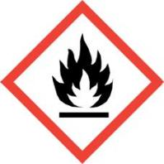**Label elements：**

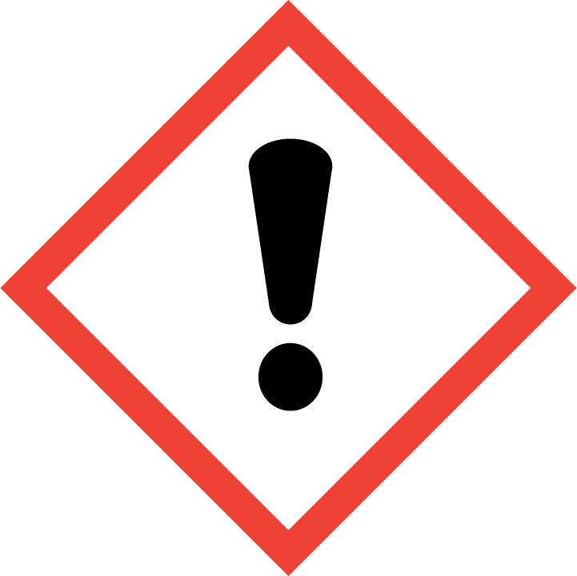Hazard pictograms：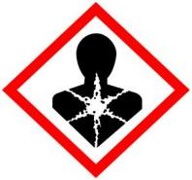

**Signal word**: Warning

**Precautionary statements:**

**Prevention:**

|  |  |
| --- | --- |
| P233 | Keep container tightly closed. |
| P235 | Keep cool. |
| P240 | Ground and bond container and receiving equipment. |
| P271 | Use only outdoors or in a well-ventilated area. |
| P210 | Keep away from heat, hot surfaces, sparks, open flames and other ignition sources. Use non-sparking tools. |
| P243 | Take action to prevent static discharges. |
| P241 | Use explosive-proof [electrical/ventilating/lighting…] equipment. |
| P280 | Wear protective glove/protective clothing/eye protection/face protection |
| P261 | Avoid breathing dust/fume/gas/mist/vapor/spray. |
| P273 | Avoid release to the environment. |

**Response to accidents:**

|  |  |
| --- | --- |
| P312 | Call a POISON CENTER/doctor/…if you feel unwell. |
| P304+P340 | IF INHALED: Remove person to fresh air and keep comfortable for breathing. |
| P305+P351+P338 | IF IN EYES: Rinse cautiously with water for several minutes. Remove contact lenses, if present and easy to do. Continue rinsing. |
| P337+P313 | If eye irritation persists: Get medical advice/attention. |
| P303+P361+P353 | IF ON SKIN (or hair): Take off immediately all contaminated clothing. Rinse skin with water [or shower]. If irritation gets worse (redness, rash, blister), get medical attention immediately. |
| P332+P313 | If skin irritation occurs: Get medical advice/attention. |
| P370+P378 | In case of fire: Use…to extinguish. |
| P391 | Collect spillage. |

**Safe storage:**

|  |  |
| --- | --- |
| P403+P235 | Store in a well-ventilated place. |
| P405 | Store locked up. |

**Disposal:**

P501 Dispose of contents/container to…

**Physical and chemical hazards:**

Flammable liquid and vapor.

**Health hazards:**

It is hazardous if inhaled or on skin. It causes skin irritation and severe eye irritation, and it may cause respiration tract irritation.

**Environmental hazards:**

It is hazardous to aquatic life with long lasting effects.

**SECTION 3 Composition/information on ingredients**

**Substance /mixture: mixture**

product ingredient:

Chemical name % CAS Number

|  |  |  |
| --- | --- | --- |
| Butyl acetate | 25-35 | 123-86-4 |
| Xylene | 25-35 | 1330-20-7 |
| Resin curing agent | 30-40 | N/A |

**SECTION 4 First aid measures**

**Description of first aid measures:**

**Inhalation:** Remove to fresh air. Keep person warm and at rest in a position comfortable for breathing.

**Skin contact:** Take off immediately all contaminated clothing. Rinse skin thoroughly with soap water. If irritation gets worse (redness, rash, blister), get medical attention immediately.

**Eye contact:** Remove contact lenses, irrigate copiously with clean, fresh water, holding the eyelids apart. Seek immediate medical advice.

**Protection of first aiders:** the rescuer should wear an appropriate mask or self-contained breathing apparatus

before enter accident scene.

**Notes to physician:** the harmful ingredients are displayed in section 3 and 11.

**SECTION 5 Firefighting measures**

**Extinguishing media:**

Use dry chemical, sand, foam or CO₂ extinguishers. Do not use water jet directly.

**Special hazards:**

Flammable liquid and vapor. Its vapor forms explosive mixtures when meets air. May cause combustion and explosion when meets with open flames and high heat. Fast flow velocity. Easy to generate and accumulate static electricity.

**Special firefighting procedure and advice for protection:**

Remove and process liquids from fire area in case of environment pollution. Fire-fighters should wear full protective clothing and self-contained breathing apparatus (SCBA) and stand on upwind area for firefighting.

|  |
| --- |
| **SECTION 6 Accidental release measures**  **Personal precautions, protective equipment and emergency procedures:**  Be stored in well-ventilated place and keep away from ignition sources.  Ensure all devices are grounded while they are working.  Emergency responders should wear full protective clothing and self-contained breathing apparatus during clean-up.  Follow the safety regulations.  **Environmental precaution：**  Avoid discharge into drains and water pipes. Inform the relevant authorities if there are pollutions entering into the rivers, lakes or waterways.  **Methods and material for containment and cleaning up:**  Small spills: Absorb with activated carbon or other inert material or wash out with lotion made by incombustible dispersant. After diluting, place it in an appropriate waste disposal container. |

Large spills: Dike the spilled material and confine the sewers, where this is possible. Cover with foam to prevent evaporation. Collect and transfer spillage with explosive-proof pump, and place in tank trucks or containers for later recycle or disposal.

**SECTION 7 Handling and storage**

**Precautions for safe handling:**

Obtain special instructions before use. Do not handle until all safety precautions have been read and understood.

The operator should wear antistatic clothing and shoes and put on rubber oil-resistant gloves.

Workplace should be partial or comprehensive ventilated.

Use explosion-proof ventilation and equipment.

Filling speed should be controlled.

Grounding device is needed to prevent static accumulation.

Loading and unloading should be careful in order to prevent the damage of package and container.

Avoid contact with eyes, skin. Do not breathe mist or vapor.

Eating, drinking and smoking are prohibited in areas where this material is handled, stored and processed.

**Conditions for safe storage, including any compatibility:**

Store in a cool and well-ventilated warehouse.

Keep away from heat, direct sunlight or any source of ignition. Storage temperature: 0-35℃. Stored in a tightly closed container. Separate from oxidizing materials.

Use explosive lightning and ventilation devices with the switch outside the warehouse. Equipped with corresponding firefighting equipment with certain quality and quantity.

Barrel stacking should not be too large because it must keep a certain distance with wall, ceiling, column and fire inspection walkway.

Use only non-sparking tools and devices.

The storage area should be provided with a leak emergency operation device and appropriate containers.

**SECTION 8 Exposure controls/personal protection**

**Occupational exposure limits:**

|  |  |  |
| --- | --- | --- |
| Ingredient name | Maximum allowable concentration | Standard |
| Butyl acetate | PC-STEL：300mg/m3；PC-TWA：200mg/m3  STEL：200ppm；TWA：150ppm | GBZ 2.1 OEL (China)  ACGIH TLV (USA) |
| Xylene | PC-STEL：100mg/m3；PC-TWA：50mg/m3  STEL：150ppm；TWA：100ppm | GBZ 2.1 OEL (China)  ACGIH TLV (USA) |

**Methods of monitoring:**

Method for determination of toxic substances in the air of workplace: Solvent Analysis-gas chromatography in GBZ/T 160.42, thermal desorption-gas chromatography, non-pump sampling -gas chromatography.

**Engineering controls:**

As flammable liquid separated workplace is needed. The operation should be done in a closed place, in order to prevent vapor leaking in the air. Promote ventilation and maintain the airborne concentrations below the occupation exposure limits. Set up automatic alarm and accidental ventilation equipment. Emergency exits and risk-elimination areas are necessary. Set up communication alarm system. Red zone warning line, warning signs and Chinese warning instructions are needed.

**Personal protective equipment:**

**Respiration protection:** If engineering controls do not maintain airborne concentrations below recommended exposure limits (where applicable), a self-absorption filter mask (half mask) must be worn. When emergency rescue or evacuation occurs, workers should wear air respirator or oxygen breathing apparatus.

**Eye protection:** wear safety goggles with side shields.

**Skin/body protection:** wear appropriate chemical resistant clothing.

**Hand protection:** wear rubber oil-resistant gloves.

**SETION 9 Physical and chemical properties**

**Appearance and character**: Transparent mucus

Boiling point (**℃**): 105-266

Flash point (**℃**): 29 (closed cup)

Upper/lower flammability or explosive limits:

Flammability limit – lower (%): N/A

Flammability limit – upper (%): N/A

Viscosity (-4 cup, second, 30**℃**): 10-50

VOC (g/L): 520-620

Relative density (assume water as 1): 0.94

Solubility: Hardly soluble in water

**SECTION 10 Stability and reactivity**

**Stability:** The product is stable.

**Possibility of hazardous reactions:** No dangerous reaction known under conditions of normal use.

**Conditions to avoid:** Avoid static electricity, high heat, open flames.

**Incompatible materials:** Strong acids, strong oxidizing agents, and strong alkali.

**Hazardous decomposition products:** No hazardous decomposition products are known under the condition of normal use.

**SECTION 11 Toxicological information**

**Acute toxicity:**

|  |  |  |  |  |
| --- | --- | --- | --- | --- |
| Ingredient name | Result | Species | Dose | Exposure |
| Butyl acetate | LC50 Vapor Inhalation  LD50 Dermal  LD50 Oral | Rat  Rabbit  Rat | 390ppm  ＞17600mg/kg  10768mg/kg | 4 hours  -  - |
| Xylene | LD50 Oral | Rat | 4300mg/kg | - |

**Irritation/corrosion:**

|  |  |  |  |  |  |
| --- | --- | --- | --- | --- | --- |
| Ingredient name | Exposure  pathway | Result | Species | Dose/time | Observation |
| Butyl acetate | Eye  Skin | Moderate irritant Moderate irritant | Rabbit  Rabbit | 100mg  500mg/24h | -  - |
| Xylene | Eye  Eye  Skin  Skin  Skin | Mild irritant  Severe irritant  Mild irritant  Moderate irritant Moderate irritant | Rabbit  Rabbit  Rat  Rabbit  Rabbit | 87mg  5mg/24h  60μL/8h  500mg/24h  100% | -  -  -  -  - |

**Reproductive toxicity:**

**Butyl acetate:** Rat inhaled a minimum toxic concentration (TCL0) of 1500ppm/7h (7-16 days of gestation), which resulting in fetal toxicity and skeletal dysplasia.

**Xylene:** Rat inhaled a minimum toxic concentration (TCL0) of 200ppm/6h (4-20 days of gestation), which resulting in abnormal skeletal development and neonatal behavior.

**Specific target organ toxicity – single exposure:**

**Butyl acetate:** Affects the central nervous system, may cause drowsiness or dizziness.

**Specific target organ toxicity – repeated exposure:**

**N/A**

**Aspiration hazards:**

May cause nasal and throat irritation. It may cause neurasthenia. The typical symptoms are: headache, drowsiness, nausea, teetering, confusion of consciousness, and unconsciousness.

**Ingestion hazard:** It may cause gastrointestinal discomfort.

**Contact hazards:**

It may cause eye irritation or burns, even skin irritation with repeated or long-term contact. Discomfort and dermatitis may occur as well.

**SECTION 12 Ecological information**

**Ecological toxicity:**

|  |  |  |  |
| --- | --- | --- | --- |
| Ingredient name | Result | Species | Exposure |
| Butyl acetate | Acute LC50 32000μg/L seawater  Acute LC50 62000μg/L | Crustacean- Artemiasalina  Fish- Daniorerio | 48hours  96hours |
| Xylene | Acute LC50 8500μg/L seawater  Acute LC50 13400μg/L freshwater | Crustacean-Palaemonetespugio  Fish-Pimephalespromelas | 48hours  96hours |

**Persistence and degradability:** Not available

**Bio-accumulative potential:**  Not available

**Mobility in soil:**  No data available

**SECTION 13 Disposal considerations**

**Chemical waste treatment methods:**

Recommend the treatment method of transferring waste into energy if possible. Incineration or landfill should only be considered when recycling is not feasible. Discharging the product into the sewage is prohibited.

**Contaminated package treatment methods:**

Empty containers should be taken to an approved waste handling site for recycling or disposal. If not, disposal should be in accordance with applicable regional laws and regulations.

**Notes for disposal:**

The applicable regional, national regulations should be read before disposal.

**SECTION 14 Transport information**

**UN number:** UN 1263

**UN proper shipping name:** Paint related material

**Transport hazard class (es):** 3

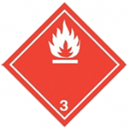**Danger Pictograms:**

**Packing group:** Ⅲ

**Package label:** flammable liquid

**Marine pollutant substances:** Not applicable

**International shipping regulations:**

**United States Department of transportation:** 49CFR rating: 3 (flammable liquid and vapor).

**Marine, IMDG rating:** 3 (flammable liquid and vapor).

**Shipping, IATA rating:** 3 (flammable liquid and vapor).

**Notes for transport:**

The transportation vehicles shall be equipped with corresponding firefighting equipment and emergency treatment devices.

All transporting trucks should have grounded devices.

It cannot be transported with oxidant and food chemicals.

Transportation should prevent insolation, rain, and high temperature. Morning and evening transport are recommended.

Stay away from fire, heat, high temperature zone when stopover.

The vehicle exhaust pipe must be equipped with a fire retardant device, and use only non-sparking machines and tools for loading and unloading.

Drivers should follow the driven routes. Do not stay in residential areas and densely populated areas. Do not use wooden, cement ships for bulk transportation because it will pollute the ocean if it leaks.

**SECTION 15 Regulatory information**

**Applicable laws and regulations:**

Safe Production Law of the People's Republic of China

Code of Occupational Disease Prevention of PRC

Environmental Protection Law of the People’s Republic of China

Laws of the People’s Republic of China on the Prevention and Control of Atmospheric Pollution

Marine Environment Protection Law of the People’s Republic of China

Law of the People's Republic of China on the prevention and control of environmental pollution by solid wastes

Fire Control Law of the People’s Republic of China

Regulations on the Control over Safety of Dangerous chemicals

Occupational Exposure Limits for Hazardous Agents in the Workplace (part 1: chemical hazardous agents) (GBZ 2.1)

Occupational Exposure Limits for Hazardous Agents in the Workplace (part 2: Physical Agents) (GBZ 2.2)

General Rules for Chemical Classification and Risk Disclosure (GB 13690)

National Hazardous Waste List

General Rules for Storage of Dangerous Chemicals (GB 15603)

List of Dangerous Goods (GB 12268)

Classification and Code of Dangerous Goods (GB 6944)

Labels for Packages of Dangerous Goods (GB 190)

**SECTION 16 Other information**

**Key to abbreviations:**

MAC --Maximum Allowable Concentration: refers to the concentration of toxic chemicals that should not exceed at any time during a working day in the workplace.

PC-TWA -- Permissible Concentration-Time Weighted Average: refers to the average level of allowable contact in the stated working day of 8 hours.

PC-STEL ---Permissible Concentration- Short Term Exposure Limit：refer to the time weighted average for any allowable contact less than 15 minutes within 8 hours.

ACGIH TWA--- American Conference of Governmental Industrial Hygienists- Time weighted average

ACGIH STEL--- American Conference of Governmental Industrial Hygienists- Short Term Exposure Limit

LD50: It refers to lethal dose with oral and dermal exposure. In statistics, it is expected to cause 50% individual deaths in a group of subjects.

LC50: It refers to lethal concentration with respiration inhalation. In statistics, it is expected to cause 50% individual deaths in a group of subjects.

EC50；It refers to the concentration that can cause the 50% of maximal effect.

**References:**

1. Zhou Guotai, *Hazardous chemicals safety technology*, Chemical Industry Press, 1997.

2. State Environmental Protection Administration of toxic chemicals management &the Beijing Institute of chemical research, *Handbook of Environmental Data for Environmental Regulations*, China Environmental Science Press, 1992.

3. Cheng nenglin, *Solvent Handbook*, Chemical Industry Press, 1994.

4. Canadian Centre for Occupational Health and Safety. CHEMINFO Database, 1989.

**Disclaimer:**

The information contained in this data sheet is based on present scientific and technical knowledge. The purpose of this information is to draw attention to the health and safety aspects concerning the products, and to recommend precautionary measures for the storage and handling of the products. The users should have their own ideas about the practical appliance of this MSDS. No warranty or guarantee is given in respect of the properties of the products. No liability can be accepted for any failure to observe the precautionary measures described in this data sheet or for any misuse of the product.