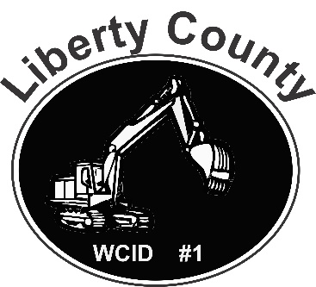

Liberty County Water Control District #1

Date of Notice Issued____________

You are being issued this letter to inform you are in violation of Liberty County Water Control Right-of-Way easement. These easements are put in place to allow the maintenance and improvement of the county’s drainage systems, at this location the easement is set at ______ feet. Your fence/structure appears to be________feet within the easement maintained by LCWCD #1. You have 30 days from the day you received this notice to comply with the above request. For further information regarding this matter call (832)-444-3935

Leonard Vyoral
President,
Liberty County Water Control District #1

