Silver Springs Fleetwood Mac Tribute

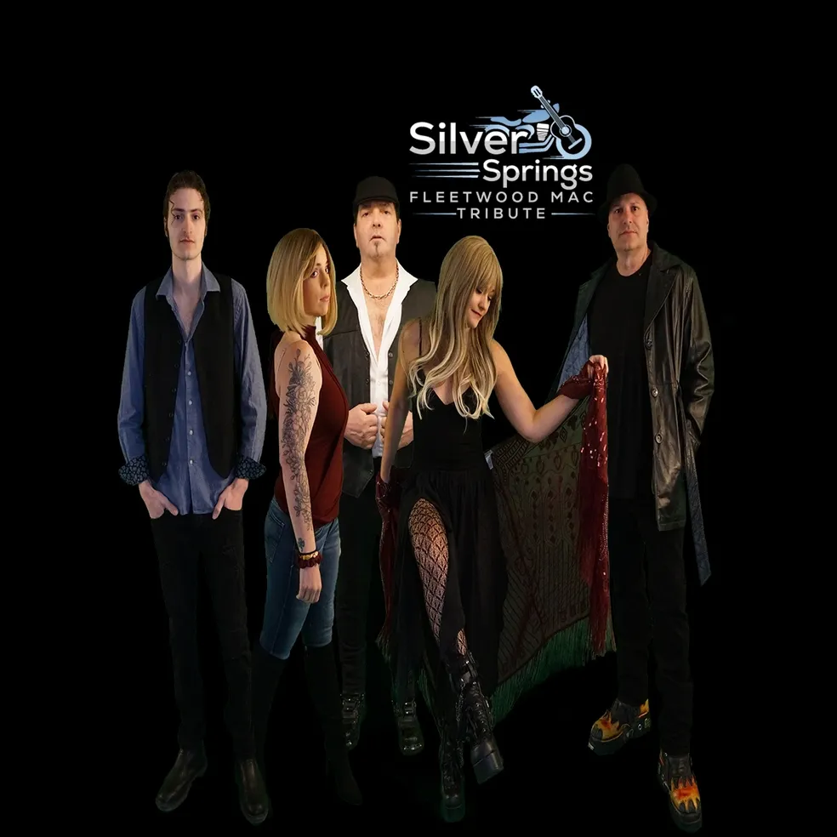

Silver Springs Fleetwood Mac Tribute, featuring current members of Leaving Eden, New England USA, Available Worldwide for any size engagements. This unique quintet covers over 4 decades of the Best Fleetwood Mac songs ever recorded. Staying true to the sound, vibe and the look of Fleetwood Mac, a theatrical performance enhanced with state of the art sound and lighting, paired with high quality video scenes, is truly second to none. Dark Star Records/Sony/Universal Worldwide Distribution.

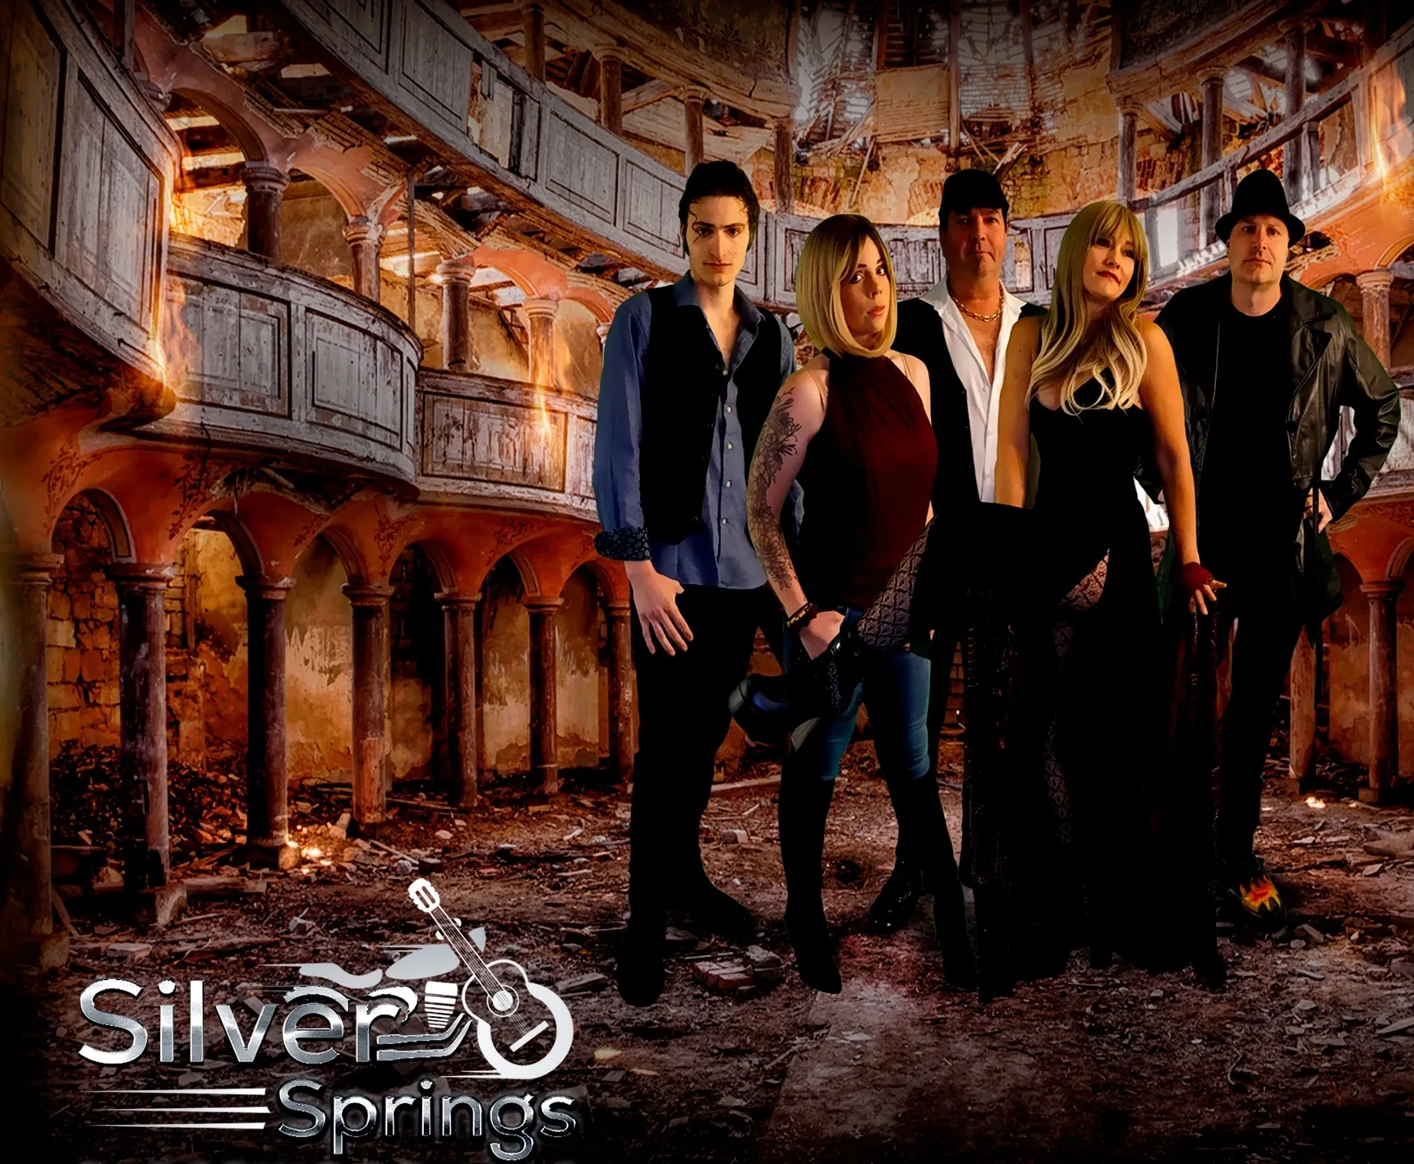

Facebook:

<https://www.facebook.com/SilverSpringsTribute/>

Instagram:

<https://www.instagram.com/silverspringsfleetwoodtribute/>

X:

<https://x.com/SpringsMac>

Youtube:

<https://www.youtube.com/channel/UCfZ6AmNcEV8YukmKIuiBgbw>

Email:

[leavingeden@comcast.net](mailto:leavingeden@comcast.net)

[Silver Springs Fleetwood Mac Tribute Live Promo Video](https://youtu.be/KaV3QA3Nb2U?si=dOau1riLWA57JXHt)

[Silver Springs Fleetwood Mac Tribute Casino Ballroom NH Promo Clip](https://youtu.be/MmmINcRdfgc)

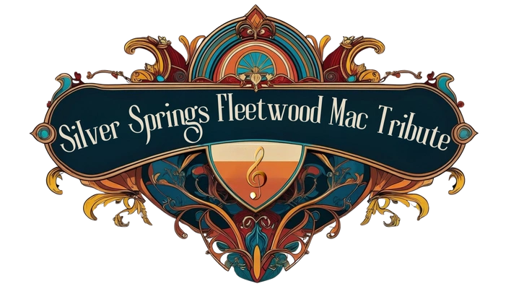

**Silver springs**

Fleetwood MacTribute

Sample Songlist

The Chain

Dreams

Monday Morning

Say you love me

Gold dust woman

Go your own way

Hold me

Landslide

Rhiannon

You make loving fun

Oh well

Gypsy

Secondhand news

Silver springs

Tusk

Don’t stop

Never going back again

Big love

Stop Dragging My Heart around (Stevie Nicks/Tom Petty)

Edge of seventeen (Stevie Nicks)