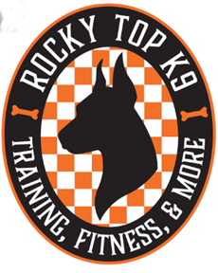

Rocky Top K9, LLC Dog Club Rules & Regulations

Rocky Top K9, LLC Dog Club has been created so that we, our clients, and their dogs can continue to keep the skills learned in our lessons sharp. Our club events are designed to engage the dog’s mind and physical conditioning as well as to keep their socialization conditioning. This is also intended as an outlet for us dog owners to hang around other like-minded, responsible dog lovers. In addition, we will be there as support if you’re having an issue. Our club events are meant to be social functions of fun and there is no competition or pressures.
- Dogs must have passed our basic & advanced obedience programs. (Or be previous client’s who have passed the advanced obedience program.)

- Dogs must have good manners and not be dog or people aggressive.

- Dog’s must be up to date on shots & be on flea / tick preventative. (We like to share, but not with this.) 😊

- A signed release of liability must be completed and on file.

- Dues must be current and in good standing.

- Registration is required for each event, to keep group sizes manageable.

- Dogs will always be leashed and kept under control.

- Owners will pick up after themselves & their dog. Please no littering of cigarette butts, trash, or poo.

- Members will be considerate & respectful of one another. We all have our differences so please keep conversations to non-controversial subjects to keep the atmosphere cohesive.

