**FOR IMMEDIATE RELEASE**

June 1, 2020

**PHILADELPHIA COMMISSIONERS HID VOTING MACHINE FAILURES**

***ExpressVote XLs had problems at more than 40% of polling locations***

In the November 2019 election, new ES&S ExpressVote XL voting machines [failed spectacularly](https://www.nytimes.com/2019/11/30/us/politics/pennsylvania-voting-machines.html) in Northampton County, Pa. But in Philadelphia, election officials claimed the $8000 machines worked smoothly.

**A** [**detailed Reuters investigation published today in *The New York Times***](https://www.reuters.com/article/us-usa-election-pennsylvania-machines-ex/exclusive-philadelphias-new-voting-machines-under-scrutiny-in-tuesdays-elections-idUSKBN23828J) **shows those claims were untrue.** Using over 600 “trouble cards,” which recorded calls for help from polling place staff to the Board of Elections, the Reuters team found:

* Problems reported with at least 366 ExpressVote XL machines — about 10% of those used.
* Problems including unusable machines affected over 40% of the county’s polling locations.
* The most frequently reported problem: difficulty voting because of screen sensitivity.
* Out-of-commission ExpressVote XL machines accounted for more than a third of the 605 trouble cards.

At the time, the City Commissioners Office, often represented by Deputy Commissioner Nick Custodio, painted a very different picture. Custodio [told WHYY](https://whyy.org/articles/philly-officials-praise-new-voting-machines-say-they-will-fix-significant-wrinkles-for-2020/) that “things went well for the most part,” [told NBC10](https://www.nbcphiladelphia.com/news/local/philadelphia_s-slow-election-results_philadelphia/2152841/), “The problems we had are problems you have with any equipment … the response I’ve gotten from voters themselves, all day long it’s been great,” and [told *Billy Penn*](https://billypenn.com/2019/11/05/twitchy-touchscreens-tiny-font-button-confusion-did-phillys-new-voting-machines-pass-their-test/) the new system wasn’t making much difference in the type of complaints coming in, saying, “The same stuff that normally dominates, dominated today…Election judges oversleeping, stuff like that. From our perspective this has been a normal election.”

***Jump to the FULL LIST OF PROBLEMS REPORTED***

The Commissioners, in their role [as the Board of Elections](https://docs.google.com/document/d/1zBUWtgBmhobIC4HepVOvq8ky4YWtzAbf-QFAEcwXMGE/), were responsible for selecting the $29 million ExpressVote XL system. Commissioner Lisa Deeley [has cited](https://youtu.be/MiYiAbA38Nk?t=741) the system’s hIgher ongoing expenses in asking for additional funding, saying otherwise, “we would be in danger of not being able to have the November election.”

Protect Our Vote Philly first brought attention to many of these problems through [its own voter survey in November](https://docs.google.com/document/d/18ngOfh3SfCy2xnvD_oWTbwQe66HSUN0RZgysdUIe5NU/) and [pointed out](https://papost.org/2019/12/12/human-error-and-sensitive-touchscreens-blamed-for-northampton-co-election-problems/) that the screen problems seen in Northampton were also common in Philadelphia. Several of its members helped Reuters obtain evidence, scanning in the “trouble cards” one at a time while closely watched by Custodio, who is also the designated right-to-know officer of the City Commissioners. Custodio is a political appointee of Deeley, who is a former staffer for indicted Councilmember Bobby Henon.

“The Commissioners operate in bad faith when they misrepresent voting machine performance to the public,” said Protect Our Vote Philly’s Scott McCarthy. “We deserve transparency and honesty.”

Voters in the primary on June 2 will be required to use the machines if they vote at a polling place, unless they are voting provisionally. Protect Our Vote Philly is again [asking voters to respond to a survey](http://survey.povphilly.org), whether they vote at a polling place or by mail-in or absentee ballot.

# # #

*For more information, contact* [*povphilly@gmail.com*](mailto:povphilly@gmail.com) *or Rich Garella at 212 473-6929.*

***SAMPLE CARDS***

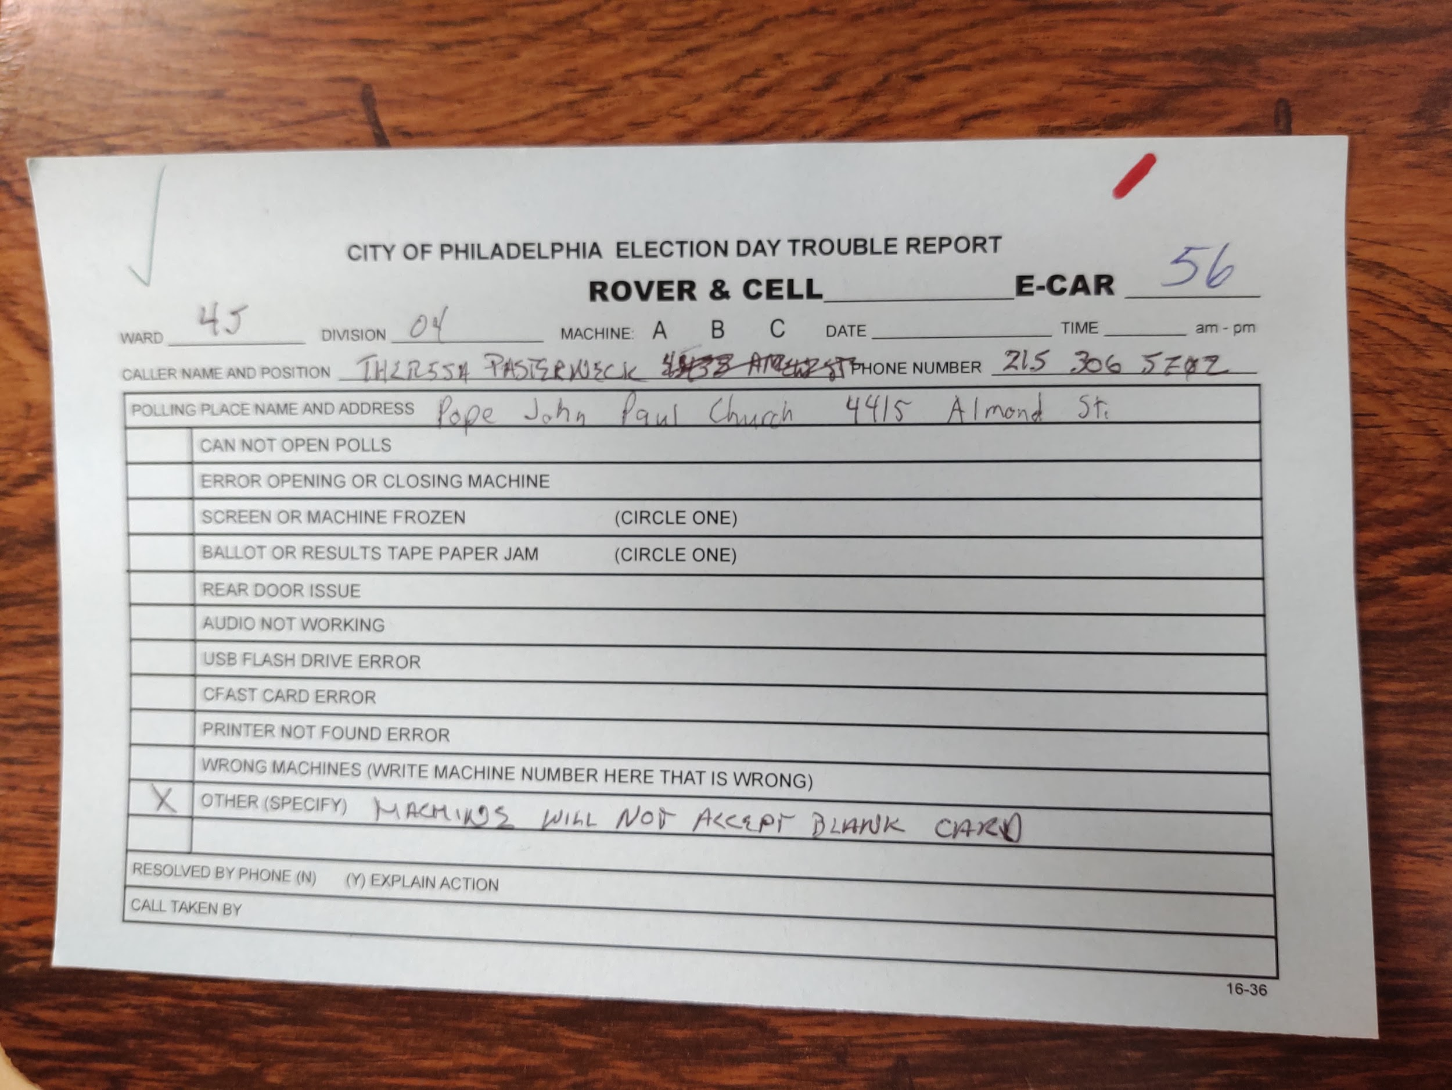

*“Machine will not accept blank card”*

This means that voting sessions cannot be initiated and the machine cannot be used.

In this case there’s no time recorded and it is unclear if, when or how the problem was resolved.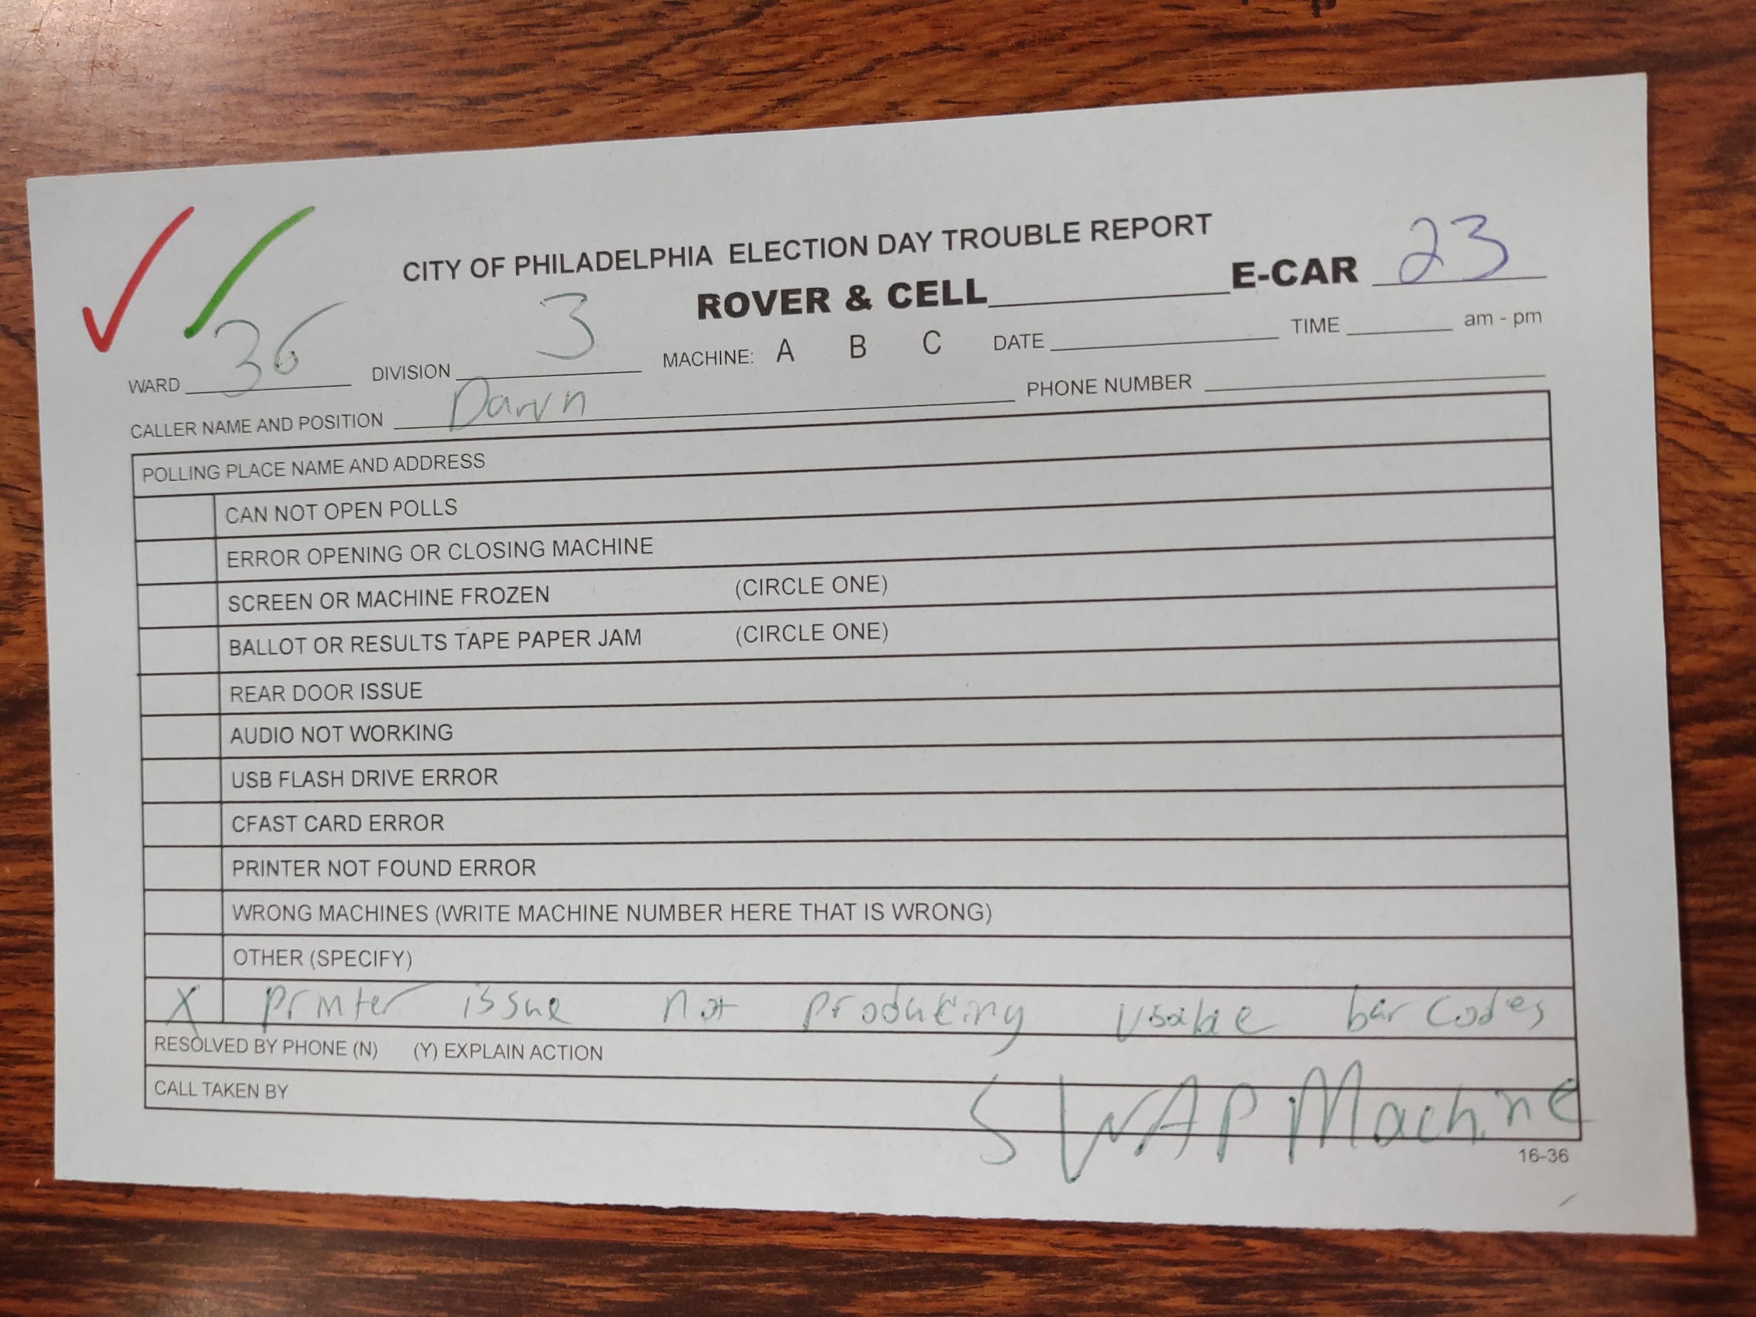

“*Printer issue not producing viable bar codes*

*SWAP MACHINES*”

If the machine fails to scan the bar codes that it prints, the ballot card is normally ejected and voting is impossible.

In this case it appears a new machine was at least requested; but again no resolution time is indicated.

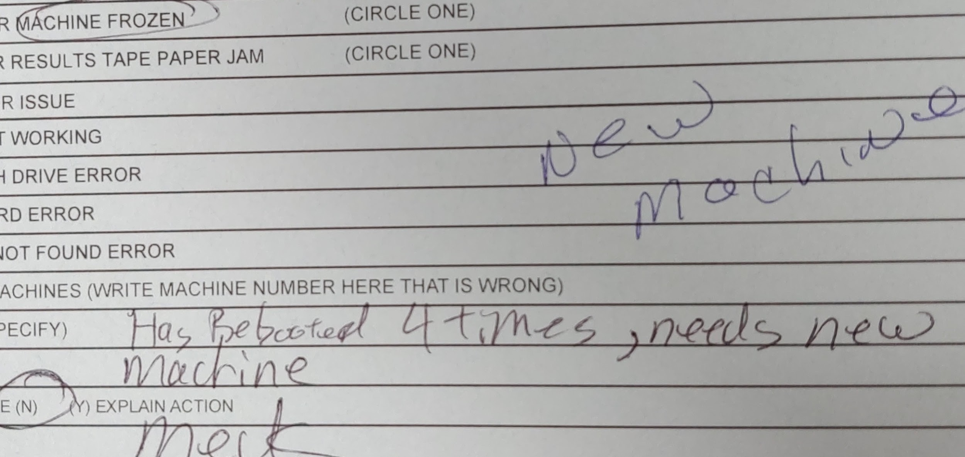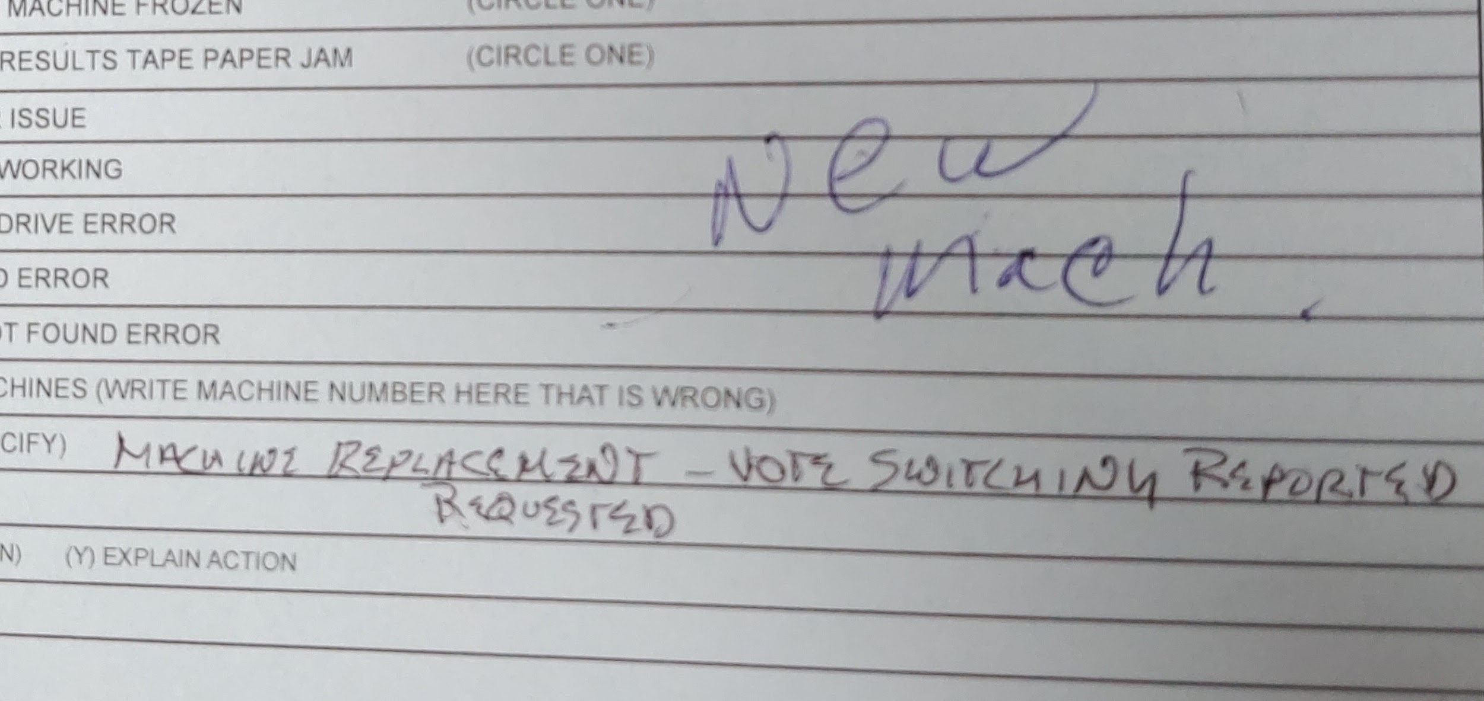

***LIST OF EXPRESSVOTE XL PROBLEMS REPORTED (PHILADELPHIA, NOV 2019)***

*machine will not start*

*Too many selections, system lags*

*code keeps coming up to be entered. tried to recalibrate, told not to resolve*

*can't open polls. can't get P/W to work. rover sent -- no resolution*

*error opening or closing machine. tried hard reset. still get invalid code. verified using gen2019*

*machine not powering on. reset, then it wouldn't accept ballot*

*second light not on, machine not turning on.*

*Not cleared*

*machine won't turn on*

*printer not able to print. paper is coming out but nothing on it.*

*screen or machine frozen. machine went down*

*machine frozen. will not print report, it's sending to vote mode without report.*

*can't get zero count - printer error. 2nd call for a tech*

*Issues printing zero reports*

*error opening or closing machine.*

*both machines are experiencing random unresponsiveness but can still vote*

*Printer not found error - fixed. Happen prior about 15 min ago*

*Insists machine is not working right, requesting tech. Would not go through calibration steps b/c it's too busy.*

*x4 machines - voting lights not coming on*

*machines down all day*

*cannot open polls. password not taking*

*Machine frozen*

*Machine frozen - new machine*

*internal device not found. fixed.*

*cannot open polls*

*has not printed zero tape*

*screen frozen*

*cannot open polls*

*Machine replacement - vote switching reported*

*One machine down*

*One machine not open - want explain issue - dispatch tech*

*Machine down*

*screen frozen below straight ticket row. voter quit session and went to other machine*

*screen frozen. frozen on zero report, printing screen after report had printed one copy*

*Side handle not registering close*

*Stated it's defaulting to Spanish - calibration??*

*defaulting language to Spanish -- won't change to English*

*Machine erases vote on questions. Automatically goes to Spanish*

*screen frozen*

*printer not found error*

*Paper shut down machine*

*Printer will not print - restarted & walked through printing report manually*

*Front is 19-2 A, back is 19-2 A - USB says 19-1 A, screen says 19-1 A*

*cannot open polls / L & A not closed/closed & repoen polls/ print zero*

*Cannot open polls*

*getting multiple kickouts when setting override code. she has correct code*

*Cannot open polls*

*screen frozen. can't get 3 final reports, machine froze (paper hanging over machine)*

*cannot open polls - machine wouldn't come on*

*system halt - walked through restart*

*Cannot open polls - reporting wrong code/code not accepted*

*Cannot open polls*

*Screen frozen - 2 others are working - 1 machine frozen*

*needing to get talked through process of booting up replacement machine*

*Machine reboot*

*Can't get hopper bag out*

*Back on machine won't unlock*

*Cannot open polls - uncompression error*

*Cannot open polls*

*screen frozen. screen was not responding correctly*

*Machine frozen*

*Error message: Internet device not found*

*Cannot open polls*

*Fatal Error*

*machine frozen.*

*the system encountered a fatal*

*Can not open polls - close polls came up & results report printing*

*Both A&B not responding correctly when "All Rep" or "All democrat" tab is voted. Showing up opposite of party!*

*Rebooted, proper boot close & press a key*

*Machine down*

*QVC port not enabled - alarm noise! can't vote - attempt to restart doesn't work*

*cannot open polls*

*cannot open polls*

*Cannot get zero to print & open poll*

*Polls already opened - No votes, 0 card count, 0 ballots in hopper*

*Error opening machine*

*Freezes when they try to open polls*

*machine wouldn't turn on. called @ 7 am. was told a new machine would be sent out. Doesn't have a new machine yet. also doesn't have ballots for other machine*

*both machines down. 1 machine not powering on, other no ballots*

*EQC'D/ replace machine*

*There is no district 9 on screen*

*Voter called in about issue with voting - said it canceled because he took to long*

*media door will not lock*

*sticks insert door doesn't lock. can't turn key to remove*

*cannot lock top panel. tried. city official took it out of service*

*door*

*cannot open back of machine*

*Top door will not close*

*machine access compartment door unlocked. has been unlocked all day, can't lock*

*access door won't lock. key can't be removed*

*seal broke and cannot be removed. unable to put second seal*

*key slot bent on back of machine. cannot close door.*

*back door will not lock and the key turns*

*rear door issue. not able to latch rear door lock.*

*Door not opening - tech bring seal (do not have any) and open top compartment door*

*seal issue*

*Back of machine is broken (lock) Hopper bag needed at the end of the night. Need site support to fix and remove hopper*

*seal broken*

*can't open to USB door*

*seals broken, confirmed okay and replace*

*seal issue*

*unsure on seals. does he need to worry and do they need to matter*

*Door was stuck open - forced shut - worried about how it will be later to get open. Someone told them they can't help (rover or tech)*

*Yellow seal broke*

*cfast card error*

*waiting for a stick over an hour*

*system encountered error, please contact help - cfast card needs reseated*

*unit in demo mode. not reading USB (invalid media)*

*demo USB in, called in before and a tech was dispatched with a new USB. Asking when the new USB should arrive*

*Card popped out - send tech*

*PPM will not process card. repeat multiple, need to swap machine out.*

*usb flash drive error*

*Need new media stick - replace EQC media and insert election media - trying to read the thumb drive*

*screen frozen. message: 0. card cannot be read.*

*Need to reset CF cards*

*card cannot be read. cannot read. frozen on screen*

*Ballot not taking [card reader error] - machine took 5 of 7 ballots*

*error message on display screen. send tech to reset the 2GB fast cards*

*screen frozen. card cannot be read.*

*USB flash drive error.*

*Machine will not accept blank card*

*Card cannot be read*

*Internal memory device (cfast card)*

*Moved all ballots to new card & resynced cards*

*New stick*

*Card cannot be read - ask an election official - can't get off that screen*

*Machine frozen - when inserting the card, voter is being instructed to accept the ward & division - cannot "accept" - no votes on machine yet*

*Internal memory device missing - send tech*

*had to plug into power outlet*

*Power issues - green light not coming on - all 3 power lights on in access panel*

*need power strip and extension cord*

*Battery not found*

*power cord came out - machine turned off*

*power cord came out - machine turned off*

*Machine not in a working outlet*

*alert system has encountered an error - ask for help*

*Machine died plugged into active outlet*

*Needs an extension cord - bad outlet*

*Machine powers off while powering off (up)*

*power issue*

*battery 40 pct to 20 pct*

*error opening machine. no power cord on either card*

*Power issue*

*Plug power in to new outlet*

*2 xls -- neither getting power -- daisy chained. no green light. 20 pct battery*

*Machine A won't power on*

*Outlet invalid*

*battery LCD at zero pct.*

*Light power*

*Batteries not charging*

*key in back. fixed*

*question about locks*

*Lock issue - key won't turn in top panel*

*Key lock top or bottom machine*

*Lock issue/keys not quite working, tech needed*

*No keys for voting machines*

*No key with bag*

*Need a set of keys*

*Missing keys*

*No keys - lost during day*

*Key not working*

*key not working*

*USB lock won't lock*

*Key not working*

*Barrel key not working in top panel*

*rear door issue. key could not open back door. states that lock looks smaller than key diameter*

*ballot or results paper jam*

*paper stuck though there is not ballot per call*

*ballot or results tape paper jam*

*Paper stuck in ballot reader, cleared out, still will not take ballots*

*ballot jam*

*Jammed*

*ballot tape jam*

*Ballot or results paper jam.*

*paper jam. ballot spoiled, voter left*

*ballot jam. won't take paper*

*ballot jam*

*Ballot jam - tech wanted to swap out hopper*

*called in needing hooper. EJ does not want to swap out. ballots are jamming, tried shaking it. There's another hopper on the way. Shannon is going to take it, and wait for EJ to call back when they want to get the new hopper.*

*ballot jam*

*ballot paper jam*

*Ballot jam*

*Ballot or results tape paper jam*

*Ballot paper jam*

*Need bin - every ballot jamming*

*ballot jam. multiple attempts to clear by shaking hopper . ballots are not bent or wrinkled*

*ballot or results tape paper jam*

*ballot jam*

*paper jam*

*Paper jam *need yellow seal for election machine*

*Ballot jam*

*Paper jam*

*Ballots will not feed, only spits them back out and says invalid*

*ballot paper jam*

*Ballot jam*

*ballot jam*

*ballot jam*

*ballot jam*

*ballot jam*

*ballot jams*

*repeated ballot james. will not feed a ballot*

*Ballot jam*

*ballot casted/counted then jammed*

*Ballot or results tape paper jam*

*Results tape jam - zero not printing*

*paper jam. ballot spoiled, voter left*

*Keeps jamming, have rebooted, still jamming - send machine*

*"Ejecting card" flashes, paper jam*

*Clear paper jam, error message remains*

*Ballot paper jam*

*Jammed machine*

*ballot jam*

*ballot jam*

*ballot paper jam*

*ballots jamming - continue to shake*

*Paper jam issue*

*Machine keeps jamming*

*Ballot jam*

*ballot jam*

*Paper jam*

*Ballot or results tape paper jam*

*ballot jam*

*ballot jam*

*ballot jam*

*ballots jamming, techs deployed, still jamming, repeat issue*

*paper jam. ballot spoiled, voter left*

*ballot or results paper jam*

*paper jam. reset but screen froze & wouldn't load post jam fix. reset machine.*

*Ballot jam - keeps spitting it out after completing*

*ballot jam - spoiled ballot procedures*

*printer jam*

*User had a ballot stuck*

*ballot paper jam*

*results paper jam*

*ballot jam*

*Ballot Jam*

*results tape paper jam. zero not printing, tried to restart*

*jam and spoiled ballot - resolved*

*not taking ballots*

*Ballot jam*

*poll worker cleared ballot jam, but cast vote a second time*

*paper jam*

*ballot jam. paper ballot printing blank first attempt. revote worked find. same piece of paper.*

*Ballot jam*

*Ballot jam*

*Requesting assistance at closing*

*Requesting assistance at closing - Close poll request*

*error closing machine*

*error closing machine. closing question - resolved*

*Only printed 1 tape - frozen now*

*question on closing polls*

*Screen frozen - closing polls*

*Error closing machine*

*Was on close polls - send tech out*

*error opening or closing machine*

*Screen frozen - closing polls*

*Closing machine - got 4 reports*

*error closing machine*

*Help closing*

*Close polls & report printing public count*

*Screen frozen - closing polls, paper touched screen*

*Close poll - replace hopper - new stick - wrong stick*

*error closing machine.*

*error closing machine*

*Printed 1 of 8 - frozen unit*

*error closing machine.*

*screen slow to show selections being made*

*Machine frozen - while printing 7/8 reports*

*Paper touching screen*

*Calibration issue*

*Voter inserted ballot but the machine did not recognize the ballot so screen is not changed from "insert ballot"*

*calibration screen*

*calibration issue persists after rover and tech have serviced the machine.*

*calibration issue persisting after rover and tech visits and phone support*

*calibration issue*

*error opening or closing screen.*

*Voter went to spoil ballot, could not return to previous screen, poll worker pushed wrong button*

*calibration screen.*

*Calibration screen appearing*

*calibration issue*

*calibration repeat*

*calibration screen.*

*Screen or machine frozen*

*screen calibration issue - need tech*

*Went to a calibration screen by accident*

*Unresponsive touchscreen*

*Screen frozen*

*Screen - tried rebooting twice*

*Got calibration screen by accident*

*screen unresponsive*

*Machine frozen - froze while reports were printing*

*Calibration issues on screen, has done it 4 times, still has to push to left of screen to work, needs tech out to check screen*

*calibration issue*

*Powers on, flashes ES&S screen, goes black. Also middle light goes out and stays black*

*Calibration issue*

*Screen frozen*

*Screen frozen - may need to be recalibrated, unable to resolve while on phone*

*Spoiled ballot, trying to follow procedures. Bad phone connections. Followed city procedure. Does not take a yes vote on the [illegible]. Calibration issue*

*unresponsive screen*

*Having issues w/"parallax" touch and getting the votes correct. Had him "up up the screen" for better viewing*

*calibration issues*

*Machine frozen - while reports were printing due to reports touching screen*

*frozen*

*screen frozen*

*Screen will stick*

*machine frozen*

*screen frozen. trying to close, screen froze. B machine is not closed yet.*

*Calibration screen*

*require hard press on screen to cast vote*

*Screen calibration*

*screen frozen. sensors messed up. can't get final reports*

*Straight Democrat ticket #116 not showing up when pushed/selected*

*Machine frozen*

*screen frozen. poll worker stuck on spoil ballot screen.*

*Reports touched screen during printing*

*The "Go to Voting" button is ghosted*

*Went into calibration mode*

*error closing machine. close polls. har restart due to calibration issue. resolved/fixed.*

*go to voting, stuck, tech has already been out - resolved -same issue. Alert: system encountered error*

*Calibration issue - wanted a technician to do it*

*screen frozen*

*Screen calibration*

*Calibration issue*

*Screen freeze*

*Screen or machine frozen*

*calibration - resolved*

*Calibration issue*

*calibration issue*

*Screen black but power is on, battery is charged*

*Screen is black*

*Black screen*

*calibration screen.*

*screen frozen*

*Machine went into calibration mode after holding black toggle switch down too long*

*Machine frozen - has rebooted 4 times, needs new machine*

*Screen blank, lights on, red button does nothing*

*Screen recalibration*

*50-0 onscreen*

*screen closed*

*touchy' selections*

*Calibration*

*Will not work unless ADA device used then touchscreen will work*

*After inserting ballot, needs ADA device to use screen*

*Machine went into calibration mode*

*screen frozen. vote session cancelled. spoiled ballot screen is frozen. tried reboot - not correct and keeps beeping.*

*error on screen.*

*screen frozen, on pg 2 of voting*

*calibration issue. Some voters reporting wrong selection being highlighted.*

*Machine went into calibration mode and froze*

*Screen not responding in go-for-voting screen*

*Closing machine/machine frozen - calibration screen*

*Screen frozen - closing polls*

*Select division 63-02 - frozen on ballot entry EQC - reload election*

*Screen frozen*

*Will not calibrate - need new machine*

*touch screen calibration*

*held mode down too long - calibration*

*screen or machine frozen*

*screen frozen.*

*Voter found it hard to do selection.Selecting yes, no is selected, and vice versa*

*Machine went into calibration mode when shutting down*

*Screen too sensitive*

*no ballots*

*ballots*

*voter abandoned ballot. needed guidance to spoil the ballot.*

*spoil ballot*

*spoiled ballots - resolved*

*no ballots*

*Spoiled ballot question*

*voter left and ballot was not cast*

*voter vacated and ballot not cast.*

*C machine will print ballot and then kick it out. in addition the other machines will not read the ballot*

*spoiled ballot*

*spoil the vote*

*Ballot not printed*

*Spoil ballot*

*blank ballot left in machine not voted on. helped him eject ballot.*

*machine not grabbing paper (ballot card)*

*Spoil report issue*

*1 time each ballot came out and needed to be inserted*

*Spoiled ballot stuck*

*Spoil ballot*

*insert paper ballot. remove hopper paper 3/4 way out. isn't pulling in ballot.*

*ballot not taking/stuck in machine*

*spoiled ballot process*

*spoiled ballot - resolved - voter left*

*voter voted in the wrong division. poll worker wanted guidance for process to spoil ballots*

*Spoiled ballot machine shut down*

*spoil ballot procedures*

*Spoiled ballot after 5 mins no activity*

*Spoiled ballot issue*

*count off. ballot spoiled. judge instructed to follow procedure for spoiled ballot and told not to worry about the book totals matching machine totals.*

*ballot did not print and stayed in PPM*

*ballot in the machine and loading, already restarted the machine*

*spoiled ballot*

*keeps rejecting ballots. did hard shut down and now working*

*machine is spitting out ballots when voters hit print and rather than entering into hopper, the ballots come out the front. when trying to enter, machine spits card right out.*

*Ballot not printing - ballot spit out front w/o pushing return/spoiled*

*error during vote session. ballot cannot be read*

*spoil ballot procedures*

*rejecting ballot. told to machine spare ballot and try again*

*new ballot hopper. ballot curled up in hopper, not allowing other ballots to drop.*

*rejecting ballots*

*reporter printer (feeder problem). please wait loading election. making noise. red triangle. report printer not found. restarted*

*spoiled ballot. when "print ballot" selected it ejects tha ballot. Tried on phone Jim and voter*

*Rejecting ballots - tried clearing, no luck*

*machine spoiling ever 2/3 ballots on its own*

*Ballots return out of machines and won't read back in*

*Cancelled ballot - changed machine w/voter*

*Ballot - the "used" message won't go away after checking hopper & plate on ballot feeder*

*voter spoiled ballot, but pollworkers were concerned that the notice to alert pollwork of issue didn't appear. Reporting at poll workers' request*

*Blank ballot not kicking out*

*Printer issue not producing viable bar codes - swap machine*

*Ballot will not feed at all*

*screen frozen. voter abandened ballot, needed help, working through ballot spoiling process*

*Machine rejects ballots*

*Ballots ejecting - not spoiled - C/B connection issue - need tech - PPM connection error*

*No paper card/ballot*

*Spoiled ballot - walked through process w/the judge*

*poll worker accidentally cast ballot when trying to spoil a ballot*

*Machine rejecting ballots*

*paper card is accept but does not show up return*

*ballot paper jam*

*spoiled ballot procedures*

*ballot voted, kicked out in front, won't cast. ballot may be compromised at bottom.*

*machine not taking blank ballot card*

*Machine keeps ejecting ballot*

*Hopper not accepting ballot*

*voter's ballot ejected, machine kept spitting it out when trying to reenter for casting vote*

*ppm not accepting ballots.*

*ballot printed, rejected through front. ballot comprmised at bottom.*

*vote was not cast. spoiled ballot*

*spoiled vote and revote*

*Spoiled ballot*

*ballot fed, then machine said to vote (to feed ballot)*

*Machine rejects ballots - no alarm, no error*

*poll worker thought the screen was frozen while spoiling ballot; they were not pressing in the red circle.*

*walk through spoil a ballot*

*zero report not printing*

*Spitting out ballots (again)*

*voter claims that while she was voting and hit a REP candidate the machine cast her ballot and she never got to finish voting.*

*Ballot spits out after selections are made. Multiple ballots inserted, all show same result.*

*Ballot is printed half only [illegible] two times with same result*

*spoil ballot*

*Machine ejected ballot; tries to insert in a different machine, machine wouldn't accept*

*spoiled ballot procedures*

*Spoiled ballot*

*Insert paper ballot*

*invalid code. needs EQC*

*tier 1 transfer*

*lights not coming on*

*wrong machines - 65-21 has 55-21*

*Their issue w/this machine is resolved*

*needs EQC*

*polling place was too dark to read printer*

*public count 12, date and time set for tomorrow*

*calling to make sure they don't need to record protected count. machines are both functioning perfectly.*

*printer won't print out report*

*other - paper tape*

*A public count = 44, B public count = 43. total 85*

*New machine did not have seal of eject panel*

*wrong machines*

*public count, not sure if election is loaded correctly. synchronized error message*

*Cannot open polls - need help to see if it has a zero count to start*

*zero report not printed*

*toggling between finding report printer and not.*

*election official message on the screen*

*Question about what seals to use when replacing*

*voting issues with clothes and screen angle*

*zero report didn't print. but now votes are on it so can't get zero report.*

*Handicap gate*

*just FYI ES&S tech used her spare hopper in swapped machine*

*tape door*

*error opening or closing machine. no receipt.*

*Does not have box with voter info*

*asked what to write down on paperwork for machine ID*

*No headset*

*Wrong machines*

*missing polling place card*

*Lights - S/D on right side / seals are confusing*

*should be in 45, he has 19 also*

*Back gray panel red non #*

*trains the machines -- went into machine with voter*

*More seals*

*Remove EQC & insert election media*

*Rover help get bin off*

*only printed 1 copy*

*No machines in polling place*

*Gummy bear in ballot inserter, a child accidentally let it get sucked in*

*write in final report did not print*

*No ballots*

*Walked thru protected versus public count concerns, all good 29 = 29*

*Machine functioning but screen is tilting badly to the left, seems to be damaged in delivery*

*A machine tilt to it*

*Swapped assent tag*

*error opening or closing machine.*

*Poll had been opened on Oct 13, needed to be reopened today*

*missing recording sheet to record all the numbers for begining and ending*

*They received ballots and wanted to close - the usual*

*Clean screen*

*Missing paper ballots*

*No Ballots*

*need clarification about voter session light. reporting that one of the curtain rods slipped down but was able to be taped.*

*counts not adding up*

*Reported machine count is good*

*No Ballots*

*zero totals report jammed - no copy of report. machine works, has been voted on*

*No Ballots*

*Wrong stick - 45-18 stick!!!*

*Wrong machines*

*Tier 1 issue*

*XL0119020002*

*Long lines*

*needed admin password*

*"Device closed & collected" - no votes today*

*Confusion on whether all seals on machines were supposed to be there - machines functioning*

*ballots needed*

*Need new stick - got wrong stick*

*Wrong council split on B Machine*

*light not on*

*Curtain rod broke*

*No ballots*

*Needs ballots*

*Printer not found error*

*Printer not found error*

*didn't print out zero report*

*was not plugged in*

*no zero report*

*no zero tape at start. votes cast since then*

*serial # on cover and machine are different. ... this is OK. called tech to confirm.*

*Wrong machine*

*needed help filling out access panel # on form*

*machine functioning, but missing serial # card on unit cover*

*No ballot*

*Open case seals missing supplies*

*Dirty screen - tech to clean machine*

*need red seal*

*Heavy voting machines*

*(new mach)*

*no green seal. public ct 5, protected at 13. card ct don't know.*

*machines functioning, question was for helping poll workers find the right division/polling place to be working*

*Zero reports print out*

*zero report affadivit, needed to print*

*machines say 55-21; ward is 65-21*

*LED lights are starting to work*

*vote report is not printing*

*no zero tape*

*zero report is blank. not a machine issue/lack of ?*

*no ballot*

*needs ballots*

*no ballots*

*date wrong at top of machine B, okayed by election official*

*Which ballot bin top seal*

*no ballots*

*voting light not coming on*

*invalid code*

*Question on machine change out*