Disinformation, Misinformation, & Fake News

Disinformation, misinformation, and fake news promotes disagreement and conflict, creates distrust, and weakens the democratic process. In more extreme cases, it encourages violence and creates permanent damage to society.

Disinformation is false, inaccurate, or confusing information intentionally spread to mislead or manipulate others.

Misinformation is false, inaccurate, or confusing information shared without the intent to mislead or manipulate.

Fake news involves false news stories - the information is made up, with no provable sources, facts, or quotes.
None of the above include satire, parody, criticisms, complaints, or protests of government actions, agencies, or processes.
Check Facts and Sources

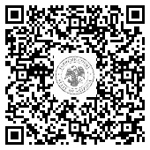

September 2021
Consider Bias

