**Establishing Arizona Judicial Branch   
Social Media Accounts**  
A recommendation from the Arizona Supreme Court  
 Task Force on Countering Disinformation

**The Recommendation**

Social media sites are increasingly relied on for news and information. Courts and members of the judicial branch are at risk of being undermined with the increase in fake websites or accounts created to spread disinformation and misinformation,

undermining trust in courts.

Today more than ever courts must increase outreach, transparency, and access to strengthen the public’s trust and confidence in the judicial system. Official social media sites help courts reinforce access to justice and share accurate and timely information and emergency messaging.

With Arizona’s urban and rural expanse and unpredictable natural events like wildfires, floods, and monsoons it important to be able to communicate timely and important information using social media.

If a court cannot immediately use these social media accounts, it should secure them and request verification to reduce the likelihood of the name being taken by others.

**The Benefits of Establishing and Maintaining Social Media Accounts**

Courts in Arizona are recommended to establish and maintain at least one verified social media account and have a social media policy in place to:

keep the public and media informed about court events;

notify the community quickly and efficiently in emergencies;

to timely counteract disinformation; and

to provide accurate information to help the public better understand court policies and procedures and rule of law.



**Before Using Social Media Accounts**

* Decide on which social media sites will work best for your court. Establish those accounts and request verification to identify them as official sites and avoid others from creating a fake site with your court’s name.
* Establish a social media policy. Include what content will and won’t be posted and acceptable responses if interacting with the public.
* Decide who will have access to accounts and who is primary and back-up for managing the accounts.
* Decide and establish acceptable response times for posting.
* Inform employees and others on the policy and provide ongoing training as needed. [See Social Media 101.](https://www.ncsc.org/topics/media/social-media-and-the-courts/social-media/social-media-101)
* Consider checking with your local government to see if there is an established handle or naming convention that your court can use. Decide on a profile name (may be your social media handle or official court name) and an appropriate image, such as your court seal or a picture of your courthouse.

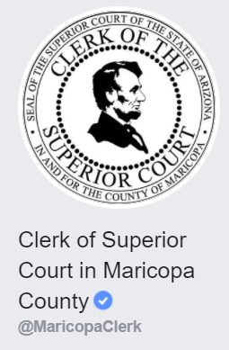**@Handles**

A social media handle is concise and descriptive and designed to be used across social media and organization to cross-promote ideas or news.

[@MaricopaClerk](https://www.facebook.com/MaricopaClerk/)– County name changes for Clerk of Superior Court in each county

[@SuperiorCourtArizona](https://www.facebook.com/SuperiorCourtofArizona/) – Maricopa County Superior Court on Facebook

[@MohaveCourts](https://twitter.com/mohavecourts) – County name changes; site includes information for multiple courts

To learn more and to read the final report from the Arizona Supreme Court’s Task Force on Countering Disinformation visit the Arizona Judicial Branch website at: <https://www.azcourts.gov/cscommittees/Task-Force-on-Countering-Disinformation>.

*Social media is one of the most powerful and cost-effective, albeit underutilized, marketing tools for sharing the court’s message. Courts, however, have been slow to tap into the unique advantages of popular platforms. More and more Americans look to social media as their primary source of news, information, and entertainment, as well as social connection. Public discourse today happens on social media. Failing to include social media in the court’s communication strategy can only widen the gap between what the public expects and what the court delivers.*

– [Social Media Marketing for Courts, NCSC Joint Technology Committee, December 2018](https://www.ncsc.org/__data/assets/pdf_file/0017/19115/2019-02-04-social-media-for-courts-final_corrected.pdf)

**Tutorials and Resources**

Step-by-step instructions to set up an official court account

<https://aspireinternetdesign.com/social-media-blogging/quick-guide-setting-social-media-accounts-business/>

Step-by-step instructions to request verification of established accounts: <https://fanbooster.com/blog/how-to-get-verified-on-social-media/#elementor-toc__heading-anchor-0>

Twitter verification FAQ and application process

<https://help.twitter.com/en/managing-your-account/twitter-verified-accounts>

Digital.gov: Improving the Accessibility of Social Media in Government

<https://digital.gov/resources/improving-the-accessibility-of-social-media-in-government/#specific>

National Center for State Courts (NCSC): Social Media and the Courts Network <https://www.ncsc.org/topics/media/social-media-and-the-courts/social-media/social-media-101>

For Courts

<https://www.ncsc.org/topics/media/social-media-and-the-courts/social-media/courts>

For Judges

<https://www.ncsc.org/topics/media/social-media-and-the-courts/social-media/forjudges>

Social Media Handles: The Complete Guide  
<https://www.brafton.com/blog/social-media/social-media-handles/>

Open Graph

<https://www.freecodecamp.org/news/what-is-open-graph-and-how-can-i-use-it-for-my-website/>

**Facebook Safety and Security Resources for Government**

Safety

* [Safety tools built for government officials](https://gcc02.safelinks.protection.outlook.com/?url=https%3A%2F%2Fwww.facebook.com%2Fgpa%2Fblog%2Fsafety-tools-and-policies-for-elected-officials-and-candidates&data=04%7C01%7Cklogalbo%40sc.pima.gov%7Ceb83c60e0cdf4c79eb8908d8d8f5002b%7C6dee49b86aab425c83df5288ae4b7222%7C0%7C1%7C637497894084437713%7CUnknown%7CTWFpbGZsb3d8eyJWIjoiMC4wLjAwMDAiLCJQIjoiV2luMzIiLCJBTiI6Ik1haWwiLCJXVCI6Mn0%3D%7C1000&sdata=TBMTAI7nyPVinYtLczk6xjPnpPnn0TuDp4c5z3P0Nsk%3D&reserved=0)
* [Restricting features](https://gcc02.safelinks.protection.outlook.com/?url=https%3A%2F%2Fabout.instagram.com%2Fblog%2Fannouncements%2Fstand-up-against-bullying-with-restrict&data=04%7C01%7Cklogalbo%40sc.pima.gov%7Ceb83c60e0cdf4c79eb8908d8d8f5002b%7C6dee49b86aab425c83df5288ae4b7222%7C0%7C1%7C637497894084457627%7CUnknown%7CTWFpbGZsb3d8eyJWIjoiMC4wLjAwMDAiLCJQIjoiV2luMzIiLCJBTiI6Ik1haWwiLCJXVCI6Mn0%3D%7C1000&sdata=SOphH0zYFZnHoQgQWugtLSL1yr3PBHd1tFgCYiUnbKw%3D&reserved=0)
* [Tools to Prevent Harassment](https://gcc02.safelinks.protection.outlook.com/?url=https%3A%2F%2Fabout.fb.com%2Fnews%2F2017%2F12%2Fnew-tools-to-prevent-harassment%2F&data=04%7C01%7Cklogalbo%40sc.pima.gov%7Ceb83c60e0cdf4c79eb8908d8d8f5002b%7C6dee49b86aab425c83df5288ae4b7222%7C0%7C1%7C637497894084447672%7CUnknown%7CTWFpbGZsb3d8eyJWIjoiMC4wLjAwMDAiLCJQIjoiV2luMzIiLCJBTiI6Ik1haWwiLCJXVCI6Mn0%3D%7C1000&sdata=lOL97HoDRgA5KGatTsFBMrp9OKMEVIfAspcKqRA4RrI%3D&reserved=0)
* [Comment management tools](https://gcc02.safelinks.protection.outlook.com/?url=https%3A%2F%2Fwww.facebook.com%2Fgpa%2Fblog%2Ffacebook-and-instagram-tools-for-comment-management&data=04%7C01%7Cklogalbo%40sc.pima.gov%7Ceb83c60e0cdf4c79eb8908d8d8f5002b%7C6dee49b86aab425c83df5288ae4b7222%7C0%7C1%7C637497894084457627%7CUnknown%7CTWFpbGZsb3d8eyJWIjoiMC4wLjAwMDAiLCJQIjoiV2luMzIiLCJBTiI6Ik1haWwiLCJXVCI6Mn0%3D%7C1000&sdata=KIle%2BaeCcs%2BE6UsDHmrRkomnvOQ44mMnmuDm8gx%2BuE8%3D&reserved=0)
* [Privacy & Safety at Facebook](https://gcc02.safelinks.protection.outlook.com/?url=https%3A%2F%2Fscontent-sea1-1.xx.fbcdn.net%2Fv%2Ft39.2365-6%2F14659086_1791754484415508_8058149440969506816_n.pdf%3F_nc_cat%3D107%26ccb%3D2%26_nc_sid%3Dad8a9d%26_nc_ohc%3DftGFiNMVgTYAX_CmmEk%26_nc_ht%3Dscontent-sea1-1.xx%26_nc_rmd%3D260%26oh%3D59be2d5a2ca96d50afaf993673979218%26oe%3D603EF92A&data=04%7C01%7Cklogalbo%40sc.pima.gov%7Ceb83c60e0cdf4c79eb8908d8d8f5002b%7C6dee49b86aab425c83df5288ae4b7222%7C0%7C1%7C637497894084457627%7CUnknown%7CTWFpbGZsb3d8eyJWIjoiMC4wLjAwMDAiLCJQIjoiV2luMzIiLCJBTiI6Ik1haWwiLCJXVCI6Mn0%3D%7C1000&sdata=3u5Md%2F78VKv7HyWxTXCAXzadG%2Btbb1KGJF4%2FccChhwI%3D&reserved=0)
* [Managing Bullying and Harassment in Facebook Communities](https://gcc02.safelinks.protection.outlook.com/?url=https%3A%2F%2Fscontent-sea1-1.xx.fbcdn.net%2Fv%2Ft39.2365-6%2F121104544_3366942393413743_2584766370613996862_n.pdf%3F_nc_cat%3D106%26ccb%3D2%26_nc_sid%3Dad8a9d%26_nc_ohc%3DGSTOPGzJ_IYAX-pO7Zt%26_nc_ht%3Dscontent-sea1-1.xx%26_nc_rmd%3D260%26oh%3D126e6f09a973cfcef249bd4d8ac67cf4%26oe%3D60400CC1&data=04%7C01%7Cklogalbo%40sc.pima.gov%7Ceb83c60e0cdf4c79eb8908d8d8f5002b%7C6dee49b86aab425c83df5288ae4b7222%7C0%7C1%7C637497894084467584%7CUnknown%7CTWFpbGZsb3d8eyJWIjoiMC4wLjAwMDAiLCJQIjoiV2luMzIiLCJBTiI6Ik1haWwiLCJXVCI6Mn0%3D%7C1000&sdata=mqEU3AMRF4M%2BBtUiyCd7%2B2TWRGu%2BhaMziCLmreh2m7w%3D&reserved=0)
* [Tips for Securing Your Facebook Account](https://gcc02.safelinks.protection.outlook.com/?url=https%3A%2F%2Fwww.facebook.com%2Fmicro_site%2Furl%2F%3Fclick_creative_path%255b0%255d%3Dlink%26click_from_context_menu%3Dtrue%26country%3DUS%26destination%3Dhttps%253A%252F%252Fwww.facebook.com%252Fgpa%252Fblog%252Ftips-for-securing-your-facebook-account-%26event_type%3Dclick%26last_nav_impression_id%3D0JSu60I7jMW0QlNcY%26max_percent_page_viewed%3D79%26max_viewport_height_px%3D936%26max_viewport_width_px%3D1920%26orig_http_referrer%3Dhttps%253A%252F%252Fwww.facebook.com%252Fgpa%252Fsearch%26orig_request_uri%3Dhttps%253A%252F%252Fwww.facebook.com%252Fgpa%252Fblog%26primary_cmsid%3D590017845029456%26primary_content_locale%3Den_US%26region%3Dnoam%26scrolled%3Dtrue%26session_id%3D1KhCwPUsnre85MsEi%26site%3Dgpa&data=04%7C01%7Cklogalbo%40sc.pima.gov%7Ceb83c60e0cdf4c79eb8908d8d8f5002b%7C6dee49b86aab425c83df5288ae4b7222%7C0%7C1%7C637497894084467584%7CUnknown%7CTWFpbGZsb3d8eyJWIjoiMC4wLjAwMDAiLCJQIjoiV2luMzIiLCJBTiI6Ik1haWwiLCJXVCI6Mn0%3D%7C1000&sdata=DLP09j1HAdWUmru22rZHZS41VIxdBTgdIeYyocflhDs%3D&reserved=0)

Security

* [Safety Center](https://gcc02.safelinks.protection.outlook.com/?url=https%3A%2F%2Fwww.facebook.com%2Fsafety&data=04%7C01%7Cklogalbo%40sc.pima.gov%7Ceb83c60e0cdf4c79eb8908d8d8f5002b%7C6dee49b86aab425c83df5288ae4b7222%7C0%7C1%7C637497894084467584%7CUnknown%7CTWFpbGZsb3d8eyJWIjoiMC4wLjAwMDAiLCJQIjoiV2luMzIiLCJBTiI6Ik1haWwiLCJXVCI6Mn0%3D%7C1000&sdata=fMEPdfYna6%2FRMwY78HW5PhEr8mq18ADogeUb8r1yHo0%3D&reserved=0)
* [To turn on 2-factor authentication](https://gcc02.safelinks.protection.outlook.com/?url=https%3A%2F%2Fwww.facebook.com%2Fhelp%2F2FAC&data=04%7C01%7Cklogalbo%40sc.pima.gov%7Ceb83c60e0cdf4c79eb8908d8d8f5002b%7C6dee49b86aab425c83df5288ae4b7222%7C0%7C1%7C637497894084477540%7CUnknown%7CTWFpbGZsb3d8eyJWIjoiMC4wLjAwMDAiLCJQIjoiV2luMzIiLCJBTiI6Ik1haWwiLCJXVCI6Mn0%3D%7C1000&sdata=vx4c2zv%2BafEThEj0%2BMN4TJIcShpASuaVdKaGLco30H8%3D&reserved=0)
* [Facebook Security Check-Up](https://gcc02.safelinks.protection.outlook.com/?url=https%3A%2F%2Fwww.facebook.com%2Fhelp%2F799880743466869&data=04%7C01%7Cklogalbo%40sc.pima.gov%7Ceb83c60e0cdf4c79eb8908d8d8f5002b%7C6dee49b86aab425c83df5288ae4b7222%7C0%7C1%7C637497894084477540%7CUnknown%7CTWFpbGZsb3d8eyJWIjoiMC4wLjAwMDAiLCJQIjoiV2luMzIiLCJBTiI6Ik1haWwiLCJXVCI6Mn0%3D%7C1000&sdata=uMs4S87R419aP%2FvJMdVWb4xGkB4f3q0ubN8ZPiDldcQ%3D&reserved=0)
* [Facebook Protect](https://gcc02.safelinks.protection.outlook.com/?url=https%3A%2F%2Fwww.facebook.com%2Fgpa%2Ffacebook-protect&data=04%7C01%7Cklogalbo%40sc.pima.gov%7Ceb83c60e0cdf4c79eb8908d8d8f5002b%7C6dee49b86aab425c83df5288ae4b7222%7C0%7C1%7C637497894084487496%7CUnknown%7CTWFpbGZsb3d8eyJWIjoiMC4wLjAwMDAiLCJQIjoiV2luMzIiLCJBTiI6Ik1haWwiLCJXVCI6Mn0%3D%7C1000&sdata=c875URWbggVaTzcsywduI%2FObMJXPA9Opxul02Pd3Y28%3D&reserved=0)
* [Tips for Moderating Your Page](https://gcc02.safelinks.protection.outlook.com/?url=https%3A%2F%2Fwww.facebook.com%2Fbusiness%2Fa%2Fpage-moderation-tips&data=04%7C01%7Cklogalbo%40sc.pima.gov%7Ceb83c60e0cdf4c79eb8908d8d8f5002b%7C6dee49b86aab425c83df5288ae4b7222%7C0%7C1%7C637497894084487496%7CUnknown%7CTWFpbGZsb3d8eyJWIjoiMC4wLjAwMDAiLCJQIjoiV2luMzIiLCJBTiI6Ik1haWwiLCJXVCI6Mn0%3D%7C1000&sdata=VgHyx98%2FaR67Lz%2Fi66%2BxGPj7LFPDMg2dCIqIJUu%2FkgE%3D&reserved=0)
* [Community Standards Against Misrepresentation](https://gcc02.safelinks.protection.outlook.com/?url=https%3A%2F%2Fwww.facebook.com%2Fcommunitystandards%2Fmisrepresentation%2F&data=04%7C01%7Cklogalbo%40sc.pima.gov%7Ceb83c60e0cdf4c79eb8908d8d8f5002b%7C6dee49b86aab425c83df5288ae4b7222%7C0%7C1%7C637497894084487496%7CUnknown%7CTWFpbGZsb3d8eyJWIjoiMC4wLjAwMDAiLCJQIjoiV2luMzIiLCJBTiI6Ik1haWwiLCJXVCI6Mn0%3D%7C1000&sdata=3OOFAUCdj8%2Bfa9ymHV6P1Mjv697NaeWHoS0ma12082Y%3D&reserved=0) (fake Profiles)

Blue Badge Verification and Ads Authorization

* [How to request verification](https://gcc02.safelinks.protection.outlook.com/?url=https%3A%2F%2Fwww.facebook.com%2Fhelp%2F1288173394636262&data=04%7C01%7Cklogalbo%40sc.pima.gov%7Ceb83c60e0cdf4c79eb8908d8d8f5002b%7C6dee49b86aab425c83df5288ae4b7222%7C0%7C1%7C637497894084497453%7CUnknown%7CTWFpbGZsb3d8eyJWIjoiMC4wLjAwMDAiLCJQIjoiV2luMzIiLCJBTiI6Ik1haWwiLCJXVCI6Mn0%3D%7C1000&sdata=OSZeNtnc6b31r5djozc5HsbeTIXMqtgGS6NDn0Whu5U%3D&reserved=0)
* [Ads Authorization Resource Hub](https://gcc02.safelinks.protection.outlook.com/?url=https%3A%2F%2Fwww.facebook.com%2Fbusiness%2Fm%2Fone-sheeters%2Fads-authorization-resource-hub%3Flocale%3Den_US&data=04%7C01%7Cklogalbo%40sc.pima.gov%7Ceb83c60e0cdf4c79eb8908d8d8f5002b%7C6dee49b86aab425c83df5288ae4b7222%7C0%7C1%7C637497894084497453%7CUnknown%7CTWFpbGZsb3d8eyJWIjoiMC4wLjAwMDAiLCJQIjoiV2luMzIiLCJBTiI6Ik1haWwiLCJXVCI6Mn0%3D%7C1000&sdata=HHVg%2BInPsNXCv1EIusChsXTlm3RQ8ACFkvR68E1ogSE%3D&reserved=0)
* [Ads Authorization](https://gcc02.safelinks.protection.outlook.com/?url=https%3A%2F%2Fwww.facebook.com%2Fgpa%2Fresources%2Fadvertising&data=04%7C01%7Cklogalbo%40sc.pima.gov%7Ceb83c60e0cdf4c79eb8908d8d8f5002b%7C6dee49b86aab425c83df5288ae4b7222%7C0%7C1%7C637497894084497453%7CUnknown%7CTWFpbGZsb3d8eyJWIjoiMC4wLjAwMDAiLCJQIjoiV2luMzIiLCJBTiI6Ik1haWwiLCJXVCI6Mn0%3D%7C1000&sdata=lZ3YT0MVVG7bmefC2wZ9rzdHxeL3NomC98ir6ijzCTs%3D&reserved=0)
* [Boosting Posts](https://gcc02.safelinks.protection.outlook.com/?url=https%3A%2F%2Fwww.facebook.com%2Fbusiness%2Fhelp%2F347839548598012%3Fid%3D352109282177656&data=04%7C01%7Cklogalbo%40sc.pima.gov%7Ceb83c60e0cdf4c79eb8908d8d8f5002b%7C6dee49b86aab425c83df5288ae4b7222%7C0%7C1%7C637497894084507409%7CUnknown%7CTWFpbGZsb3d8eyJWIjoiMC4wLjAwMDAiLCJQIjoiV2luMzIiLCJBTiI6Ik1haWwiLCJXVCI6Mn0%3D%7C1000&sdata=WVUVNEL9MMMdyfzBbKFXLmwp5D0H9DJ2vt9xQengyDM%3D&reserved=0)
* [Confirmed Page Owner](https://gcc02.safelinks.protection.outlook.com/?url=https%3A%2F%2Fwww.facebook.com%2Fhelp%2F323314944866264%2F&data=04%7C01%7Cklogalbo%40sc.pima.gov%7Ceb83c60e0cdf4c79eb8908d8d8f5002b%7C6dee49b86aab425c83df5288ae4b7222%7C0%7C1%7C637497894084507409%7CUnknown%7CTWFpbGZsb3d8eyJWIjoiMC4wLjAwMDAiLCJQIjoiV2luMzIiLCJBTiI6Ik1haWwiLCJXVCI6Mn0%3D%7C1000&sdata=xnA2By3v7HXm%2FevK4i26qMSvbEEiIZeS1m4zQ70iWT0%3D&reserved=0)
* [Page Publishing Authorization](https://gcc02.safelinks.protection.outlook.com/?url=https%3A%2F%2Fwww.facebook.com%2Fhelp%2F1939753742723975&data=04%7C01%7Cklogalbo%40sc.pima.gov%7Ceb83c60e0cdf4c79eb8908d8d8f5002b%7C6dee49b86aab425c83df5288ae4b7222%7C0%7C1%7C637497894084507409%7CUnknown%7CTWFpbGZsb3d8eyJWIjoiMC4wLjAwMDAiLCJQIjoiV2luMzIiLCJBTiI6Ik1haWwiLCJXVCI6Mn0%3D%7C1000&sdata=EOOzOMVJegz196Tcju7XnUvIvJc%2Fj9ov9%2Ffi5jRtV7o%3D&reserved=0)

Government, Politics, and Advocacy Specific Resources

* [GPA Best Practices](https://gcc02.safelinks.protection.outlook.com/?url=https%3A%2F%2Fwww.facebook.com%2Fgpa&data=04%7C01%7Cklogalbo%40sc.pima.gov%7Ceb83c60e0cdf4c79eb8908d8d8f5002b%7C6dee49b86aab425c83df5288ae4b7222%7C0%7C1%7C637497894084517367%7CUnknown%7CTWFpbGZsb3d8eyJWIjoiMC4wLjAwMDAiLCJQIjoiV2luMzIiLCJBTiI6Ik1haWwiLCJXVCI6Mn0%3D%7C1000&sdata=q6V%2Bd7TaaUPYMr1rHIFXxmQg%2FS%2FE%2BrryZAMlVP0k1Wc%3D&reserved=0" \o "https://www.facebook.com/gpa" \t "_blank)
* [Instagram Best Practices](https://gcc02.safelinks.protection.outlook.com/?url=https%3A%2F%2Fabout.instagram.com%2Fpolitics&data=04%7C01%7Cklogalbo%40sc.pima.gov%7Ceb83c60e0cdf4c79eb8908d8d8f5002b%7C6dee49b86aab425c83df5288ae4b7222%7C0%7C1%7C637497894084517367%7CUnknown%7CTWFpbGZsb3d8eyJWIjoiMC4wLjAwMDAiLCJQIjoiV2luMzIiLCJBTiI6Ik1haWwiLCJXVCI6Mn0%3D%7C1000&sdata=Fff035oSDhtjvOJ7bU%2BFMc2rRScip%2FM7WKLtNfNS7r4%3D&reserved=0)
* [GPA Help Portal](https://gcc02.safelinks.protection.outlook.com/?url=https%3A%2F%2Fwww.facebook.com%2Fgpa%2Fhelp&data=04%7C01%7Cklogalbo%40sc.pima.gov%7Ceb83c60e0cdf4c79eb8908d8d8f5002b%7C6dee49b86aab425c83df5288ae4b7222%7C0%7C1%7C637497894084517367%7CUnknown%7CTWFpbGZsb3d8eyJWIjoiMC4wLjAwMDAiLCJQIjoiV2luMzIiLCJBTiI6Ik1haWwiLCJXVCI6Mn0%3D%7C1000&sdata=21Qh1aOY8mt3yVZFj65MT%2FaRhNJvBtVfSMmpOlz09Z0%3D&reserved=0)
* [GPA Facebook Page](https://gcc02.safelinks.protection.outlook.com/?url=https%3A%2F%2Fwww.facebook.com%2FGovtPolitics%2F&data=04%7C01%7Cklogalbo%40sc.pima.gov%7Ceb83c60e0cdf4c79eb8908d8d8f5002b%7C6dee49b86aab425c83df5288ae4b7222%7C0%7C1%7C637497894084527321%7CUnknown%7CTWFpbGZsb3d8eyJWIjoiMC4wLjAwMDAiLCJQIjoiV2luMzIiLCJBTiI6Ik1haWwiLCJXVCI6Mn0%3D%7C1000&sdata=h0GKLahR7my%2BojnJ9rGdGpvDiiQv0656d8WN2FC0uTU%3D&reserved=0)
* [GPA Facebook Group](https://gcc02.safelinks.protection.outlook.com/?url=https%3A%2F%2Fwww.facebook.com%2Fgroups%2F1129493057216927%2F&data=04%7C01%7Cklogalbo%40sc.pima.gov%7Ceb83c60e0cdf4c79eb8908d8d8f5002b%7C6dee49b86aab425c83df5288ae4b7222%7C0%7C1%7C637497894084527321%7CUnknown%7CTWFpbGZsb3d8eyJWIjoiMC4wLjAwMDAiLCJQIjoiV2luMzIiLCJBTiI6Ik1haWwiLCJXVCI6Mn0%3D%7C1000&sdata=Nzpjsk4VT6tsbmBLRau9wSG8ajeJFyQzPhCAROqzS0g%3D&reserved=0)

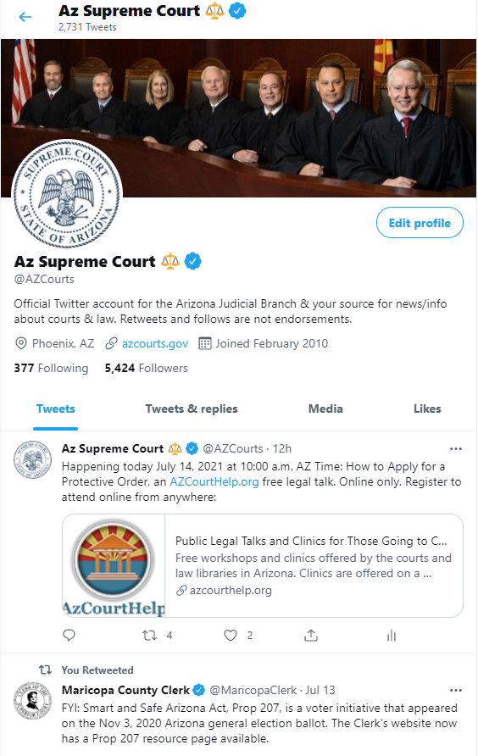

**Verification Badge  
on Twitter**

**Twitter Handle**

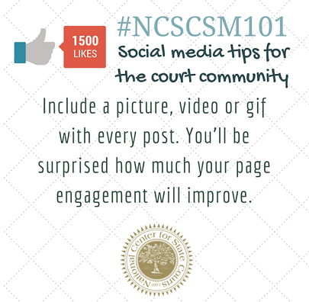

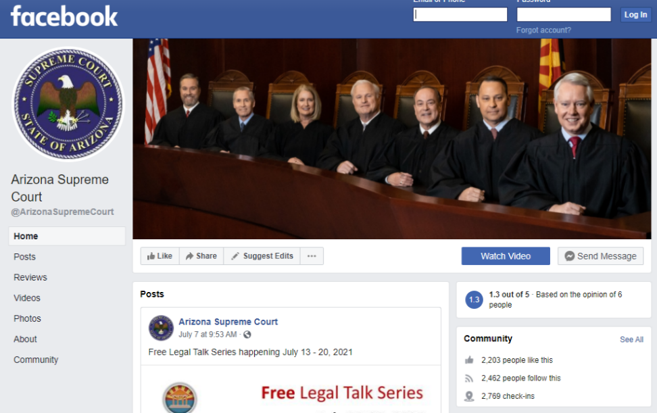

****

**Court Seal**

**Court Name**

**Handle**

Follow us on Facebook [@ArizonaSupremeCourt](https://www.facebook.com/ArizonaSupremeCourt/)