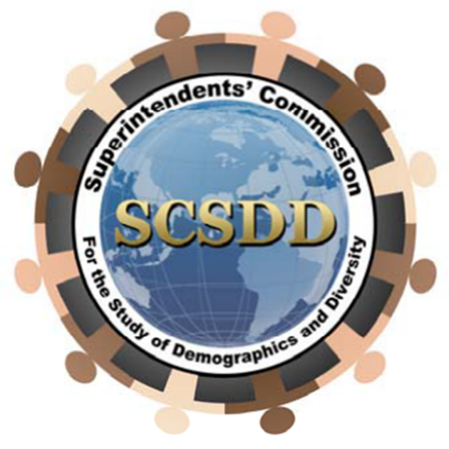
Call for Presentations
March 21, 2025
Tinley Park Convention Center
18451 Convention Center Drive
Tinley Park, IL 60477

TOPIC AREAS
Cultural Relevancy
Trauma Informed Practices
Fine Arts
SEL Standards
Google Classroom
Human Trafficking
Restorative Practices
Special Education Law
Health & Wellness
Your Mental Health/First Aid
Business Office Practices
Custodians
Secretaries
Nurses/Social Workers
Classroom instruction for paraprofessionals
Proposals should be no more than two pages, double spaced and:
- Include a title for the presentation
- Indicate who will make the presentation and include:
      - Name of contact person, address, telephone number and email address
      - Name of presenter, address, telephone number and email address
- Describe the purpose of the research or the innovative program
  - Describe in detail the innovative program or methodology used (design of project, sample size, site/participant selection criteria, data collection method(s), data analysis technique(s), response rate
  - Provide a summary of findings and indicate grade level(s): primary, intermediate or high school
- Explain the implications for education
  - Include AV Needs: LCD projector (you must provide your own computer)
- Related to at least one of the four topic areas listed above
Availability, Please check one:
______Friday AM only _______Friday PM only _______Friday (all sessions)

Incomplete proposals will not be considered
- Include a one-page biography or vita of the principal presenter
- If selected, prepare handouts for approximately 50 people per session
- You will be notified in writing no later than March 4, 2025
- Proposals may be submitted via email
- All presenters must register for the conference

Deadline for Proposals is February 17, 2025

Inquiries and proposals should be directed to:
Dr. Kimako Patterson
Email: docmako55@yahoo.com
Phone: 708-704-5063
Conference website: www.scsdd.net

