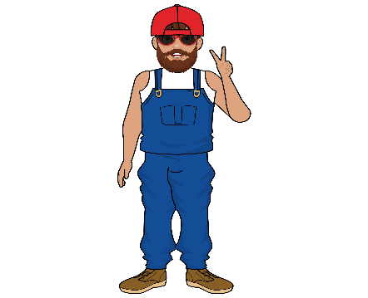
REDNECK HIBACHI

EMPLOYMENT APPLICATION
We are a fast-growing Food Truck.
Please complete the application below to be considered for a position in a FUN, fast paced, high-volume Food Truck.
We are looking for unique candidates that wield the skills that are required/necessary in creating a unique experience for our guests!
(Organization, Attention to detail, Serve Safe, Personable, follows direction, on time, isn’t afraid to work) these are just some examples of what we are looking for.
If you think you have what it takes to be a REDNECK, we encourage you to fill out an application can come ting it up!
Please Print and fill this out, scan or take a GOOD picture and email it to
redneckhibachi23@gmail.com Subject line: RNH APPLICATION

Applicant Information (please be ACCURATE)
Full Name: |  |  |  | Date:
 | Last | First | Middle

Address:
 | City | State | ZIP

Phone: |  | Email

Date Available: |  | Social Security No.: |  | Desired HOURLY: | $

Are you able to work long hours?

Are you authorized to work in the U.S.? | YES | NO | Reliable Transportation? | YES | NO

Have you ever been convicted of a crime/felony/misdemeanor? | YES | NO

If yes, explain:

Education
High School: |  | Address:

From: |  | To: |  | Did you graduate? | YES | NO | Diploma:

College: |  | Address:

From: |  | To: |  | Did you graduate? | YES | NO | Degree:

Other: |  | Address:

From: |  | To: |  | Did you graduate? | YES | NO | Degree:

References
Full Name: |  | Relationship:
Company: |  | Phone:
Address:
Full Name: |  | Relationship:
Company: |  | Phone:
Address:
Full Name: |  | Relationship:
Company: |  | Phone:
Address:

Employment History
Company: |  | Phone:
Address: |  | Supervisor:

Job Title: |  | Starting Salary: | $ | Ending Salary: | $

Responsibilities:

Start date: |  | End: |  | Reason for Leaving:

Company: |  | Phone:
Address: |  | Supervisor:

Job Title: |  | Starting Salary: | $ | Ending Salary: | $

Responsibilities:

Start date: |  | To: |  | Reason for Leaving:

Company: |  | Phone:
Address: |  | Supervisor:

Job Title: |  | Starting Salary: | $ | Ending Salary: | $

Responsibilities:

Start date: |  | To: |  | Reason for Leaving:

Military Service
Branch: |  | From: |  | To:

Rank at Discharge: |  | Type of Discharge:
Please use this space to explain what makes you the right fit for a position at Redneck Hibachi.
If other than honorable, explain:

Disclaimer and Signature
I certify that my answers are true and complete to the best of my knowledge.
If this application leads to employment, I understand that false or misleading information in my application or interview may result in my release.
Signature: |  | Date:

