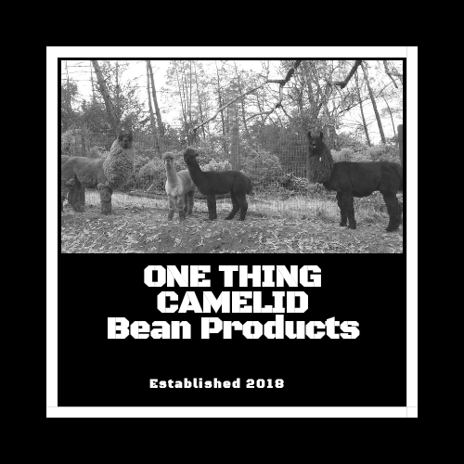
Alpaca Pooh “Tea”
Alpacas and llamas, as you can see, are the cutest animals ever! Even their poop is cute! It is often compared to coffee beans or blueberries. To nourish your houseplants or garden, these odorless air-dried “beans” are packaged in burlap or paper “teabags”, ready to soak in water overnight to create a plant nutrient “tea”. We probably shouldn’t be telling you this, but the tea bags are usually good for multiple batches of tea!
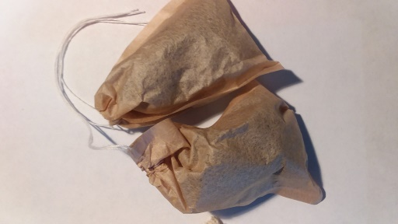
- Place one small paper teabag in a large squirt bottle (or two in 2 quart pitcher, 3 in a gallon size) and soak overnight until liquid is dark. Spray or water plants as usual.
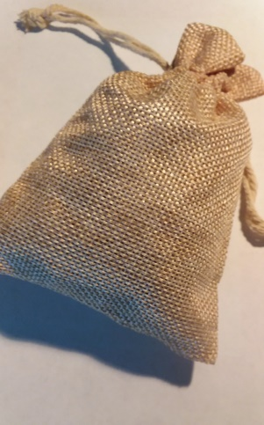
- Place one large burlap teabag in a gallon container and soak overnight until liquid is dark. Water plants as usual.
- Also available in an extra-large size (large burlap feed bag) for larger gardens or crops. Place “giant tea bag” in a large drum (that is mounted in a vehicle) and soak until water turns dark. Then spray or sprinkle plants as you drive. Please call or go to our website to find out more.

Note: All tea bags are compostable. “Beans” can be put directly on your soil when you are done. Be sure to wash your hands after preparation…it is “poop”, after all!

