**Dude Ranch Stay**

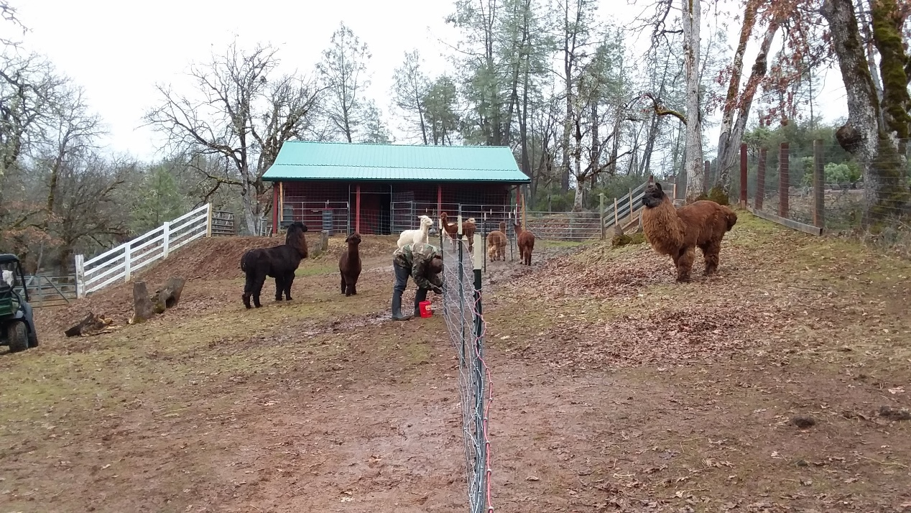**So you think you want alpacas or llamas?**

1. Here’s the upside:

* They are so cute!
* They can make you some money!
* They are the most “inexpensive” livestock to raise in terms of feed and maintenance!
* They are “trendy” right now so you could have your own “agri-tourism” business, too!

1. Here’s the downside:

* They are so cute! But, addicting…around here we refer to them as “al-CRACK-as” and “LLOVE-amas” because once you start, it’s a hard habit to break!
* They can cost you some money…they become a “money pit” as there are a lot of costs involved in setting up your property!
* They are a lot of work…to maintain their health and wellbeing, fiber quality, etc.!
* Unfortunately, a lot end up in rescues because owners did not “count the cost” before they jumped into the business!

1. Here’s the opportunity:

* Stay one night free on our ranch!
* Free meals!
* Bond with these amazing animals!
* Learn a lot in a short time!

1. Here’s the challenge:

* Wake up at the “crack of dawn” (also, you may have to share your “bunkhouse” with other “ranch hands” or stay in a tent site if all of our other Glamping trailers are booked up on the night you want to visit)
* Put on your work gloves, clothes that you won’t mind getting torn or spit on, “muck boots” (muck= a mixture of mud and manure), and your hazmat gear (just kidding)!
* Follow us around for all of your waking hours to do what we do all day…mostly scooping poop…to care for the animals!
* Work on whatever projects needs doing…put up or repair fencing and shelters, rake the paddocks, clean the Glamping trailers and campsites, scrub out the troughs, process the “bean products”, assist customers & visitors…the list could go on!

1. Here’s what you’ll need:

* Signed “Release of Liability” form (downloaded from Documents page)
* Make sure your tetanus shot is up to date in case of cuts and scratches in the “line of duty”
* Positive attitude about hard work
* Work clothes: boots, gloves, layers of clothing to suit the weather and that aren’t like “Velcro” to attract hay (like fleece…you’ll start looking like one of the alpacas!!!)
* Make an appointment on our webpage for your “free” night (you can also add another night to recover in your Glamping trailer by booking a paid night on Hipcamp.com)