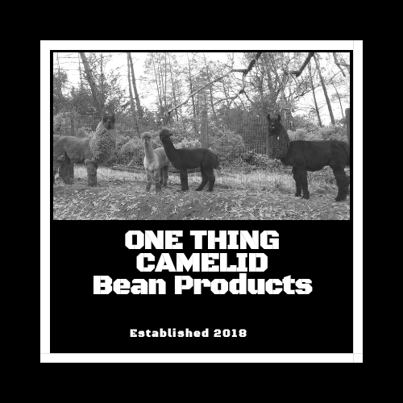
Dried Bean Fire Starters
At your next campfire, amaze your family or friends with a quick start to your fire with something they have NEVER heard of: Dried bean (alpaca and llama manure) fire starters! For centuries, mankind has used dried manure in their fires as an excellent source of energy, and around the world it is still being used. We add some paraffin to ensure a good start to your fire (and a nicer “packaging” for the beans…it is poop, after all!).
- The smaller ones (mini cupcake size) are great for campfires or fireplaces but be aware that too much paraffin (like all fire starter products) can build up on the inside of your chimney when used in excess. | 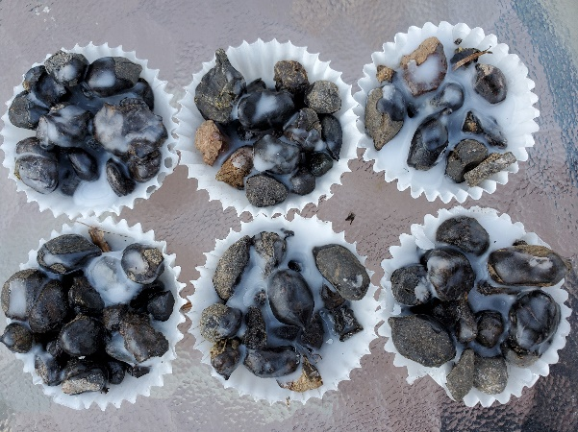

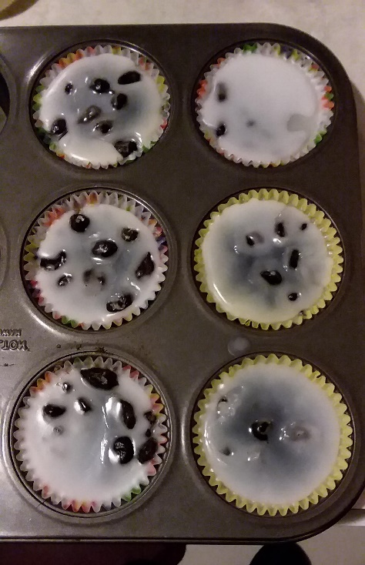 | - The large ones (regular cupcake size) are good for larger campfires or burn piles, especially when the fuel is wet.

